Analysis Plan: OpenBIS Implementation

Date: 02/25/2026
Author: Melody R. Smith

Objective
Approximate BIS values from raw EEG data using the Openibis algorithm and explore machine learning-based classification of depth of anesthesia (the brain’s response to anesthetic dose).

Data management
File paths to the data and code (more important for projects with shared access)
- Data source: https://figshare.com/articles/dataset/EEG_and_BIS_raw_data/5589841
- Code repository: https://github.com/melodyreese/custom-Python-functions/tree/main
- OpeniBIS Reference: Connor CW. Open Reimplementation of the BIS Algorithms for Depth of Anesthesia. Anesth Analg. 2022;135(4):855–864. https://doi.org/10.1213/ANE.0000000000006119 (PMC9481655)

Analysis overview
- Load in, inspect, and plot the raw EEG data
- Implement the OpeniBIS algorithm from the reference article using parameters described in the paper
- Perform quality control checks and descriptive statistics to confirm data distributions and algorithm behavior
- Classify depth of anesthesia based on openibis scores alone according to pre-defined BIS-based thresholds for awake, sedated, etc. Then, classify depth of anesthesia using supervised machine learning models of openibis values.
- Report model performance (accuracy, ROC-AUC, precision-recall)
- Explore alternative features for improved classification performance

Analysis in detail
- Plot and inspect the raw EEG data files
- Each case contains bis and EEG as n x 1 vectors, different lengths indicate different sampling frequencies
- Assuming a BIS sampling frequency of 5 Hz, EEG sampling frequency of 128 Hz (would need explicit verification in practice, but all example cases are consistent with a BIS interval of ~5 Hz)
- Cohort EEG amplitude range = -62.5 to 62.5 µV, standard deviation = 13.2 µV

Figure 1. Raw EEG signal from an example case 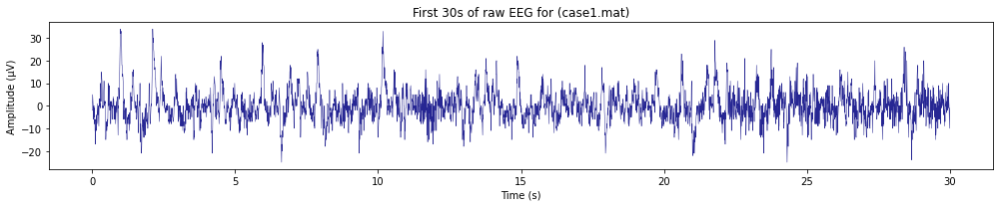

- OpenBIS implementation, including EEG feature extraction
- My initial implementation gave openibis values skewed toward 0 values, which is not realistic. I realized that the x50_ga variable from the Connor implementation was based on the median gamma power of the Connor dataset (as in, a dataset-specific hard-coded variable). Thus, I changed this hardcoded variable from -5 to our dataset gamma power median (-17). This resulted in more realistic distributions centered values around 30-40 like the true BIS.
- A specific burst suppression calculation is not described in the reference paper, and the openibis values seemed very sensitive to how burst suppression was coded. I kept the calculation simple here by coding suppression as instances below 5 µV. For future improvement, I would implement the Connor (2025) OpenBSR algorithm, a more advanced burst suppression algorithm.

- Quality control checks
- Data visualization confirms that openibis output approximates the distribution of ground-truth BIS values

Figure 2. Ground truth BIS vs. Openibis data distributions
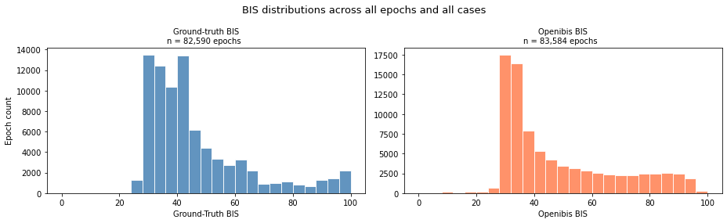

Table 1. Descriptive statistics confirm plausible distributions of openibis approximations
BIS Measure | Mean | Median | SD | Min | Q1 | Q3 | Max
Ground-Truth BIS | 45.85 | 41 | 16.97 | 20 | 33 | 52 | 98
Openibis | 48.81 | 39.25 | 20.28 | 0.84 | 32.45 | 63.24 | 97.23
Note: Potential openibis outlier(s) worth inspecting further

Figure 3. Bland-Altman vs. ground-truth BIS value comparisons
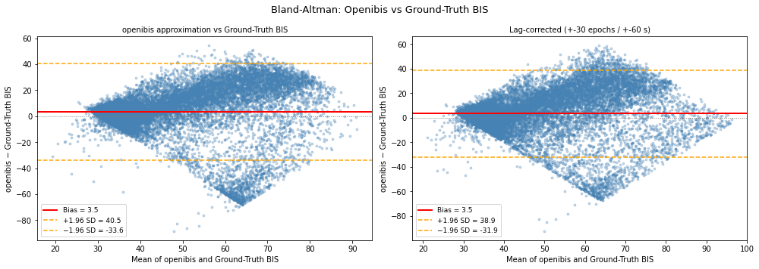

- Pearson correlation between ground-truth BIS and Openibis: 0.42
- Spearman correlation between ground-truth BIS and Openibis: 0.57

- Apply machine learning algorithm
- Depth of anesthesia classes (based on ground-truth BIS values)
  - ≥80: Awake
  - 60–79: Sedated
  - 40–59: Anesthetized
  - <40: Deep Anesthesia / Burst Suppression
- Machine learning model: An extreme gradient-boosted tree approach (XGBoost). XGBoost is more computationally efficient and less prone to model overfit or underfit than standard random forest models. XGBoost also tends to generalize better, which is important in the broader clinical context of this work. Additionally, we can inspect tree model decision points, making this and other tree-based approaches more informative than alternative black box methods.
- Validation approach: Leave-one-out cross-validation (LOOCV). LOOCV iteratively trains the model on N = 23 patients, leaving one out each iteration as a test case. For extremely imbalanced classes, I would suggest stratified k-fold cross-validation.

- Model performance
Without machine learning: Openibis classification performance using the BIS-based threshold points:
  - Accuracy: 0.487
  - Precision: 0.346
  - Recall: 0.336
With machine learning: Classification of anesthetic depth with openibis, model-selected threshold points:
  - Accuracy: 0.630
  - Precision: 0.587
  - Recall: 0.442
  - ROC-AUC: 0.723

- Exploration of alternative EEG features
- Preprocessing: 0.5–47 Hz bandpass and 60 Hz notch filter, exclusion of epochs >100 µV
- Feature extraction:
  - Spectral bands: delta, theta, alpha, beta, gamma
  - Spectral edge frequency: 50%, 95%
  - Permutation entropy
  - Burst suppression ratio
- Machine learning performance with openibis + alternative EEG features:
  - Accuracy: 0.679
  - Precision: 0.670
  - Recall: 0.663
  - ROC-AUC: 0.888 (This is impressive!!!)
Brain State | Precision | Recall
Awake | 0.71 | 0.81
Sedated | 0.60 | 0.45
Anesthetized | 0.61 | 0.66
Deeply Anesthetized/Burst Suppression | 0.75 | 0.73

*Performance visualization on the next page

Figure 4. Data Visualization and Model Performance Output
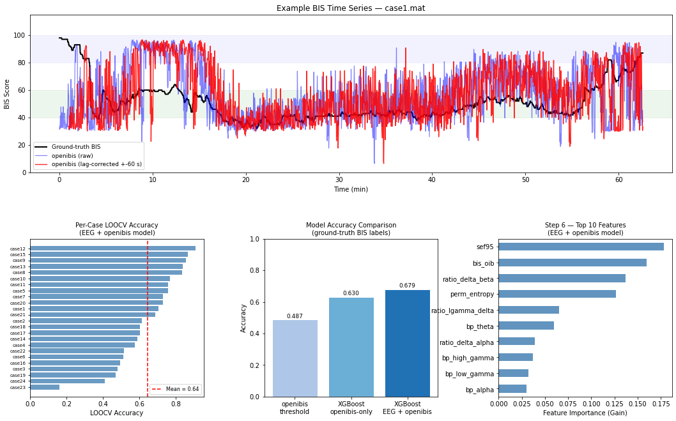Note: There was a systematic lag of ~60 seconds between the openibis approximate values and ground-truth BIS values as seen in the first plot panel above. Systematic bias was also found in Connor (2022).

Conclusions
- While the openibis approximates BIS value distributions, XGBoost models trained on additional EEG features outperform simple openibis-based anesthetic depth classification
- An improved BIS-based algorithm could help advance identification of instances when anesthetic concentrations are too high or low and to avoid unintended, potentially harmful burst suppression

Limitations
- Openibis provides approximate BIS values but is sensitive to dataset-specific parameters, which could be overcome with algorithm adjustments (e.g., data normalization). The true BIS monitor uses a more complex burst suppression calculation than used here for openibis.
- EEG contains a variety of intraoperative artifacts from sources such as electrocautery, patient repositioning, EMG, surgical intervention, or electrical noise. While we have accounted for egregious artifacts, this pipeline could be further refined to potentially improve model performance.
- Model generalizability could be impacted by anesthesia type or other intraoperative medications.

Planned Future Additions
- I would be interested in running this XGBoost model on the internal components of BIS/openibis (instead of overall BIS scores) to see which EEG features BIS relies on most and to see if adding new EEG features to this BIS-based algorithm could improve performance.
- Remove or more closely inspect case24, since >90% of the dataset had an amplitude exceeding 100 µV
- Optimize model parameters for generalizability
- Refine the burst suppression calculation using the newer OpenBSR method: https://journals.lww.com/anesthesia-analgesia/citation/2025/01000/openbsr__an_open_algorithm_for_burst_suppression.30.aspx
- I would consider another modeling approach that accounts for potential time-dependence (this version assumes that each epoch is independent, which is ok for a first pass, but perhaps not optimal)

