maven-assembly-plugin打可执行包:

pom.xml配置:

|  |
| --- |
| <properties>  <project.build.sourceEncoding>UTF-8</project.build.sourceEncoding>  <maven.compiler.source>1.8</maven.compiler.source>  <maven.compiler.target>1.8</maven.compiler.target> </properties>  <dependencies>  *<!-- https://mvnrepository.com/artifact/org.apache.commons/commons-lang3 -->* <dependency>  <groupId>org.apache.commons</groupId>  <artifactId>commons-lang3</artifactId>  <version>3.8.1</version>  </dependency>  *<!-- https://mvnrepository.com/artifact/commons-io/commons-io -->* <dependency>  <groupId>commons-io</groupId>  <artifactId>commons-io</artifactId>  <version>2.6</version>  </dependency> </dependencies>  <build>  <plugins>  <plugin>  <groupId>org.apache.maven.plugins</groupId>  <artifactId>maven-compiler-plugin</artifactId>  <version>3.8.1</version>  <configuration>  <source>${maven.compiler.source}</source>  <target>${maven.compiler.target}</target>  </configuration>  </plugin>  <plugin>  <groupId>org.apache.maven.plugins</groupId>  <artifactId>maven-resources-plugin</artifactId>  <version>3.1.0</version>  </plugin>  <plugin>  <groupId>org.apache.maven.plugins</groupId>  <artifactId>maven-clean-plugin</artifactId>  <version>3.1.0</version>  </plugin>  <plugin>  <groupId>org.apache.maven.plugins</groupId>  <artifactId>maven-jar-plugin</artifactId>  <version>3.1.1</version>  </plugin>  <plugin>  <groupId>org.apache.maven.plugins</groupId>  <artifactId>maven-assembly-plugin</artifactId>  <version>3.1.1</version>  <configuration>  <descriptorRefs>  <descriptorRef>jar-with-dependencies</descriptorRef>  </descriptorRefs>  <archive>  <manifest>  <mainClass>org.example.App</mainClass>  </manifest>  </archive>  </configuration>  <executions>  <execution>  <phase>package</phase>  <goals>  <goal>single</goal>  </goals>  </execution>  </executions>  </plugin>  </plugins> </build> |

效果:

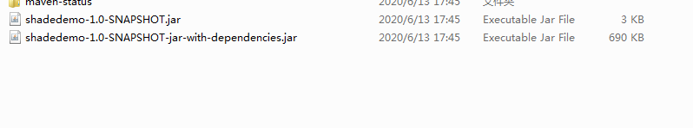

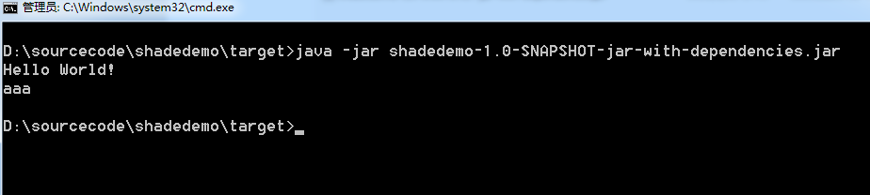

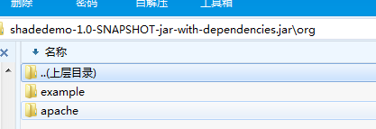

META-INF/MANIFEST.MF

