maven-shade-plugin打可执行包:

官方内置的descriptorRef

pom.xml配置:

|  |
| --- |
| <properties>  <project.build.sourceEncoding>UTF-8</project.build.sourceEncoding>  <maven.compiler.source>1.8</maven.compiler.source>  <maven.compiler.target>1.8</maven.compiler.target> </properties>  <dependencies>  *<!-- https://mvnrepository.com/artifact/org.apache.commons/commons-lang3 -->* <dependency>  <groupId>org.apache.commons</groupId>  <artifactId>commons-lang3</artifactId>  <version>3.8.1</version>  </dependency>  *<!-- https://mvnrepository.com/artifact/commons-io/commons-io -->* <dependency>  <groupId>commons-io</groupId>  <artifactId>commons-io</artifactId>  <version>2.6</version>  </dependency> </dependencies>  <dependencies>  <dependency>  <groupId>org.apache.commons</groupId>  <artifactId>commons-lang3</artifactId>  <version>3.8.1</version>  </dependency>  <dependency>  <groupId>commons-io</groupId>  <artifactId>commons-io</artifactId>  <version>2.6</version>  </dependency> </dependencies>  <build>  <resources>  <resource>  <directory>src/main/resources</directory>  <includes>  <include>**/*.*</include>  </includes>  <filtering>true</filtering>  </resource>  </resources>  <plugins>  <plugin>  <groupId>org.apache.maven.plugins</groupId>  <artifactId>maven-compiler-plugin</artifactId>  <version>3.8.1</version>  <configuration>  <source>${maven.compiler.source}</source>  <target>${maven.compiler.target}</target>  </configuration>  </plugin>  <plugin>  <groupId>org.apache.maven.plugins</groupId>  <artifactId>maven-resources-plugin</artifactId>  <version>3.1.0</version>  </plugin>  <plugin>  <groupId>org.apache.maven.plugins</groupId>  <artifactId>maven-clean-plugin</artifactId>  <version>3.1.0</version>  </plugin>  <plugin>  <groupId>org.apache.maven.plugins</groupId>  <artifactId>maven-jar-plugin</artifactId>  <version>3.1.1</version>  </plugin>  <plugin>  <groupId>org.apache.maven.plugins</groupId>  <artifactId>maven-shade-plugin</artifactId>  <version>3.2.1</version>  <configuration>  <transformers>  <transformer  implementation="org.apache.maven.plugins.shade.resource.ManifestResourceTransformer">  <mainClass>org.example.App</mainClass>  </transformer>  </transformers>  </configuration>  <executions>  <execution>  <phase>package</phase>  <goals>  <goal>shade</goal>  </goals>  </execution>  </executions>  </plugin>  </plugins> </build> |

效果:

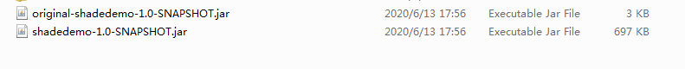

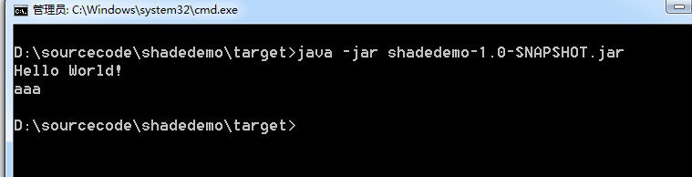

META-INF/MANIFEST.MF

