**Team**

Tanzir Islam : Prototyping, task analysis, software development

Roza Tabassum Ratri : Prototyping, drawing sketches, storyboarding

Meem Arafat Manab : Conducting user research, task analysis, project management

Shahreen Salim : Prototyping, project management, software development

Melody Soptaka : Prototyping, user research, storyboarding

**Problem and Solution Overview**

Excessive mobile phone usage has decreased user productivity and hindered their daily routine for the last decade or so. We decided to tackle this problem through the very same mobile phones. Our goal is to find a way to nudge people into reducing the amount of wasted time as much as possible along with increasing the overall productivity. According to a recent survey [1], people are prone to distraction even when they are not checking notifications, merely by the remotest alerts. Hence we are not proposing to block notifications for an indefinite period of time; rather our goal is to stall it for a healthy time span. The application will have rewarding schemes to ensure user participation. Features our project will explore include a semi-intelligent approach to notification blocking that caters to user preference and their behavior pattern, user response oriented screen-time reduction, and an empathy-based approach to *gamification*.

That mobile phone usage detains a user from reaching their creative zenith can hardly be denied nowadays. Especially after smart phones were developed, the onslaught of notifications has made attention span a scarcity for the users. When smart phones were first developed, their ability for such distraction was widely unnoticed. And yet by now, this capacity has attained its full force, literally rendering users unable to leave the phone for a remote while. The problem may not sound profound enough to prescribe a solution, but the large number of smart phone users across social strata and geographic barrier tells us otherwise. Even if we delimit our focus on users in the largest age demographic, that of 15 to 29, it is undeniable that the most productive portion of the populace falls within this spectrum. Our society cannot properly function if its brightest segment toils away continuously checking their phones for the latest notification. A small survey we conducted showed that more than 70 per cent of the notifications we receive on our phones are not urgent, and more than half of them are devoid of any useful content.

Based on these observations, we have decided to build a project that introduces subtle changes in the user behavior. We are not violently forcing users to give up checking notifications. To be specific, we cannot stop a user from reaching his phone if he is adamantly vying to use it. We will have a modest reproach that reduces user anxiety associated with smart phone notifications by stalling notifications which are not urgent per se. A reward-based feature will seek to maximize user participation and make the experience more worthwhile for the mass. As recent studies have showed, this reward-oriented approach is extremely useful for guaranteeing prolonged usage of applications.

**Initial Paper Prototype**

Our initial paper prototype focused on both the mobile application, and the critical aspects pertaining to user attention as well.

On one level, we created the initial design of how the application should function and interact, and on the other level, we built hypothetical scenarios that correspond to losses of user attention span due to smart-phones. In the design spectra, we wanted to ensure the look-and-feel of the application before embarking upon making a full fledged prototype. Questions such as whether users should be able to stall system notifications and trivialities as whether the settings should be drop-down or a static page were resolved in this stage. Some plans from this phase did not make it to the end, as they were easier to contemplate than to implement.

Our paper prototype also had its share of story-boarding, which made it easier for us to picture user-application interaction and how the user's behavior can be intervened without their conscious action. A key decision that came to fruit out of this paper prototyping was how this behavior can be intervened, ie how the user can be effectively nudged. We went through an array of options, including blurring the screen, bulk loading notifications, and so on, and settled for only the subtlest ones.

**<<<<<<<<<<<<<<<<<<INSERT PICTURE>>**

**Testing Process**

After creating our initial paper prototype, we decided to conduct some tests on a variety of users. We ran a survey on 28 users on-line, and another 34 off-line. These anonymous users responded to our questions in the survey, which have been appended to the report at the rear end. Some of these questions assume that the user has previously used an application of this category before, which made a heuristic comparison easier for us. The questions had been kept to a bare minimal so as not to alienate the participant.

We also conducted in-depth interviews of eight users, who provided a wide range of information on what they may be looking for in such a service, or how specifically their productivity is disrupted by their own mobile phones. They had been shown the paper prototype to elicit their responses based on the prototype itself.

**Testing Results**

Among the questions they were interviewed on are whether they have any prior experience in using such an application, how much they welcome the idea of award system, whether they would allow the application to read their mails and messages, and such others. A sample blank survey sheet has been added in Appendix 1.

Below are plotted some of the responses of the users :

Fig : The prior experience of users regarding this service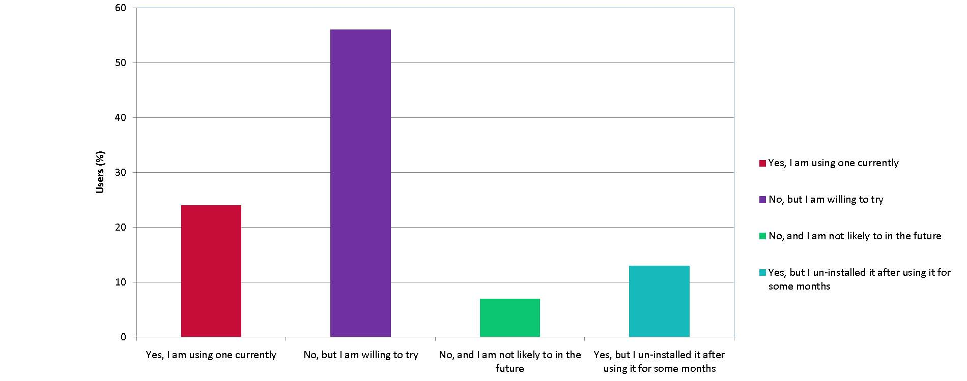

This graph shows how many users have in fact never been subjected to such services. The fact that most of them are willing to use this has showed us the market instinct.

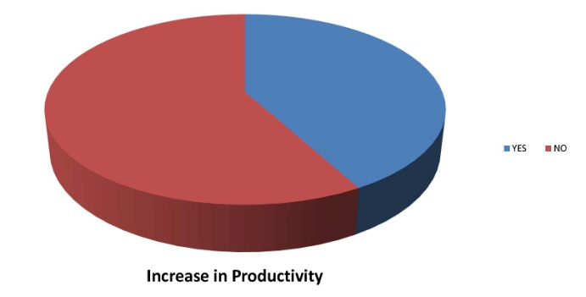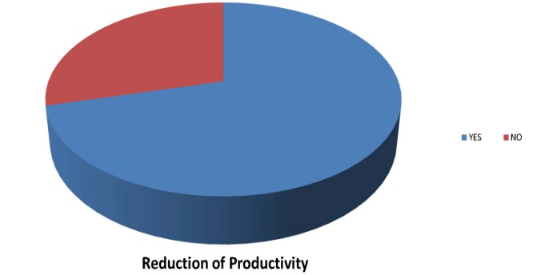

Fig : Users' thoughts on smartphone's adverse effect on productivity, and how previous applications had fared.

The previous two pi-charts show that a substantial amount of users hold smart-phones to be responsible for their decreased productivity, whereas the users who utilized such service before are mostly dissatisfied. This accounts for why more than one fifth of our surveyed users have admitted using services such as these before, and then had purged the practice. This also gives us ideas on how to outperform the previous incarnations.

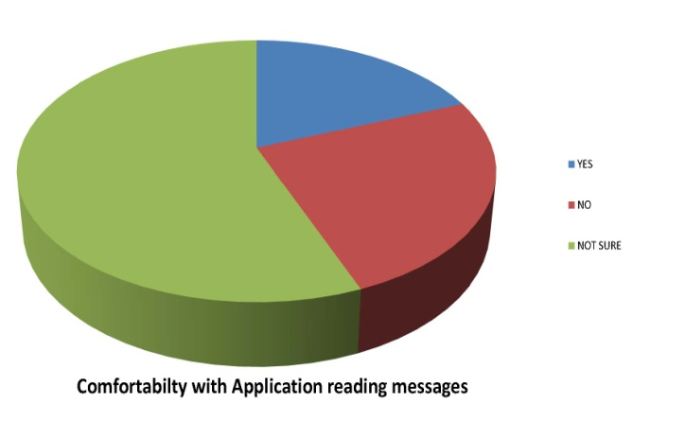

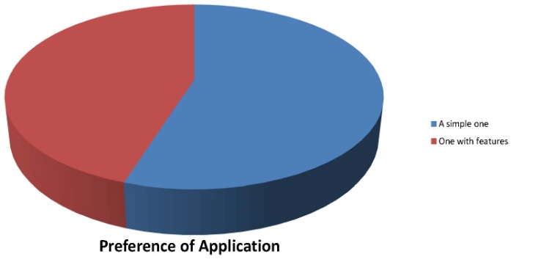

Fig : The user preference for design and privacy

As an almost even proportion of the users have opted for simpler/feature-heavy design, our decision is still undivided. We have looked into how natural language processing can help us do our task, especially how messages can be stalled for a time proportional to the importance of its content. The user response indicates that it should be an optional feature at most.

Fig : User preferences for the maximum stretch of time a phone should be used 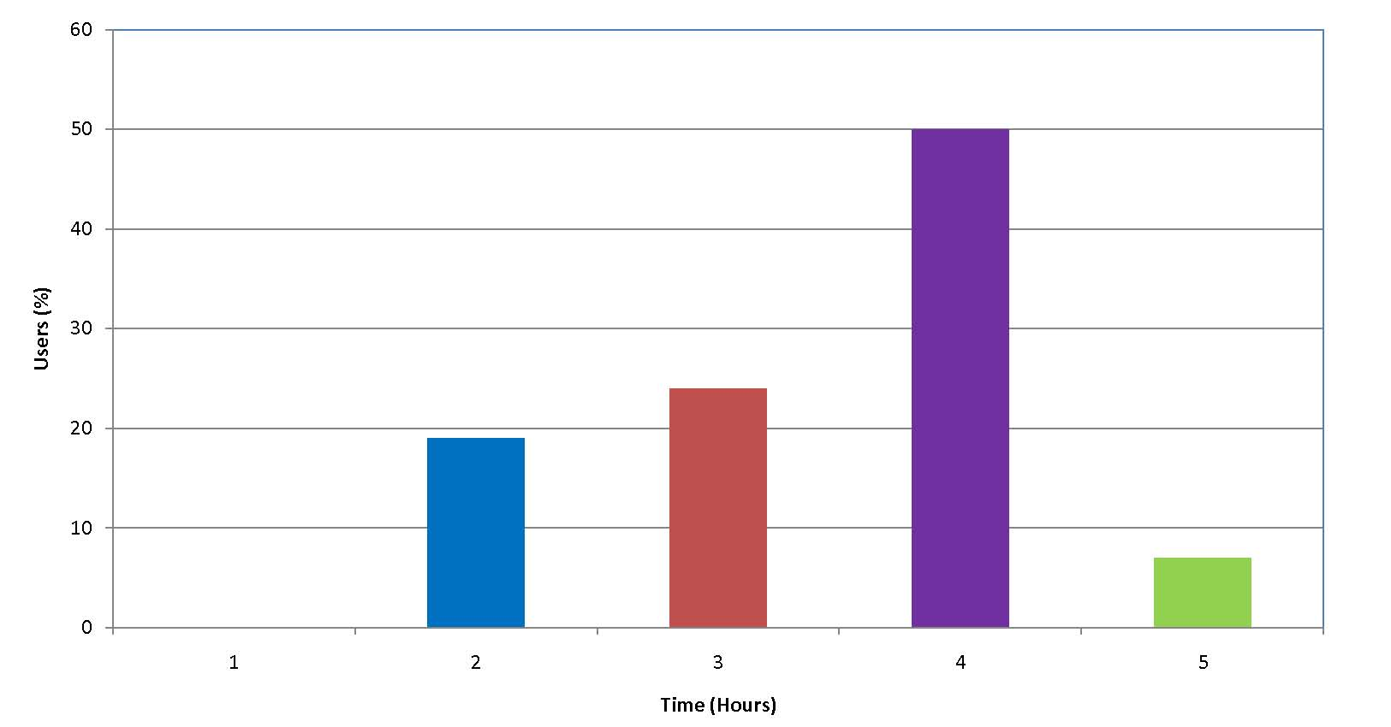

An interesting problem was that most users believed it was alright to use a phone for as long as three hours in a row. Preference for such prolonged usage tells us that even though we can stall the notifications, to reduce self-indulged over-usage, we must resort to some perhaps other means.

The verbose questions, i.e. what the failure of the previous services were, and what applications generate wayward notifications the most have generated segregated outputs. Failures of previous incarnations have ranged in a large scale, from being too deceptively simple to how the application had blocked all notifications without user concerns. These responses suggest erraticness on behalf of a large sample, but it also tells us that we cannot rely on initially set user preferences. It is more likely that we will have to analyze their usage pattern to some degree. The most notorious applications were however unanimously selected to be social media and instant messaging applications.

This discussion so far speaks for the survey. As for the interviews, the participants related to us how some complications in the design should be dropped, and how the gamification strategy should be more visual than a simple point-based ladder. This was a valuable suggestion of us on the overall composition of our service.

They also pointed out how the project could gain longevity, for example, by linking the application with social media, and by creating variable avatars for users in the UI. Suggestions as invaluable as these could only be garnered by interviewing them personally. These interviews have been stored as a part of the video documents.

The user response was overall extremely positive. Most users who have not yet been aided by similar services seemed willing to try it in the future, and more than a few of them have confessed to giving this service a thought before. Some of their demands were, undoubtedly, outrageous. For example, a few of them demanded to have stalled vital notifications such as battery failure. In those cases, we must admit to ourselves that one cannot cater to everyone's taste.

**Final Prototype**

**<<<<<<<<<<<<<<<<<<<<<<WRITE AND PASTE>>**

**User Feedback for Final Prototype**

We did a usability testing of the application on 16 anonymous users. All of them had used such application before, and discarded them. These users were given this application for a day, and then their final responses were recorded.

While four of them had felt no impulse to use this service farther, twelve of the users have responded very positively. We have attributed their response to the addition of avatars and the lack of simple point based maneuver after questioning them for a prolonged period of time. These questions were not formalized as a survey, rather we conducted an informal interview with each of them.

None of them has designated the design as particularly denigrating, a success we ascribe to our multiple phases of paper prototype. Nevertheless, the fact that a quarter of the users felt disinterested a\bout our service tells us that we need to reevaluate some of our functionalities. A detailed conversation with them tells us that this time, instead of being too complicated for some users, our application has become overtly simple. The users seem to be looking for additional services from us, which calls forth for a balance between simplicity and functionality.

**Future Directions**

Our project can only be a cog in the wheel of service that can be provided on this issue. A deficiency we cannot overlook is the incompleteness of the notification-stalling mechanism, which can create a balanced usage pattern for any user.

Another prospect that we are looking into is an in-built user behavior-pattern analysis for further evolution of the service. Such analytic module can create personalized schemes for inducing behavior change without any conscious hegemony upon the active user.

Other obvious directions this project can go into include social community based platform to engage mass users. A less obvious direction is to create multi-modal UI for different users strata, and creating a child-safe version for concerned parents. Rest assured, a pressing and newly formed problem such as this asks for a myriad of solutions, and we are expoliring it only from a constrained angle.

**Discussion**

**<<<<<<<<<<<<<<<<<<WRITE SOMETHING>>**

**Bibliography**

Stothart, Cary, Ainsley Mitchum, and Courtney Yehnert. "The attentional cost of receiving a cell phone notification." Journal of experimental psychology: human perception and performance 41.4 (2015): 893.

**Appendix I**

**Initial Survey for User Response to *Get Productive***

1. Have you used a notification blocking application before?

(a) Yes, I am using one currently.

(b) No, but I am willing to try.

(c) No, and I am not likely to in the future,

(d) Yes, but I un-installed it after using it for _____ month(s).

2. Would you say that your smart-phone is reducing your creativity?

(a) Yes

(b) No

3. Would you prefer a simple notification blocking application, or one with added features?

(a) A simple one

(b) One with features

4. (If you used a notification blocker beforehand) Did it increase your productivity significantly?

(a) Yes

(b) No

(c) N/A

5. (If you used a notification blocker beforehand) What was one aspect of it you would have liked to change?

Ans. ________________

6. Would you be comfortable with the application reading your messages/mails to screen the unimportant ones?

(a) Yes

(b) No

(c) Not sure

7. What kind of applications seem to pop useless notifications the most?

Ans _______________________________________

8. What is the longest stretch of time a user should be allowed to operate his smart-phone?

Ans _______________________________________ Hours