### Setup Amazon Managed Grafana

* Login to the AWS console and open [Amazon Grafana Workspace](https://docs.aws.amazon.com/grafana/latest/userguide/AMG-create-workspace.html).
* Select ***Create Workspace*** and enter the details as shown in the following:
  + ***tfc-summit***as Workspace name, click ***Next****.*

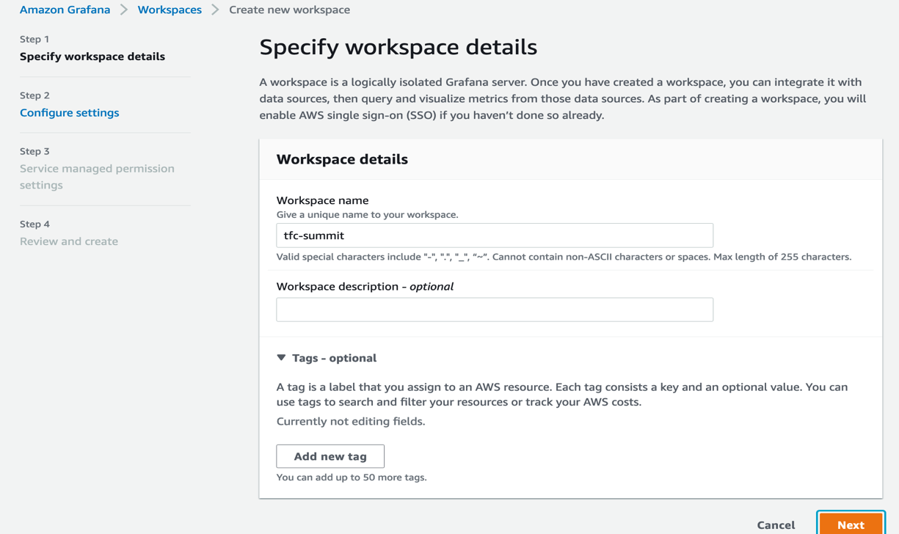

* If you haven’t set up an AWS SSO user, follow the instruction to [Enable AWS Single Sign-On](https://catalog.us-east-1.prod.workshops.aws/workshops/1f91e1d4-5587-40ff-8d5d-54fc86e0ddc1/en-US/advanced/emr-studio/configuring-aws-sso#enable-aws-single-sign-on) before proceed to the next step. It’s OK to reuse your existing SSO user if it’s in a different region.
* Choose ***AWS Single Sign-On (AWS SSO)***in Authentication Access, then click ***Next*** button.

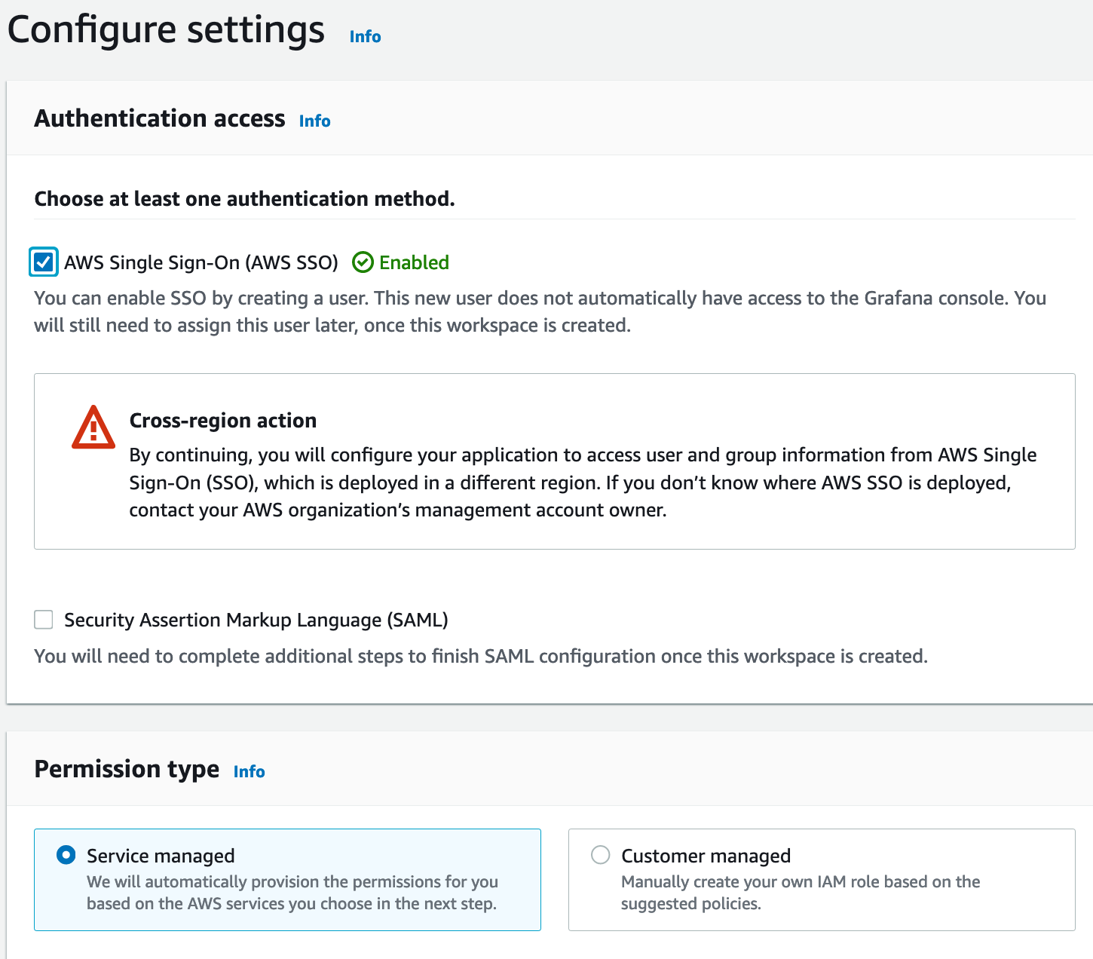

* In the Data sources and notification channels – optional section, select ***Amazon Managed Service for Prometheus****,* then***Next.***

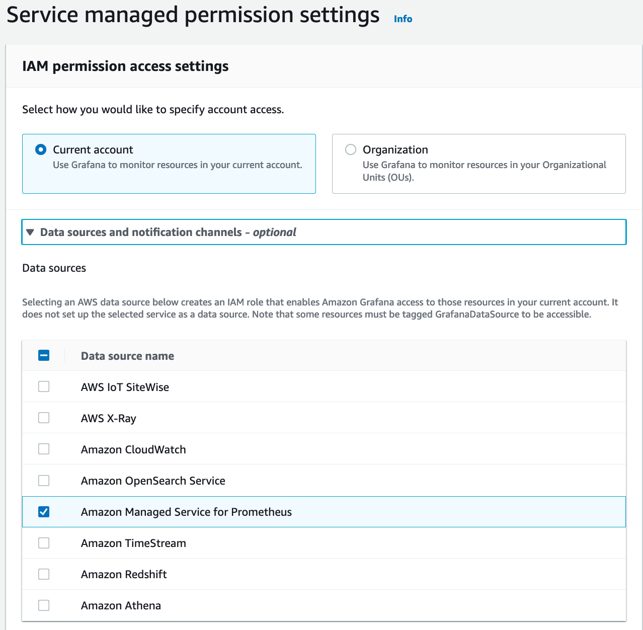

* In the Review and access page, click ***Create workspace***

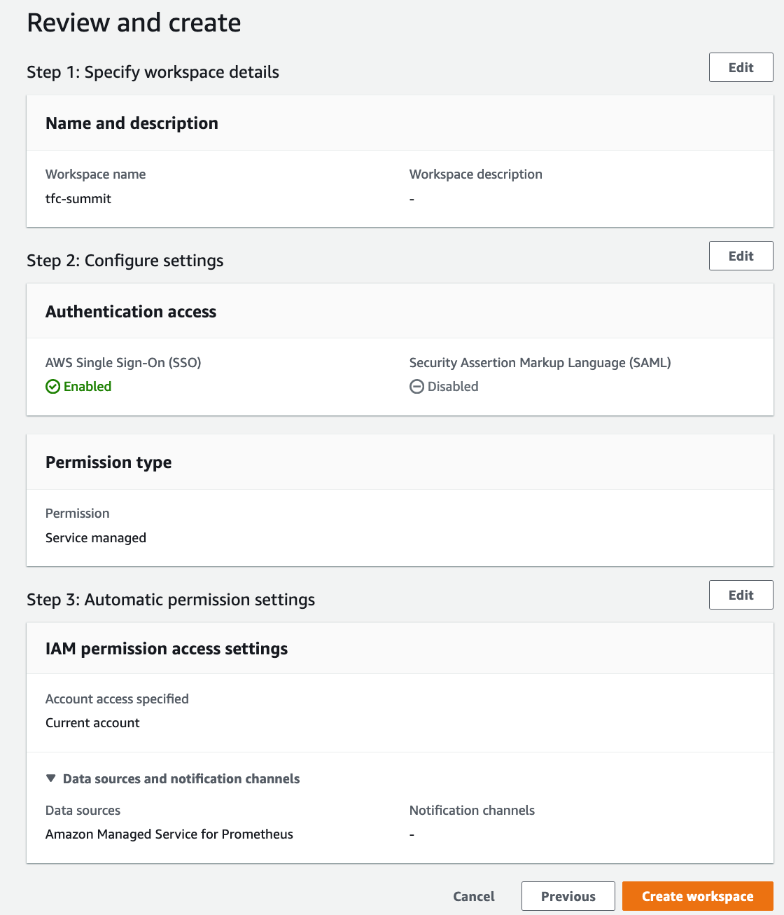

* After created the workspace, click on the ***Assign new user or group button***on the top.

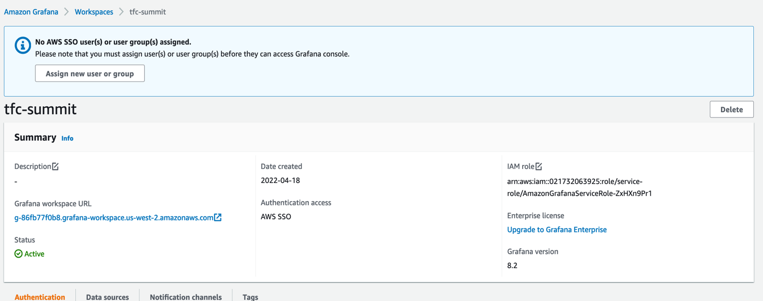

* Select an SSO user you have created, then click the ***Assign users and groups*** button.

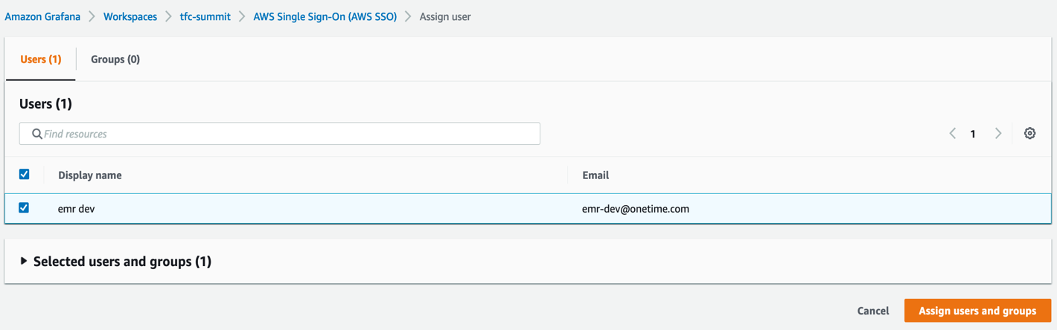

* Make the user as an admin by selecting the **Make admin** button. This option lets users add data sources to the Grafana dashboard in the next steps.

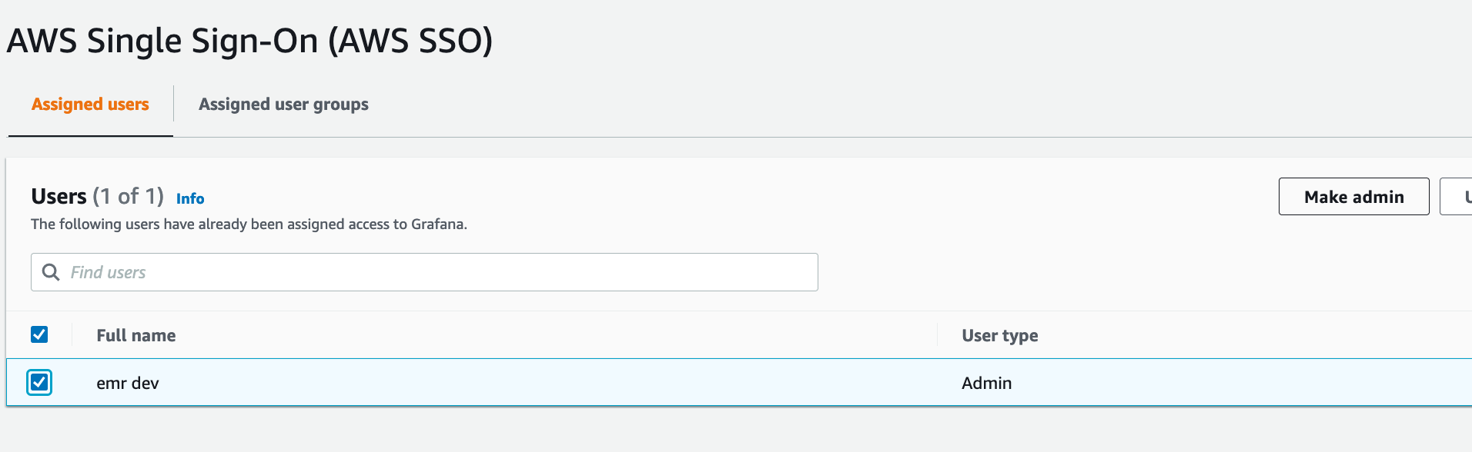

* Go back to the Grafana’s workspace console and click **Grafana workspace URL**.

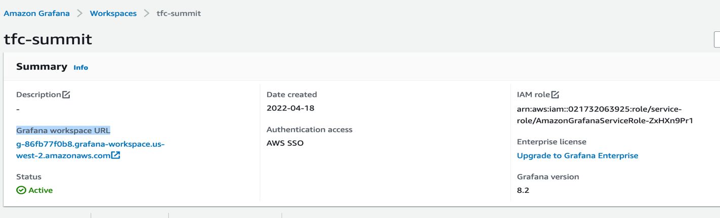

* Login to the Grafana dashboard by providing your AWS SSO User and password.
* Once you are logged in, select the smaller **AWS logo** on the left ribbon just above the settings icon, then choose **AWS services -> Amazon Managed Service for Prometheus** as a data source.

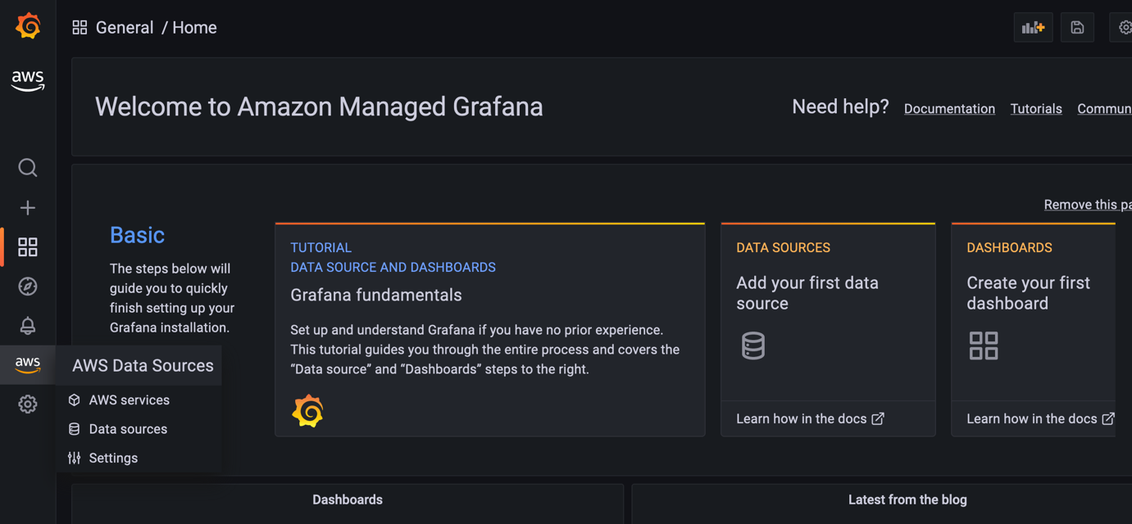

* Choose your region, then click the button **Add 1 data source.**

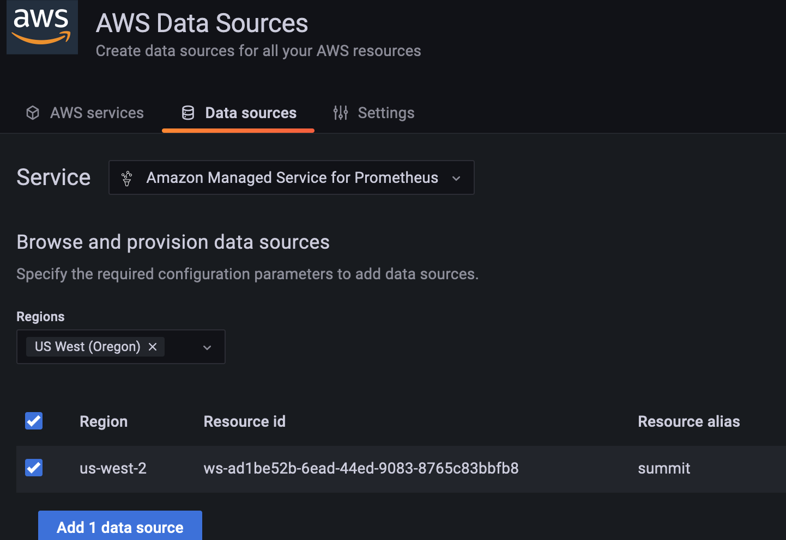

### Create Spark Metrics Dashboard

We have already created a Spark Grafana dashboard template file for this workshop.

* Open the following URL and copy the template file content.

<https://raw.githubusercontent.com/aws-ia/terraform-aws-eks-blueprints/main/examples/analytics/emr-on-eks/examples/grafana-dashboard-for-spark/emr-eks-grafana-dashboard.json>

* Go to your Grafana dashboard, click the **+** icon and **Import** option, then paste the template file content tothe **Import via panel json** section**,** finally click **the Load** then **Import** buttons**.**

