**PRAKTIKUM PEMOGRAMAN 2**



Nama Praktikan : Rizka Diah

NPM : 4511210018

**FAKULTAS TEKNIK JURUSAN TEKNIK INFORMATIKA UNIVERSITAS PANCASILA JAKARTA**

**2013**

**BAB I**

**Laporan Praktikum**

**Source Code**

1. Pertemuan 4

mvn archetype:create -DgroupId=com.p2.jdbc -DartifactId=belajar-jdbc

*package com.p2.jdbc.latihan;*

*import java.sql.Connection;*

*import java.sql.DriverManager;*

*import java.sql.PreparedStatement;*

*import java.sql.SQLException;*

*import java.util.logging.Level;*

*import java.util.logging.Logger;*

*import java.math.BigDecimal;*

*public class Main*

*{*

*public static void main( String[] args )*

*{*

*try{*

*//paramenter yang dikirim adalah host,port , nama database ,user,password*

*Connection conn = DriverManager.getConnection("jdbc:mysql://localhost:3306/p2","root","");*

*String query = "INSERT INTO produk(nama,harga) values (?,"+new BigDecimal(23000)+")";*

*PreparedStatement ps = conn.prepareStatement(query);*

*ps.setString(1,"lala");*

*ps.executeUpdate();*

*}catch(SQLException se){*

*Logger.getLogger(Main.class.getName()).log(Level.SEVERE,null,se);*

*}*

*}*

*}*

*package com.p2.jdbc.latihan;*

*import java.sql.*;*

*import java.util.logging.Level;*

*import java.util.logging.Logger;*

*import java.math.BigDecimal;*

*import javax.swing.*;*

*public class Update*

*{*

*public static void main( String[] args )*

*{*

*try{*

*//paramenter yang dikirim adalah host,port , nama database ,user,password*

*Connection conn = DriverManager.getConnection("jdbc:mysql://localhost:3306/p2","root","");*

*Statement atm = conn.createStatement();*

*String query = "UPDATE produk set nama='dipsi' ,harga='4500' WHERE nama='lala'";*

*int hasil = atm.executeUpdate(query);*

*if(hasil == 1){*

*JOptionPane.showMessageDialog(null,"berhasil update");*

*}*

*else{*

*JOptionPane.showMessageDialog(null,"gagal update");*

*}*

*}catch(SQLException se){*

*Logger.getLogger(Main.class.getName()).log(Level.SEVERE,null,se);*

*}*

*}*

*}*

mvn exec:java -Dexec.mainClass=com.p2.jdbc.latihan.Update

*create table create table pembelian(*

*id_brg int PRIMARY KEY,*

*nama_brg varchar(20) ,*

*jumlah_brg int,*

*tgl_beli date,*

*ket text,*

*berat_brg decimal );*

*package com.p2.jdbc.soal;*

*import java.sql.Connection;*

*import java.sql.DriverManager;*

*import java.sql.PreparedStatement;*

*import java.sql.SQLException;*

*import java.util.logging.Level;*

*import java.util.logging.Logger;*

*import java.math.BigDecimal;*

*public class Insert*

*{*

*public static void main( String[] args )*

*{*

*try{*

*//paramenter yang dikirim adalah host,port , nama database ,user,password*

*Connection conn = DriverManager.getConnection("jdbc:mysql://localhost:3306/p2","root","");*

*String query = "INSERT INTO pembelian(id_brg,nama_brg,jumlah_brg,tgl_beli,ket,berat_brg) values ( 1 ,'Java',"+new Integer(5)+",'2012-04-04','baru', 3 )";*

*PreparedStatement ps = conn.prepareStatement(query);*

*ps.executeUpdate();*

*}catch(SQLException se){*

*Logger.getLogger(Insert.class.getName()).log(Level.SEVERE,null,se);*

*}*

*}*

*}*

Buat Delete.java difolder soal berisi

*package com.p2.jdbc.soal;*

*import java.sql.Connection;*

*import java.sql.DriverManager;*

*import java.sql.PreparedStatement;*

*import java.sql.SQLException;*

*import java.util.logging.Level;*

*import java.util.logging.Logger;*

*import java.math.BigDecimal;*

*public class Delete*

*{*

*public static void main( String[] args )*

*{*

*try{*

*//paramenter yang dikirim adalah host,port , nama database ,user,password*

*Connection conn = DriverManager.getConnection("jdbc:mysql://localhost:3306/p2","root","");*

*String query = "DELETE from pembelian where id_brg = 1";*

*PreparedStatement ps = conn.prepareStatement(query);*

*int hasil = ps.executeUpdate();*

*if(hasil == 1){*

*System.out.println("Berhasil Didelete");*

*}*

*else{*

*System.out.println("Gagal Didelete");*

*}*

*}catch(SQLException se){*

*Logger.getLogger(Delete.class.getName()).log(Level.SEVERE,null,se);*

*}*

*}*

*}*

*package com.p2.jdbc.soal;*

*import java.sql.Connection;*

*import java.sql.DriverManager;*

*import java.sql.PreparedStatement;*

*import java.sql.SQLException;*

*import java.util.logging.Level;*

*import java.util.logging.Logger;*

*import java.math.BigDecimal;*

*public class Update*

*{*

*public static void main( String[] args )*

*{*

*try{*

*//paramenter yang dikirim adalah host,port , nama database ,user,password*

*Connection conn = DriverManager.getConnection("jdbc:mysql://localhost:3306/p2","root","");*

*String query = "UPDATE pembelian set id_brg=1,nama_brg='Apel',jumlah_brg="+new Integer(3)+",tgl_beli='2012-04-05',ket='bekas',berat_brg=5 where id_brg = 1";*

*PreparedStatement ps = conn.prepareStatement(query);*

*int hasil = ps.executeUpdate();*

*if(hasil == 1){*

*System.out.println("Berhasil Diupdate");*

*}*

*else{*

*System.out.println("Gagal Diupdate");*

*}*

*}catch(SQLException se){*

*Logger.getLogger(Update.class.getName()).log(Level.SEVERE,null,se);*

*}*

*}*

*}*

**BAB 2**

**Laporan Praktikum**

**PRINT SCREEN**

mvn clean package

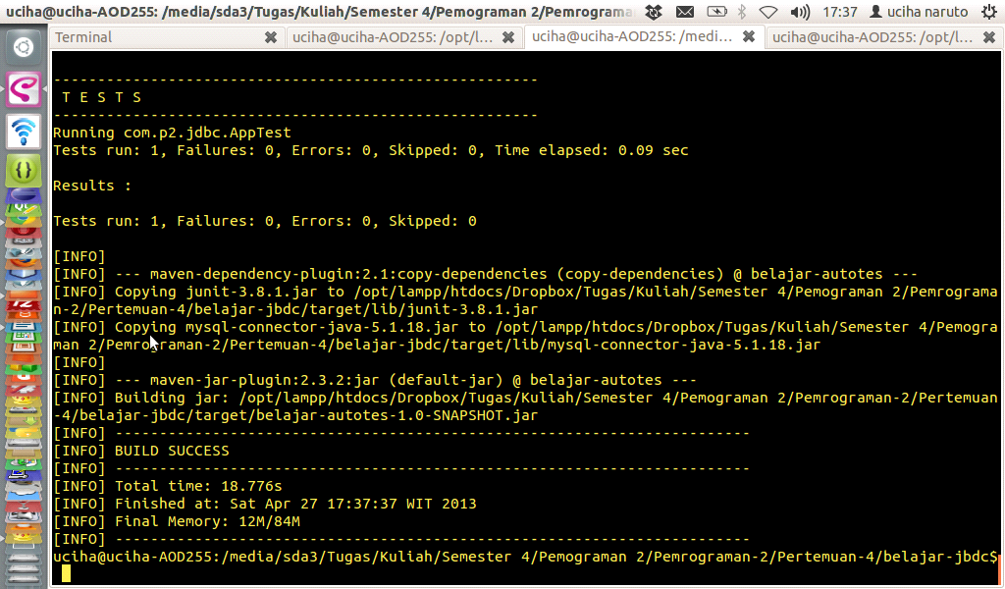

mvn exec:java -Dexec.mainClass=com.p2.jdbc.latihan.Main

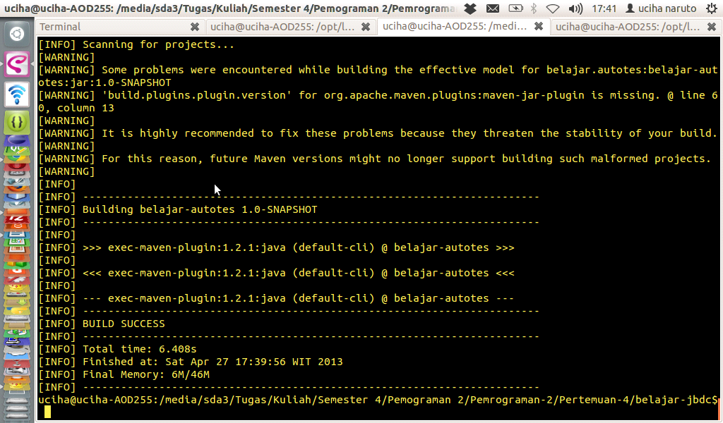

mvn clean package

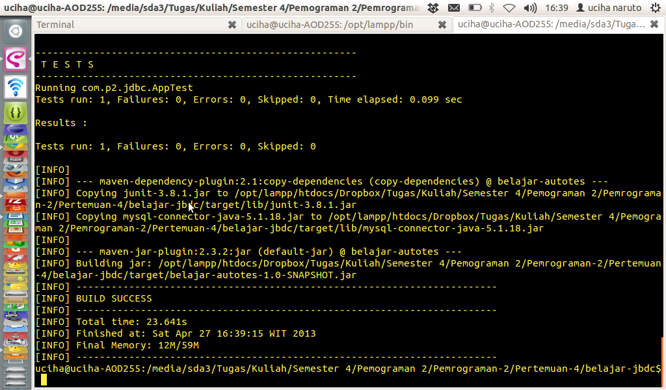

mvn exec:java -Dexec.mainClass=com.p2.jdbc.soal.Insert

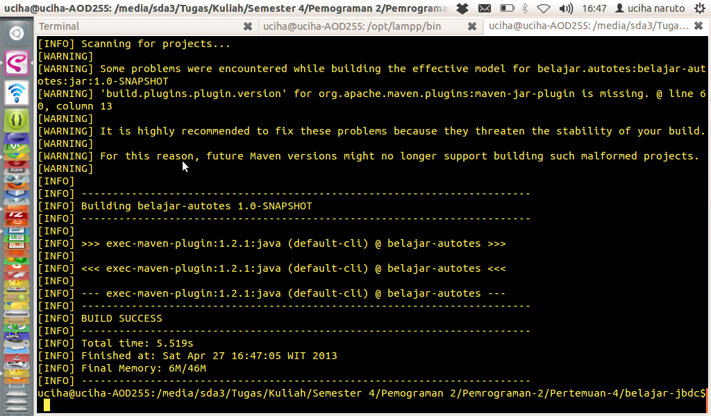

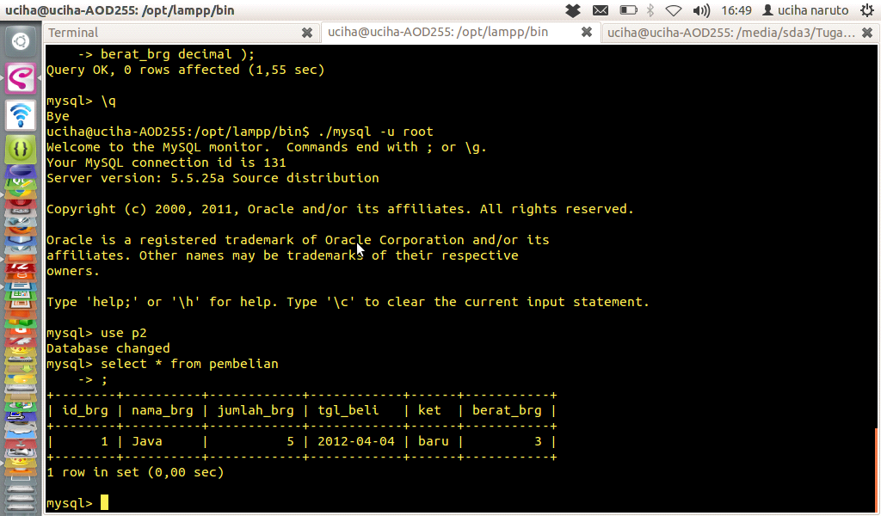

mvn clean package

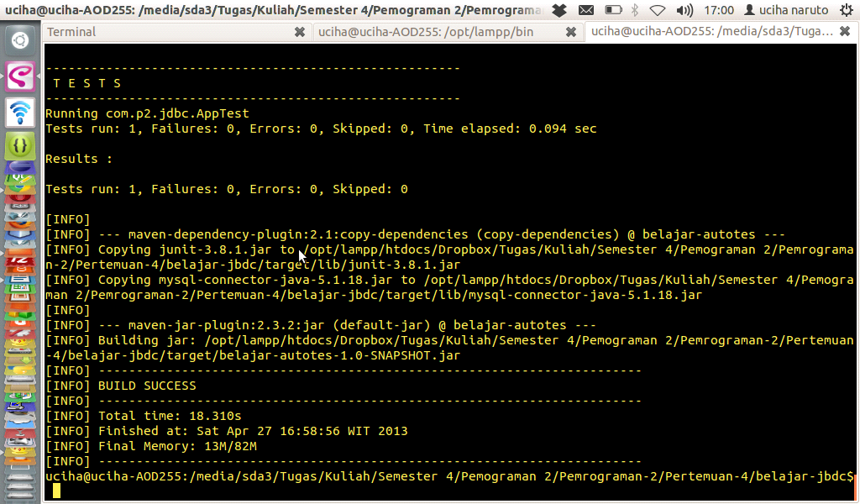

mvn exec:java -Dexec.mainClass=com.p2.jdbc.soal.Update

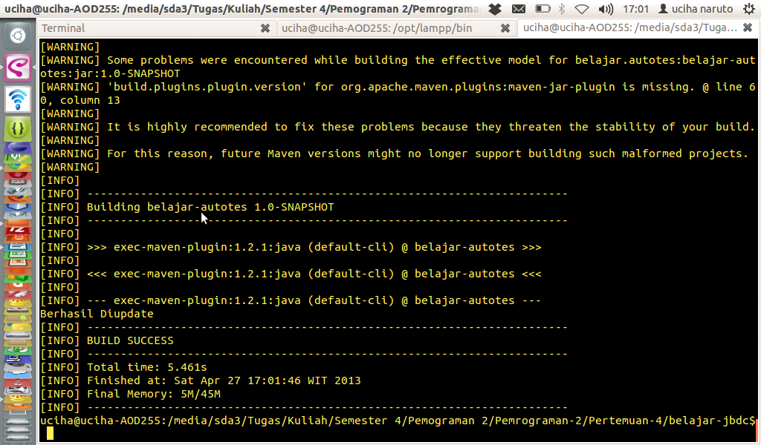

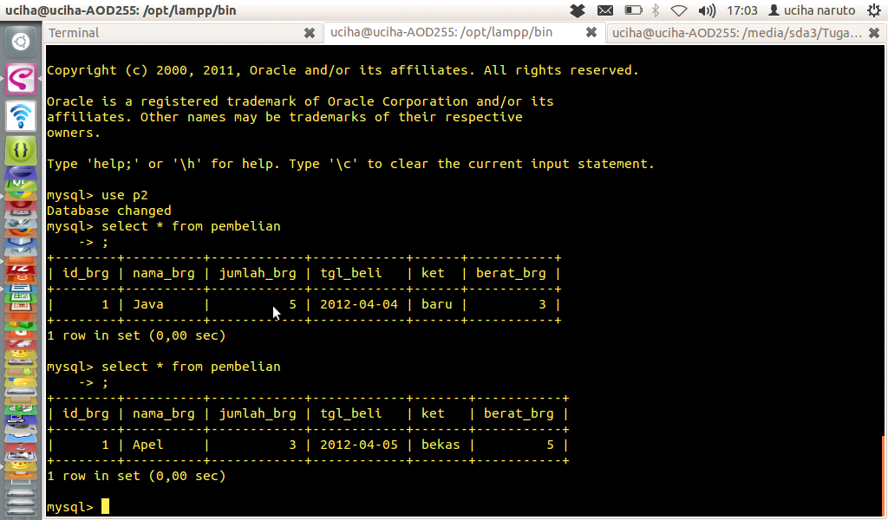

mvn clean package

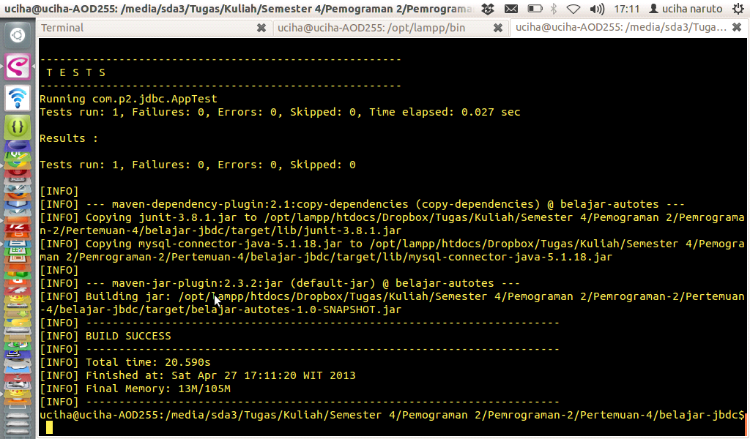

mvn exec:java -Dexec.mainClass=com.p2.jdbc.soal.Delete

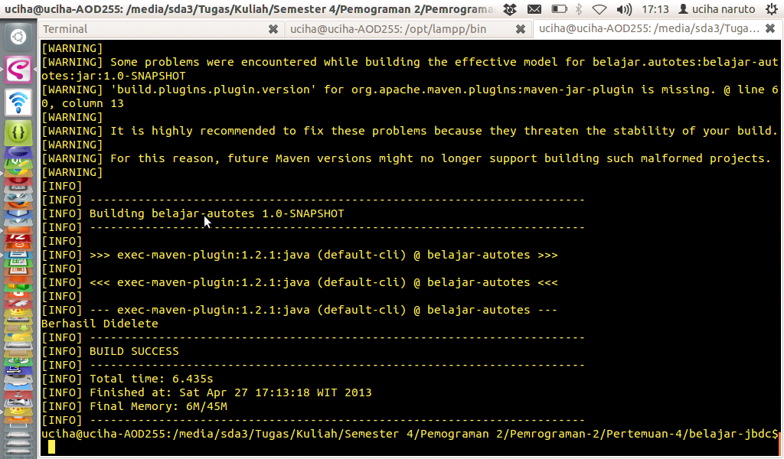

cek dimysql dengan mengetik “select * from pembelian;”

