**PRAKTIKUM PEMOGRAMAN 2**



Nama Praktikan : Rizka Diah

NPM : 4511210018

**FAKULTAS TEKNIK JURUSAN TEKNIK INFORMATIKA UNIVERSITAS PANCASILA JAKARTA**

**2013**

**BAB I**

**Laporan Praktikum**

**Source Code**

1. Pertemuan 2

*APP.JAVA*

*package belajar.autotes;*

*public class App*

*{*

*public static void main( String[] args )*

*{*

*System.out.println( "Hello World!" );*

*System.out.println( "hallo belajar run!" );*

*}*

*}*

*Apptest.java - Source code*

*package belajar.autotes;*

*import junit.framework.Test;*

*import junit.framework.TestCase;*

*import junit.framework.TestSuite;*

*/\*\**

*\* Unit test for simple App.*

*\*/*

*public class AppTest*

*extends TestCase*

*{*

*/\*\**

*\* Create the test case*

*\**

*\* @param testName name of the test case*

*\*/*

*public AppTest( String testName )*

*{*

*super( testName );*

*}*

*/\*\**

*\* @return the suite of tests being tested*

*\*/*

*public static Test suite()*

*{*

*return new TestSuite( AppTest.class );*

*}*

*/\*\**

*\* Rigourous Test :-)*

*\*/*

*public void testApp()*

*{*

*assertTrue( true );*

*}*

*}*

*Hello test.java - Source code*

*package belajar.autotes;*

*import junit.framework.Test;*

*import junit.framework.TestCase;*

*import junit.framework.TestSuite;*

*/\*\**

*\* Unit test for simple App.*

*\*/*

*public class AppTest*

*extends TestCase*

*{*

*/\*\**

*\* Create the test case*

*\**

*\* @param testName name of the test case*

*\*/*

*public AppTest( String testName )*

*{*

*super( testName );*

*}*

*/\*\**

*\* @return the suite of tests being tested*

*\*/*

*public static Test suite()*

*{*

*return new TestSuite( AppTest.class );*

*}*

*/\*\**

*\* Rigourous Test :-)*

*\*/*

*public void testApp()*

*{*

*assertTrue( true );*

*}*

*}*

**BAB 2**

**Laporan Praktikum**

**PRINT SCREEN**

*mvn archetype:create -DgroupId=belajar.autotes -DartifactId=belajar-autotes*

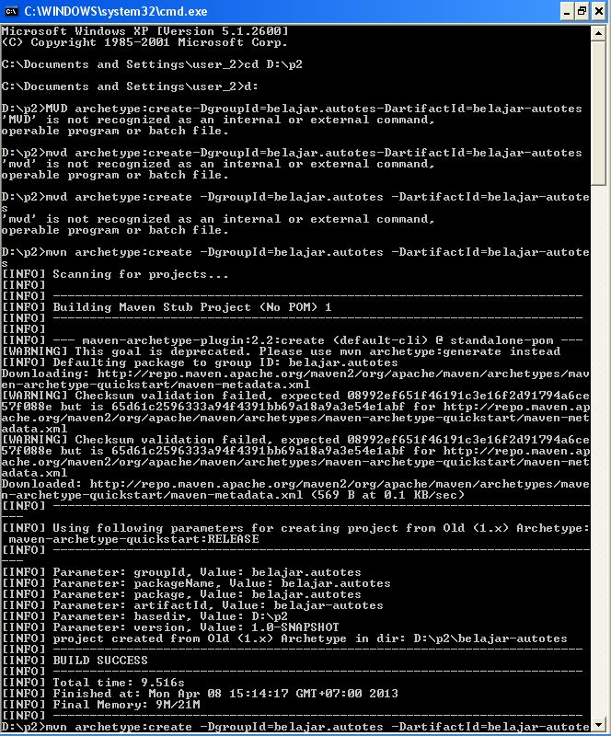

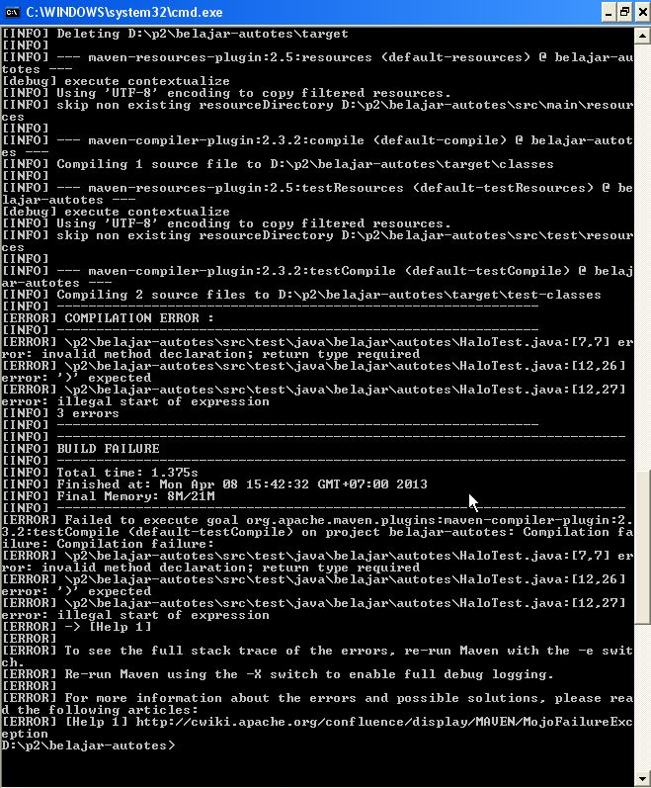

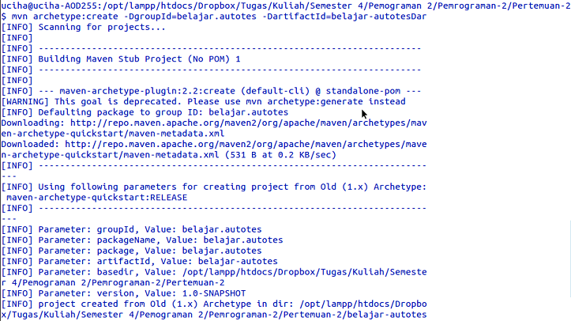

*mvn clean package*

