‘New’ Conductivity HOBO monthly plots

Mary Lofton & Lauren Wind

Mar. 22, 2020

#load packages

#install.packages("pacman")  
pacman::p_load(tidyverse, lubridate, zoo,cowplot)

#read in Bridge 1 data conductivity and discharge data

B1 <- read_csv("./B1_QAQC_3_20_2020_LLW.csv") %>%  
 mutate(DateTime = as.POSIXct(DateTime,format="%m/%d/%Y %H:%M",tz=Sys.timezone()))

## Parsed with column specification:  
## cols(  
## DateTime = col_character(),  
## Full.Conductivity = col_double(),  
## Temp_F = col_double(),  
## Sp.Conductivity = col_double(),  
## Lvl_m = col_double(),  
## Discharge = col_double(),  
## Flag_Lvl_m = col_double(),  
## Flag_Temp_F = col_double(),  
## Flag_SpCond_uScm = col_double()  
## )

#Visualize how much data this QA is flagging

##HISTOGRAM OF SPCOND  
hist(B1$Sp.Conductivity)

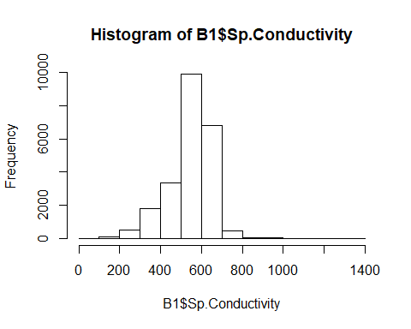

##HISTOGRAM OF LVL_M  
hist(B1$Lvl_m, breaks = seq(0,2,by = 0.01), main = "Red line is if we cut off at 0.02 m")  
abline(v = 0.02, lwd = 2, col = "red")

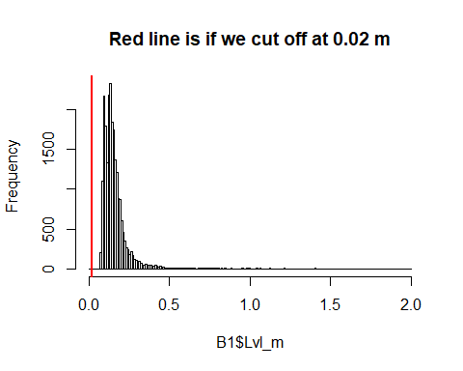

#on manual inspection, these low-flow values are from Aug-Oct 2019  
# check <- B1 %>%  
# filter(Lvl_m <=0.1)  
  
#check relationship btwn. discharge and cond.  
plot(B1$Discharge,B1$Sp.Conductivity)

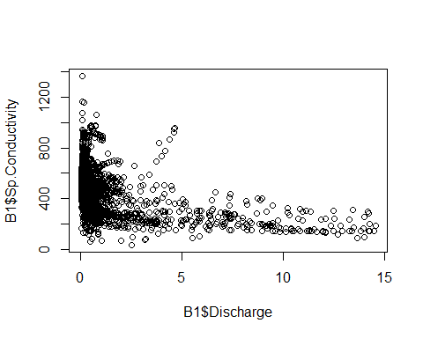

#now on log scale  
plot(log(B1$Discharge),log(B1$Sp.Conductivity))

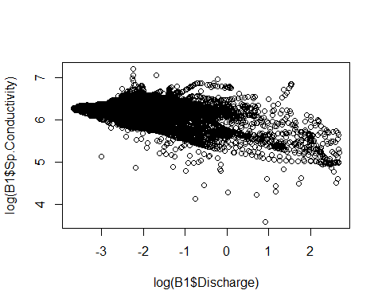

#Pngs with a Lvl_m cutoff at 0.02 m

##DATA VIZ FOR DISCHARGE AND CONDUCTIVITY ONLY  
B1_viz <- B1 %>%  
 mutate(Discharge_cms_perc = ifelse(Discharge >= quantile(Discharge, probs = 0.90, na.rm = TRUE),1,0),  
 Flag_SpCond_uScm = ifelse(!is.na(Lvl_m) & Lvl_m < 0.02,1,Flag_SpCond_uScm)) %>%  
 select(DateTime, Sp.Conductivity, Flag_SpCond_uScm, Discharge, Discharge_cms_perc) %>%  
 mutate(Month = month(DateTime),  
 Year = year(DateTime),  
 Flag_SpCond_uScm = as.factor(Flag_SpCond_uScm),  
 Discharge_cms_perc = as.factor(Discharge_cms_perc))   
  
months <- c(6:12,1:3)  
   
 for (j in 1:length(months)){  
   
 month <- subset(B1_viz, Month == months[j])  
   
 p1 <- ggplot(data = month, aes(x = DateTime,y = Sp.Conductivity, color = Flag_SpCond_uScm))+  
 geom_point()+  
 theme_bw() +  
 ggtitle(paste(months[j]," 1=out of water",sep = ""))  
   
 p2 <- ggplot(data = month, aes(x = DateTime,y = Discharge, color = Discharge_cms_perc))+  
 geom_point()+  
 theme_bw() +  
 ggtitle(paste(months[j]," 1=90th perc.",sep = ""))  
   
 p3 <- plot_grid(p1,p2,align = "hv", nrow = 2, ncol = 1)  
   
 print(p3)  
 # ggsave(p3, filename = paste0("C:/Users/Mary Lofton/Documents/IGC/Stroubles_project/EDI_data_viz/Cond+Discharge/",paste("Cond_Discharge",yrz[i],months[j],sep = "-"),".png"),height = 14, width = 14, units = "in", scale = 0.5)  
 }

