AI-Based Early Disease Outbreak Prediction Using Mobility and Health Data
TABLE OF CONTENTS
Chapter 1: Introduction and Objectives 3
1.1 Background of the Study 3
1.2 Research Problem 3
1.3 Aim and Objectives 3
1.3.1 Aim 3
1.3.2 Objectives 3
1.4 Research Questions 4
1.5 Significance of the Study 4
1.6 Scope and Limitations 4
1.7 Structure of the dissertation 5
1.8 Chapter Summary 5
References 7

Chapter 1: Introduction and Objectives

1.1 Background of the Study
During the last few years, the outbreak of infectious diseases has been a major problem in the global population health, as seen in the COVID-19 case. The spread of diseases among regions has been stimulated by rapid urbanisation coupled with high population mobility and increased global travels (Villanueva-Miranda, Xiao and Xie, 2025). The conventional surveillance methods tend to identify outbreaks when there is a lot of transmission, thus curtailing the efficiency of early intervention measures. The development of Artificial Intelligence (AI) and machine learning offers new opportunities to process massive amounts of health and mobility data to determine patterns related to the spread of diseases.

1.2 Research Problem
Although there is an increased effort in the better monitoring of public health, most disease outbreaks are being detected late thus being unable to adequately prevent the mass spread of the disease. Conventional epidemiological surveillance tools are mainly based on past history records of health and manual reporting that can slow the process of detecting emerging disease patterns (MacIntyre et al., 2023). Moreover, the current predictive systems do not usually integrate the real-time human mobility data, which has a potent impact on the process of infectious diseases distribution across regions. Owing to this, the organizations of health at the public level might not have the right early warning against possible outbreaks. The research problem is that the methods of Artificial Intelligence can be used to combine mobility and health data and enhance the timely detection of disease outbreaks and more proactive decisions on the health of the population.

1.3 Aim and Objectives

1.3.1 Aim
This research paper is focused on creating an AI-driven model that can forecast early outbreaks of diseases based on the trends in population mobility data and public health information.

1.3.2 Objectives
- To gather and combine mobility and health data of disease outbreaks.
- To prepare and interpolate datasets to determine patterns regarding the spread of diseases.
- To create machine learning models to predict possible disease outbreaks.
- To test the prediction models with the help of the right evaluation measures.

1.4 Research Questions
- Which datasets on mobility and health are useful in making disease outbreak predictions?
- What does the mobility and health data trends tell us about disease transmission?
- What are the most effective machine learning systems to estimate patterns of early disease outbreaks?
- What is the accuracy of the created models on what will develop into a disease outbreak?

1.5 Significance of the Study
This study is important because it can enhance the early detection of an outbreak of infectious disease using Artificial Intelligence and data-driven solutions. The conventional disease surveillance systems are usually based on the late reports and past health records, which can restrict the reaction of authorities (Li et al., 2024). Combining mobility information with health-related data, AI-based models will be able to detect trends that might point to the possible spread of the disease at its initial stages. The study has made a contribution to the emerging sub-discipline of AI in the context of public health by examining how proactive decision-making can be conducted by the means of predictive analytics.

1.6 Scope and Limitations
This study is limited in scope and aims at developing a predictive algorithm that uses mobility and health data to detect possible disease outbreaks through AI. The secondary data that will be used in the study will be in the form of publicly available data like global health organisations and mobility reports. It will use machine learning methods to study the trends of these data and create predictive models to identify early outbreaks (Badidi, 2023). The study will entail the pre-processing of data, analysis of features, formulation of the model, and performance measurement by conventional metrics. The research is more aimed at the analysis of trends of the chosen data sets instead of the real-time monitoring of the diseases. The findings will seek to establish how mobility data can be used in enhancing the predictive models in the field of public health.
This study has a number of limitations which could affect the results. The research is based on the secondary data, which can imply incomplete, consolidated or late information. Regions may have different levels of mobility and health data and the quality of this may impact the accuracy of predictive models (Erfani and Frias-Martinez, 2023). Moreover, the study will interpret small sets of data during the project period which might limit the possibility to extrapolate the findings to all disease epidemics. The machine learning models trained in the present study will not perhaps understand all the complex factors affecting disease spread including environmental conditions or change in behaviour.

1.7 Structure of the dissertation

Chapter 1 — Introduction and Objectives
Chapter 2 — Literature Review
Chapter 3 — Methodology
Chapter 4 — Results and Discussion
Chapter 5 — Project Management
Chapter 6 — Critical Appraisal
Chapter 7— Conclusion & Future Work
Figure 1: Dissertation Structure

1.8 Chapter Summary
This chapter presented the research problem of early disease outbreak prediction using mobility and health data based on AI. It started with the background of the study, which is the growing significance of data-based solutions in the context of monitoring the population and surveillance of diseases. The research problem that emerged in the chapter was the constraints of traditional outbreak detection systems and the necessity to have more proactive prediction systems. Aim, objectives and research questions were outlined in a clear manner to bring some direction to the study. Moreover, the research importance was outlined, and the way in which the study can be helpful in enhancing the early outbreak prediction. Lastly, the scope and limitations of the research were defined to establish the limits and restrictions of the research.

References
Badidi, E. (2023). Edge AI for Early Detection of Chronic Diseases and the Spread of Infectious Diseases: Opportunities, Challenges, and Future Directions. Future Internet, 15(11), pp.370–370. https://doi.org/10.3390/fi15110370.
Erfani, A. and Frias-Martinez, V. (2023). A fairness assessment of mobility-based COVID-19 case prediction models. PLOS ONE, 18(10), p.e0292090. https://doi.org/10.1371/journal.pone.0292090.
Li, Z., Meng, F., Wu, B., Kong, D., Geng, M., Qiu, X., Cao, Z., Li, T., Su, Y. and Liu, S. (2024). Reviewing the progress of infectious disease early warning systems and planning for the future. BMC Public Health, 24(1). https://doi.org/10.1186/s12889-024-20537-2.
MacIntyre, C.R., Chen, X., Kunasekaran, M., Quigley, A., Lim, S., Stone, H., Paik, H.-Y., Yao, L., Heslop, D., Wei, W., Sarmiento, I. and Gurdasani, D. (2023). Artificial intelligence in public health: the potential of epidemic early warning systems. The Journal of International Medical Research, [online] 51(3), p.3000605231159335. https://doi.org/10.1177/03000605231159335.
Villanueva-Miranda, I., Xiao, G. and Xie, Y. (2025). Artificial intelligence in early warning systems for infectious disease surveillance: a systematic review. Frontiers in Public Health, 13. https://doi.org/10.3389/fpubh.2025.1609615.

CHAPTER -2
LITERATURE REVIEW
Table of Contents
Chapter 2: Literature Review 3
2.1 Introduction 3
2.2 Machine Learning Models for Disease Outbreak Prediction 3
2.3 Human Mobility Data in Epidemic Modelling 4
2.4 AI Frameworks Integrating Mobility and Epidemiological Data 6
2.5 AI-Based Early Warning and Disease Surveillance Systems 7
2.6 Critical review of selected studies 8
2.7 Theoretical Underpinning 9
2.7.1 Epidemiological Transmission Theory 9
2.7.2 Network Theory 10
2.7.3 Predictive Analytics Theory 10
2.8 Conceptual Framework 11
2.9 Research Gap 11
2.10 Chapter Summary 12
Reference List 13

Chapter 2: Literature Review

2.1 Introduction
The chapter summarises the literature regarding the use of artificial intelligence-based disease outbreak prediction based on health and mobility data. This review aims to understand existing methods applied in predicting outbreaks of infectious diseases and the strengths and weaknesses of the methods. Recent studies have shown that machine learning methods have been used to analyse epidemiological data more often with the aim of uncovering trends related to disease transmission, as well as patterns in terms of the spread of diseases and outbreaks. The chapter initially analyses the research on machine learning models to predict the disease outbreaks. It subsequently examines the research exploring the importance of human mobility in the spread of epidemics. Also, the chapter studies integrated models, which integrate mobility and health data into artificial intelligence models. By critically comparing these studies, the chapter provides research gaps which exist and forms the basis of the proposed predictive framework.

2.2 Machine Learning Models for Disease Outbreak Prediction
There has been an increase in the application of machine learning techniques in epidemiological data to facilitate prediction of outbreaks of infectious diseases. These methods can detect more complex trends in large health data and, as such enhance better forecasting. Santangelo et al. (2023) state that machine learning algorithms can be useful in the analysis of infectious disease trends, as they are able to identify nonlinear relationships that are not always detected by conventional statistical models. Their systematic review compared a number of machine learning methods used in surveillance and prediction of diseases. The research posted that support vector machine models, neural networks and ensemble algorithms are the most frequently used models that demonstrate better predictive power as compared to traditional epidemiological prediction techniques. Nevertheless, the review also noted that most predictive models mostly rely on historical case information and thus may decrease their capability to detect developing outbreaks based on behavioural or environmental alterations.
The article by Zhang et al. (2024) has suggested an outbreak risk prediction tool that is a machine-learning universal model aimed at estimating the risk of diseases in various geographic areas. The framework incorporates the epidemiological indicators and the demographic variables in identifying the patterns that are linked to the possible outbreaks. According to Zhang et al. (2024), machine learning algorithms can be successfully used to process complicated health data and establish the relationships that cannot be evident using other methods. They found that they achieved better predictive work than the conventional surveillance models. However, the suggested system is mostly dependent on epidemiological variables. Lack of mobility-related indicators restricts the model's ability to reflect behaviour-related factors affecting the transmission of diseases. A similar study was carried out by Manshi (2024), who used various machine learning algorithms on the public health data to forecast epidemics. Algorithms that were compared in the study were decision trees, random forests, and ensemble learning techniques. According to Manshi (2024), the ensemble models demonstrated the best accuracy in prediction since they involve a combination of more than one algorithm and minimise the prediction error. The findings established the fact that machine learning techniques can be successful at detecting trends in epidemiological data.
Cheah et al. (2025) also discussed the usage of artificial intelligence in the prediction and surveillance of infectious diseases. They were reviewed with regard to the machine learning model's role in disease detection and forecasting diagnoses or outbreaks. According to Cheah et al. (2025), artificial intelligence has enhanced the ability of the public health systems to process high amounts of epidemiological data. Meanwhile, the authors noted that limited integration of heterogeneous datasets is one of the crucial weaknesses of the current studies. All these studies prove the usefulness of machine learning in the process of predicting outbreaks and depict the necessity of predictive models that would incorporate both mobility data and traditional health indicators.

2.3 Human Mobility Data in Epidemic Modelling
Human mobility plays a major role in the spatial transmission of infectious diseases due to population movement that causes channels through which the pathogens are transmitted across the regions. Consequently, mobility datasets have been subject to more and more analysis in order to comprehend the dynamics of epidemics. Mayemba et al. (2024) state that mobility prediction methods have come to play a significant role in epidemic modelling since they indicate patterns of human movement that affect the transmission of diseases. Their survey looked at computational methods applied to study mobility behaviour in epidemics, such as transformer-based models and new large language model methods. The authors noted that the data on the digital mobility, obtained through the use of mobile gadgets and transport systems, can be very useful when it comes to the study of the population behaviour in the context of an outbreak of the disease. Nevertheless, their review also revealed that most studies concentrate on forecasting the mobility behaviour instead of making a direct prediction of the disease outbreaks.
Zhao et al. (2024) investigated the practicality of artificial intelligence techniques for studying the transmission of infectious diseases based on a variety of data. According to Zhao et al. (2024), mobility information, including travel trends and transportation systems, is an important factor when it comes to the spatial distribution of infectious diseases. Their study has highlighted that mobility datasets should be combined with epidemiological data helping a researcher to define the possible hotspots of outbreaks and study the transmission patterns at a regional level. Although these benefits are present, the research was primarily analytic in nature as opposed to predictive machine learning systems that can predict outbreaks.
This limitation was overcome by Jiao et al. (2025) who created a spatiotemporal epidemic forecasting model that uses mobility information as part of a deep learning architecture. The proposed model is based on long short-term memory networks and an attention mechanism, which identify spatial and temporal relations in epidemic data. According to Jiao et al. (2025), the integration of mobility data made prediction accuracy higher than when other models were built based on epidemiological data. The authors, however, also observed that the model also demands large datasets and high computing power. These results suggest that mobility data can give valuable insights into the dynamics of the epidemic, although the additional studies are required to combine such information successfully into scalable predictive frameworks.
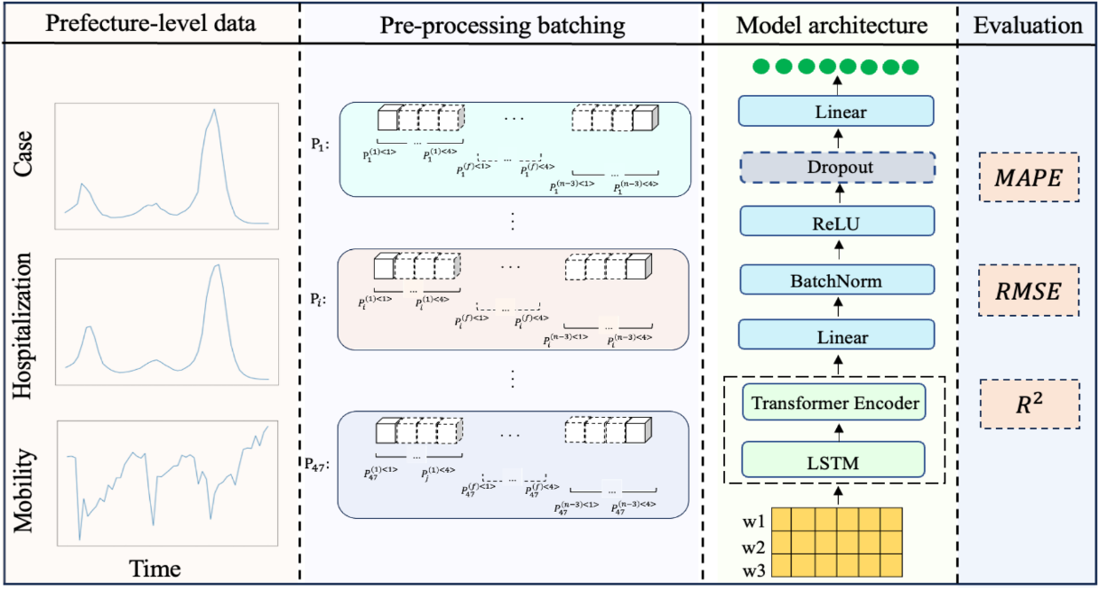

Figure 2.3.1: spatio-temporal prediction framework
(Source: Alwakeel, 2025)

2.4 AI Frameworks Integrating Mobility and Epidemiological Data
More recent studies have centred around incorporating mobility data with epidemiological data so as to augment disease outbreak prediction. The aim of these hybrid approaches is to define the two biological transmission mechanisms and the pattern of the behavioural movement that determines the propagation of the infection. The article by Cao et al. (2023) presents a new framework of the epidemic forecasting based on the graph neural network named MepoGNN. The model networks the geographic regions as nodes and mobility routes amongst the regions as connections amongst the nodes. According to Cao et al. (2023), such a structure enables the model to model the spatial interactions among populations and study the effect of the movement patterns on the dynamics of the epidemics. The outcome of the experiment proves that graph-based neural networks could be useful to simulate the complex interregional transmission lines. The model, however, needs detailed mobility flow data and this may not always be available in the real world settings.
Ye et al. (2025) discuss the approach to integrating artificial intelligence methods with the mechanistic models of epidemiology. Their review discusses the hybrid models that integrate classic compartmental models with machine learning models. According to Ye et al. (2025), data-driven models could be implemented along with the epidemiological theory to enhance the accuracy of forecasts and the readability of the predictions. Hybrid frameworks enable the researcher to include the knowledge of the domain but take advantage of the pattern recognition ability of machine learning. Although these are the benefits, the authors note that there are a number of challenges that are related to the hybrid modelling methods. These are data heterogeneity, computational complexity and challenges to integrate various datasets of dissimilar origin. The example of the deep learning model suggested by Jiao et al. (2025) also shows how mobility data could be used in conjunction with epidemiological data to gain potential benefits. The model recorded a better prediction accuracy than the traditional models by including mobility indicators in forecasting epidemics. According to Jiao et al. (2025), it is possible to capture spatial diffusion patterns which can be difficult to detect by epidemiological data alone, using mobility-informed deep learning models. However, the research also demonstrates a practical problem connected to the huge volumes of data integration and the cost of calculations. These constraints reveal that although hybrid AI models present encouraging findings, additional studies are required in order to come up with scalable AI models to integrate heterogeneous data efficiently.

2.5 AI-Based Early Warning and Disease Surveillance Systems
Artificial intelligence technologies are used more frequently in the early warning systems aimed at the real-time tracking of infectious diseases. The purpose of these systems is to identify unusual trends in the epidemiological data and give early warning of the possible outbreaks. According to Villanueva-Miranda et al. (2025), artificial intelligence has boosted disease surveillance by creating the possibility of analysing big datasets of public health in a short duration. Their systematic review reviews the article that observes different AI-based surveillance systems designed to identify and monitor outbreaks. The authors state that machine learning algorithms are able to detect abnormal epidemiological trends sooner than conventional surveillance processes. The review however also presents issues pertaining to the integration of data and the scarcity of quality epidemiological information. Alwakeel (2025) suggests an artificial intelligence-based monitoring system that is supposed to be used in real-time to distinguish infectious diseases in cities. The framework combines machine learning models with epidemiological streams of data to detect abnormalities in prevalence of diseases. According to Alwakeel (2025), the system architecture allows tracking infection indicators in regions of the city on a consistent basis. The proposed model, according to the study, has promising predictive ability in the early outbreak warning. The author however underlines that such surveillance systems require reliable data integration and data streams in order to be effectively implemented.
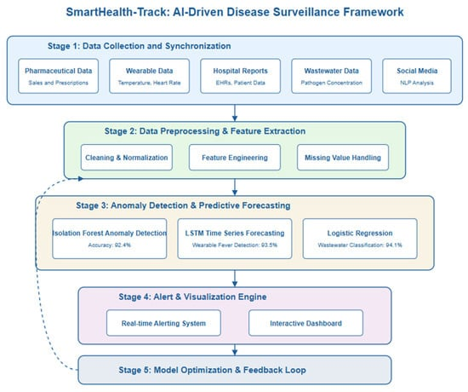

Figure 2.5.1: AI monitoring architecture
(Source: Alwakeel, 2025)
Rudwan et al. (2026) also examine AI-driven strategies of monitoring and predicting an outbreak. Their research examines a number of machine learning methods used in monitoring and predictive epidemiology of health among the populace. According to Rudwan et al. (2026), the analysis of complicated relationships in health data using artificial intelligence can facilitate detection at an early stage of an outbreak. As well, the authors identify a number of limitations related to AI-based surveillance systems, that are data privacy, limited accessibility and computational demands of data. Nevertheless, these issues notwithstanding, the research finds that AI-based surveillance systems could go a long way in enhancing the early detection of outbreaks. Nevertheless, to be able to attain good predictive performance, mobility data should be properly combined with epidemiological indicators.

2.6 Critical review of selected studies
Study | Method | Dataset / Environment | Contribution | Strengths | Limitations | Relevance to the Present Study
Santangelo et al. (2023) | Systematic review of ML algorithms | Multiple epidemiological datasets from previous studies | Examines applications of machine learning for infectious disease prediction | Provides a comprehensive overview of ML techniques used in epidemiology | Does not focus on mobility data integration | Establishes the foundation of ML-based outbreak prediction
Zhang et al. (2024) | Machine learning outbreak prediction model | Epidemiological and demographic datasets across regions | Developed a universal outbreak risk prediction tool | Demonstrates improved predictive accuracy using ML models | Relies mainly on historical health indicators | Shows the effectiveness of ML methods in outbreak forecasting
Manshi (2024) | Ensemble ML models, including Random Forest and Decision Tree | Public health datasets with infection records | Predicts disease outbreaks using multiple ML algorithms | Ensemble models improve prediction reliability | Does not include mobility-related variables | Supports the use of ML techniques for outbreak prediction
Mayemba et al. (2024) | Mobility prediction models using transformer architectures | Mobility datasets from digital devices and transportation networks | Analyses mobility prediction techniques used in epidemic modelling | Highlights the importance of mobility data in disease spread | Focuses on mobility prediction rather than outbreak forecasting | Demonstrates the significance of mobility behaviour in epidemics
Jiao et al. (2025) | LSTM deep learning with an attention mechanism | Mobility data combined with epidemiological datasets | Developed a spatio-temporal epidemic forecasting model | Integrates mobility data and improves prediction accuracy | Requires large datasets and computational resources | Demonstrates benefits of mobility-informed AI models
Cao et al. (2023) | Graph Neural Network (MepoGNN) | Mobility flow networks across geographic regions | Forecasts the epidemic spread using network-based deep learning | Captures spatial interactions between populations | Requires detailed mobility network datasets | Shows advanced AI methods for mobility-based epidemic prediction
Alwakeel (2025) | AI-based surveillance framework | Urban infectious disease monitoring system | Developed a real-time disease monitoring architecture | Supports continuous surveillance and early outbreak detection | Data integration challenges for large-scale deployment | Relevant for designing AI-based early warning systems

2.7 Theoretical Underpinning

2.7.1 Epidemiological Transmission Theory
The epidemiological transmission theory describes the way infectious disease spread in populations because of the interaction between the susceptible and infected persons. Classical epidemiological models split the population into categories of susceptible, infected and recovered. These models calculate the time dependence of infection rates in accordance with patterns of contacts between people. The epidemiological transmission theory argues that the spread of the disease is determined by the frequency of interaction and the likelihood of infection during the interaction (Garira and Maregere, 2023). The theory offers a background to the study on outbreak prediction since it explains the biological processes that stimulate epidemic expansion. Epidemiological data sets in the framework of prediction systems based on artificial intelligence are indicators of infection dynamics. These datasets can be analysed by machine learning algorithms and identified to determine patterns related to disease spread. Nevertheless, the classical epidemiological models tend to believe that all populations interact in a similar manner. Human movement in fact plays a significant role in contact patterns and hence transmission risk. The incorporation of mobility information in predictive models enables the investigator to capture the real behaviour of epidemics.

2.7.2 Network Theory
The network theory describes the impact of interconnected systems on the transmission of information, resources or diseases. In epidemiology, nodes in a network can be people or geographic areas with links between them being interactions or mobility (Bellingeri et al., 2024). Transmission of the disease, then, takes place via network structure linkages. This point of view is especially applicable to the research that examines the patterns of mobility during the epidemics. Movement of cities or regions forms dynamic networks that the infections spread. These mobility networks can be analysed using artificial intelligence models in order to determine transmission pathways and high-risk areas. The network theory hence justifies the incorporation of the mobility datasets into the predictive outbreak models.

2.7.3 Predictive Analytics Theory
The theory of predictive analytics is based on the utilisation of the past data and calculations to predict what is going to happen in the future. According to the theory, the trends in historical data could be applied to predict future results with the help of statistical and machine learning models. Predictive analytics gives the idea of data-driven outbreak forecasting, which is the conceptual foundation in disease surveillance research (Ezeh et al., 2024). Mobility data and epidemiological data can be analysed by machine learning algorithms that can identify undiscovered trends regarding the dynamics of the infection. This school of thought consequently assists in the creation of artificial intelligence systems which can be used in predicting the early outbreak of the disease.

2.8 Conceptual Framework
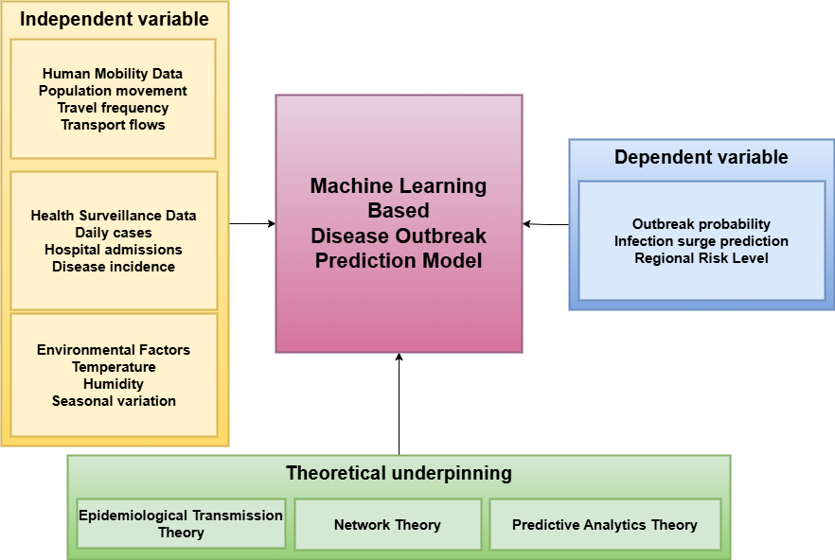

Figure 2.8.3: Conceptual framework for AI-based early disease outbreak prediction using mobility and health data

2.9 Research Gap
Current literature indicates that there is a profound advancement in using machine learning in disease outbreak prediction. There are numerous epidemiological models that are used to predict the trends in infections through the generation of epidemiological data sets. Nevertheless, there are a number of restrictions existing in the existing research. First, most predictive models use primarily historical health data and do not take much mobility information that affects the spread of diseases. Second, the research based on the mobility datasets is often aimed at studying the movement patterns but not predicting the outbreaks. Third, some of the integrated models demand sophisticated computing infrastructure or localised data. These constraints make the currently predictive systems less practical. Consequently, scalable artificial intelligence frameworks nursing mobility and epidemiological data to aid in early outbreak prediction are needed. The current study fills this gap by suggesting an AI-based predictive system, which integrates health monitoring data and mobility.

2.10 Chapter Summary
The chapter discussed the literature available regarding disease outbreak prediction with the help of artificial intelligence and mobility and health data. The discussion mentioned the increasing application of machine learning methods to process epidemiological data and predict the trends of infections. Research of human mobility revealed that population migration is a major determinant of disease transmission process. Recent studies involving mobility data combined with epidemiological data are proving to bring positive results in terms of accuracy of prediction of outbreaks. Nonetheless, issues of data integration, predictive systems scaling and real-time implementation are still there. These shortcomings suggest that better AI-based systems are required that can merge different data types to identify an outbreak early. The following chapter contains the research methodology that will be employed to design and test the proposed predictive model.

Reference List
Alwakeel, M.M. (2025). AI-Assisted Real-Time Monitoring of Infectious Diseases in Urban Areas. Mathematics, [online] 13(12), p.1911. https://doi.org/10.3390/math13121911.
Bellingeri, M., Bevacqua, D., Scotognella, F. and Cassi, D. (2024). The Critical Role of Networks to Describe Disease Spreading Dynamics in Social Systems: A Perspective. Mathematics, [online] 12(6), p.792. https://doi.org/10.3390/math12060792.
Cao, Q., Jiang, R., Yang, C., Fan, Z., Song, X. and Ryosuke Shibasaki (2023). MepoGNN: Metapopulation Epidemic Forecasting with Graph Neural Networks. Lecture notes in computer science, 2(1), pp.453–468. https://doi.org/10.1007/978-3-031-26422-1_28.
Cheah, B.C.J., Vicente, C.R. and Chan, K.R. (2025). Machine Learning and Artificial Intelligence for Infectious Disease Surveillance, Diagnosis, and Prognosis. Viruses, [online] 17(7), p.882. https://doi.org/10.3390/v17070882.
Ezeh, J., Chioma, S., Oyewole, N.S. and David (2024). The role of predictive analytics in enhancing public health surveillance: Proactive and data-driven interventions. World Journal of Advanced Research and Reviews, 24(3), pp.3059–3077. doi: https://doi.org/10.30574/wjarr.2024.24.3.3909.
Garira, W. and Maregere, B. (2023). The transmission mechanism theory of disease dynamics: Its aims, assumptions and limitations. Infectious Disease Modelling, 8(1), pp.122–144. doi: https://doi.org/10.1016/j.idm.2022.12.001.
Jiao, S., Wang, Y., Ye, X., Nagahara, L. and Sakurai, T. (2025). Spatio-temporal epidemic forecasting using mobility data with LSTM networks and attention mechanism. Scientific Reports, [online] 15(1). doi: https://doi.org/10.1038/s41598-025-94089-9.
Manshi (2024). Predicting Disease Outbreaks using Machine Learning Models on Public Health Data. International Journal For Multidisciplinary Research, 6(5). doi: https://doi.org/10.36948/ijfmr.2024.v06i05.28999.
Mayemba, C.N., D’Jeff K, N., Tshimula, J.M., Maximilien V, D., Muabila, J.T., Didier, M.M., Kanda, H., Galekwa, René Manassé, Fita, Heber Dibwe, Mundele, S., Kalala, K., Ilunga, A., Ntobo, Lambert Mukendi, Muteba, D. and Abedi, A.A. (2024). A Short Survey of Human Mobility Prediction in Epidemic Modeling from Transformers to LLMs. [online] arXiv.org. Available at: https://arxiv.org/abs/2404.16921.
Rudwan, E., Ali, M., Ibrahim, M. and Rudwan, A. (2026). Artificial Intelligence-Driven Approaches to Disease Surveillance and Outbreak Prediction. Open Access Library Journal, [online] 13(02), pp.1–16. doi: https://doi.org/10.4236/oalib.1114831.
Santangelo, O.E., Gentile, V., Pizzo, S., Giordano, D. and Cedrone, F. (2023). Machine Learning and Prediction of Infectious Diseases: A Systematic Review. Machine Learning and Knowledge Extraction, 5(1), pp.175–198. doi: https://doi.org/10.3390/make5010013.
Villanueva-Miranda, I., Xiao, G. and Xie, Y. (2025). Artificial intelligence in early warning systems for infectious disease surveillance: a systematic review. Frontiers in Public Health, 13(1). doi: https://doi.org/10.3389/fpubh.2025.1609615.
Ye, Y., Pandey, A., Bawden, C., Dewan , Md.S., Rajput, R., Shoukat, A., Singer, B.H., Moghadas, S.M. and Galvani, A.P. (2025). Integrating artificial intelligence with mechanistic epidemiological modeling: a scoping review of opportunities and challenges. Nature Communications, [online] 16(1). doi: https://doi.org/10.1038/s41467-024-55461-x.
Zhang, T., Rabhi, F., Chen, X., Paik, H. and MacIntyre, C.R. (2024). A machine learning-based universal outbreak risk prediction tool. Computers in Biology and Medicine, [online] 169(1), p.107876. doi: https://doi.org/10.1016/j.compbiomed.2023.107876.
Zhao, A.P., Li, S., Cao, Z., Hu, P.J.-H., Wang, J., Xiang, Y., Xie, D. and Lu, X. (2024). AI for Science: Predicting Infectious Diseases. Journal of Safety Science and Resilience, 5(2), pp.130–146. doi: https://doi.org/10.1016/j.jnlssr.2024.02.002.

