Chapter -3
TABLE OF CONTENTS
Chapter 3: Methodology 3
3.1 Introduction 3
3.2 Research Philosophy 3
3.3 Research Approach 4
3.4 Research Design 5
3.5 Research Strategy 6
3.6 Data Collection Method 8
3.7 Data Analysis 9
3.8 Sampling Method 11
3.9 Research Ethics 12
3.10 Conclusion 12
References 14

Chapter 3: Methodology

3.1 Introduction
The chapter has summarized the methodology that is used to meet the research objective of predicting early disease outbreaks through artificial intelligence and integrated mobility and health data. It discusses the research philosophy, approach, design and strategy that will inform the general investigation. The research relies on the secondary data retrieved through an open access dataset of COVID-19 epidemiological indicators and human mobility patterns. When analysing the data, a quantitative research approach is used to predict patterns and make predictions based on machine learning. The data collection process, method of analysis, the sampling method, and considerations that were respected in the research have also been outlined in the chapter. The implementation of data preprocessing, feature engineering, and model development is performed in Python programming in Google Colab. This methodological approach is well structured so that the research questions are systematically answered and also the findings are reliable, valid and in accordance with the objectives of the study.

3.2 Research Philosophy
The philosophy of research used in this research is positivism where the philosophy is suitable in studies that are based on observable data, objective measurement and quantitative analysis. The assumption of positivism is the reality that is quantifiable and can be comprehended by means of empirical observation and statistical analysis. The study in the frame of the given research is aimed at the examination of numerical data associated with the COVID-19 cases and human mobility patterns to detect the relations and anticipate the next disease outbreaks (Liu, 2024). This follows the positivist approach that stresses application of systematic methods and scientific procedures to come up with dependable and generalisable results. It was decided to use positivism due to the character of the research aim and objectives which are the creation of machine learning models on the base of existing datasets.
The research is not based on the subjective interpretation and human experiences but rather on the measurable signs including the number of cases every day, mobility, and time. Statistical and computational analysis can be used to analyse these variables to determine patterns in the transmission of diseases. Moreover, the positivist methodology is utilised through the application of algorithms like regression or ensemble models because they are based on the principles of mathematics and objective thinking.
The other reason why this philosophy has been chosen is that it fits in research of predictive analytics. The research is also meant to predict early disease will break out and this involves finding regularities in the past. Positivism allows systematic testing of such relationships on the part of the study and measuring the strengths of prediction based on well-established measures of performance, including the mean absolute error and root mean square error (Christo El Morr et al., 2024). This is to ensure that the results are founded on facts and not assumptions. Moreover, positivism is the theory that encourages reproducibility of research results, since the procedures and samples employed can be repeated by other scholars. This increases validity and credibility of the study. Consequently, the introduction of a positivist research philosophy is quite useful in a data-driven study of the disease outbreak prediction with the assistance of artificial intelligence and mobility data.

3.3 Research Approach
The method of research used in this study is the deductive approach, which is suitable in investigations that attempt to test existing theories based on empirical information. Deductive reasoning takes on the form of known theoretical ideas and prior research information, and then the hypothesis or expectations are developed that are to be tested using the data. The methodology used in this work is based on the current theories like the epidemiological transmission theory, the network theory and the predictive analytics theory, which postulates that the human mobility patterns have a critical effect on the transmission of infectious diseases (Inam, 2025). On the basis of these theoretical backgrounds, the study also investigates the question of whether mobility information can be used with epidemiological variables to enhance disease outbreak forecasts.
The adoption of a deductive method is stipulated by the character of the research purposes, which aims at creating and testing machine learning models using structured and quantitative data. The study does not seek to produce new ideas instead it seeks to prove and use the existing knowledge in a data-driven environment. The chosen dataset, which is a compilation of COVID-19 cases and mobility patterns, gives an appropriate starting point to test the relationships between population movement and disease transmission patterns (Olalere and Uzu-Okoh, 2024). The study examines whether such relationships can be well applied to predict early outbreaks by analysing this data through machine learning techniques. Moreover, the deductive methodology permits the application of statistical and computational techniques in the study of a phenomenon, and this enables the research to make rational conclusions using facts that are measurable. This is a process of data preprocessing, feature selection, developing a model, and reviewing the performance and can be described as a series of steps that follow the deductive reasoning process (Sanjay Ramdas Bauskar et al., 2022). The results of the models are then matched with real data to establish their predictability capability. This is a series of systematic testing to make sure that conclusions are objective and evidence-based.

3.4 Research Design
The study design used in this study is a quantitative research design, the design fits the analysis of numerical data and patterns identification using the statistical and computational methods. Such design is appropriate to the research purpose of predicting disease outbreaks based on machine learning models, as it can be used to conduct the systematic analysis of massive datasets with epidemiological and mobility variables within them (Adewumi, 2025). The quantitative design enables the work to quantify the relationship of variables that include daily COVID-19 cases and mobility patterns in various sectors which include workplaces, retail and transit.
The main characteristic of this research design is its dependence on the structured data and objective analysis. The dataset adopted in the current study is time-series data in counties of the United States, which includes the number of cases, deaths and mobility factors per day. The structured format allows using machine learning algorithms to determine trends and patterns in disease transmission (Balaji Chode, 2023). The design entails a number of steps that involve data preprocessing, exploratory data analysis, feature engineering, model development, as well as evaluation. The respective stages will be used to develop a sound predictive model capable of approximating the possible outbreaks using past data.
The study design is also the correlational and predictive design. The correlational component entails the study of the connection between patterns of mobility and the change in the rate of infections, whereas the predictive component entails the utilization of the connection to predict future trends in cases. Such machine learning models as regression or ensemble methods are used to evaluate such relations and provide predictions. Performance metrics are then used in evaluating the results to determine the accuracy and reliability of the models (Kaur and Butt, 2025). Also, quantitative design guarantees uniformity, repeatability and objectivity in carrying out the research. The results of the research can be verified and replicated by other scholars who employ comparable research methods since the research is based on numerical data and algorithmic analysis. This increases the validity of the research. Thus, it is possible to state that the quantitative research design is a powerful and adequate framework to achieve the research objectives and answer the research questions connected with disease outbreak prediction.

3.5 Research Strategy
The study method used in the present research is a quantitative, data-driven research approach, which deals with the implementation of machine learning methods to study structured data sets. The present strategy is suitable as the study is supposed to predict the occurrence of early diseases based on numerical data obtained through the analysis of epidemiological and mobility parameters. This research makes use of computational approaches to data analysis to establish patterns, relationships and trends in large datasets unlike qualitative approaches that depend on subjective interpretation.
The analysis will be based on a systematic analysis process involving preprocessing of data, exploratory data analysis, feature engineering, model building, and performance assessment. The dataset is first processed by cleaning and preparing it through missing values, formatting variables, and dependency across features. It is then succeeded by exploratory analysis where the distribution of the variables is understood and correlations between the mobility patterns and the COVID-19 cases are determined (Safari et al., 2025). It is then processed using feature of engineering, including the generation of lag variables and rolling averages, to extract temporal relationships in the data, which are required in prediction of outbreaks.
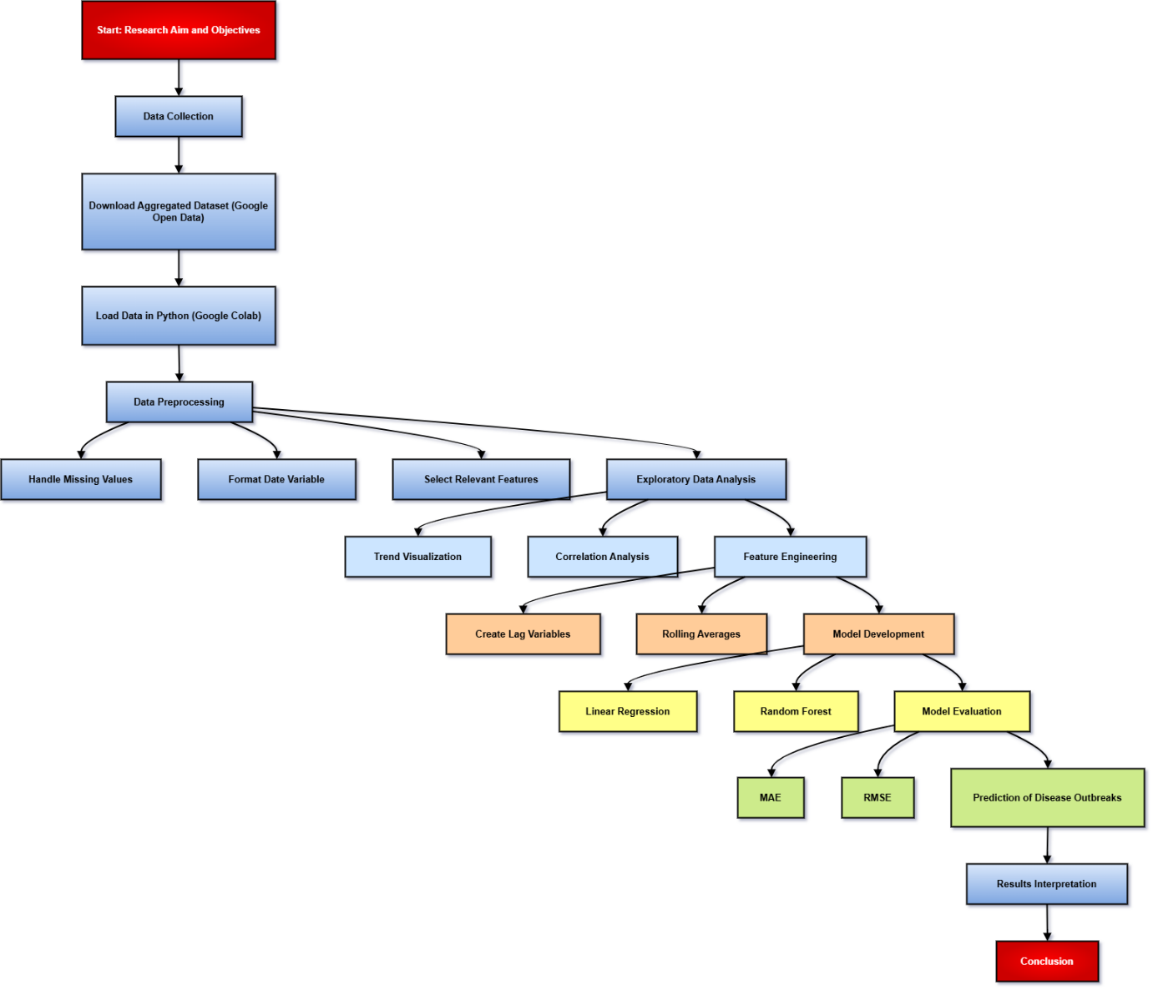
Figure 1: Action Plan
(Source: Self-Created)
Figure 1 gives the action plan of the study, the stepwise process of data collection and preprocessing through feature engineering, model construction, evaluation, and prediction. This is a systematic workflow that guarantees an approach based on data and systematic methods to predict disease outbreaks using machine learning methods.
The fundamental attribute of research strategy consists in the creation of machine learning models to forecast daily COVID-19 cases. Patterns can be learned using algorithms like linear regression, decision trees or ensemble models by using historical data. These models are trained using part of the dataset and then they are tested on unseen data to test their predictive accuracy. Mean absolute error, root mean square error are some of the performance measures of the models to determine accuracy and reliability of the models. The application of Python programming to Google Colab can be used to fulfil this strategy since this platform offers a flexible and efficient data analysis and model development environment (Umit Demirbaga, Kaur and Aujla, 2024). Generally, quantitative research strategy is justified because it guarantees systematic, replicable and objective nature of conducting a mobility and health data analysis, which aims at supporting fulfillment of objectives and goals of the research.

3.6 Data Collection Method
The data collection method adopted in this research is secondary data collection, which is the use of existing data collected from credible sources. The primary data collected and used in this research is collected from the Google COVID-19 Open Data source, which provides epidemiological and mobility data collected from multiple sources, including global health organizations and Google Community Mobility Reports (Mayur Suresh Gawande et al., 2025). The primary data collected is in the form of structured data, consisting of time series data collected on COVID-19 and human mobility patterns in different regions, making the data appropriate for the application of ML algorithms in the prediction of COVID-19 outbreaks.
The secondary data collected is appropriate for this research as the large volume of data collected is reliable and can be accessed easily, as collecting large volumes of data using primary data collection methods is time-consuming and challenging. The epidemiological data collected contains daily records of confirmed cases, deaths, and recoveries, while the mobility data contains indicators reflecting changes in human mobility patterns in areas such as workplaces, retail, transit, and residential areas.

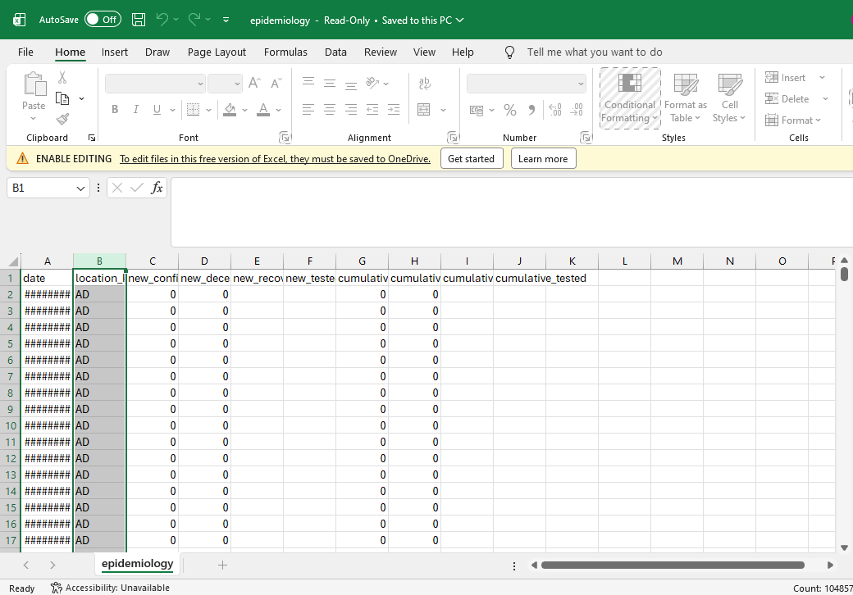
Figure 2: Epidemiological Dataset

This epidemiological and behavioural data directly supports the research aim of integrating the mobility and health data to improve the prediction of disease outbreaks. In the process of collecting the required data, the epidemiological and behavioural datasets are downloaded in CSV format from the Google COVID-19 Open Data repository and then imported into a Python-based environment using the Google Colab tool. After the import of the required datasets into the environment, the preprocessing of the data is conducted to make it suitable for analysis. This process includes handling the missing values and converting the dates into the appropriate format and selecting the required features of the datasets for the purpose of analysis (Olalere and Uzu-Okoh, 2025).
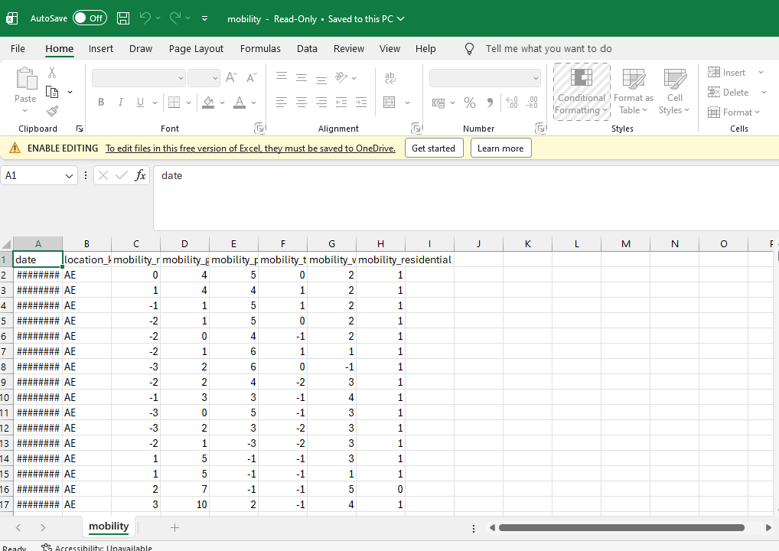
Figure 3: Mobility Dataset

Additionally, the epidemiological and behavioural datasets are combined on the basis of common characteristics such as dates and locations to generate a single dataset suitable for analysis. The selection of the epidemiological and behavioural datasets is based on the relevance, accuracy, and comprehensiveness of the datasets required to support the analysis and generation of the required results. Moreover, the datasets are appropriate for the analysis and application of sophisticated analytical tools such as machine learning.

3.7 Data Analysis
The analysis of the data in this research is performed through a quantitative and computational method to investigate the trends in the infection of COVID-19 and forecast criminal outbreaks of the disease. The analysis is carried out with help of Python programming in Google Colab that offers effective tools and libraries like Pandas, NumPy, Matplotlib, and Scikit-learn to process and analyze data and conduct machine learning (Attai et al., 2024). The steps will start with preprocessing of data where missing data is filled in, irrelevant data is dropped and data of different types will be converted to correct formats, mostly in the case of time-series analysis, using the date variable.
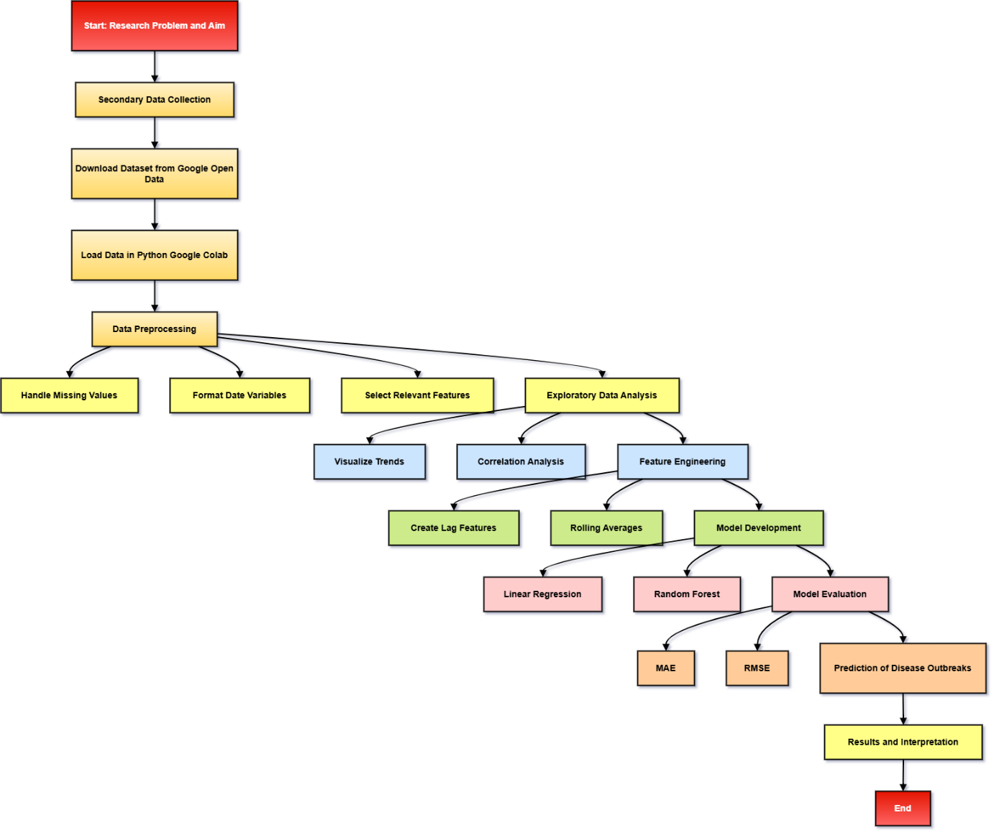
Figure 4: Research Methodology Flowchart
(Source: Self-Created in draw.io)
After preprocessing, the exploratory data analysis (EDA) is performed to be aware of the data structure and distribution. This involves plotting the trends of COVID-19 cases daily and analysing the mobility data (workplace, retail, and transit movements) by time. Correlation analysis is also conducted to find out the relation between mobility patterns and infection rates to help in the selection of relevant features to be used in model development.
The feature engineering is important in the predictable power of the models. The methods of forming lag variables (e.g. previous day or previous week cases) and rolling averages are used to utilize the temporal dependencies within the data. These characteristics allow the models to acquire disease progression patterns more efficiently. Machine learning algorithms are then trained in order to forecast cases of COVID-19 each day. An evaluation of the model performance is done by dividing the dataset into training and testing sets. The algorithms (linear regression), as well as ensemble models (random forest), are used to train relationships between the variables in mobility and the number of cases (Ghazaleh Babanejaddehaki, An and Manos Papagelis, 2024). The performance measures of the models, mean absolute error (MAE) and root mean square error (RMSE), are used to measure the performance of the models. This analytical process is systematic in order to make the results reliable, objective, and according to the research purpose of predicting the occurrence of diseases.

3.8 Sampling Method
The sampling technique in this research is non-probability sampling, namely purposive sampling because the study is based on an existing secondary data that has been chosen according to its suitability to the research purposes. This study does not involve sample as is done in primary data collection where a sample is selected in a population, instead, a complete set of data is already assembled and organised. The chosen dataset consists of county-level COVID-19 and mobility statistics in the United States in 2021 (more than 3,000 counties and about 935,000 records) (Wang et al., 2023). Such a big and extensive data also means that it eliminates the necessity of conventional sampling methods, as it has a wide reaching coverage of the target population.
In this context, purposive sampling would be suitable since the data used is selected intentionally with the purpose to fulfill the research objective of predicting the outbreak of the disease on the basis of the mobility and health data. These two variables epidemiological and behavioural are sufficient to ensure that the data used in the study meets the objectives and research questions of the study. This research is not just picking the data points randomly but all the available observations in the dataset are used by the research to optimise the accuracy of the analysis and model performance.
Moreover, a type of time sampling is used in the stage of analysis. This dataset is separated in training and testing sets, which is usually split by time, with the previous data serving to train the model and subsequent data serving to test the predictive power of that model. This will make sure that the model will be tested on unknown data which is a representation of real world forecasting conditions. It also can be used to avoid overfitting and enhances the generalisability of the results. Such an extensively large dataset helps to improve the reliability and validity of the findings since it helps to capture various patterns of disease spread in different regions and over time (Albalawi and Mustafa, 2022). Hence, the purposive sampling technique, paired with time data division offers a solid background on carrying out predictive analysis on this study.

3.9 Research Ethics
Ethics is significant in ensuring that the research is responsible, transparent as well as in line with scholarly norms. The research relies mostly on secondary data derived through the open sources that minimizes the chances of ethical concerns associated with the involvement of human beings. No personally identifiable information is present in the dataset used in this study because the data involved includes aggregated COVID-19 case data and mobility trends of the counties. Thus, the problem of privacy invasion and confidentiality risks is reduced to the minimal (Petersson et al., 2023). Even though secondary data has been used, it has been ethically accountable because the data is not used with any other purpose but to facilitate academic and research purposes. The data is properly recognized as to its sources, which include the platform of which the data was gathered. This prevents plagiarism and will promote intellectual honesty. The data is not misrepresented and any preprocessing processes are performed openly so as to preserve data integrity.
The other ethical concern is proper presentation of findings. This study will make sure that the findings are not manipulated or biased. Appropriate performance metrics are used to evaluate machine learning models and any drawbacks of the dataset or methodology are explicitly recognized (Epelde, 2024). This helps avoid the misinterpretation of results and the fact that the conclusion is backed by evidence.
Also, in the application of artificial intelligence methods ethical considerations are upheld. The study models have been developed to be applied only in academic understanding and not in the real-world decision-making without validating them adequately. The paper too recognizes the weaknesses of predictive models, especially in the situation of community health where the incorrect predictions may be disastrous. Lastly, the study complies with the policies of institutional guidelines and academic integrity.

3.10 Conclusion
This chapter has presented the methodological framework that was embraced in an effort to achieve the research objective of the prediction of disease outbreaks based on artificial intelligence and combined mobility and health data. It addressed research philosophy, approach, design, and strategy that are based on quantitative and data-driven approach. The chapter also reported how secondary data was used, methods of analysis and sampling method used in the study. Furthermore, ethical issues were also raised to make the research conducted in a responsible and transparent manner. Disease transmission patterns can be analyzed using machine learning and time-series data analysis methods as these would provide a very good base on which to build the predictive models.

References
Adewumi, I.O. (2025). AI for Cholera Outbreak Prediction, Real-Time Tracking, and Low-Resource Diagnostics using Federated and Privacy-Preserving Machine Learning. Research Square (Research Square). doi:https://doi.org/10.21203/rs.3.rs-7441133/v1.
Albalawi, U. and Mustafa, M. (2022). Current Artificial Intelligence (AI) Techniques, Challenges, and Approaches in Controlling and Fighting COVID-19: A Review. International Journal of Environmental Research and Public Health, 19(10), p.5901. doi:https://doi.org/10.3390/ijerph19105901.
Attai, K., Ekpenyong, M., Amannah, C., Asuquo, D., Ajuga, P., Obot, O., Johnson, E., John, A., Maduka, O., Akwaowo, C. and Uzoka, F.-M. (2024). Enhancing the Interpretability of Malaria and Typhoid Diagnosis with Explainable AI and Large Language Models. Tropical Medicine and Infectious Disease, 9(9), p.216. doi:https://doi.org/10.3390/tropicalmed9090216.
Balaji Chode (2023). Development of an AI-Based Disease Spread Forecasting Platform for Early Community Risk Mitigation. INTERANTIONAL JOURNAL OF SCIENTIFIC RESEARCH IN ENGINEERING AND MANAGEMENT, 07(09), pp.1–9. doi:https://doi.org/10.55041/ijsrem25861.
Christo El Morr, Ozdemir, D., Yasmeen Asdaah, Saab, A., Yahya El-Lahib and Elie Salem Sokhn (2024). AI-based epidemic and pandemic early warning systems: A systematic scoping review. Health Informatics Journal, 30(3). doi:https://doi.org/10.1177/14604582241275844.
Epelde, F. (2024). How AI Could Help Us in the Epidemiology and Diagnosis of Acute Respiratory Infections? Pathogens, [online] 13(11), pp.940–940. doi:https://doi.org/10.3390/pathogens13110940.
Ghazaleh Babanejaddehaki, An, A. and Manos Papagelis (2024). Disease Outbreak Detection and Forecasting: A Review of Methods and Data Sources. ACM Transactions on Computing for Healthcare, 6(2). doi:https://doi.org/10.1145/3708549.
Inam, S.A. (2025). A review of artificial intelligence for predicting climate driven infectious disease outbreaks to enhance global health resilience. Discover Public Health, 22(1). doi:https://doi.org/10.1186/s12982-025-01167-4.
Kaur, J. and Butt, Z.A. (2025). AI-driven epidemic intelligence: the future of outbreak detection and response. Frontiers in Artificial Intelligence, 8. doi:https://doi.org/10.3389/frai.2025.1645467.
Liu, J. (2024). AI-Based Epidemic Spread Prediction and Public Health Response Optimization: A Systematic Study from Data Analysis to Policy Implementation. Applied and Computational Engineering, 118(1), pp.1–7. doi:https://doi.org/10.54254/2755-2721/2025.18470.
Mayur Suresh Gawande, Zade, N., Kumar, P., Swapnil Gundewar, Induni Nayodhara Weerarathna and Verma, P. (2025). The role of artificial intelligence in pandemic responses: from epidemiological modeling to vaccine development. Molecular Biomedicine, [online] 6(1). doi:https://doi.org/10.1186/s43556-024-00238-3.
Olalere, S.O. and Uzu-Okoh, J.E. (2024). AI-Based Risk Modeling of Infectious Disease Spread and Its Implications for Public Health Security in Vulnerable Populations. International Journal of Medical and All Body Health Research, 5(4), pp.241–250. doi:https://doi.org/10.54660/ijmbhr.2024.5.4.241-250.
Olalere, S.O. and Uzu-Okoh, J.E. (2025). Artificial Intelligence–Driven Epidemiological Surveillance for Early Detection of Emerging Infectious Diseases and National Health Security. International Journal of Medical and All Body Health Research, [online] 6(2), pp.155–164. doi:https://doi.org/10.54660/ijmbhr.2025.6.2.155-164.
Petersson, L., Vincent, K., Svedberg, P., Nygren, J.M. and Larsson, I. (2023). Ethical considerations in implementing AI for mortality prediction in the emergency department: Linking theory and practice. Digital health, 9. doi:https://doi.org/10.1177/20552076231206588.
Safari, M., Alireza Zali, Hatami, H., Elnaz Amanzadeh Jajin and Meisam Akhlaghdoust (2025). Predicting Infectious Disease Incidence After Flooding Using Artificial Intelligence Models: A Retrospective Pre–Post Cohort Study Using Routinely Collected EHR Data. Health Science Reports, [online] 8(11), pp.e71470–e71470. doi:https://doi.org/10.1002/hsr2.71470.
Sanjay Ramdas Bauskar, Chandrakanth Rao Madhavaram, Galla, E.P., Sunkara, J.R. and Hemanth Kumar Gollangi (2022). PREDICTING DISEASE OUTBREAKS USING AI AND BIG DATA: A NEW FRONTIER IN HEALTHCARE ANALYTICS. European Chemical Bulletin. doi:https://doi.org/10.53555/ecb.v11:i12.17745.
Umit Demirbaga, Kaur, N. and Aujla, G.S. (2024). Uncovering hidden and complex relations of pandemic dynamics using an AI driven system. Scientific Reports, [online] 14(1). doi:https://doi.org/10.1038/s41598-024-65845-0.
Wang, S., Zhao, X., Qiu, J., Wang, H. and Tao, C. (2023). WDCIP: spatio-temporal AI-driven disease control intelligent platform for combating COVID-19 pandemic. Geo-spatial Information Science, 27(6), pp.2023–2047. doi:https://doi.org/10.1080/10095020.2023.2182236.

