AISENTRYD
Operator's Manual
24/7 login & port-scan banning • idle-time vuln/malware scans • AI-written reports • threat-intel blocklists
Package version 2.10-3 — Debian / Ubuntu (amd64)
Prepared for Sean Mullen

1. What aisentryd is
aisentryd is a single background daemon that replaces fail2ban and PortSentry, adds always-on threat-intelligence blocking, and runs idle-time vulnerability/malware/hardening scans with an AI-written plain-English report. Everything below is one Debian package (aisentryd_2.10-3_amd64.deb) built around one Python 3 program, /usr/sbin/aisentryd, with /usr/sbin/aisentryctl as a symlink to it (argv[0] decides which behaviour runs).
As of 2.6-1 the old standalone sentryd binary and its sentryctl tool are gone. aisentryd's own Python scan-detection engine (built in since 2.5) does that job itself, fully in readable source — there is no second, unauditable port-scan detector bundled anymore.
At a glance
Runs continuously as aisentryd.service (systemd), not on a timer.
Login and port-scan monitoring: always on, negligible overhead.
rkhunter / lynis / clamscan / debsecan / aide: only run when the machine is idle.
Threat-intel IP/domain blocklists: enforced continuously via nftables and /etc/hosts.
Bans are applied with ufw — ufw must be installed, enabled, and (for scan detection) logging.
Everything it does automatically is narrow and reversible: quarantine (never delete), patch known CVEs, ban an IP. Everything else is report-only.

1.1 The two tiers of work
Tier | Runs | What it does
Always on | Every POLL_INTERVAL_SECONDS (default 30s) | Journal-based login monitoring (SSH + local), ufw denied-connection monitoring, port-scan detection, ban enforcement, threat blocklist maintenance, the running event log.
Idle-time heavy scan | Only after IDLE_THRESHOLD_SECONDS idle (default 5 min) and SCAN_INTERVAL_SECONDS since the last one (default 6h) | rkhunter, lynis, clamscan, debsecan, aide — in that order, each niced and idle-I/O-scheduled, results collected into one Markdown report.

1.2 What it does completely on its own (no human input)
- Bans a source IP with ufw when it fails logins repeatedly (fail2ban-style) or probes enough closed ports (PortSentry-style).
- Un-bans it again automatically when the ban expires (unless the ban escalated to permanent).
- Downloads and continuously enforces public threat-intel IP/domain blocklists (on by default).
- Quarantines (moves, never deletes) a file clamscan flags as infected — AUTO_QUARANTINE_MALWARE=1 by default.
- Runs unattended-upgrade to patch a CVE debsecan finds affecting an installed package — AUTO_FIX_UPDATES=1 by default.
- Writes a timestamped Markdown report every heavy scan and fires a desktop notification for anything notable.
Everything else — rkhunter warnings, lynis hardening suggestions, most findings — is report-only with a suggested fix command. aisentryd never executes anything an AI model says; the model only writes the explanation text.

2. Packages required
Installing the .deb pulls these in automatically via apt. You do not need to install them by hand.

2.1 Hard dependencies (Depends:)
Package | Why it's needed
python3 | aisentryd/aisentryctl are Python 3, stdlib only — no pip packages required.
ca-certificates | TLS validation for the Anthropic API and the HTTPS-only threat-feed downloads.
rkhunter | Rootkit / anomaly detection scanner.
lynis | General security hardening audit.
clamav, clamav-freshclam | Antivirus engine (clamscan) and its signature updater.
debsecan | Reports CVEs affecting your currently installed package versions.
aide | File-integrity baseline / change detector.
unattended-upgrades | What AUTO_FIX_UPDATES actually invokes to patch a CVE.
systemd | aisentryd.service, and journalctl for reading login events.
nftables | Enforces the threat-intel IP blocklist (separate table from ufw).
iproute2 | Used to discover this host's own addresses/gateways so they're never banned.
ufw | The single enforcement point for every ban this package issues.

2.2 Recommended / suggested (not required)
- libnotify-bin (Recommends) — desktop notifications on findings/bans/quarantine. Silently skipped on a headless box.
- dnsmasq (Suggests) — only needed if you set THREAT_DOMAIN_MODE=dnsmasq instead of the default /etc/hosts mode.
- polkit-1-auth-agent (Suggests) — any desktop's PolicyKit agent; GNOME/KDE/MATE/LXQt all ship one already.
- aisentryd-gui-kde (Suggests) — the Qt5/KDE aisentry-gui dashboard app, with ClamGuard folded in. See section 6.
- aisentryd-gui-gtk (Suggests) — the native GTK3 aisentry-gui dashboard app (GNOME/Cinnamon/MATE/Budgie), with ClamGuard folded in the same way. Independent implementation of the same dashboard, no Qt dependency. See section 6.
- Ollama (external, not packaged) — only if you want a free local AI model instead of the Anthropic API. Install separately: curl -fsSL https://ollama.com/install.sh | sh
The aisentryd package itself is headless — no GUI dependency at all. Everything in this section is optional; the daemon, its scans, its bans and its threat blocklists all work identically with none of it installed.

3. Installing

3.1 From the prebuilt .deb
sudo apt-get install ./aisentryd_2.10-3_amd64.deb
apt resolves and installs every dependency in section 2.1 automatically. The package is architecture-specific (amd64), Section: admin, Priority: optional.

3.2 Building it yourself from source
sudo apt-get install build-essential debhelper
dpkg-buildpackage -us -uc -b
sudo apt-get install ../aisentryd_2.10-3_*.deb

3.3 What the installer does for you
- Locks down /etc/aisentryd/aisentryd.conf to 0600 root:root (it can hold your Anthropic API key).
- Creates /var/lib/aisentryd, /var/lib/aisentryd/threat, /var/lib/aisentryd/quarantine, /var/lib/aisentryd/backups and the configured REPORT_DIR.
- Enables and starts aisentryd.service immediately — no reboot needed.
- Warns you on stderr if no ANTHROPIC_API_KEY is set and AI_PROVIDER isn't ollama (the tool still runs — just without AI write-ups).
- Warns you if ufw is installed but inactive, or installed but not logging (both needed for ban enforcement / scan detection).
- Rebuilds the desktop menu/icon cache if the tools for that are present.
Upgrading from an older aisentryd / from the old standalone sentryd package
Your /etc/aisentryd/aisentryd.conf and any bans already in place are kept across an upgrade.
If you still have the old standalone sentryd package installed, this package Conflicts/Replaces it and dpkg removes it automatically — you don't need to remove it by hand first.
Any ufw deny rules that old sentryd previously installed are left in place and still enforced by ufw; they're just no longer tracked by a separate tool. Check current state with `aisentryctl bans` and `ufw status numbered`.

4. Configuring
Everything lives in one file: /etc/aisentryd/aisentryd.conf (KEY=VALUE, # starts a comment). A change takes effect on the daemon's next poll tick (default within 30s) — no restart needed, including turning a monitor on that started out disabled.

4.1 AI write-up backend
Setting | Default | Meaning
SEND_TO_AI | 1 | 0 = skip the AI step entirely; falls back to a plain grouped listing.
AI_PROVIDER | anthropic | anthropic | ollama | none.
ANTHROPIC_API_KEY | (empty) | Required if AI_PROVIDER=anthropic. Never logged, never in the report.
ANTHROPIC_MODEL | claude-sonnet-5 | Model name sent to the Anthropic API.
OLLAMA_URL | http://127.0.0.1:11434 | Local Ollama server address.
OLLAMA_MODEL | llama3.1 | Any Ollama-served model (llama3.2, mistral, qwen2.5, ...).
Free / local AI option
curl -fsSL https://ollama.com/install.sh | sh
ollama pull llama3.1
Then set AI_PROVIDER=ollama in aisentryd.conf. Zero API cost, nothing leaves the machine.

4.2 Scans and scheduling
Setting | Default | Meaning
REPORT_DIR | /var/lib/aisentryd-reports | Must be ≥ 2 path levels deep — old reports are rmtree'd from here on retention.
REPORT_RETENTION_DAYS | 30 | How long a report subfolder is kept.
RUN_RKHUNTER / RUN_LYNIS / RUN_CLAMAV / RUN_DEBSECAN / RUN_AIDE | 1 (all on) | Toggle each scanner independently.
SCAN_PATHS | /home /etc /usr/local /opt | clamscan targets when FULL_SCAN=0.
FULL_SCAN | 0 | 1 scans / instead — thorough, much slower.
IDLE_THRESHOLD_SECONDS | 300 | Continuous idle time required before a heavy scan may start.
SCAN_INTERVAL_SECONDS | 21600 (6h) | Minimum time between heavy scans.
MAX_LOAD_AVERAGE | 2.0 | Skip a heavy scan if 1-minute load average exceeds this.
TOOL_TIMEOUT_SECONDS | 3600 | Hard per-scanner timeout; the whole process group is killed on expiry.
NICE_LEVEL | 10 | CPU niceness for every scanner subprocess (also run at idle I/O priority).

4.3 Automatic fixes
Setting | Default | Meaning
AUTO_FIX_UPDATES | 1 | Run unattended-upgrade the moment debsecan finds a CVE. Set 0 for report-only.
AUTO_QUARANTINE_MALWARE | 1 | Move (never delete) a clamscan hit into QUARANTINE_DIR. Set 0 for report-only.
QUARANTINE_DIR | /var/lib/aisentryd/quarantine | Mirrors the original path underneath, e.g. /home/x/bad.exe → QUARANTINE_DIR/home/x/bad.exe.
BACKUP_DIR / BACKUP_RETENTION_DAYS | /var/lib/aisentryd/backups / 30 | Where corrupted state files get backed up before being reset.

4.4 Login monitoring & ban engine (fail2ban-style)
Setting | Default | Meaning
ENABLE_AUTH_MONITOR | 1 | Master switch for the login-failure jail.
SSH_UNITS | ssh.service sshd.service | systemd units to read for SSH logins. Empty falls back to this default, not the whole journal.
AUTH_IDENTIFIERS | sshd sshd-session sudo su login gdm-password sddm lightdm | Journal identifiers whose PAM successes/failures count.
AUTH_FAIL_THRESHOLD / AUTH_FAIL_WINDOW_SECONDS | 5 / 600 | Ban after this many failures within this window.
AUTH_BAN_SECONDS | 3600 | 0 = never auto-unban.
AUTH_BAN_ESCALATE | 1 | Each repeat offense doubles the ban length, up to AUTH_BAN_MAX_SECONDS (604800).
RECIDIVE_OFFENSES / RECIDIVE_WINDOW_SECONDS | 5 / 604800 | This many bans inside the window → the next ban is permanent. 0 = never escalate to permanent.
SENTRY_IGNORE_FILE | /etc/aisentryd/ignore.hosts | One address/CIDR per line, never banned.
SENTRY_IGNORE_IPS | (empty) | Same, inline in the config, comma or space separated.
SENTRY_IGNORE_PRIVATE | 1 | Never ban RFC1918/ULA/CGNAT sources. Set 0 to also defend against other LAN machines.

4.5 Port-scan detection (PortSentry-style)
Setting | Default | Meaning
ENABLE_PORTSCAN_DETECT | 1 | Master switch.
PORTSCAN_THRESHOLD / PORTSCAN_WINDOW_SECONDS | 5 / 3600 | Ban after this many distinct closed ports touched within this window.
PORTSCAN_BAN_SECONDS | 86400 | 0 = permanent.
PORTSCAN_TRAP_PORTS | (empty) | A single hit on any of these ports bans immediately (tripwire ports).
CONN_LOG_DENIED / ENABLE_CONN_MONITOR | 1 / 1 | Log every ufw-denied connection to the event log.
This requires ufw logging
Port-scan detection reads ufw's own denied-connection log. If ufw isn't enabled, or is enabled with logging off, nothing is detected.
sudo ufw enable
sudo ufw logging low

4.6 Threat-intel blocklists
Setting | Default | Meaning
ENABLE_THREAT_BLOCK | 1 | Master switch — on by default.
THREAT_UPDATE_INTERVAL_SECONDS | 21600 | Floored at 3600 (feed operators ask for no more than hourly).
THREAT_BLOCK_IPS | 1 | Enforce the IP feeds via the aisentryd nftables table.
THREAT_DOMAIN_MODE | hosts | hosts | dnsmasq | off.
THREAT_MAX_DOMAINS | 500000 | Safety cap; a feed producing more than this is refused as suspicious.
THREAT_ALLOW_IPS / THREAT_ALLOW_DOMAINS | (empty) | Always-allow list — use this for a false positive from threat-check.
THREAT_IP_FEEDS | Spamhaus DROP v4/v6, abuse.ch Feodo, Emerging Threats | Space-separated https:// URLs.
THREAT_DOMAIN_FEEDS | StevenBlack hosts, abuse.ch URLhaus, a phishing filter | Space-separated https:// URLs.
Feeds must be https:// (a redirect to http:// is refused), downloads are capped at 64 MB, and the blocklist can never cover loopback, private/reserved space, this host's own addresses, its gateway, its DNS resolvers, or a range broader than /8 (IPv4) / /16 (IPv6) — whatever a feed says.

5. Command reference (aisentryctl)
aisentryctl is a symlink to /usr/sbin/aisentryd; the subcommand you pass decides what it does. Commands that change firewall state need root (sudo).

5.1 Scanning & reports
Command | What it does
aisentryd run | Run all enabled scans once and write a report (this is also the default action with no subcommand).
aisentryctl status | Daemon running? idle state? ban count? timestamp of the last report?
aisentryctl gui | Interactive terminal status view (also runs from the desktop menu entry).
aisentryctl last | Print the most recent report to stdout.
aisentryctl list | List past report timestamps/directories.
aisentryctl aide-update | Accept the current filesystem state as AIDE's new baseline.

5.2 Login & ban engine
Command | What it does
aisentryctl tail [-n N] | Tail the condensed event log (logins, bans, denied connections). Default 40 lines.
aisentryctl bans | List every active ban: address, jail, since, until, reason.
sudo aisentryctl ban <ip|cidr> [-r reason] [--force] | Permanent manual ban. Accepts a bare address or a CIDR range (2.7+). --force is required to ban a normally-protected address/range.
sudo aisentryctl unban <ip|cidr> | Lift a ban (same address or CIDR string used to create it) and forget its repeat-offender history.
CIDR bans (new in 2.7)
aisentryctl ban 203.0.113.0/24 # ban a whole range, not just one address
aisentryctl ban 2001:db8::/32
A CIDR is refused if it's broader than /8 (IPv4) or /16 (IPv6) — the same floor used by the threat blocklists — or if it overlaps any protected range (this host, its gateway/DNS, loopback, or private space) unless you pass --force. A CIDR ban is always permanent/manual, same as a single-IP CLI ban.

5.3 Threat blocklists
Command | What it does
sudo aisentryctl threat-update | Download the feeds now and (re)apply the blocklists; shows per-feed results.
aisentryctl threat-status | What's currently blocked, when it last updated, feed health.
aisentryctl threat-check <ip|cidr|domain> | Is this listed? By which feed? Is it on the never-block list? — the false-positive triage tool.
sudo aisentryctl threat-off | Remove all blocklist rules right now (nftables table, /etc/hosts block, dnsmasq file).

5.4 GUI subcommands used by aisentry-gui
These four exist purely to give a GUI safe, validated access to root-owned data without ever running the GUI itself as root. They're ordinary aisentryctl subcommands — nothing stops you from scripting them too.
Command | What it does
aisentryctl status --json / bans --json / threat-status --json / list --json | Same data as the plain-text forms above, as JSON — for a GUI or script to parse instead of screen-scrape.
aisentryctl show-report <name> [--raw FILE] | Print an arbitrary past report's report.md (or one of its raw/ tool-output files) — the only way a GUI can read report history, since REPORT_DIR is root:root 0750.
aisentryctl list-raw <name> | JSON list of a past report's available raw/ tool-output filenames, for populating a "view raw output" picker.
sudo aisentryctl set-config KEY=VALUE [KEY=VALUE ...] | Validate and write one or more settings to aisentryd.conf. Uses the exact same validation the daemon itself uses; on any rejected value, nothing at all is written.

5.5 ClamGuard and the aisentry-gui dashboards
aisentry-gui # KDE/Qt5 dashboard, package aisentryd-gui-kde
aisentry-gui-gtk # GTK3 dashboard, package aisentryd-gui-gtk
#
# ClamGuard alone, without the rest of the dashboard:
clamguard-kde # ships inside aisentryd-gui-kde, folded in as its ClamGuard section
clamguard-gtk # ships inside aisentryd-gui-gtk, folded in as its ClamGuard section
ClamGuard is folded into both dashboard apps as their own section rather than a window you launch separately — see section 6.9. The old standalone aisentryd-clamguard-kde and aisentryd-clamguard-gtk packages are both gone; aisentryd-gui-kde and aisentryd-gui-gtk each Provide/Conflict/Replace their respective standalone package, so upgrading from either removes it automatically. Both `clamguard-kde` and `clamguard-gtk` still exist as their own binaries on disk and can still be launched directly (or via `aisentryctl clamguard`, which picks whichever is installed) if you want ClamGuard without the rest of the dashboard.

6. aisentry-gui — the dashboard apps
aisentry-gui puts everything above behind one dashboard-style window: status cards up top, a sidebar to navigate between sections, no terminal required for day-to-day use. It ships as two independent, functionally-equivalent implementations so it fits whichever desktop you're actually on — both are entirely optional; the daemon works identically with either, both, or neither installed.
 | aisentry-gui (KDE edition) | aisentry-gui-gtk (GTK edition)
Package | aisentryd-gui-kde | aisentryd-gui-gtk
Toolkit | PyQt5 (python3-pyqt5) | GTK3 / PyGObject (python3-gi, gir1.2-gtk-3.0)
Best fit for | KDE Plasma (native tray, KNotification over D-Bus) | GNOME, Cinnamon, MATE, Budgie and other GTK desktops
Independent code? | Yes — not a shared module with the GTK edition | Yes — not a re-skin of the KDE edition
Install either one (they're independent packages), or both side by side — nothing about one conflicts with the other, and they read/write the exact same aisentryd state, so switching which one you use day-to-day never loses anything.
How they talk to aisentryd
Neither one ever reads aisentryd's files directly, and neither ever runs as root.
Everything they display comes from unprivileged aisentryctl JSON output (status/bans/threat-status/list/show-report/list-raw --json).
Everything they change (ban/unban, saving settings, updating threat feeds, disabling blocklists) goes through `pkexec aisentryd ...` — you'll get the normal PolicyKit authentication prompt for those, the same as any other privileged desktop action.

6.1 Installing
sudo apt-get install ./aisentryd-gui-kde_1.0-2_amd64.deb # KDE/Qt5 edition
sudo apt-get install ./aisentryd-gui-gtk_1.0-2_all.deb # GTK3 edition
Both pull in aisentryd itself (>= 2.9-1) and policykit-1 automatically, plus their own toolkit's dependency (python3-pyqt5, or python3-gi + gir1.2-gtk-3.0). Either one requires aisentryd already configured and running for anything on the dashboard to have data to show.

6.2 Starting and stopping
Both are regular desktop applications, not systemd services — there's nothing to enable or start at boot, and nothing keeps running after you fully quit either one (aside from aisentryd itself, which is unaffected either way). The one real behavioral difference between the two editions is what closing the window does:
Action | aisentry-gui (KDE) | aisentry-gui-gtk
Start it | Application menu → "aisentry", or run `aisentry-gui`. | Application menu → "aisentry", or run `aisentry-gui-gtk`.
Close the window ([x]) | Minimizes to the system tray — keeps polling status and the live log in the background. | Quits outright. GTK3 has no first-class, non-deprecated tray icon API to minimize to, so this edition just closes like any other window.
Bring it back | Click the tray icon, or its context menu → "Show dashboard". | Re-launch it from the application menu or a terminal.
Refresh immediately | "Refresh now" on the Dashboard, or the tray menu's own "Refresh now". | "Refresh now" on the Dashboard. Otherwise both refresh on their own every 5 seconds (status) / 4 seconds (live log).
Quit it completely | Tray icon's context menu → "Quit" (closing the window alone does not quit it). | Close the window — that's the whole shutdown, there's nothing else running to quit.

6.3 The Dashboard section
Six status cards, refreshed automatically, each summarizing one thing you'd otherwise check with a separate command — identical content and layout in both editions:
Card | Reads like | Same as running
Daemon | running / stopped / unknown | systemctl status aisentryd
Active bans | a count | aisentryctl bans
Threat blocklist | enabled/disabled, plus IP + domain counts | aisentryctl threat-status
System load | current 1-minute load average, idle or busy | aisentryctl status (idle state)
Last report | the most recent report's directory name | aisentryctl list (newest entry)
AIDE baseline | present / not built yet / disabled | aisentryctl status (AIDE line)
Below the cards, a scrolling "Recent activity" panel shows the last ~15 lines of the event log — the same lines `aisentryctl tail` would print, without needing a terminal open.
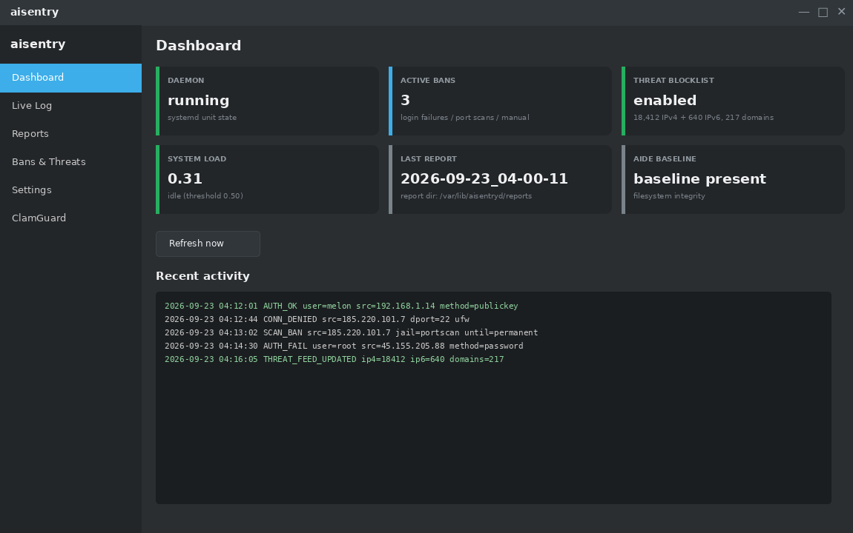
Figure 1 — aisentry-gui (KDE/Qt5 edition): Dashboard section, dark Breeze-style theme throughout.
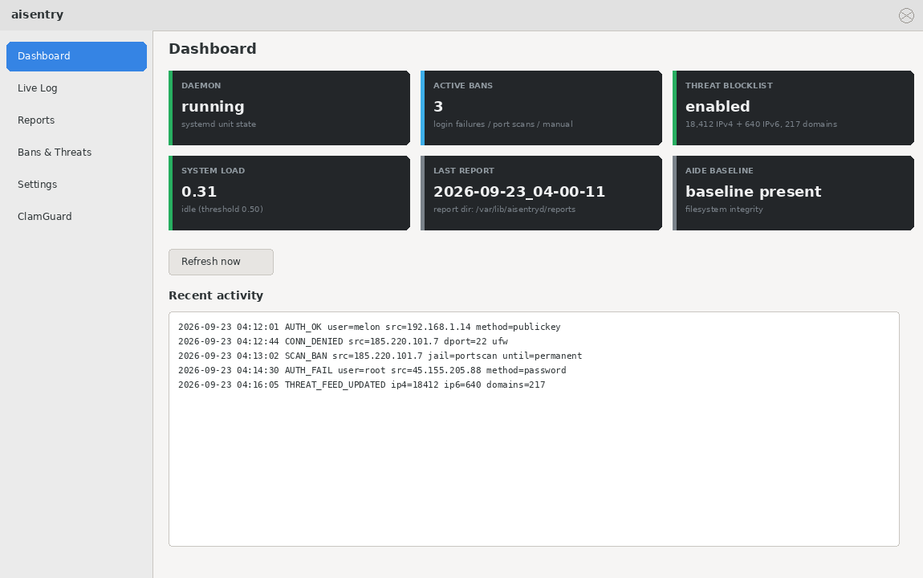
Figure 2 — aisentry-gui-gtk (GTK3 edition): Dashboard section. Only the status cards carry their own dark styling (a CSS class on the card itself) — the rest of the window follows whatever GTK theme the desktop is using, light or dark, unlike the KDE edition's fixed dark palette.

6.4 The Live Log section
A filterable, continuously-refreshing view of the full condensed event log (polls `aisentryctl tail` every 4 seconds). Type in the filter box to narrow to lines containing that text (case-insensitive substring match — e.g. type an IP address to see only that source's activity), and use Pause to freeze the view without stopping the underlying polling, so you can read a moment in time without it scrolling out from under you.
The event-log line formats themselves (AUTH_OK, AUTH_FAIL, SCAN_BAN, CONN_DENIED, etc.) are documented in section 7 with the raw `aisentryctl tail` output.

6.5 The Reports section (Zenmap-style browser)
A two-pane browser over every report aisentryd has ever written, in the same spirit as Zenmap's saved-scan list: a list of past reports on the left (newest first), the selected report's content on the right.
- Click a report in the left-hand list to load its report.md on the right (via `aisentryctl show-report`).
- The "raw output" dropdown above the detail pane lists every raw/ tool-output file that report has (via `aisentryctl list-raw`) — switch it to view rkhunter's, lynis's, clamscan's, debsecan's or aide's actual unprocessed output for that run, instead of just the AI-summarized report.
- "Refresh list" re-fetches the report list — useful right after a scan finishes, since the list doesn't poll on its own.

6.6 The Bans & Threats section
Everything from sections 5.2 and 5.3, without the command line:
- A table of every active ban (address, jail, since, until, reason) — the same data as `aisentryctl bans`.
- Ban: type an IP or CIDR and an optional reason, click Ban. Equivalent to `sudo aisentryctl ban <ip> -r <reason>`. You'll get the PolicyKit prompt (pkexec), then a confirmation dialog before it actually runs.
- Unban selected: select a row in the table, click Unban selected. Equivalent to `sudo aisentryctl unban <ip>`.
- A read-only panel showing threat-blocklist state — enabled/disabled, IPv4/IPv6/domain counts, last update time, and per-feed health — the same content as `aisentryctl threat-status`.
- Update feeds now: equivalent to `sudo aisentryctl threat-update`.
- Disable blocklist enforcement: equivalent to `sudo aisentryctl threat-off`, after a confirmation dialog (this removes the nftables table, /etc/hosts block, and dnsmasq file immediately).
As with the command line, banning a broader-than-allowed CIDR, or one overlapping a protected range, is refused — the GUI doesn't offer a --force option, so use `sudo aisentryctl ban ... --force` directly if you genuinely need to override that.
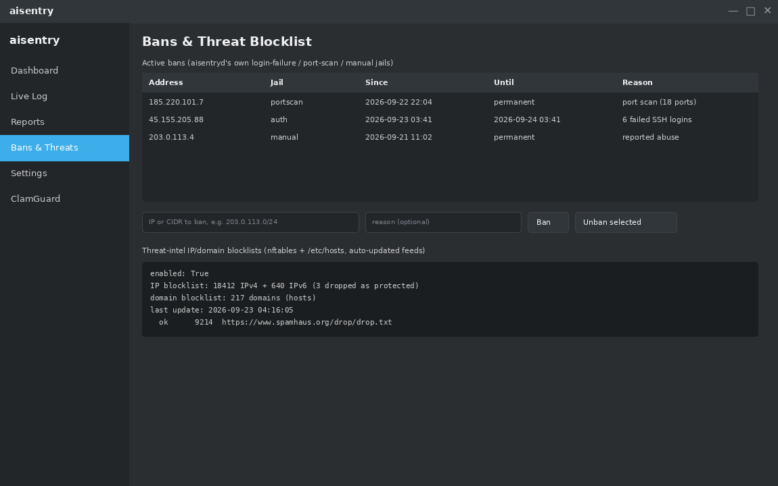
Figure 3 — aisentry-gui (KDE/Qt5 edition): Bans & Threat Blocklist section.
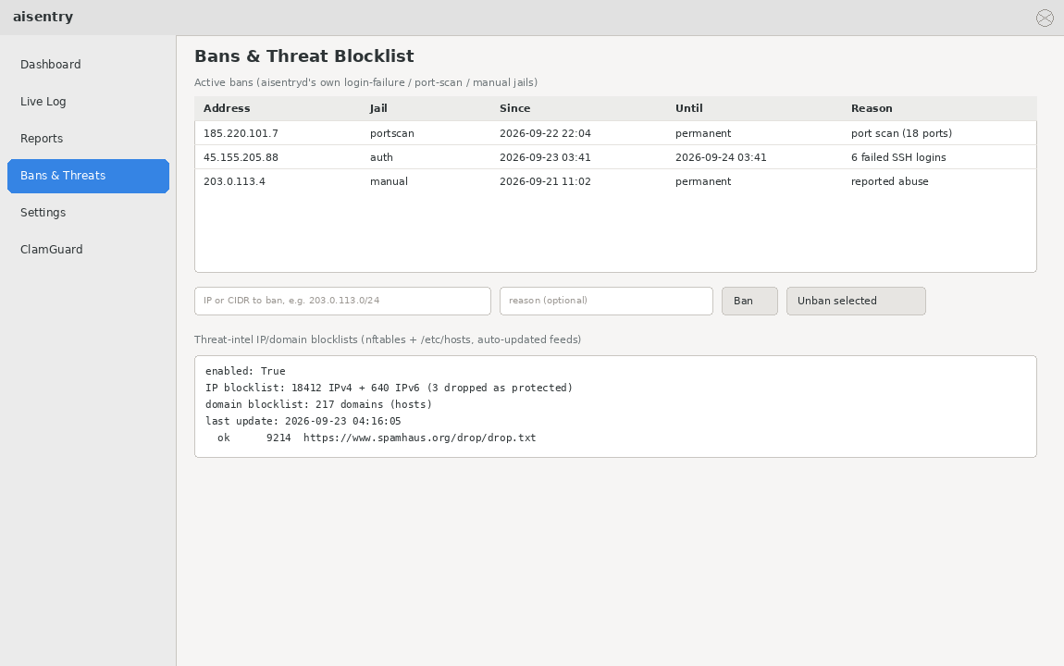
Figure 4 — aisentry-gui-gtk (GTK3 edition): Bans & Threat Blocklist section. Same fields, same controls, same data — a plain GtkTreeView and light-themed panel in place of Qt's dark QTableWidget.

6.7 The Settings section
A form covering the settings you're most likely to change day-to-day (scanners to run, the idle-load threshold, per-tool timeout, niceness, and the four master on/off switches: threat blocking, auth monitoring, port-scan detection, and rkhunter's own auto-update). It does not attempt to show every single key in aisentryd.conf — anything not listed here is still fully configurable by editing the file directly (section 4).
How Save actually works
Clicking Save collects every changed field into one `sudo aisentryctl set-config KEY=VALUE [KEY=VALUE ...]` call.
That call validates every value with the exact same logic the daemon uses to load its own config — the GUI cannot write a value the daemon would reject.
If any single value fails validation, nothing at all is written — never a half-applied settings change.
A successful save takes effect on the daemon's next poll tick (within ~30 seconds) — no restart needed.

6.8 Notes specific to the GTK edition
- No system tray icon — see the table in 6.2. This is a GTK3 platform limitation (no non-deprecated StatusIcon replacement), not a missing feature.
- Desktop notifications go through Gio.Notification first (native to GtkApplication, no extra dependency), falling back to libnotify and then notify-send if neither is available — every layer degrades silently rather than erroring.
- The window otherwise follows your system GTK theme (light or dark) rather than forcing one, which is why the Dashboard and Bans screenshots above look different in tone from the KDE edition despite showing identical data.

6.9 The ClamGuard section
The full ClamGuard application for that toolkit — Scan, Update, Quarantine and History tabs — embedded as this dashboard's last section rather than a separate window. aisentry-gui embeds clamguard-kde (Qt5, system-tray icon, KNotification over D-Bus); aisentry-gui-gtk embeds clamguard-gtk (GTK3, Gio.Notification). Both behave identically otherwise: interactive scans (quick, full-system via pkexec, or a chosen file/folder), a quarantine manager (restore or permanently delete, with overwrite-refusal on restore), freshclam definition updates with an auto-update toggle, and scan history. Both share the exact same ~/.local/share/clamguard and ~/.config file formats, so switching which dashboard you use — or running both — never duplicates or orphans your scan history, preferences or quarantined files.

7. What a scan report looks like
Written to REPORT_DIR/<timestamp>/report.md, plus raw tool output under raw/. REPORT_DIR/latest-report.md always points at the newest one. Only severities in REPORT_DETAIL_SEVERITIES (critical, high by default) get a full per-finding write-up in the prose — everything else is folded into a one-line count per source. Nothing is ever discarded: full detail for every severity is always in the report's raw JSON section.
# aisentryd security report - 2026-09-22 20:42:08 -0500

| severity | count |
|---|---|
| critical | 1 |
| high | 3 |
| low | 14 |

## Tool status
- rkhunter: rc=0, 2 warning(s)
...

## Automatic fixes applied this run
- quarantined /var/www/html/shell.php (Php.Trojan.Generic-1234)
-> /var/lib/aisentryd/quarantine/var/www/html/shell.php

## Findings and recommended fixes
### CRITICAL (1)
- [clamav] malware found: Php.Trojan.Generic-1234
fix: `quarantine ...`
...
- 14 low finding(s) (11 lynis, 3 rkhunter) - full detail in the raw JSON below
Example event-log lines (aisentryctl tail):
AUTH_OK src=192.0.2.10 user=sean method=publickey port=51122
AUTH_FAIL user=root src=203.0.113.9 port=40222 why=failed-password
AUTH_INVALID_USER user=oracle src=203.0.113.9 port=40224
AUTH_FAIL_LOCAL svc=sudo user=sean tty=/dev/pts/2
AUTH_OK_LOCAL svc=sudo user=root by=sean
CONN_DENIED src=203.0.113.9 dst=192.168.1.10 dport=3389 proto=TCP
SCAN_DETECT src=203.0.113.9 closed-ports=5 (>=5 within 3600s; 22,80,443,3306,8080)
SCAN_BAN src=203.0.113.9 jail=portscan ... ban=86400s offense=1
AUTH_BAN src=203.0.113.9 jail=sshd failures=5 (>=5 within 600s) ban=3600s offense=1
AUTH_UNBAN src=203.0.113.9 jail=sshd (expired)

8. Troubleshooting

Nothing is being banned even though I see failed logins
ufw is either not installed, not enabled, or has no active deny rules being inserted — aisentryd's bans are only as good as ufw's enforcement.
sudo ufw status verbose
sudo ufw enable
aisentryctl status # shows UFW_INACTIVE if this is the problem

Port scans aren't being detected
Port-scan detection reads ufw's own kernel denial log ([UFW BLOCK] lines). If ufw logging is off, there's nothing to read.
sudo ufw logging low
aisentryctl tail -n 50 # look for CONN_DENIED lines appearing

Reports have no AI-written explanation, just a plain list
SEND_TO_AI=0, or AI_PROVIDER=anthropic with no ANTHROPIC_API_KEY set, or AI_PROVIDER=ollama with no Ollama server reachable at OLLAMA_URL.
sudo systemctl status ollama # if using ollama
curl -s http://127.0.0.1:11434/api/tags # confirm it answers
# then edit /etc/aisentryd/aisentryd.conf and:
sudo systemctl restart aisentryd

A legitimate IP got banned (false positive)
It tripped the login-failure or port-scan threshold — common after a typo'd password loop, a monitoring tool probing ports, or a shared/NAT address.
sudo aisentryctl unban <ip>
# then add it permanently so it never happens again:
echo '<ip>' | sudo tee -a /etc/aisentryd/ignore.hosts

A site/service I need is unreachable and I suspect the threat blocklist
aisentryctl threat-check is built exactly for this — it tells you which feed lists the address/domain, and whether it's already protected.
aisentryctl threat-check 45.148.10.5
aisentryctl threat-check example.com
# if it's a false positive, allow it permanently in /etc/aisentryd/aisentryd.conf:
THREAT_ALLOW_IPS=45.148.10.5
THREAT_ALLOW_DOMAINS=example.com
sudo systemctl restart aisentryd # or wait for the next poll tick

I need to turn off the threat blocklists entirely
Either disable the feature or remove what's already applied right now.
sudo aisentryctl threat-off # removes nftables table, /etc/hosts block, dnsmasq file now
# and/or, to keep it off permanently:
# set ENABLE_THREAT_BLOCK=0 in /etc/aisentryd/aisentryd.conf

The daemon doesn't seem to be running at all
Check systemd's view of it first — a crash-loop, a bad config value, or a permissions problem on REPORT_DIR/etc. will show up in the unit's own log.
systemctl status aisentryd
journalctl -u aisentryd -n 100 --no-pager

A heavy scan never seems to run
The idle gate is strict on purpose: it needs IDLE_THRESHOLD_SECONDS of continuous idle (checked via logind session idle-hints and a load-average ceiling) and SCAN_INTERVAL_SECONDS since the last scan.
aisentryctl status # shows current idle state and time since last scan
sudo aisentryctl run # force one heavy scan right now, outside the schedule

"another run is already in progress" (exit code 2)
Only one heavy scan can run at a time — you tried a manual `run` while the daemon's own scheduled scan (or another manual run) was still going. This is by design, to avoid scanning the disk twice or racing two unattended-upgrade calls.
aisentryctl status # check whether a scan is currently running before retrying

A state file (bans, journal cursor) got corrupted
aisentryd never crashes on a corrupt state file. It backs up the unreadable copy with a timestamp under BACKUP_DIR and starts fresh from a safe default instead of guessing.
ls /var/lib/aisentryd/backups/
journalctl -u aisentryd | grep -i corrupt

AIDE keeps reporting the same files as changed after every scan
You made a change on purpose (a package upgrade, an intentional edit) and need to accept it as the new normal.
sudo aisentryctl aide-update

Upgraded from an old standalone sentryd install and want to know what's left of it
sentryd (the separate binary/service) is fully removed as of 2.6-1. Any ufw rules it previously installed are untouched and still enforced by ufw — they're just no longer tracked by a dedicated tool.
aisentryctl bans
sudo ufw status numbered

9. Removing it
sudo apt-get remove aisentryd # stops the service, removes threat-blocklist rules, keeps your reports/config
sudo apt-get purge aisentryd # also removes /etc/aisentryd; still keeps quarantined files and reports
What's deliberately left behind
/var/lib/aisentryd (quarantined malware — review-before-delete data) and REPORT_DIR (your reports) survive both remove and purge. Delete them by hand if you actually want them gone.
Any ufw deny rules already in place are not removed automatically — review `ufw status numbered` and remove entries by hand if you want a clean slate.
Uninstalling does clean up threat-blocklist enforcement automatically: the nftables table, the marked /etc/hosts block, and any dnsmasq drop-in are all removed as part of package removal, so it never leaves the machine blocking things with nothing left to manage or explain them.

10. Security notes
- Runs as root — rkhunter/lynis/clamscan/debsecan need it to see the whole filesystem and package database; the journal-based monitors and ufw ban/unban need it too.
- The Anthropic API key lives in a 0600 root-only conffile, never written to the report, never logged.
- Only structured finding metadata (package names, CVE IDs, file paths, clamav signature names) is ever sent to the AI backend — never file contents — and the call is skipped on a clean run with zero findings.
- Threat-feed downloads are treated as untrusted input to a root process: https-only, size-capped, strictly parsed, and structurally unable to block private/loopback/reserved space, this host's own addresses, its gateway/DNS resolvers, or the domains the system updates from.
- The AI is advisory-only by construction — there is no code path anywhere that executes text a model returned.
- Disable the network call entirely with SEND_TO_AI=0, or keep it fully local with AI_PROVIDER=ollama, for an air-gapped or privacy-sensitive box.
- Every scanner binary is resolved to a trusted absolute path once (root-owned, non-writable system directories only) — never a bare command name handed to a fresh PATH search at exec time.
- AUTO_QUARANTINE_MALWARE never follows a symlink and verifies the real path it's about to move actually falls under a directory this run scanned.
- All daemon state (journal cursors, the ban list) is written atomically; a crash mid-write cannot leave a corrupt file behind.
- If one scanner throws an unexpected exception, that failure is recorded as CRASHED: <reason> in the report and the run continues with whatever the others found — one bad scanner never kills the whole report.

