|  |  |  |  |  |  |  |  |  |  |  |  |  |  |  |  |  |  |  |  |  |  |  |  |  |  |
| --- | --- | --- | --- | --- | --- | --- | --- | --- | --- | --- | --- | --- | --- | --- | --- | --- | --- | --- | --- | --- | --- | --- | --- | --- | --- |
| |  |  | | --- | --- | | For office use only | | | T1 | \_\_\_\_\_\_\_\_\_\_\_\_\_\_\_\_ | | T2 | \_\_\_\_\_\_\_\_\_\_\_\_\_\_\_\_ | | T3 | \_\_\_\_\_\_\_\_\_\_\_\_\_\_\_\_ | | T4 | \_\_\_\_\_\_\_\_\_\_\_\_\_\_\_\_ | | |  | | --- | | Team Control Number **47375** | |  | | Problem Chosen **A** | | |  |  | | --- | --- | | For office use only | | | F1 | \_\_\_\_\_\_\_\_\_\_\_\_\_\_\_\_ | | F2 | \_\_\_\_\_\_\_\_\_\_\_\_\_\_\_\_ | | F3 | \_\_\_\_\_\_\_\_\_\_\_\_\_\_\_\_ | | F4 | \_\_\_\_\_\_\_\_\_\_\_\_\_\_\_\_ | |

**2016   
MCM/ICM  
Summary Sheet**

Summary

There are mainly three problems when taking a bath: unevenness of temperature, cooling of bathwater and a waste of resources.

In order to address problems above and provide the best strategy for bathers, we conclude five sub-problems and their solutions in our paper: 1) determine the best spatial strategy; 2) determine the best timing strategy; 3) Influence of the bath itself; 4) Influence of bathers; 5) Influence of bubble bath additive.

We apply **principles of heat transfer** and means of **finite element analysis** to obtain detailed temperature distribution in the tub. In the first model, we use **genetic algorithms** and **principle component** **analysis** to seek the best solution to our **multi-objective programming model** after determining the best position of heat source. Secondly, we attain the changing curve of temperature with time. Therefore, position at the midpoint of the bottom, inlet width of 0.03m, input water temperature of is our best spatial strategy. Besides, change the input water temperature into in 36 minutes is our best timing strategy.

We explore effects of different factors on water temperature comprehensively by the method of controlling variates. We conclude that shapes of tub, postures and motions of human, along with bubbles above water have great impacts on temperature distribution, while the influence about volumes of tub and human is unobvious.

Results of sensitivity analysis shows that temperature distribution is sensitive to the original temperature and insensitive to the consumption of bubble bath additive. As to the extension of our model, we apply the ideas of control theory to maintain the temperature. Finally, we analyze the strengths and weakness of our models.

Contents

**1 Introduction**………………………………………………………………………...3

**2 Nomenclatures**……………………………………………………………………...4

**3 Assumptions**………………………………………………………………………...4

**4 Basic Laws in Thermal Physics**……………………………………………………5

4.1 Heat Equation…………………………………………………………………...5

4.2 Dimensionality Reduction………………………………………………………6

4.3 Boundary Conditions………………………………………………………........6

4.4 A Water Cooling Model…………………………………………………………7

**5 Model One: The Temperature of the Bathtub Water in Space to Determine the Best Spatial Strategies**……………………………………………………………9

5.1 Determine the Best Position of the Hot Water Inlet...............................................9

5.1.1 Positions influence water temperature evenness..........................................9

5.1.2 Samples and Variance to Measure Evenness................................................9

5.1.3 Data Processing and the Best Position.......................................................11

5.2 A Multi-Objective Programming Model.............................................................12

5.2.1 Two impact factors.....................................................................................12

5.2.2 Variance Affected by the Temperature and Amount of Hot Water.............13

5.2.3 Mean Temperature Affected by the Temperature and Amount of Hot Water...........................................................................................................13

5.2.4 Build a Multi-Objective Programming Model…………………………...13

5.2.5 Apply Genetic Algorithms to Seek the Optimal Solution………………..14

5.3 Model on Reflecting the Speed of Water Temperature Change………………..15

5.4 Comparison of Situations Before and After Using Genetic Algorithm…..........16

**6 Model Two: The Temperature of the Bathtub Water Over Time to Determine the Best Timing Strategy**……………………………………………………………..17

6.1 Introduction to Our Time Strategy……………………………………………...17

6.2 Method of Determining Our Time Strategy…………………………………….17

6.3 Summary on Our Time Strategy………………………………………………..18

**7 Model Three: The Influence of the Shape and Volume of the Tub**……………..19

7.1 The Shape of the Tub…………………………………………………………..19

7.1.1 Introduction to How We Choose the Shape that We Need to Consider….19

7.1.2 Conclusion……………………………………………………………...20

7.2 The Volume of the Tubs……………………………………………………..…20

**8 Model Four: The Influence of the Volume and Condition of Human**………..…21

8.1 Introduction to the Volume and Condition We Defined……………………….21

8.1.1 Determination of New Boundary Conditions……………………….…21

8.1.2 Conclusion…………………………………………………………….21

8.2 Effect of Human Body Surface on Water Temperature……………………….24

8.2.1 The Effect of Heat Absorption on Human Body Surface when Entering the Water…………………………………………………………...…24

8.2.2 The Effect of Heat Loss from Body Surface after Leaving Water…….25

**9 Model Five: The Influence of Bubble Bath Additive on Water Temperature**…..26

9.1 Heat Quantity Absorbed by Hydrolysis Reaction of Bicarbonate Ion………..26

9.2 The Influence of Carbon Dioxide on Heat Dissipation of Water……………..27

**10 Sensitivity Analysis**………………………………………………………………27

10.1 Sensitivity Analysis of Optimum Water Temperature…………………….…27

10.2 Sensitivity Analysis of the Amount of Bubble Bath Additive…………….…29

**11 Model Extension: PID Controller**…………………………………………….…30

**12 Strengths and Weakness**…………………………………………………………30

**13 Non-Technical Explanation for Users**…………………………………………...32

**14 References**……………………………………………………………………..….33

**15 Appendix and Supporting data**……………………………………………...…..33

# Introduction

A hot bath must be the most pleasant gift for a dirty and tired man after a day of work. Soaking in hot water improves our blood circulation, helps us fall asleep, and even helps lose weight and stays in shape. It benefits us not only physically but also mentally. Life is full of stressful events, and a hot bath can be that shoulder you need to cry on. Take a good soak and try to relax, it is known that when we feel better physically, we get more confident in ourselves and more convinced we are up to the challenges ahead.

However, most bathers at home are confronted with two awful predicaments—the gradually cooling water and the uneven water temperature. In order to address problems above and provide the best strategy that the bather can adopt, we conclude five sub-problems to tackle in our paper.

* Model building of the temperature of the bathtub in space to determine the best position, width, and temperature of hot water inlet
* Model designing of the temperature of the bathtub over time to determine the strategy to maintain its temperature
* Exploring the effects of the shape and volume of the tubs on water temperature average and distribution
* Analyzing how the shape/volume/temperature/motions of the person influence the evenness and maintaining of water temperature
* Discussing the impact of bubble bath additive

**Our work**

Since the problem of cooling bathwater and uneven temperature upset many people, a useful mathematical model is demanded. In order to obtain the optimal results, we build a multiple objective programming model and apply Generic Algorithms to seek the best position, width, and temperature of hot water inlet. Then we try to search the changing pattern of bathwater temperature over time.

A lot of other factors, including the shapes and volumes of the tubs may also affect the results of temperature distribution. For this reason, three models in different situations are built separately to help users take proper actions when they are taking a hot bath. Finally, we write an easy-to-understand explanation to users.

# Nomenclatures

|  |  |
| --- | --- |
| Symbols | Definitions |
|  | Mean temperature of bathwater |
|  | Variance of sample data |
|  | The initial temperature of hot water |
|  | The width of hot water inlets |
|  | The temperature of monitoring point |
| A | The area of heat transfer surface |
|  | Heat transfer power |
| *h* | Convective coefficient |
|  | Convective coefficient of human |
|  | Temperature difference between two sides of heat transfer surfaces (thermodynamic temperature) |
| *k* | Thermal conductivity of human skin |
| *Q* | Heat transfer quantity |
|  | The mass of water in the bathtub |
| *H* | Heat transfer power |
|  | Thermal diffusivity |
|  | Density |
|  | Specific heat capacity at constant pressure |
|  | The magnitude of heat flux intensity |
|  | The environment temperature |
|  | The velocity of the input hot water |
|  | The water temperature at a time *t* |
| *l* | The length of human in water |
| *d* | The thickness of human body |

# Assumptions

1. The initial shape of the bathtub is simplified into a standard cuboid with the size of 1.5m×0.8m×0.5m.
2. The heat distribution is symmetric.
3. The heat source is movable by connecting the faucet with a flexible sleeve.
4. The width of the inlet and outlet are same to each other.
5. The hydraulic pressure of input water can meet the requirement of pouring the water into the bath from the bottom.
6. The optimum temperature for taking a bath is .
7. The temperature in the bathroom is and remains unchanged during the bath.
8. The variation of water temperature can be considered as unchanged within 6 minutes
9. The velocity of water flow in the bath will not excess 3m/s.
10. Regardless of heat absorbed by skin, human body can be considered as a thermal insulator because of subcutaneous fat.

# Basic Laws in Thermal Physics

## Heat Equation

The heat equation is a parabolic partial differential equation that describes the distribution of heat in a given region over time.

Suppose there exists a function *u* that describe the temperature at a certain position in the bathtub at the moment *t*. The value of *u* will change over time since heat spreads throughout space. *Fourier's law* states that the time rate of heat transfer through a material is proportional to the negative gradient in the temperature and to the area, at right angles to that gradient, through which the heat flow. On the other hand, the *law of conservation of energy* indicates that heat transfers from one object to another. Based on the above-mentioned physical principles, the heat equation can be deduced as follows,

Where the coefficient is called thermal diffusivity, the thermal conductivity divided by density and specific heat capacity at constant pressure . It can be expressed as.

## Dimensionality Reduction

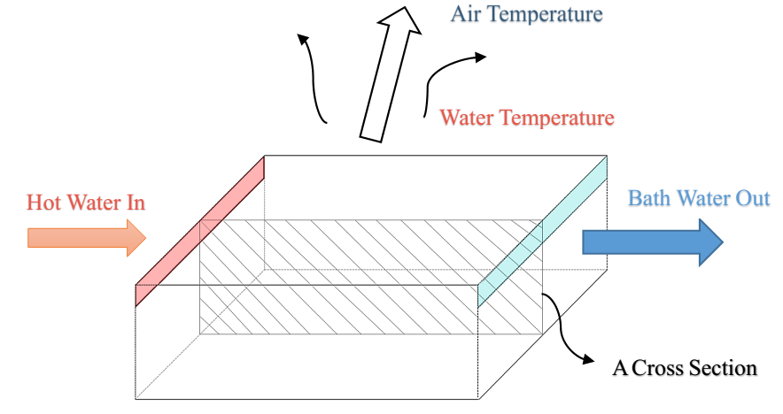

A Cross Section

*Diagram 4.2 The three-dimensional structure*

A three-dimensional diagram is shown in the figure above. The reason why the bath gets noticeably cooler lies in the considerable loss of heat from bath water to ambient air. Therefore, we have to add a constant trickle of hot water to make up for the heat transfer to keep the water temperature almost even over time. With regard to the aspect of space, we assume that water temperature varies in *length* and *heights*, but is irrelevant to *width* (according to symmetry of our bathtub) since heat spreads from left to right and from top to bottom. Hence, water temperature distribution in a tub can be analyzed in a two-dimensional cross section.

## Boundary Conditions

There are three types of boundary conditions commonly encountered in the solution of heat equations.

1. Dirichlet boundary conditions specify the value of the function on a surface.

If the source of heat supply has a property of homoiothermy, in other words, water temperature near the faucet remains constant, the boundary condition can be written as

1. Neumann boundary conditions specify the values that the derivative of a solution on the boundary of the domain.

Assume that the left, right and bottom side of the cuboid bathtub consists of thermal insulation material. Thus, there is no heat exchange in those three surfaces, the boundary equation has the following form.

Considering the portion of heat taken away by excess water through outlets, we regard this situation as the second-type boundary condition, so

Where represents the magnitude of heat flux intensity.

1. Robin boundary conditions specify a linear combination of the values of a function and the values of its derivative on the boundary of the domain.

According to *Newton's law of cooling*, the rate of heat loss of a body is proportional to the difference in temperatures between the body and its surroundings. That is,

Where  represents the environment temperature. It is transformed into

The figure below shows the different boundary conditions of the bathtub.

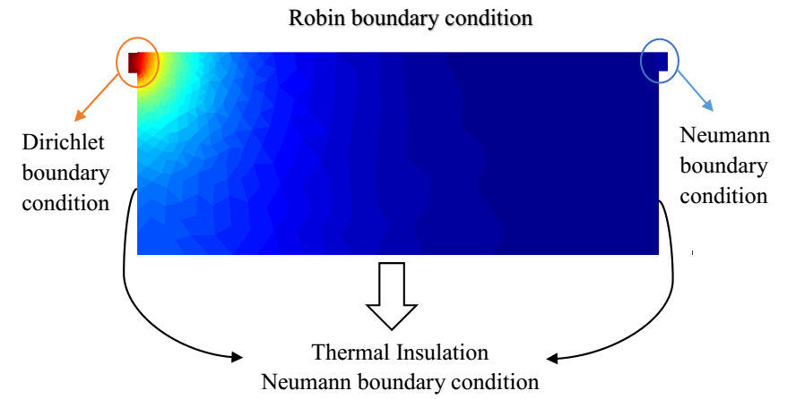

*Diagram 4.3 Illustrations of boundary conditions*

## A Water Cooling Model

Hypothesize that the faucet is shut off, then we explore the process of natural cooling in order to help the following analysis of bath-water temperature distribution in space and time.

*Newton’s Law of Cooling* describes the cooling of a warmer object to the cooler temperature of the environment. The formula is:

Where is the water temperature at a time *t*; is the initial water temperature; is the constant temperature of surroundings. If , , , we can obtain the changing curve of temperature with time.

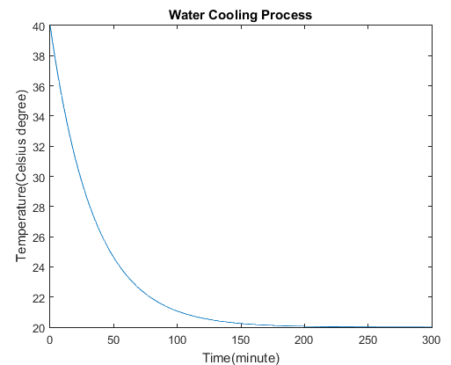

*Figure 4.4 Water Cooling Process*

From the figure above, we can see that bathwater temperature decreases in a negative exponential pattern. Large temperature differences at initial time lead to the steep slope of the changing curve. After about one hour, the bath gets noticeably cool. What’s more, there is nearly no heat exchange in 200 minutes since infinitesimal temperature differences means a state of thermal equilibrium. This is an important element for us to determine the *temperature* and *amount* of hot water constantly poured into the tub, which aims to make it as close as possible to the initial temperature without wasting too much water.

# Model One: The Temperature of the Bathtub Water in Space to Determine the Best Spatial Strategies

## Determine the Best Position of the Hot Water Inlet

### Positions influence water temperature evenness

It is clear that positions of external heat source play an important role in the average temperature and distributional evenness throughout the bathtub.

For example, diagram (*a*) and diagram (*b*) below are remarkably different perceptually. The red bulgy small rectangle represents the inlets of hot water while the blue one on the right side is the overflow drain. If the inlet is placed at the top, a large amount of heat is lost as hot water near the inlet transfers much heat into air at a fast rate. Therefore, heat source from top cannot spread very far and deep. When the inlet is located at the bottom, the upper water prevents heat source from transferring heat into air, so the heat can travel further and bath water temperature in such a situation can be more evenly maintained.

The following calculations can prove it that the magnitude and flatness of bathwater temperature distribution is largely influenced by positions of inlets of hot water. Thus, we need to seek the best position to make users of the bathtub feel more comfortable while taking a bath.

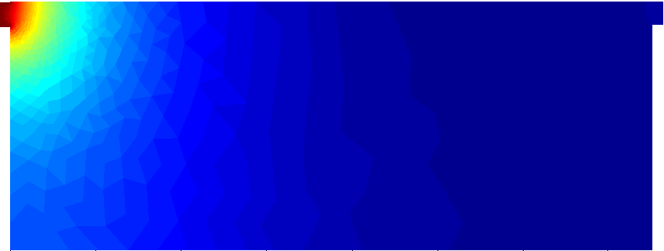

1. *Inlets at the top of the side*

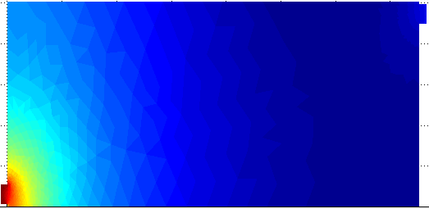

1. *Inlets at the bottom of the side*

The method of changing the place of the water inlet is using a **flexible faucet sleeve** of different length and sizes. In our paper, we choose the left and bottom side as our objects of study. The hot water from the bottom to fill the tub can be achieved by bending the faucet sleeve or through an underground pipe.

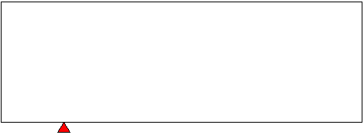

1. (b)

### Samples and Variance to Measure Evenness

We put the cross section of the bathtub in a Cartesian coordinate system. Suppose the length is 1.5m and the height is 0.5m, which are reasonable parameters for an ordinary tub. The diagram is drawn as follows.

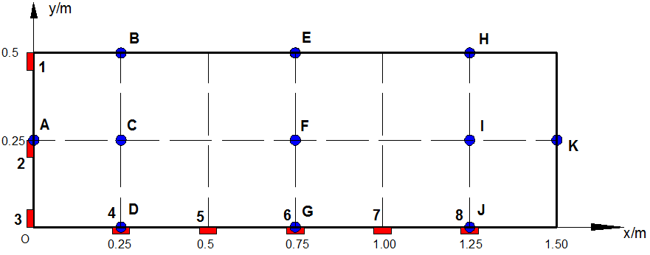

*Diagram 5.1.2 Illustrations of heat source points and monitoring points*

There are eight red small rectangles which stand for inlets of hot water at different positions. We use number sequence to mark those positions. In order to reflect water temperature distribution in the whole bathtub, eleven blue round dots are selected as monitoring points. These points are marked alphabetically.

***How do we measure the maintaining and evenness of water temperature?***

Applying the knowledge of statistics, we determine to use *mean value* and *variance* of sample data to estimate the maintaining and evenness of water temperature. If the mean value of water temperature is closer to the hypothetical initial temperature of , and the variance is as small as possible, then we consider this point as an excellent position. The formula is

### Data Processing and the Best Position

The table below shows the data of temperature with heat source at various situations. And, the second table contains the statistical results.

*Table 5.1.3 Data on Original Temperature*

|  |  |  |  |  |  |  |  |  |
| --- | --- | --- | --- | --- | --- | --- | --- | --- |
| Sample Position | 1 | 2 | 3 | 4 | 5 | 6 | 7 | 8 |
| A | 39.65 | 47.99 | 39.36 | 39.49 | 37.27 | 35.91 | 35.39 | 35.19 |
| B | 38.78 | 38.58 | 36.82 | 37.63 | 36.84 | 35.68 | 35.08 | 34.80 |
| C | 38.03 | 39.03 | 38.04 | 39.38 | 37.94 | 36.27 | 35.55 | 35.28 |
| D | 37.67 | 39.00 | 39.50 | 48.39 | 39.25 | 36.54 | 35.72 | 35.43 |
| E | 35.25 | 35.40 | 35.15 | 35.73 | 36.42 | 36.74 | 36.39 | 35.71 |
| F | 35.74 | 35.76 | 35.60 | 36.47 | 32.05 | 38.21 | 37.43 | 36.22 |
| G | 35.83 | 35.96 | 35.85 | 36.53 | 38.48 | 49.20 | 38.27 | 36.49 |
| H | 34.86 | 34.88 | 34.85 | 34.98 | 35.26 | 35.80 | 36.71 | 37.54 |
| I | 35.28 | 35.29 | 35.26 | 35.42 | 35.70 | 36.42 | 37.74 | 39.06 |
| J | 35.38 | 35.41 | 35.39 | 35.49 | 35.81 | 36.61 | 38.74 | 48.10 |
| K | 35.31 | 35.32 | 35.31 | 35.39 | 35.58 | 36.10 | 37.27 | 39.39 |

*Table 5.1.4 Data on Statistical Calculation*

|  |  |  |  |  |  |  |  |  |
| --- | --- | --- | --- | --- | --- | --- | --- | --- |
| Factors position | 1 | 2 | 3 | 4 | 5 | 6 | 7 | 8 |
| Mean Value | 36.52 | 37.51 | 32.83 | 37.72 | 36.42 | 37.59 | 36.75 | 37.56 |
| Variance | 2.82 | 2.67 | 2.96 | 2.73 | 3.74 | 0.52 | 1.53 | 2.65 |

From the table of results, it is quite obvious that the position of No.6 is the best spot where hot water should be infused. In conclusion, the heat source at *the midpoint of the bottom side* is the best position of hot water inlet.

## A Multi-Objective Programming Model

### Two impact factors

After determining the best position, there are still two important factors that users should consider, the initial temperature of hot water and the width of inlets/diameter of faucet sleeve .

Since the heat loss often cannot be fully compensated, the hot water temperature of inlets has to be slightly higher if a person wants to bath in the perfect temperature as long as possible. Larger value of can increase the mean value but also increase the unevenness of temperature distribution.

Considering that the velocity of flow remains unchanged, the width of inlets decided the rate of heat supply, so the wider inlets lead to the increase of both variance and mean value at the same time. The statistical data is shown as follows.

*Table 5.2.1 Variance and Mean Value with Different and*

|  |  |  |  |
| --- | --- | --- | --- |
| Factors | | Variance | Mean Value |
| Temperature | Width of inlets |
| 45 | 0.03 | 36.63 | 0.25 |
| 0.04 | 36.64 | 0.28 |
| 0.05 | 36.67 | 0.27 |
| 0.06 | 36.70 | 0.28 |
| 47 | 0.03 | 36.95 | 0.36 |
| 0.04 | 36.99 | 0.34 |
| 0.05 | 37.05 | 0.38 |
| 0.06 | 37.07 | 0.41 |
| 50 | 0.03 | 37.42 | 0.55 |
| 0.04 | 37.58 | 0.61 |
| 0.05 | 37.59 | 0.52 |
| 0.06 | 37.66 | 0.65 |
| 52 | 0.03 | 37.97 | 0.61 |
| 0.04 | 37.93 | 0.79 |
| 0.05 | 38.01 | 0.77 |
| 0.06 | 38.06 | 0.83 |
| 55 | 0.03 | 38.41 | 0.86 |
| 0.04 | 38.45 | 0.92 |
| 0.05 | 38.58 | 1.10 |
| 0.06 | 38.65 | 1.18 |

### Variance Affected by the Temperature and Amount of Hot Water

Applying MATLAB Fitting Toolbox, we can get the fitted equation between temperature variance and two factors.

|  |  |  |  |
| --- | --- | --- | --- |
| SSE | R-square | Adjusted R-square | RMSE |
| 0.02425 | 0.9841 | 0.9784 | 0.04162 |

From the table above, we can see that the fitting result is excellent.

### Mean Temperature Affected by the Temperature and Amount of Hot Water

We can also get the fitted equation between mean temperature and two factors.

|  |  |  |  |
| --- | --- | --- | --- |
| SSE | R-square | Adjusted R-square | RMSE |
| 0.02145 | 0.9976 | 0.9968 | 0.03915 |

From the table above, we can see that the fitting result is excellent.

### Build a Multi-Objective Programming Model

Previous analysis shows that we hope to achieve a smaller variance and a higher temperature. Generally, the width of inlet is 0.03~0.06 m, while the hot water temperature varies from 45 to 55. Then, a multi-objective programming model is developed to seek the best solution. The problem can be expressed as

### Apply Genetic Algorithms to Seek the Optimal Solution

Many optimization algorithms can be applied in this case in order to find the optimal solution. Genetic Algorithms are a search heuristic that imitates the process of natural selection. This heuristic is routinely used to generate useful solutions to optimization and search problems.

Applying MATLAB Genetic Algorithm Toolbox, we can get the following arithmetic solutions.

*Table 5.2.5 Some results calculated by genetic algorithm*

|  |  |  |  |  |
| --- | --- | --- | --- | --- |
| Serial Number | Variance | Mean value | Width of inlets |  |
| 1 | 0.268663871 | 36.60448129 | 0.03 | 45.00001002 |
| 2 | 0.260841297 | 36.69199939 | 0.059990464 | 44.99902344 |
| 3 | 0.260841297 | 36.69199939 | 0.059990464 | 44.99902344 |
| 4 | 0.26645269 | 36.63141692 | 0.040293315 | 45.00317004 |
| 5 | 0.267582653 | 36.6168919 | 0.034995437 | 45.00061121 |
| 6 | 0.263362682 | 36.66384608 | 0.051475074 | 44.99969035 |
| 7 | 0.265801262 | 36.6366291 | 0.042357053 | 45.00020536 |
| 8 | 0.268663871 | 36.60448129 | 0.03 | 45.00001002 |
| 9 | 0.264786921 | 36.65104966 | 0.047069827 | 45.0038873 |
| 10 | 0.261962922 | 36.67959307 | 0.056328476 | 44.99946034 |

Having got the results after applying Genetic Algorithm, we should pick up one of them as the final solution. Therefore, we intend to build a simple model for evaluation, by using a method called Principal Component Analysis. We choose variance, mean value and width of inlets as the indicators of the model. As the three indicators interact with each other, it is necessary for us to extract the independent part of each one, which can be met by Principal Component Analysis. Based on this consideration, we choose to apply this method to build a model for evaluation.

All those solutions are very close to another. Considering that the wider inlet result in larger consumption of water, we introduce another factor and re-rank the ten candidate schemes by using *Principal Component Analysis*. At last, the hot water of 45 and width of 0.04m is the best strategy.

## Model on Reflecting the Speed of Water Temperature Change

As data on water temperature of monitoring points is collected, measures should be taken to prove the validity of our previous conclusions. A sequence of data at monitoring point (0.5, 0.25) in an hour is

Where is the temperature of monitoring point (0.5, 0.25) at time , and then we construct a sequence of data to show the speed of water temperature change

Where

Similarly, we can get and , the figure below shows variation trends of these three sequences

*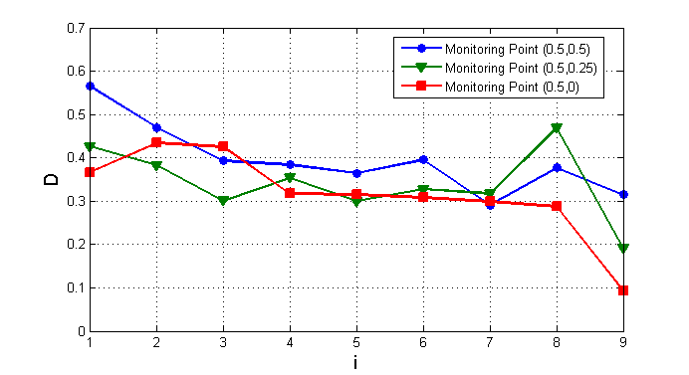Figure5.3 variation trends of three sequences*

Firstly, we can see that the value of is always greater than 0, which means that the temperature keeps decreasing. Secondly, according to the figure, the value of becomes smaller and smaller with time, which means the difference between the previous temperature and the current temperature is decreasing. In other words, the speed of water temperature change is becoming slow. This trend proves that our previous work dose make the water temperature change slower.

## Comparison of Situations Before and After Using Genetic Algorithm

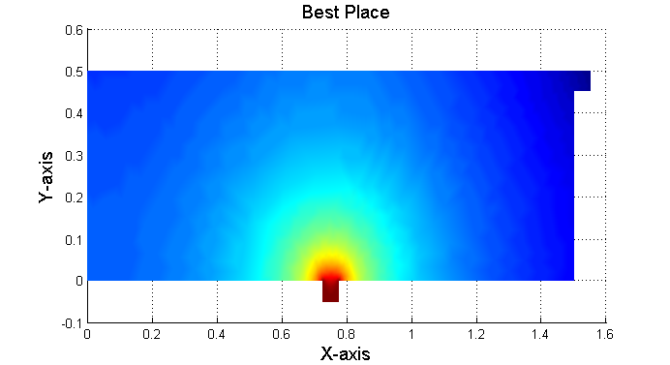

1. *Before*

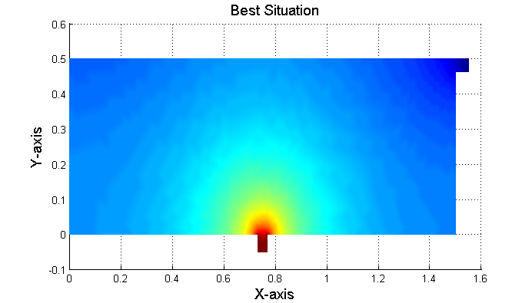

1. *After*

From the diagrams above, we can conclude that the optimization of the width of the inlet and the water temperature from the inlet is effective. The evenness of water temperature in diagram (b) is much better than diagram (a), so we consider our strategy of space useful and feasible.

# Model Two: The Temperature of the Bathtub Water Over Time to Determine the Best Timing Strategy

## Introduction to Our Time Strategy

After determining the best position, width of the inlet and water temperature from the inlet, now we need to develop an appropriate time strategy for users. The strategy for users should be as simple as possible like when to increase the water temperature, instead of asking users to measure the temperature personally and taking measures according to their actual situations. **So we decide to provide them with a simple guide rather than the method of making this guide**.

## Method of Determining Our Time Strategy

Firstly, we shorten the interval into 6 minutes in a bid to understand the changes on temperature distribution better. According to our previous work, the best position of the inlet is at the middle of the bath bottom, the width of the inlet is 0.04 m and the water temperature is . Average Temperature is also achieved by calculating the average of all 9 monitoring points’ temperature. The positions of monitoring points are (0, 0.25), (0.5, 0.5), (0.5, 0.25), (0.5, 0), (1, 0.5), (1, 0.25), (1, 0), (1.5, 0.25). The table below shows average temperature variations.

*Table 6.2 Average Temperature variations in an hour*

|  |  |  |  |
| --- | --- | --- | --- |
| Time (min) | Average Temperature | Time (min) | Average Temperature |
| 6 | 39.54121 | 36 | 37.515 |
| 12 | 39.0613375 | 42 | 37.1245 |
| 18 | 38.656425 | 48 | 36.77975 |
| 24 | 38.269375 | 54 | 36.446375 |
| 30 | 37.88175 | 60 | 36.1855 |

Secondly, we set the critical temperature as , which is also normal body temperature. When the average temperature is lower than critical temperature, users will feel uncomfortable and need to take measures to increase the temperature. So we take 36 min as our recommended time, and this time will shift to an earlier time after considering motions made by users.

*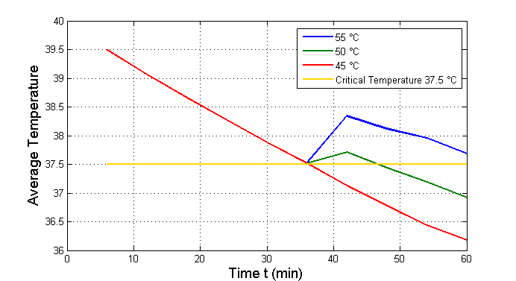*Since the problem on when is solved, the next problem is how. The position and width of the inlet are fixed according to our assumption, so changing water temperature of the inlet is the main way to increase average temperature. However, the temperature cannot be too high in order to avoid scalding skin, so the highest temperature is set as . The figure below shows average temperature changes after changing the water temperature from the inlet.

*Figure6.2 Average temperature after changing water temperature from the inlet*

From the figure, the conclusion that increasing water temperature from the inlet at 36 min does increase average temperature can be drawn. Finally, we set the recommended temperature as 50 after considering both results and safety.

## Summary on Our Time Strategy

According to the work above, our time strategy is that users should increase the water temperature of the inlet from to at about 36 min, and this recommendation can shift to an earlier time after considering motions made by users. So people’s subjective feelings are also important. We will focus on influence of people’s motions later to prove that the recommended time will be even earlier.

# Model Three: The Influence of the Shape and Volume of the Tub

## The Shape of the Tub

### Introduction to How We Choose the Shape that We Need to Consider

There are many kinds of tubs with different shapes in the market. Some of them focus on comfort that consumers can enjoy, others focus on decreasing the cost of the bath or providing convenience. So it is a big and important problem on choosing representative shapes. After doing a market research online, we decide to include three shapes in addition. New shapes are rounded rectangle, semicircle and complex curve, which we think are highly representative.

Subsequently we need to decide their volumes as tubs with different volumes have quite different temperature distributions. According to our previous assumptions, the size of the initial tub is 1.5m0.8m0.5m, so the volumes of new tubs with different shapes should equal to about 0.6.On the other hand, all these tubs are symmetric, so the work is to make sure the areas of their cross-sections are close to each other. Figures below show sizes of three tubs we design, along with their areas. Red dots are positions of inlets.

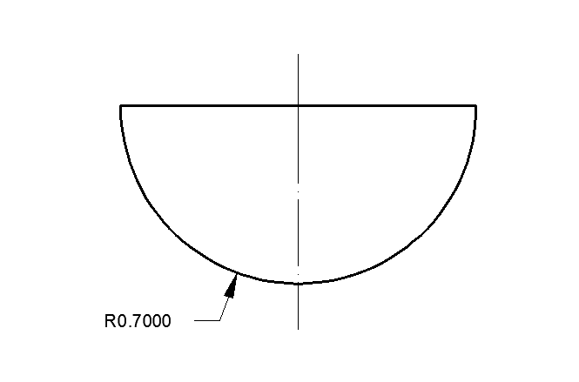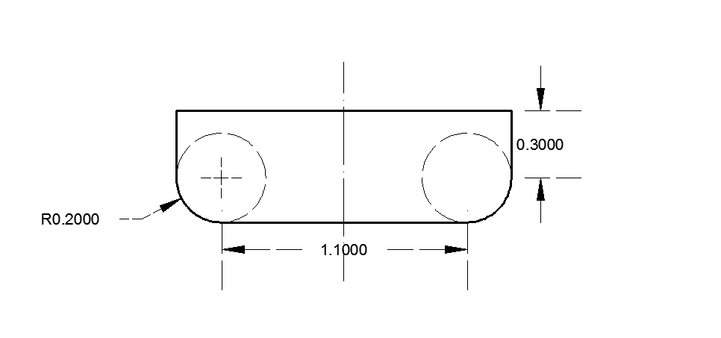

*Rounded Rectangle Semicircle*

*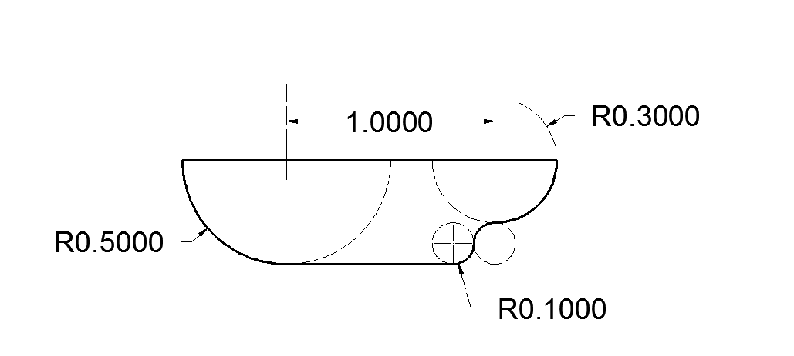*

*Complex Curve*

*Table 7.1.1 Areas of all four bathes*

|  |  |
| --- | --- |
| Shape | Area of Cross-Section () |
| Standard Rectangle | 0.75 |
| Rounded Rectangle | 0.7328 |
| Semicircle | 0.7697 |
| Complex Curve | 0.7548 |

### Conclusion

After calculating temperature distributions of three new bathes above, results are that tubs with complex curve have the largest variances and the lowest average temperature. Besides, all their average temperature is lower than the initial bath slightly. The reason for this result is that irregular surfaces prevent the current from moving in a normal direction. The changes on directions result in complex flow situations and thus causes more heat loss.

## The Volume of the Tubs

Another important factor of tubs is their volumes. Tubs with a great volume tend to hold more water and according to the equation

Where Q is total heat absorbed by water, C is the specific heat capacity of water (which can be considered as a constant here), and is temperature difference. Assuming that the density of water maintains 1000 , the mass of water in larger tub is bigger than in smaller tub, thus water needs to absorb more heat to reach the same temperature.

Table below shows the variances and average temperature of tubs s with different sizes.

|  |  |  |
| --- | --- | --- |
| Size (Length Height) | Average Temperature | Variances |
| 1.3 0.5 | 36.0958 | 0.226656622 |
| 1.5 0.5 | 35.8881 | 0.277819656 |
| 1.7 0.5 | 35.7051 | 0.254007211 |
| 1.5 0.4 | 36.0786 | 0.4572876 |
| 1.5 0.6 | 35.8352 | 0.245347956 |

From the table we can see that increasing the length and height both cause average temperature to decrease. However, this change is not very obvious and the reason that can account for this unobvious change is that all data are collected in t = 1h, further research shows that the speed of changing increases with time.

**Conclusion**

Considering that situations that spending more than an hour taking a bath are quite rare, so here we assume that the size of tub does not have a large impact.

# Model Four: The Influence of the Volume and Condition of Human

## Introduction to the Volume and Condition We Defined

In a bid to simplify our model, we combine the analysis of shape and the analysis of volume as they have similar impacts on the temperature distribution. People with larger volume will push aside more water and the increase of body surface area will lead to absorbing more heat from hot water. However, it is not feasible to build an exact model to describe the variation trend quantitatively and precisely. As a result, we finally do a qualitative analysis by dividing people into three parts according to their shape.

*Table8.1 Data on people of different sizes*

|  |  |  |
| --- | --- | --- |
| Different Shape | Length in Water *l* (m) | Thickness *d* (m) |
| Tall and Thin | 1.44 | 0.144 |
| Normal Size | 1.36 | 0.162 |
| Short and Fat | 1.28 | 0.183 |

**The condition we defined here is mainly used to describe the positions of legs in the water, which will influence the temperature distribution in the tub greatly.** We divide all conditions into three kinds, long sitting, huddling up and lying. Figure below shows these three conditions. Besides, when considering huddling up, we simplify the condition into a rectangle, which is shown by red dashed lines. All precise data that we will use are available on the figure, along with the table above.

*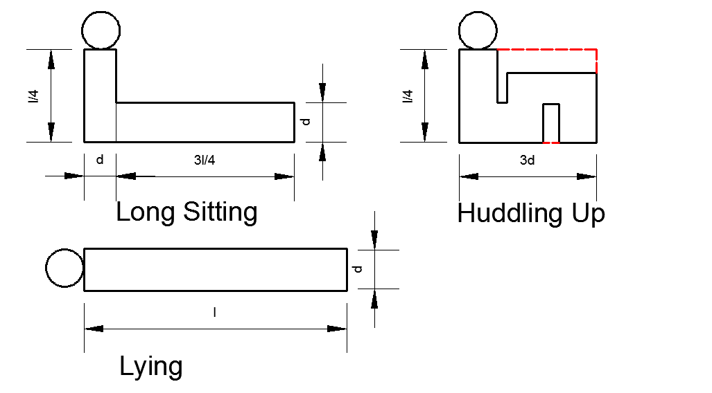Figure 8.1.1 Different Positions of Legs in the Water*

### Determination of New Boundary Conditions

At the process of calculating, we set boundary conditions of the skin as Neuman conditions according to two assumptions. The first one is that subcutaneous fat has an impact of heat isolation. The second one is that the duration time that skin absorbs heat from the water is quite transient, which makes it hard to consider in the whole process of bathing. We will talk on this process later separately, on the part of how skin temperature influences water temperature.

### Conclusion

Figures below show temperature distributions with different conditions that we have defined above. The size of people we used here is the type ‘tall and thin’.

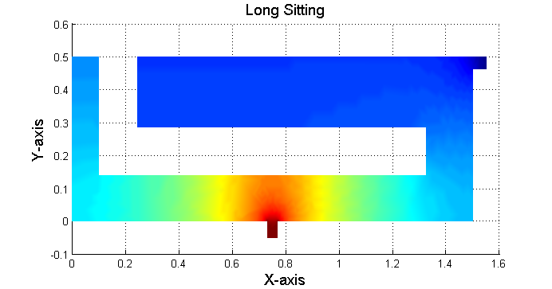

*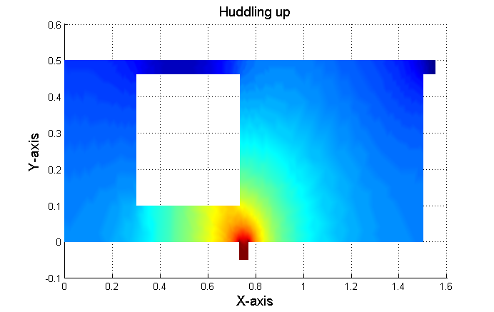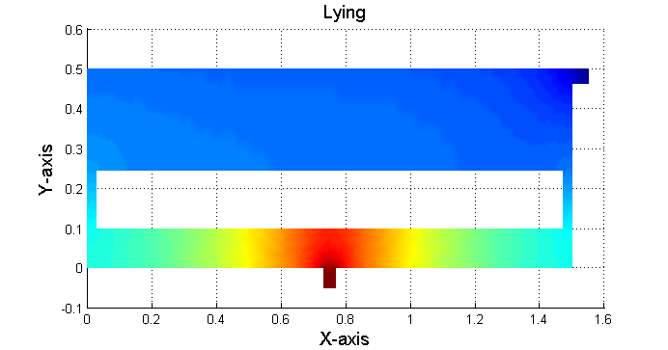*

*Figure8.1.2 Temperature Distributions with different conditions*

From figures above, conclusions that different conditions do influence temperature distributions greatly can be drawn. Based on common sense, body will prevent hot water from moving normally and when water moves to the prevented place through another way, its temperature and speed have already decreased sharply.

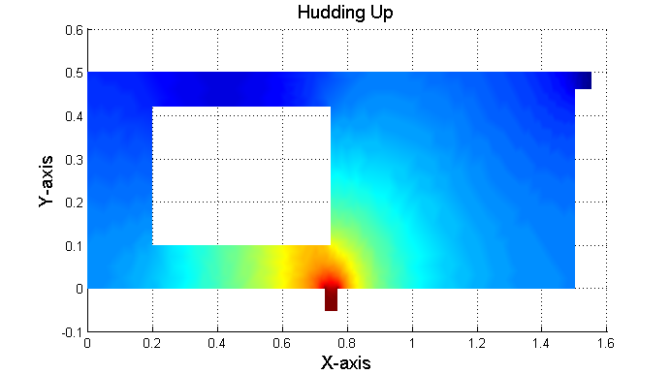As to the influence of size, different from our previous reasoning, changes on temperature are not obvious according to our calculation, partly because the simplification of the bath we make. Figures below show temperature distributions of a tall, thin human and a short, fat human in the same huddling up condition.

*Short and fat human Tall and thin human*

## Effect of Human Body Surface on Water Temperature

### The Effect of Heat Absorption on Human Body Surface when Entering the Water

As we know, human is a kind of homothermal animals, but the temperature of body surface can vary in a large range under different circumstances. That is to say, when we get into the bathtub with hot water, once the temperature of our surface is not consistent to the temperature of water, there will be heat conduction from water to our body surface, till they get to the point with the same temperature.

To figure out the specific relationship between body surface temperature and the effect of heat absorption on it, we should use a formula relating to the amount of heat transfer.

Where stands for the amount of heat transfer and *h* is convective coefficient of human. *A* is the area of heat transfer surface, which means area of body surface here. means temperature difference between two sides of heat transfer surface.

Based on our work above, we still need to give the value of . According to previous surveys, a practical formula has been worked out. That is,

Where *v* is the velocity of water. Considering actual situation, we pick up 0.5 *m/s* as the value of water velocity caused by our motion and as the value of *A*. So,

Besides, we assume that human surface temperatures are , , for summer, autumn, winter. Thus,

Combine these formulas and data, we get the value of finally ( stand for the value of in summer, autumn, winter respectively).

From the results of , we can get that there exists the effect of heat absorption on body surface indeed, whose heat quantity comes from water in the bathtub. This effect will disappear when the temperature of body surface is close to water temperature. Though heat quantity transferred is so small, it affects human body greatly. Furthermore, as we choose the temperature of body surface according to the environmental temperature, the heat conduction between air and the water is greater in cold weather while less in hot weather. As a result, spending a long time bathing in winter is not recommended.

### The Effects of Heat Loss from Body Surface after Leaving Water

It is quite frequent for us to lift our arms during the bath. In this case, we cannot ignore such a situation: the bathing man moves his arms out of water and there must be heat conduction from arms to air. Then, the heat conduction from the skin generates. So, the water temperature cannot maintain the same after several times of such motions.

In order to verify the rationality of this speculation, it is necessary for us to calculate the *heat transfer powe*r when arms are exposed to air.

The formula form of *Fourier’s Law* is

Where *H* is heat transfer power, *k* is thermal conductivity of body skin (generally equals to ), is the temperature difference between skin and air. *l* is the *thickness of heat transfer* (generally equals to 0.03 *m*) and the area of arms is about 18 percent of the whole area.

In this way, the value of *H* can be obtained.

The result verifies previous analysis simply and clearly. Therefore, we should not expose skins to air for too many times, in case that water gets cold in a shorter time.

Besides, considering that human’s motions have effects on the vibration of water, we think that the state of water will turn from *natural convection* into *forced convection*. If so, the heat convective coefficient will increase noticeably. Consequently, the decline of water temperature will be severer. Moving less might be a better choice in a bid to relax for a longer time.

# Model Five: The Influence of Bubble Bath Additive on Water Temperature

## Heat Quantity Absorbed by Hydrolysis Reaction of Bicarbonate Ion

Bubble bath is welcomed by people who have bought a bathtub. Bubble helps us clean dirt of body, it also offers us a magic feeling, which creates a relaxing atmosphere. As a result, it is worth studying the water variation in a bubble bath.

The bubble is usually made from bubble bath additive. Its main component is baking soda, a kind of common chemical substances. Baking soda belongs to strong electrolyte, so it’s redundant to analyze its dissolution process. Then, bicarbonate ions are generated, which has the potential to combine the hydrogen ion. So, the requirements for promoting hydrolysis are fulfilled, and nearly all hydrogen ion in water can combine the hydrogen ion from water, generating carbonic acid. The process can be described as the following chemical equations.

Water-splitting reaction

Hydrolysis reaction of bicarbonate ion

From the second equation, we can get that the hydrolysis reaction of bicarbonate ion is endothermic.

Then we take a kind of commonly used bath salt for instance. The commonly used quantity is about while the relative molecular mass of sodium bicarbonate is . Combine the second equation, we can get the heat quantity absorbed by the equation.

The next step is to determine the variation extent of water temperature caused by *Q*.

The total volume of our bathtub is , considering the volume of human, we select as the volume of water. Use the following formula to calculate the variation of water temperature

Along with

The variation of water temperature can be obtained afterwards.

And

According to the result, It’s obvious that the value of is quite small, which indicates that the water temperature stands nearly still, though hydrolysis reaction of bicarbonate ion absorbs a portion of heat quantity from water, tiny variations of water temperature cannot be perceived by our body. Therefore, we can say that the impact of the generation of bubble on water temperature can be ignored.

## The Influence of Carbon Dioxide on Heat Dissipation of Water

Based on previous analysis, we get that there will be dissolved in the water. But is not stable and it is easy for to decompose into water andcarbon dioxide, which can be described in chemical equation

So, the carbon dioxides generated will cover the surface of the water in the bathtub. That is to say, the carbon dioxides will prevent the water from contacting air. It is equivalent to the decrease of the heat transfer surface of bath water. According to previous formulas, the power of heat conduction is proportional to the area of heat conduction. From this point of view, the heat transfer power will drop. Hence, adding bubble bath additive into the bath water maybe have positive effects on keeping ideal temperature of water for bath, instead of negative effects as we used to think.

# Sensitivity Analysis

## Sensitivity Analysis of Optimum Water Temperature

Our model aims to find the best strategy to maintain the temperature as close as possible to the initial temperature. We assumed that the ideal water temperature is previously. Now we consider that the situation when optimum water temperature is respectively. After applying the three temperatures into our model, three diagrams can be obtained as below.

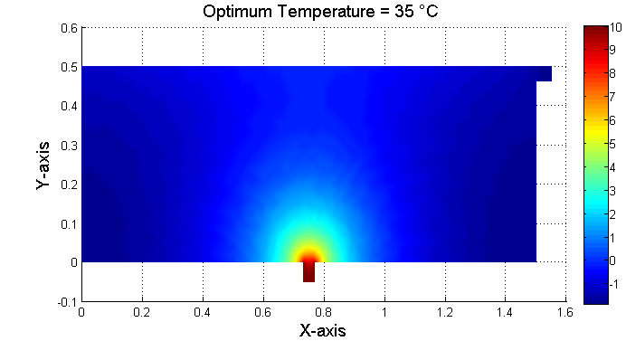

*Diagram 10.1 temperature distribution when optimum temperature is*

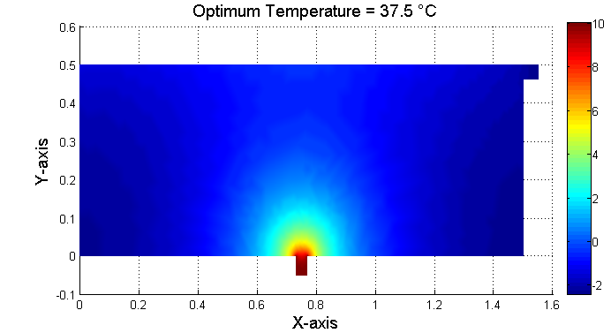

*Diagram 10.2 temperature distribution when optimum temperature is*

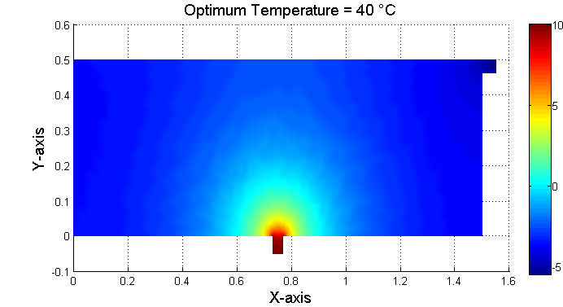

*Diagram 10.3 of temperature distribution when optimum temperature is*

From three diagrams above, even though the color distribution of the three diagram which stand for the temperature distribution seems alike, the similarity is caused by that our processing objects are relative temperature. Hence, if there are two areas with the same color, but not in the same diagram, the actual temperature of them are not equal.

Having made this point clear, we can see the average temperature of each diagram is close to zero, according to the color bar, which means that they are close to the optimum temperature,. In other words, temperature distribution can reflect the optimum temperature significantly. Therefore, we can conclude that our model is very sensitive to the optimum temperature we set.

## Sensitivity Analysis of the Amount of Bubble Bath Additive

When we study the influence of bubble bath additive to water temperature, we took a kind of commonly used bath salt for instance. Based on common sense, we set the amount of bubble bath additive in a bath is 25g. So, the heat quantity absorbed by hydrolysis reaction of bicarbonate ion is just for this specific case.

In order to analyze the sensitivity of the bath salt, we should observe the relationship among those parameters. The amount of bath salt determines the molar mass of the hydrolysis reaction of bicarbonate ion. And the molar mass is proportional to the heat quantity absorbed by hydrolysis reaction of bicarbonate ion. It’s natural for us to speculate the amount of bubble bath additive should be proportional to the heat quantity absorbed.

To verify the speculation, we adjust the amount of bubble bath additive to stand for various conditions. Therefore, we can get a curve that reflects the relationship between the quantity of bath salt and temperature variations.

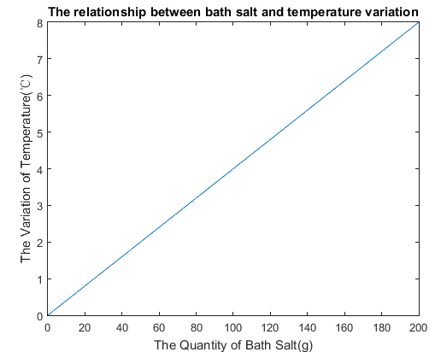

*The relationship between bath salt and temperature variation*

From the diagram, we can verify the speculation that the amount of bubble bath additive should be proportional to the heat quantity absorbed. The form of the concrete relation is. When x rises to the greatest value in the diagram, the value of y is . So such extent of temperature variation can be ignored apparently.

# Model Extension: PID Controller

The model of temperature change over time shows that bathwater will slowly get cooler since the input heat cannot completely make up for the heat loss. If we could precisely increase the temperature of hot water when the temperature average is lower than 37.5, we can maintain the water temperature at a relatively constant value. This principle is just like the working mechanism of a controlling system, which uses the feedback to continually change the amount and temperature of hot water. The most often used controller is PID controller. The basic structure is shown on the next page.



# Strengths and Weakness

**Strengths**

1. Our method of determining the space and time strategy is detailed and extensible.
2. When considering the influence of shapes of the bath, we make a market survey, which makes our work more representative.
3. By taking discrete methods to solve continuous problems, some factors that cannot be solved by continuous methods are figured out.

**Weakness**

1. Our method of determining average temperature is calculating the average of total 11 monitoring points, which is subjective and not comprehensive.
2. To simplify the problem, we use symmetry to ignore temperature distributions on Y-axis, which will decrease the validity of our model.
3. All our data are calculated by theoretical derivation, lacking actual operation.
4. Our model does not take the fact that different parts of human body have different optimum temperature into consideration.

# snow_bkgrnd_b&w.jpgdiamonds_b&w.jpgA Non-Technical Explanation for Users

**USER’S MANUAL FOR OUR BATHTUB**

To all bathtub users,

Taking a hot bath is a good way to cleanse, but also make your body and mind relax. However, are you still upset about the quick cooling bathwater? Do you feel uncomfortable when the water temperature throughout the tub is very uneven? *User’s manual* offers the best strategy for customers and a reasonable explanation.

**The best strategy users can adopt**

* The hot water inlet is suggested to be placed at the center of bottom side (a flexible faucet sleeve or a water pipe)
* Width of inlet: 0.04m; Initial water temperature: 45
* Increase temperature of hot water to 50 for a while in 36 min; bath time should be no longer than 1 hour; shorten time in winter.
* No big difference for tubs of different volumes and bubble bath. But temperature distribution varies according to the shape of tubs.
* Persons’ conditions and behaviors influence temperature greatly; too much movement should be avoided.

**Difficulty in maintaining and evening temperature**

* The wall of bathtub is not completely adiabatic, and the ambient air of lower temperature is difficult to predict.
* The flow and vibration of water caused by motions make our model inaccurate.

Yours sincerely

# References

[1] Hans U. Fuchs. The Dynamics of Heat: A Unified Approach to Thermodynamics and Heat Transfer 2nd ed. BeiJing: World Book Inc. 2014.7.

[2] Si ShouKui, Sun Xijing. Mathematical Modeling. BeiJing: National Defense Industry Press. 2015.7

[3] Wang JiTao. Modern Thermodynamics and a View of Whole Thermodynamics. ShangHai: Fudan Press. 2005.9

[4] Hu ShouSong. Automatic Control Theory. BeiJing: Science Press. 2013.3

[5] Huang HouCheng, Wang QiuLiang. Heat Transfer Finite Element Analysis. BeiJing: Science Press. 2011.5

[6] 10 Health Benefits of Taking a Good Hot Bath

http://www.ba-bamail.com/content.aspx?emailid=14678

[7] Cooling Water

http://jwilson.coe.uga.edu/EMAT6680Fa07/Lowe/Assignment%2012/CoolingWater.html

# Appendix and Supporting data

**15.1 The function of fitting surface**

function f = fun(x)

f = [4.596-45.26\*x(1)-0.1991\*x(2)-1.485\*x(1).^2+1.003\*x(1)\*x(2)+0.00229\*x(2).^2

-12.81-19.56\*x(1)+0.1402\*x(2)+18.48\*x(1).^2+0.4627\*x(1)\*x(2)+0.0002721\*x(2).^2];

end

**15.2 Principal Component Analysis**

function PCA(A)

a = size(A,1);

b = size(A,2);

for i=1:b

SA(:,i) = (A(:,i)-mean(A(:,i)))/std(A(:,i));

end

CM = corrcoef(SA);

[V,D] = eig(CM);

for j=1:b

DS(j,1) = D(b+1-j,b+1-j);

end

for i=1:b

DS(i,2) = DS(i,1)/sum(DS(:,1));

DS(i,3) = sum(DS(1:i,1))/sum(DS(:,1));

end

T = 0.9;

for K=1:b

if DS(K,3) >= T

Com\_num = K;

break;

end

end

for j=1:Com\_num

PV(:,j) = V(:,b+1-j);

end

new\_score = SA\*PV;

for i=1:a

total\_score(i,1) = sum(new\_score(i,:));

total\_score(i,2) = i;

end

result\_report = [new\_score,total\_score];

**15.3 Data on Determining the Best Timing Strategy**

**0.1 0.2 0.3 0.4 0.5 0.6 0.7 0.8 0.9**

**1**

**(0,0.25) -0.5021 -1.034 -1.545 -2.028 -2.483 -2.913 -3.321 -3.709 -4.079 -4.432**

**(0.5,0.5) -0.8429 -1.408 -1.878 -2.271 -2.655 -3.019 -3.414 -3.705 -4.082 -4.397**

**(0.5,0.25)-0.433 -0.8593 -1.242 -1.543 -1.897 -2.197 -2.525 -2.842 -3.311 -3.502**

**(0.5,0) 0.2212 -0.1457 -0.5796 -1.005 -1.322 -1.637 -1.945 -2.244 -2.532 -2.625**

**(1,0.5) -0.8445 -1.409 -1.899 -2.305 -2.744 -3.086 -3.512 -3.876 -4.156 -4.489**

**(1,0.25) -0.4736 -0.8992 -1.1296 -1.585 -2.065 -2.309 -2.795 -3.145 -3.302 -3.463**

**(1,0) -0.291 -0.4241 -0.8894 -1.005 -1.182 -1.645 -1.961 -2.269 -2.57 -2.861**

**(1.5,0.25) -0.5044 -1.05 -1.586 -2.103 -2.598 -3.074 -3.531 -3.972 -4.397 -4.747**