Software Architecture & Design Specification
Bank Management System
Team E11
Meghna Sanjeev PES1UG24CS269
Mrinmayi Raman PES1UG24CS278
Advika Raj PES1UG24CS906
Manasi Vipin PES1UG24CS260

1. Introduction
This document defines the architecture and detailed design needed to implement the Bank Management System described in the SRS. The design uses a simple modular layered structure so the team can implement it without an external database, network service or REST API.

1.1 Design Goals
- Keep implementation simple enough for an academic mini-project.
- Separate user interaction, authentication, business rules and file storage.
- Make each SRS requirement traceable to a small set of modules.
- Provide enough structure for testing without introducing unnecessary frameworks.

2. Architecture

2.1 Architectural Pattern
The system follows a simple layered/modular architecture: Presentation Layer → Service/Business Layer → Persistence Layer. Authentication is a shared service used by employee and customer flows. This is intentionally not a distributed or web architecture.

2.2 Component Diagram
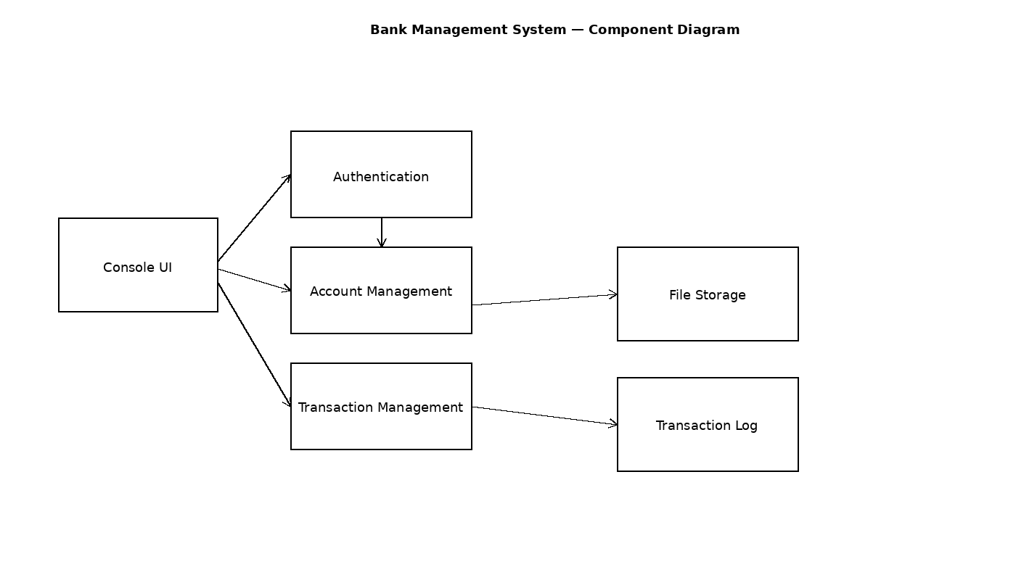
Figure 1. Component-level architecture.

2.3 Component Descriptions
Component | Responsibility
Console UI | Displays menus, reads input, validates basic format and displays results.
Authentication | Checks employee username/password and customer account number/PIN.
Account Management | Creates, searches, updates and closes accounts; generates account numbers.
Transaction Management | Validates deposits/withdrawals, updates balances and creates transaction entries.
File Storage | Reads and writes persistent account records.
Transaction Log | Stores transaction entries used by the mini-statement.

2.4 Data Flow
- User selects an operation from the console.
- Console UI collects input and sends it to the relevant module.
- Authentication verifies access where required.
- Business modules validate the operation and update the in-memory record.
- File Storage persists the changed account/transaction data.
- The result is returned to the console for display.

2.5 Architecture Traceability
Module | Main SRS Requirements
Console UI | FR-1 to FR-12, NFR-2
Authentication | FR-10, FR-11, SEC-1, SEC-2, SEC-3
Account Management | FR-1, FR-2, FR-7, FR-8, FR-9
Transaction Management | FR-3, FR-4, FR-5, FR-6, SEC-4
File Storage / Transaction Log | FR-13, NFR-3, NFR-6

3. Security Architecture
Security is implemented through simple access-control checks rather than a complex security framework.
Control | Design
Employee access | Employee login is checked before administrative menu operations.
Customer access | Account number + PIN is checked before self-service operations.
Failed authentication | The requested operation is not executed and an error is displayed.
Transaction validation | Only positive amounts are accepted; withdrawal balance is checked before update.
Scope limitation | The system is an academic local simulation and does not claim production banking security.

4. Detailed Design

4.1 Data Structures
Structure | Suggested Fields
Account | accountNumber, name, address, contactNumber, pin, balance, status
Transaction | transactionId, accountNumber, type, amount, date/time
Employee | username, password
These are suggested simple structures, not a commitment to a particular file format. The implementation team may use C structs or C++ classes.

4.2 API Design — Internal Module Interfaces
Because the project is a console application, 'API Design' refers to internal function/module interfaces rather than REST or web APIs.
Module | Suggested Function Interface | Purpose
Authentication | loginEmployee(); authenticateCustomer(accountNo, pin) | Return success/failure for access checks.
Account Management | createAccount(); searchAccount(accountNo); updateAccount(); closeAccount(accountNo) | Perform employee account operations.
Transactions | deposit(accountNo, amount); withdraw(accountNo, amount); getBalance(accountNo); getMiniStatement(accountNo) | Perform customer transactions.
Persistence | loadAccounts(); saveAccount(account); saveTransaction(txn); | Read/write local files.
Function names are illustrative and may be changed during implementation; the important design constraint is the separation of responsibilities.

4.3 Sequence Diagram — Employee Creates Account
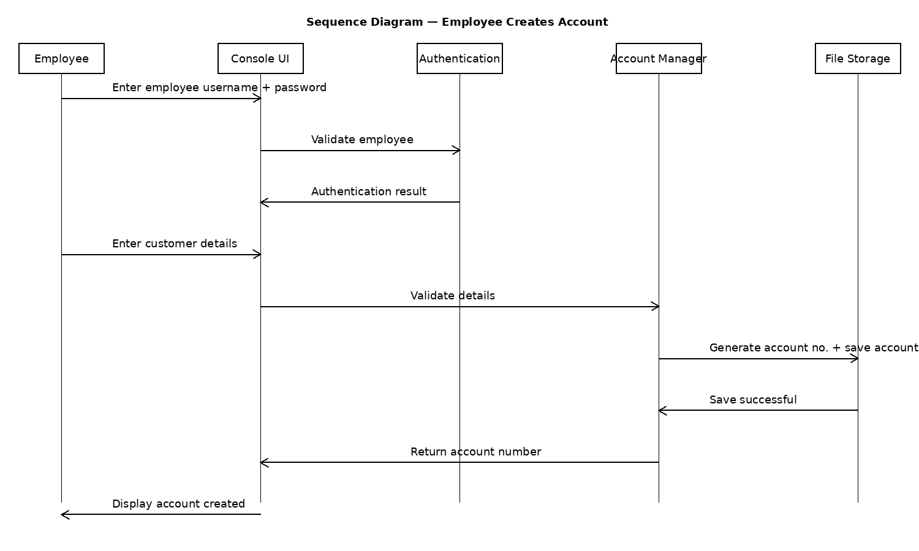
Figure 2. Account creation sequence.

4.4 Sequence Diagram — Customer Deposit
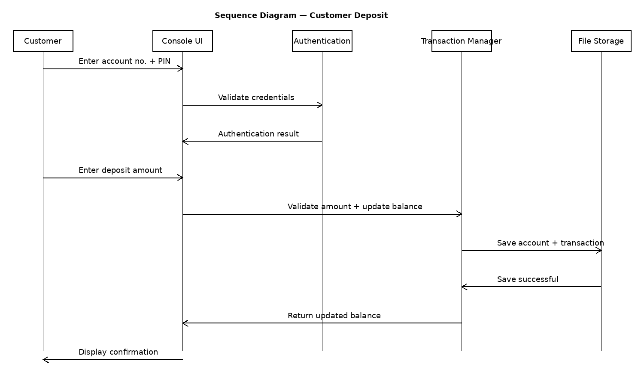
Figure 3. Deposit sequence.

5. Error Handling
Error | Handling
Invalid login | Display authentication error; return to login/menu.
Invalid account number | Display account-not-found message; do not modify data.
Duplicate account data | Reject creation and display an appropriate message.
Invalid/negative/zero amount | Reject operation; balance remains unchanged.
Insufficient balance | Reject withdrawal; display insufficient-balance message.
File read/write failure | Display storage error and do not report the operation as successful.
Invalid menu choice | Display a simple error and request another choice.

6. Design Constraints and Deliberate Scope
To keep the implementation achievable, the design does not include a database server, REST API, GUI framework, network communication, encryption infrastructure, concurrency control, real payment processing or production-grade banking compliance.

7. Design-to-Requirement Traceability
Requirement Group | Design Element | Verification
FR-1, FR-2 | Account Management + File Storage | TC-01
FR-3, FR-4, FR-5, FR-6 | Transaction Management + Transaction Log | TC-03 to TC-08
FR-7, FR-8, FR-9 | Account Management | TC-09 to TC-11
FR-10, FR-11, SEC-1 to SEC-3 | Authentication | TC-12, TC-13
FR-12, SEC-4 | Validation + Error Handling | TC-04, TC-06, TC-14
FR-13, NFR-6 | File Storage | TC-15
NFR-1, NFR-2 | Console UI + local modules | TC-16, TC-17
NFR-4, NFR-5 | Modular code + compiler | TC-18

8. Implementation Plan
- Create Account and Transaction structures/classes.
- Implement file load/save functions.
- Implement employee and customer authentication.
- Implement employee account operations.
- Implement customer transaction operations.
- Connect all modules through the console menus.
- Run the test cases and fix only defects within the stated scope.

