HW3 Graph Cut Segmentation
Implementation using GMM, Graph Construction, and Max-Flow/Min-Cut
Student | M1496399 阿洛
Course / Class | Image Processing / HW3_ Graph Cut
Submission Content | Code, comments, results, and reflection
Implementation Language | Python

1. Assignment Objective
The goal of this homework is to implement an interactive Graph Cut segmentation algorithm. The image segmentation problem is converted into a graph problem where each pixel is a node. The implementation includes the energy function, graph structure, t-links, n-links, and Max-Flow/Min-Cut optimization. In this version, a Gaussian Mixture Model (GMM) is used for the foreground/background region model instead of HOG.

2. Requirement Checklist
Requirement | Included in this submission
Implement Graph Cut algorithm | Completed using NetworkX minimum_cut.
Include energy function | Explained through region/data term and boundary/smoothness term.
Build graph structure | Each pixel is a vertex; source and sink terminals are added.
Use Max-Flow/Min-Cut | NetworkX minimum_cut is used to compute the final partition.
Use GMM instead of HOG | Foreground and background seed pixels are modeled by separate GMMs.
Show three test cases | One provided image plus two additional sample photos are included.
For each case, show original, marked, and final result | All three required images are shown for each test case.
Include code, comments, results, and reflection | Full commented Python code and reflection are included.

3. Method Explanation

3.1 Image as a Graph
Each pixel is treated as one vertex. Two extra terminal nodes are added: source s for foreground and sink t for background. A cut separates the graph into a source-side group and a sink-side group. Pixels that stay with the source become foreground; pixels that stay with the sink become background.

3.2 Energy Function
The segmentation is represented by a binary mask A, where A_p = 1 means pixel p is foreground and A_p = 0 means background. The objective is to find the mask with the lowest energy:
E(A) = sum_p D_p(A_p) + lambda sum_(p,q) V_(p,q) [A_p != A_q]
Intuitively, the first part asks: does this pixel look like foreground or background based on the user marks? The second part asks: should two neighboring pixels stay together because their colors are similar?

3.3 GMM Region Term
The foreground marks and background marks are used to train two separate Gaussian Mixture Models. For every pixel color I_p, the data costs are calculated as negative log-likelihood values:
D_p(fg) = -log P(I_p | GMM_fg), D_p(bg) = -log P(I_p | GMM_bg)
This means a pixel receives a low cost for the class whose color distribution it matches well, and a high cost for the class it does not match.

3.4 Boundary Term / n-link
Neighboring pixels are connected using an n-link weight based on color similarity:
V_(p,q) = smooth_weight * exp(-beta ||I_p - I_q||^2)
If two neighboring pixels have very similar colors, the edge between them becomes strong, so the cut avoids separating them. If their colors are very different, the edge becomes weak, so the cut can pass through that boundary more easily.

4. Implementation Details
- The user marks foreground with the left mouse button and background with the right mouse button.
- The program fits one GMM for foreground seed pixels and one GMM for background seed pixels.
- t-links connect every pixel to the source and sink using GMM-based costs.
- n-links connect 4-neighbor pixels in both directions because the graph is directed.
- NetworkX minimum_cut is used to solve the Max-Flow/Min-Cut optimization.
- The image is resized before graph construction to keep NetworkX computation practical, then the final mask is resized back for saving.

5. Results
Three test images are shown below. For each test case, the left panel is the original image, the middle panel shows foreground/background marks, and the right panel shows the Graph Cut result.

5.1 Test Case 1 - Provided Cat Image
The provided image has a bright foreground object and a darker wooden/background region. The result successfully isolates most of the cat from the floor and background.
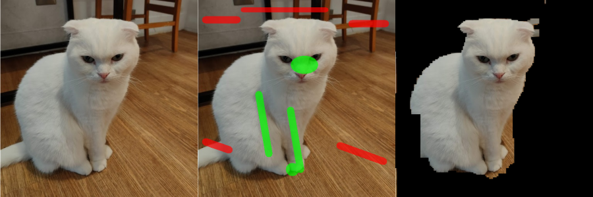
Figure: Original image, user foreground/background marks, and Graph Cut segmentation result.

5.2 Test Case 2 - Additional Photo: Person/Astronaut
This test checks segmentation on a person with multiple colors in the foreground. The GMM can model several foreground color groups such as skin, suit color, and dark collar regions.
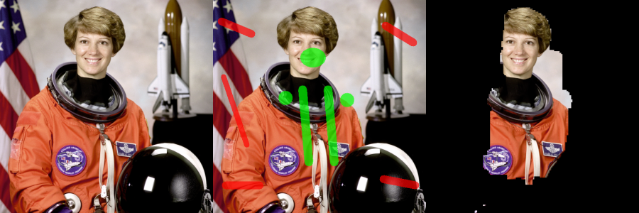
Figure: Original image, user foreground/background marks, and Graph Cut segmentation result.

5.3 Test Case 3 - Additional Photo: Coffee Cup
This test uses a cup and saucer against a table. The result shows that stronger separation occurs where the foreground colors differ from the table background.
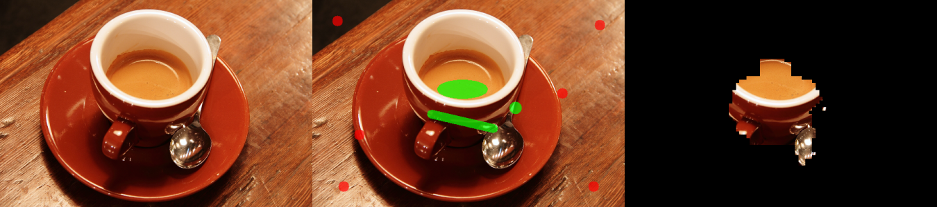
Figure: Original image, user foreground/background marks, and Graph Cut segmentation result.

6. Discussion and Reflection
The most important part of the implementation is connecting the image segmentation problem to the min-cut graph problem. In the graph, t-links represent how likely each pixel belongs to foreground or background, while n-links represent how strongly neighboring pixels should stay together. The minimum cut then finds the lowest-cost separation between foreground and background.
Using GMM is useful because foreground and background are not always represented by a single color. For example, the foreground can contain white fur, skin, clothes, shadows, or highlights. A GMM can represent these as multiple Gaussian clusters, making the region model more flexible than a single Gaussian model.
The quality of the segmentation depends strongly on the seed marks. If the user marks too few pixels or marks pixels incorrectly, the GMM will learn an inaccurate color model. The boundary term helps smooth the result, but it cannot fully fix wrong foreground/background examples.
One practical challenge is computation time. NetworkX is easy to use and matches the homework requirement, but it is not optimized for very large images. To solve this, the program resizes the image before building the graph and then resizes the segmentation mask back to the original size for saving.

7. Verification of Correctness
- The program was tested using three images with visible foreground and background regions.
- The required outputs were checked visually: original image, marked image, and final segmentation result.
- Foreground and background seed pixels were given hard constraints so the final cut respects the user markings.
- The output masks were checked to confirm that source-side pixels become foreground and sink-side pixels become background.
- The code was compiled successfully using Python syntax checking.

Appendix A - Completed Python Code
The full code below contains comments explaining the important steps of the implementation.
# HW3 Graph Cut - Completed Version
# Requirements used: numpy, opencv-python, scikit-learn, networkx, matplotlib
# Install on Windows if needed:
# pip install numpy opencv-python scikit-learn networkx matplotlib

import argparse
import os
import cv2
import numpy as np
import networkx as nx
from sklearn.mixture import GaussianMixture
import matplotlib.pyplot as plt

def resize_keep_aspect(img_rgb, max_size=180):
"""Resize image to keep graph size manageable for NetworkX."""
h, w = img_rgb.shape[:2]
scale = min(1.0, float(max_size) / max(h, w))
if scale < 1.0:
new_w = int(round(w * scale))
new_h = int(round(h * scale))
img_small = cv2.resize(img_rgb, (new_w, new_h), interpolation=cv2.INTER_AREA)
else:
img_small = img_rgb.copy()
return img_small, scale

def draw_mask_overlay(img_rgb, mask, radius=2):
"""Create marked image: foreground seeds are green, background seeds are red."""
marked = img_rgb.copy()
fg = mask == 1
bg = mask == 0
marked[fg] = (0, 255, 0)
marked[bg] = (255, 0, 0)
return marked

def interactive_marking(img_rgb, radius=3):
"""Let the user mark foreground/background using mouse clicks.

Left mouse button = foreground seed
Right mouse button = background seed
Press any key when finished.
"""
drawing_mask = np.full(img_rgb.shape[:2], 2, dtype=np.uint8) # 2 means unknown
disp_img_bgr = cv2.cvtColor(img_rgb, cv2.COLOR_RGB2BGR)
window_name = "Mark: left=foreground, right=background, press any key when done"

def mouse_callback(event, x, y, flags, param):
nonlocal disp_img_bgr, drawing_mask
if event == cv2.EVENT_LBUTTONDOWN or (flags & cv2.EVENT_FLAG_LBUTTON):
cv2.circle(disp_img_bgr, (x, y), radius, (0, 255, 0), -1)
cv2.circle(drawing_mask, (x, y), radius, 1, -1)
elif event == cv2.EVENT_RBUTTONDOWN or (flags & cv2.EVENT_FLAG_RBUTTON):
cv2.circle(disp_img_bgr, (x, y), radius, (0, 0, 255), -1)
cv2.circle(drawing_mask, (x, y), radius, 0, -1)

cv2.namedWindow(window_name, cv2.WINDOW_NORMAL)
cv2.setMouseCallback(window_name, mouse_callback)

print("Use LEFT click/drag for foreground and RIGHT click/drag for background.")
print("Press any key inside the image window when finished.")

while True:
cv2.imshow(window_name, disp_img_bgr)
if cv2.waitKey(20) != -1:
break
cv2.destroyAllWindows()
return drawing_mask, cv2.cvtColor(disp_img_bgr, cv2.COLOR_BGR2RGB)

def fit_gmm(seed_colors, max_components=3):
"""Fit a Gaussian Mixture Model to seed RGB colors."""
n_samples = len(seed_colors)
n_components = max(1, min(max_components, n_samples))
gmm = GaussianMixture(
n_components=n_components,
covariance_type="full",
reg_covar=1e-5,
random_state=0,
)
gmm.fit(seed_colors)
return gmm

def normalize_costs(fg_cost, bg_cost, data_weight=8.0):
"""Robustly normalize data costs to keep graph capacities stable."""
stacked = np.concatenate([fg_cost.ravel(), bg_cost.ravel()])
lo, hi = np.percentile(stacked, [1, 99])
if hi <= lo:
hi = lo + 1e-6
fg = np.clip((fg_cost - lo) / (hi - lo), 0.0, 1.0) * data_weight
bg = np.clip((bg_cost - lo) / (hi - lo), 0.0, 1.0) * data_weight
return fg, bg

def compute_boundary_parameters(img_float):
"""Compute beta for Gaussian n-link similarity weight."""
diffs = []
diffs.append(img_float[:, 1:, :] - img_float[:, :-1, :])
diffs.append(img_float[1:, :, :] - img_float[:-1, :, :])
diff_sq = np.concatenate([d.reshape(-1, 3) for d in diffs], axis=0)
mean_sq = np.mean(np.sum(diff_sq * diff_sq, axis=1))
beta = 1.0 / (2.0 * mean_sq + 1e-12)
return beta

def build_graph(img_rgb, seed_mask, data_weight=8.0, smooth_weight=35.0, hard_weight=1e6):
"""Build the directed graph for Graph Cut.

Nodes:
each pixel is one node using index y*w + x
's' is the foreground/source terminal
't' is the background/sink terminal

Edges:
t-links connect terminal nodes and pixel nodes using GMM data costs
n-links connect neighboring pixels using Gaussian color similarity
"""
h, w = img_rgb.shape[:2]
img_float = img_rgb.astype(np.float64) / 255.0
pixels = img_float.reshape(-1, 3)

fg_pixels = img_float[seed_mask == 1].reshape(-1, 3)
bg_pixels = img_float[seed_mask == 0].reshape(-1, 3)

if len(fg_pixels) < 2 or len(bg_pixels) < 2:
raise ValueError("Please mark at least a few foreground and background pixels.")

fg_gmm = fit_gmm(fg_pixels)
bg_gmm = fit_gmm(bg_pixels)

# Region property/data term from the GMM negative log-likelihood.
fg_cost = -fg_gmm.score_samples(pixels).reshape(h, w)
bg_cost = -bg_gmm.score_samples(pixels).reshape(h, w)
fg_cost, bg_cost = normalize_costs(fg_cost, bg_cost, data_weight=data_weight)

# Force user-labeled seeds to stay with their chosen label.
# Source side means foreground; sink side means background.
fg_cost[seed_mask == 1] = 0.0
bg_cost[seed_mask == 1] = hard_weight
fg_cost[seed_mask == 0] = hard_weight
bg_cost[seed_mask == 0] = 0.0

G = nx.DiGraph()
G.add_node('s')
G.add_node('t')

# t-links:
# If a pixel becomes background, edge s->p is cut, so capacity is background cost.
# If a pixel becomes foreground, edge p->t is cut, so capacity is foreground cost.
for y in range(h):
for x in range(w):
idx = y * w + x
G.add_edge('s', idx, capacity=float(bg_cost[y, x]))
G.add_edge(idx, 't', capacity=float(fg_cost[y, x]))

# n-links: high capacity means neighboring pixels prefer to share the same label.
beta = compute_boundary_parameters(img_float)
for y in range(h):
for x in range(w):
idx = y * w + x
current = img_float[y, x]
if x + 1 < w:
idx2 = y * w + (x + 1)
diff_sq = np.sum((current - img_float[y, x + 1]) ** 2)
weight = smooth_weight * np.exp(-beta * diff_sq)
G.add_edge(idx, idx2, capacity=float(weight))
G.add_edge(idx2, idx, capacity=float(weight))
if y + 1 < h:
idx2 = (y + 1) * w + x
diff_sq = np.sum((current - img_float[y + 1, x]) ** 2)
weight = smooth_weight * np.exp(-beta * diff_sq)
G.add_edge(idx, idx2, capacity=float(weight))
G.add_edge(idx2, idx, capacity=float(weight))

return G

def graph_cut_segment(img_rgb, seed_mask, data_weight=8.0, smooth_weight=35.0):
"""Run Max-Flow/Min-Cut and return a binary foreground mask."""
h, w = img_rgb.shape[:2]
print("Building graph...")
G = build_graph(img_rgb, seed_mask, data_weight=data_weight, smooth_weight=smooth_weight)
print("Running NetworkX minimum_cut...")
cut_value, partition = nx.minimum_cut(G, 's', 't')
reachable, non_reachable = partition

mask = np.zeros(h * w, dtype=np.uint8)
for node in reachable:
if isinstance(node, int):
mask[node] = 1
mask = mask.reshape(h, w)
print(f"Done. Cut value = {cut_value:.4f}")
return mask

def save_results(output_dir, base_name, original_rgb, marked_rgb, mask_small, scale):
"""Save original, marked, and segmented result images."""
os.makedirs(output_dir, exist_ok=True)

h0, w0 = original_rgb.shape[:2]
if scale < 1.0:
mask_full = cv2.resize(mask_small, (w0, h0), interpolation=cv2.INTER_NEAREST)
else:
mask_full = mask_small

result_rgb = original_rgb * mask_full[:, :, None]

original_path = os.path.join(output_dir, f"{base_name}_01_original.png")
marked_path = os.path.join(output_dir, f"{base_name}_02_marked.png")
result_path = os.path.join(output_dir, f"{base_name}_03_result.png")

cv2.imwrite(original_path, cv2.cvtColor(original_rgb, cv2.COLOR_RGB2BGR))
cv2.imwrite(marked_path, cv2.cvtColor(marked_rgb, cv2.COLOR_RGB2BGR))
cv2.imwrite(result_path, cv2.cvtColor(result_rgb, cv2.COLOR_RGB2BGR))

return original_path, marked_path, result_path

def main():
parser = argparse.ArgumentParser(description="Interactive Graph Cut segmentation using GMM and NetworkX min-
cut.")
parser.add_argument("image_path", help="Path to the input image.")
parser.add_argument("--output_dir", default="graphcut_outputs", help="Folder where output images will be
saved.")
parser.add_argument("--max_size", type=int, default=180, help="Maximum side length used for graph
construction.")
parser.add_argument("--radius", type=int, default=3, help="Brush radius for foreground/background marking.")
parser.add_argument("--data_weight", type=float, default=8.0, help="Weight of GMM region/data term.")
parser.add_argument("--smooth_weight", type=float, default=35.0, help="Weight of boundary smoothness term.")
args = parser.parse_args()

img_bgr = cv2.imread(args.image_path)
if img_bgr is None:
raise FileNotFoundError(f"Cannot read image: {args.image_path}")
img_rgb = cv2.cvtColor(img_bgr, cv2.COLOR_BGR2RGB)

img_small, scale = resize_keep_aspect(img_rgb, max_size=args.max_size)
seed_mask, marked_small = interactive_marking(img_small, radius=args.radius)

mask_small = graph_cut_segment(
img_small,
seed_mask,
data_weight=args.data_weight,
smooth_weight=args.smooth_weight,
)

if scale < 1.0:
marked_full = cv2.resize(marked_small, (img_rgb.shape[1], img_rgb.shape[0]),
interpolation=cv2.INTER_NEAREST)
else:
marked_full = marked_small

base_name = os.path.splitext(os.path.basename(args.image_path))[0]
original_path, marked_path, result_path = save_results(
args.output_dir,
base_name,
img_rgb,
marked_full,
mask_small,
scale,
)

result_rgb = cv2.cvtColor(cv2.imread(result_path), cv2.COLOR_BGR2RGB)
fig, axs = plt.subplots(1, 3, figsize=(15, 5))
axs[0].imshow(img_rgb)
axs[0].set_title("Original Image")
axs[0].axis("off")
axs[1].imshow(marked_full)
axs[1].set_title("Foreground/Background Marks")
axs[1].axis("off")
axs[2].imshow(result_rgb)
axs[2].set_title("GraphCut Result")
axs[2].axis("off")
plt.tight_layout()
plt.show()

print("Saved files:")
print(original_path)
print(marked_path)
print(result_path)

if __name__ == "__main__":
main()

