Semantic Cues, Rather Than Scores, Drive LLM-Simulated ADHD-like Participants
A Human-Benchmark, Cue-Contribution, and Individual-Prediction Study

Wei Zhang¹, Songjie Tian², Chenguang Zhao¹, and Yangjing Long²*
¹ School of Psychology, Central China Normal University, Wuhan 430079, China
² School of Mathematics and Statistics, Central China Normal University, Wuhan 430079, China

Author Note
Correspondence concerning this article should be addressed to Yangjing Long, School of Mathematics and Statistics, Central China Normal University, Wuhan 430079, China. Email: yangjing@ccnu.edu.cn
Author emails: psyzhwccnu@126.com; tiansongjie@foxmail.com; yangjing@ccnu.edu.cn; 1136702339@qq.com
Suggested article type: General Article

Abstract
Large language models (LLMs) are increasingly used as simulated participants, but their psychological plausibility may reflect stereotypes rather than valid behavioral prediction. We evaluated this risk using ADHD-related traits in young adults (questionnaire N = 2,016; task subsample N = 157). Human data showed robust associations between ADHD-related traits and problematic digital-use measures. Task behavior, however, was heterogeneous: CPT-defined I/C participants showed near-zero Stroop differences, modestly lower n-back accuracy, and lower, not higher, BART adjusted pumps. By contrast, five LLM families generated coherent ADHD-like profiles characterized by poorer executive-function performance, higher risk-taking, and stronger immediate-reward preference. Cue-contribution analyses showed that labels and symptom descriptions, rather than anonymized numeric scores, drove these outputs. Individual-level LLM predictions did not outperform statistical baselines. A secondary problematic digital-use generalization check showed similar cue dominance and effect-size inflation in reward-risk predictions. These findings indicate that LLM-simulated clinical or behavioral profiles require human benchmarks and cue-sensitivity audits before they are used as substitutes for participants.
Keywords: large language models; simulated participants; ADHD-related traits; problematic digital use; clinical stereotypes; cue-contribution analysis; predictive validity

Introduction
Large language models have entered the scientific workflow not only as writing or coding assistants, but also as candidate simulated participants in behavioral and psychological research. This use is attractive because models can rapidly generate responses across conditions, profiles, and hypothetical experiments. Yet a central validity question remains unresolved: when an LLM produces a response that appears psychologically plausible, is it recovering empirical human behavior or reproducing familiar stereotypes embedded in language data?
ADHD-related traits provide a stringent test case. ADHD is commonly associated with attention problems, executive dysfunction, inhibitory-control difficulties, impulsivity, reward sensitivity, and delay aversion. These associations are psychologically meaningful, but they can also become overgeneralized stereotypes. Real task behavior is often heterogeneous: ADHD-related traits may relate strongly to one task, weakly to another, or in unexpected directions depending on sample, task parameters, comorbid traits, and measurement reliability. ADHD-like simulation therefore allows us to test whether LLMs produce task-specific behavioral predictions or a simplified template, such as "ADHD means worse executive function and higher risk-taking."
ADHD theory and measurement further motivate this design. Meta-analytic evidence indicates that executive-function weaknesses are reliably associated with ADHD, but are not universal across individuals and are insufficient to characterize ADHD-related behavior on their own (Willcutt et al., 2005). Dual-pathway and delay-aversion accounts similarly distinguish executive-control and motivational or reward-processing routes, emphasizing heterogeneity rather than a single impairment profile (Sonuga-Barke, 2003; Jackson et al., 2016; Kofler et al., 2019). This theoretical background motivated our inclusion of cold executive-function tasks (Stroop and n-back) and reward or choice tasks (BART and delay discounting).
This heterogeneity is especially important for interpreting the BART. The BART was introduced as a behavioral measure of risk taking (Lejuez et al., 2002) and has been used to examine risk taking and punishment sensitivity in ADHD-related samples (Humphreys et al., 2011). However, BART performance reflects a mixture of reward sensitivity, punishment sensitivity, learning, and strategy adjustment, rather than a one-dimensional measure of impulsivity. A direct mapping from ADHD-like labels to higher BART risk taking is therefore plausible as a stereotype, but not guaranteed as an empirical prediction.
ADHD-related traits also co-occur with problematic digital-use symptoms. Reviews of Internet addiction and problematic Internet use, together with meta-analytic evidence on problematic Internet use and ADHD-related symptoms, support the value of combining attention-related and digital-use measures (Kuss & Lopez-Fernandez, 2016; Augner et al., 2023). At the same time, continuous performance tests and self-report rating scales should not be treated as stand-alone clinical diagnoses. Recent systematic reviews caution that CPTs have limited diagnostic utility when used in isolation, and studies of CAARS highlight limitations of self-report scales as diagnostic instruments (Harrison et al., 2019; Callan et al., 2024; Varela et al., 2024). Accordingly, throughout this manuscript we refer to ADHD-related traits, CPT-defined attention profiles, and ADHD-like simulated profiles rather than clinically diagnosed ADHD patients.
Recent work has generated both optimism and caution about LLM-simulated participants. Early studies introduced language-model Turing Experiments and silicon samples as ways to simulate human-subject experiments or population subgroups (Aher et al., 2023; Argyle et al., 2023), and related work examined LLMs as economic or social-science agents (Horton, 2023). A large-scale replication study in Nature Computational Science found that LLMs could often recover main effects in scenario-based psychology and management studies, but also tended to amplify effect sizes and performed less well on socially sensitive topics (Cui et al., 2025). In parallel, Centaur was proposed as a foundation model for predicting and simulating human cognition from natural-language experiment descriptions (Binz et al., 2025).
At the same time, recent critiques warn against treating LLM outputs as substitutes for human behavior. Dillion et al. (2023) emphasized caveats in using AI as participants in psychological science, and Lin (2025) identified interpretive fallacies that undermine the replacement perspective. Empirical studies show that LLM-generated survey and persona responses can exhibit social desirability biases, social-identity biases, identity flattening, and implicit biases even when models are explicitly instructed to be unbiased (Salecha et al., 2024; Hu et al., 2025; Wang et al., 2025; Bai et al., 2025). More directly, Schröder et al. (2025) argued that LLMs do not simulate human psychology without task-specific validation, and Gao et al. (2025) urged caution in using LLMs as human surrogates.
Most directly for the present journal context, Lin (2026) recently framed LLMs as psychological simulators and proposed methodological guidance for role and persona simulation, cognitive-process modeling, prompt sensitivity, implementation artifacts, validation tiers, and ethical constraints. Our contribution is complementary. Rather than offering a general guide, we provide an empirical stress test showing how profile-level plausibility can diverge from behavioral predictive validity when clinical or behavioral labels are used.
The present work extends this debate to clinical and neurodevelopmental labels. Recent ADHD-related LLM studies have focused mainly on psychometric or educational persona stability: interview-grounded LLMs can approximate some adult neurodivergent questionnaire profiles, whereas LLM-based human-simulation studies examine persona stability but raise questions about observable behavior (Chiappone et al., 2026; Gonnermann-Müller et al., 2026). Our study differs by directly contrasting profile-level plausibility with empirical task behavior, prompt-cue mechanisms, and individual-level predictive validity.
We make four contributions. First, we establish a human benchmark showing that ADHD-related questionnaire associations are robust, whereas task behavior is heterogeneous and task-specific. Second, we show that five LLM families generate coherent ADHD-like profiles that diverge from this benchmark. Third, we use cue-contribution analysis to show that clinical semantic cues dominate anonymized numeric information in driving stereotype-oriented simulations. Fourth, we show that these plausible profiles do not translate into valid individual-level behavioral prediction. ADHD-related traits serve as the primary stress test, and problematic digital use serves as a secondary generalization domain for the broader claim that LLMs rely more on semantic labels and symptom language than on anonymized numerical scores when simulating clinically or behaviorally meaningful participant profiles.

Research Transparency and Disclosures
General disclosures. Conflicts of interest: The authors declare no conflicts of interest with respect to the authorship or publication of this article. Funding: This work was supported by the National Social Science Fund of China (22BSH093). Artificial intelligence: The authors used AI-assisted tools for programming assistance, formatting, language refinement, and manuscript organization. All data analyses, outputs, interpretations, and final manuscript decisions were checked and verified by the authors. The LLMs reported as study objects were not used as authors or autonomous analysts. Ethics: The study was reviewed and approved by the Ethics Committee of Central China Normal University. All participants provided informed consent before participation, and all analyzed data were de-identified. The final approval number and approval date should be verified by the authors before submission.
Preregistration. The analyses were not preregistered. The manuscript distinguishes primary analyses from the secondary problematic digital-use extension. Deviations and exploratory analyses are documented in the Supplemental Material.
Materials, data, and online resources. Prompt templates, JSON schemas, parsed LLM outputs, de-identified aggregate tables, analysis scripts, figure-generation scripts, and a codebook are available in the project repository: https://github.com/melt502/adhd-it-addiction-experiment. Raw individual-level human data are not publicly released because they contain sensitive mental-health-related and behavioral measures. Qualified researchers may request access from the corresponding author, subject to institutional approval and a data-use agreement.
Statistical reproducibility. Inferential statistics, effect-size estimates, confidence intervals, exclusion counts, and baseline-prediction metrics can be regenerated from the analysis scripts deposited in the repository. The manuscript reports exact p values where feasible, effect sizes in raw and standardized units, and 95% confidence intervals for effect sizes.
Analysis scripts. All scripts needed to reproduce the reported simulations, cue-contribution analyses, individual-prediction comparisons, and tables are provided at https://github.com/melt502/adhd-it-addiction-experiment.
Reporting. We report how the sample size was determined, data exclusions, prompt manipulations, and measures included in the study. Detailed run logs and exclusion logs are provided in the Supplemental Material.

Method

Study design overview
The project comprised four linked components (Figure 1). Study 1 established a human benchmark using questionnaire and task data. Study 2 tested whether LLMs generated ADHD-like profiles that matched or diverged from this benchmark. Study 3 used factorial prompt-cue experiments and cue-contribution analysis to identify which input cues drove stereotype-oriented outputs. Study 4 tested whether the same models could predict real individuals' task behavior from anonymized questionnaire information. We also report a secondary problematic digital-use extension as a generality check.
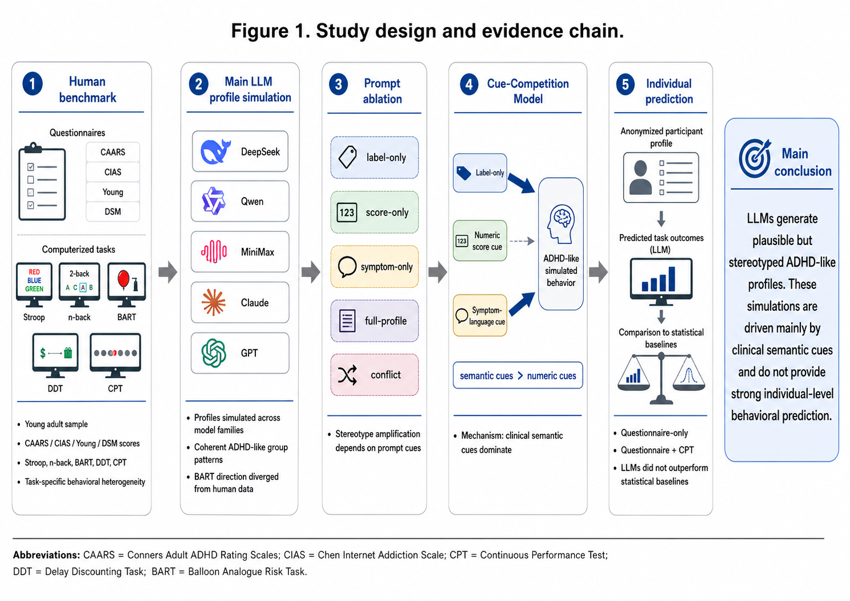
Study design and evidence chain. The workflow links the human benchmark, LLM profile simulation, prompt ablation, cue-contribution analysis, and individual-prediction validation.

Human data and measures

Participants
We used a convenience sample recruited in classroom settings at two universities in Hubei Province, China. The proximal population was young adults enrolled at these universities, and generalization should therefore be limited to similar young-adult educational samples unless replicated in broader populations. The survey yielded responses from 2,100 participants. We excluded responses with an average response time below 2 s per item, patterned response styles, or incomplete questionnaires. Screening retained 2,016 complete and valid responses, corresponding to a valid-completion rate of 96.0%. Demographic information included age, gender, residence, family structure, only-child status, and gaming experience. Participants had a mean age of 19.35 years; 733 identified as male and 1,283 as female. The available eligible sample determined the sample size. No prospective power analysis was preregistered for the secondary LLM-validation analyses. All participants provided informed consent before participation.

Measures
Chinese Version of the Internet Addiction Scale (CIAS). The CIAS, developed by Chen et al. (2003), is widely used to assess problematic Internet-use symptoms in China. It contains 26 items across five dimensions: compulsive Internet use, withdrawal symptoms, tolerance symptoms, interpersonal and health problems, and time-management problems. Participants rated each item on a 4-point scale from 1 (strongly disagree) to 4 (strongly agree). Prior work reported internal consistency coefficients from .79 to .93 and test-retest reliability of .83 (Chen et al., 2003).
Internet Addiction Test (IAT). The IAT was developed by Young (1998) to assess problematic Internet-use symptoms. The original version contains 20 items; the present study used an 8-item short form. Items were scored dichotomously, with yes scored as 1 and no scored as 0.
Conners' Adult ADHD Rating Scale (CAARS). The CAARS was developed by Conners et al. (2002) and adapted into Chinese by Wu et al. (2009) to assess adult ADHD-related symptoms. The short version used here consists of 26 items covering inattention problems, hyperactivity/restlessness, impulsivity/emotional lability, problems with self-concept, and an ADHD index. Participants rated each item on a 4-point scale from 0 (never) to 3 (always). Prior work reported internal consistency coefficients from .82 to .89 and test-retest reliability of .77 (Wu et al., 2009).
The experimental subsample (N = 157) completed computerized Stroop, n-back, BART, DDT, and CPT-derived attention-profile assessments. Questionnaire and task records were linked using de-identified participant identifiers. CPT-derived labels were treated as attention-profile indicators rather than clinical diagnoses. Main analyses contrasted Normal versus I/C profiles, with uncertain labels handled cautiously or in sensitivity analyses. Accordingly, we refer to ADHD-related traits, CPT-defined attention profiles, and ADHD-like simulated profiles rather than clinically diagnosed ADHD patients.

This measurement decision follows current evidence that CPT indices and adult ADHD rating scales are best interpreted as components of multi-method assessment rather than as stand-alone diagnoses (Harrison et al., 2019; Callan et al., 2024; Varela et al., 2024). Accordingly, the human benchmark quantified task-specific behavioral patterns associated with ADHD-related traits and CPT-defined attention profiles, rather than making clinical diagnostic claims.

LLM models and roles
The project used a tiered model strategy. DeepSeek, Qwen, and MiniMax were treated as high-throughput models for the complete cue-contribution and individual-prediction analyses. Claude and GPT-5.5 were included as frontier-model replications of the main profile-simulation pattern. GPT-5.5 served as a balanced OpenAI-family replication, with 25/25 profile-task cells covered and 34-35 valid samples per cell.
Table 1
Model configuration and analytic role
Model | Role | Temperature | Valid outputs | Notes
deepseek-v4-pro | Main, ablation, individual prediction, cue model | 0.7 | component-specific counts in Supplemental Material | High-throughput mechanistic model
Qwen-plus | Main, ablation, individual prediction, cue model | 0.7 | component-specific counts in Supplemental Material | High-throughput mechanistic model
MiniMax-M2.5 | Main, ablation, individual prediction, cue model | 0.7 | component-specific counts in Supplemental Material | High-throughput mechanistic model
Claude-opus-4-7 | Frontier baseline replication | 0.7 | 1224 main outputs | Baseline profile simulation
GPT-5.5 | OpenAI-family balanced replication | 0.7 | 859 main outputs | 34-35 samples per profile-task cell
Note. The table summarizes model roles and run settings reported in the manuscript. Model versions, access dates, API or platform names, maximum-token settings, invalid-output counts, and component-specific output counts should be checked against the available repository logs and run manifests before submission. Full model-specific run counts are reported in the Supplemental Material.

Prompt design and no-leakage safeguards
For profile simulation, prompts described five profile conditions and asked models to produce numeric task outcomes. For cue-contribution analyses, prompts crossed label, score, and symptom-language cues in a factorial design. For individual prediction, prompts used anonymized real-participant information. In the questionnaire-only condition, prompts did not include the terms ADHD, CAARS, CIAS, Young, DSM, internet addiction, or network addiction. Metadata fields, including profile identifiers and task identifiers, were saved for analysis but were not sent to the model as part of the user-facing prompt.
All model calls used structured JSON schemas that required numeric outputs. Raw outputs, parsed outputs, run identifiers, model names, temperature, profile identifiers, task identifiers, cue condition identifiers, and repeat identifiers were saved. Invalid outputs were logged and excluded according to pre-specified parsing and numeric-validation rules.

Secondary generalization domain: problematic digital use
Problematic digital use (PDU) was treated as a secondary generalization domain rather than as a second primary clinical topic. The goal was not to make claims about Internet addiction diagnosis. Instead, the extension tested whether the same cue-driven mechanism appeared when the label domain changed from ADHD-related traits to a behaviorally meaningful digital-use profile. The PDU extension reused the same prompt architecture and task outcomes but replaced ADHD-like profiles with high-versus-low problematic digital-use profiles. Human PDU contrasts were computed from the existing questionnaire and task data. LLM analyses addressed the same three methodological questions: whether high-PDU profiles generated stereotyped task patterns, whether label and symptom-language cues dominated anonymized numeric-score cues, and whether individual-level predictions exceeded simple statistical baselines.

Statistical analyses, effect sizes, and reproducibility checks
Human questionnaire associations were estimated using Spearman correlations. We report ρ, Fisher-z 95% confidence intervals, and two-sided p values. For human task benchmarks, CPT I/C minus Normal contrasts are reported in original task units and as standardized mean differences (Hedges g), with 95% confidence intervals and exact p values for the corresponding group comparison. LLM profile-simulation contrasts were computed as ADHD-like profile means minus the P1 low-ADHD/low-digital-use baseline means, using valid parsed outputs after JSON-schema and range validation.
Cue-contribution analyses used standardized domain-level contrasts, aligned so that larger values indicated stronger stereotype-oriented output. Label, numeric-score, and symptom-language effects were estimated as average marginal cue contributions across factorial prompt conditions. For individual prediction, repeated LLM outputs for the same participant, task, model, and input condition were averaged before evaluation. Prediction validity was assessed using Pearson correlation, Spearman correlation, RMSE, and out-of-sample R² relative to the mean baseline. Statistical baselines included mean prediction, CPT/PDU group mean, ridge regression, random forest, and label-augmented variants. Baseline models were evaluated using participant-level cross-validation. All outcomes from the same participant were kept in the same fold to prevent leakage. Preprocessing and model tuning were performed within training folds. The exact fold structure, repeat count, and hyperparameter grids are reported in the analysis scripts and Supplemental Material.
Missing data and task cleaning. The initial questionnaire pool contained 2,100 responses. We excluded 84 incomplete questionnaires, yielding 2,016 complete questionnaire records. In the final questionnaire dataset, all CIAS, Young, DSM, and CAARS item-level responses and total scores were complete, and item sums matched the recorded totals. The computerized-task subsample contained 157 participants. Analyses used task-wise deletion, and no primary analysis used imputation. Strict valid counts were 124 for Stroop, 111 for BART, 109 for n-back, 96 for DDT, and 112 for parsed CPT reports. Stroop indicators were retained when reaction times were between 200 and 3000 ms, accuracies were between 0 and 1, and no accuracy index was below .50. n-back indicators were retained when accuracies were between 0 and 1, reaction times were between 200 and 3000 ms, and overall accuracy was at least .60. BART indicators were retained when adjusted average pumps were between 0 and 100 and explosions were between 0 and 30. DDT was retained when k was positive and the model fit index was between .60 and 1.00.

Results

Study 1: Human benchmark showed task-specific behavioral heterogeneity
The human dataset comprised a broad questionnaire sample (N = 2,016) and an experimental subsample (N = 157) that completed computerized executive-function and reward-processing tasks. ADHD-related traits were indexed by CAARS total score, and problematic digital-use symptoms were indexed using CIAS, Young, and DSM-derived measures. Questionnaire associations were stable: CAARS correlated with CIAS (Spearman ρ = .467, 95% CI [.432, .500], p = 9.75 10^110), Young (ρ = .400, 95% CI [.363, .436], p = 2.49 10^78), DSM1 (ρ = .513, 95% CI [.480, .544], p = 9.52 10^136), and DSM2 (ρ = .496, 95% CI [.462, .528], p = 1.14 10^125). These associations were consistent in direction and magnitude.
Task behavior showed greater heterogeneity. Relative to Normal participants, CPT-defined I/C participants showed near-zero Stroop differences, modestly lower n-back accuracy, and lower, rather than higher, BART adjusted average pumps. This task-specific pattern provided the benchmark for evaluating LLM-generated ADHD-like profiles. BART offered a particularly stringent test because a simple stereotype would predict higher risk-taking, whereas the observed human contrast was negative.
Table 2 reports task-level contrasts in original units to preserve interpretability. Standardized effects confirmed the task-specific pattern. Stroop accuracy showed a small, nonsignificant CPT I/C minus Normal effect, g = -0.220, 95% CI [-0.645, 0.206], p = .253. Stroop mean RT was also near zero, g = 0.062, 95% CI [-0.363, 0.486], p = .774. n-back accuracy showed a moderate negative I/C effect, g = -0.732, 95% CI [-1.170, -0.293], p = .000168. BART adjusted average pumps were lower in the I/C group, g = -0.558, 95% CI [-0.985, -0.132], p = .018. DDT discounting k showed a small nonsignificant effect, g = -0.282, 95% CI [-0.752, 0.189], p = .267.

Study 2: Five LLM families generated coherent but stereotyped ADHD-like profiles
The profile-simulation experiment evaluated five model families: DeepSeek, Claude, Qwen, MiniMax, and GPT-5.5. GPT-5.5 was included as a balanced OpenAI-family replication after two runs were merged and complete profile-task coverage was verified (25/25 cells; 34-35 valid samples per cell). Across models, the same qualitative pattern emerged. ADHD-like profiles were simulated as slower and less accurate on Stroop, less accurate on n-back, more risk-taking on BART, and more biased toward immediate rewards in DDT.
Table 2 shows the key contrasts. All LLMs generated positive BART adjusted-pump contrasts for ADHD-like profiles, whereas the human CPT I/C contrast was negative. The models therefore appeared to map ADHD-like profiles onto a canonical "impulsive risk-taking" template that was not supported by the human benchmark.
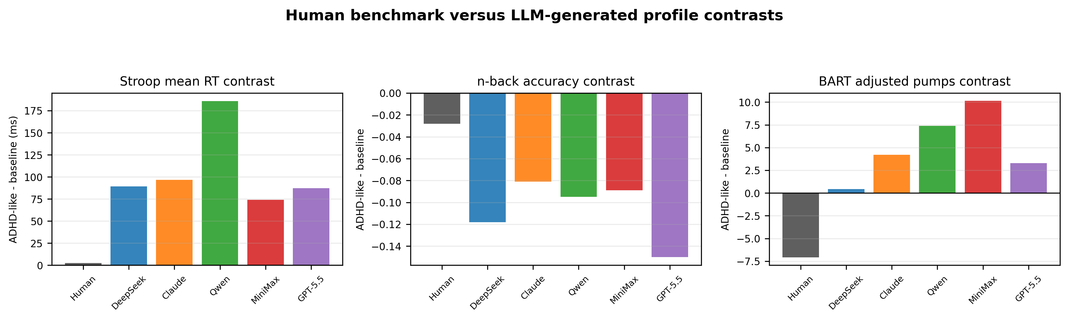
Human benchmark versus LLM-generated group contrasts. GPT-5.5 is shown as a balanced OpenAI-family replication. Values summarize contrasts between ADHD-like/CPT I/C profiles and baseline/Normal profiles.
Table 2
Human benchmark and five-model LLM profile-simulation contrasts
Metric | Human | DeepSeek | Claude | Qwen | MiniMax | GPT-5.5
Stroop accuracy | -0.001 | -0.075 | -0.032 | -0.081 | -0.065 | -0.050
Stroop mean RT (ms) | 2.67 | 89.33 | 96.63 | 185.65 | 74.06 | 87.28
n-back accuracy | -0.028 | -0.118 | -0.081 | -0.095 | -0.089 | -0.150
BART adjusted pumps | -7.085 | 0.443 | 4.193 | 7.397 | 10.136 | 3.298
DDT immediate reward | -0.006 | 0.511 | 0.272 | 0.382 | 0.377 | 0.355
Note. Values are ADHD-like or CPT I/C minus baseline/Normal contrasts. BART = Balloon Analogue Risk Task; DDT = Delay Discounting Task; RT = reaction time.

Study 3: Prompt ablation revealed cue-dependent stereotype amplification
To identify which prompt components triggered ADHD-like simulated behavior, we conducted a prompt-ablation experiment with five cue conditions. In the label-only condition, the model received only a profile label, such as low-ADHD, inattentive, or combined ADHD-like profile, without questionnaire scores or symptom descriptions. In the score-only condition, the model received only anonymized numeric scores, presented as Scale A-D, without terms such as ADHD, CAARS, CIAS, Young, DSM, internet addiction, or network addiction. In the symptom-only condition, the model received behavioral descriptions, such as sustained-attention difficulty, inhibitory-control problems, or impulsive decision making, but no diagnostic/profile label or numeric scores. In the full-profile condition, label, scores, and symptom descriptions were all provided. In the conflict condition, label and numeric information were deliberately inconsistent, allowing us to test whether models followed semantic labels or quantitative evidence when the two cues disagreed.
This design distinguished three possibilities: LLMs might respond mainly to diagnostic/profile labels, to quantitative score information, or to symptom-language descriptions. Label-only and symptom-only prompts were sufficient to elicit strong ADHD-like task contrasts, whereas score-only prompts produced weaker effects in several models. Conflict prompts showed that models could use quantitative information when inconsistency was explicit, but ordinary full-profile prompts still tended to produce stereotype-consistent outputs.
These findings motivated a formal cue-contribution analysis. Instead of treating prompt ablation as a set of descriptive comparisons, we estimated how much each type of input information contributed to ADHD-like simulated behavior.

Study 3b: Cue-contribution analysis identified semantic cue dominance

Simple cue-contribution analysis
To keep the mechanism interpretable, we did not present a long interaction regression in the main text. Instead, we grouped task outcomes into three behavioral domains: control impairment, working-memory impairment, and reward-risk stereotype. Control impairment included Stroop accuracy and mean reaction time; working-memory impairment included n-back accuracy; and reward-risk stereotype included BART adjusted pumps and delay-discounting immediate choice.
For each behavioral domain, we computed an ADHD-like contrast, defined as the standardized difference between ADHD-like profiles and the low-ADHD baseline profile under a given prompt condition. Task directions were aligned so that larger values always indicated a more stereotypically ADHD-like prediction, such as slower Stroop responses, lower n-back accuracy, higher BART risk-taking, or stronger immediate-reward preference.
We then compared prompt conditions with and without each cue. The label contribution estimated how much the ADHD-like contrast increased when a profile label was added. The numeric-score contribution estimated the same quantity for anonymized questionnaire scores. The symptom-language contribution estimated the same quantity for behavioral descriptions. This approach quantified whether model outputs were driven mainly by clinical semantic cues or by anonymized quantitative information.
Technically, cue contributions were estimated as average marginal effects across all cue combinations. This Shapley-style calculation accounts for the fact that cues can appear alone or together. Full subset-weighted calculations and factorial-regression sensitivity analyses are reported in the Supplementary Methods.
Table 3
Symbols used in the cue-contribution analysis
Cue / quantity | Plain-language meaning
Label cue | A profile label, such as inattentive, combined, low-ADHD, or high problematic digital-use profile.
Numeric-score cue | Anonymized Scale A-D scores, without explicit clinical or scale names.
Symptom-language cue | Text descriptions of attention, self-regulation, impulsive decision making, or problematic digital-use behaviors.
ADHD-like contrast | The standardized difference between ADHD-like profiles and the low-ADHD baseline, with task directions aligned so that larger values indicate more stereotypically ADHD-like prediction.
Semantic dominance | The share of cue-attributed contrast explained by label and symptom-language cues rather than numeric scores.

We summarized the result using a semantic dominance index, defined as the proportion of cue-attributed contrast explained by labels and symptom-language descriptions. A value close to 1 indicates that model output is driven mainly by clinical semantic cues rather than by anonymized numeric scores.
This formulation keeps the main analysis interpretable. The key question is whether LLM behavior is driven primarily by labels and symptom language or by anonymized individual scores.

Empirical cue-contribution results
The factorial cue results were clear (Figure 3). Score-only prompts produced a weak ADHD-like contrast (mean z = 0.349), similar to the weak no-cue baseline (mean z = 0.491). By contrast, label-only (mean z = 2.005) and symptom-only (mean z = 2.061) prompts produced large stereotype-oriented shifts. Combined cue conditions also remained high: label+score (2.567), label+symptom (2.569), score+symptom (2.400), and full-profile (2.681). These values are standardized contrasts; values around 2 indicate that the model separated ADHD-like profiles from the low-ADHD baseline by roughly two standard-deviation units in the stereotype-oriented direction.
The cue-contribution analysis showed that the two semantic components were much stronger than anonymized quantitative scores. The main cue contributions were:
Label contribution = 1.130; numeric-score contribution = 0.218; symptom-language contribution = 1.075.
Label and symptom-language cues were therefore much larger than the numeric-score cue, indicating that clinical semantic information dominated anonymized numeric information. Model-level dominance indices showed the same pattern: semantic cues accounted for approximately 87.6% of cue-attributed contrast in DeepSeek, 89.5% in MiniMax, and 98.0% in Qwen.
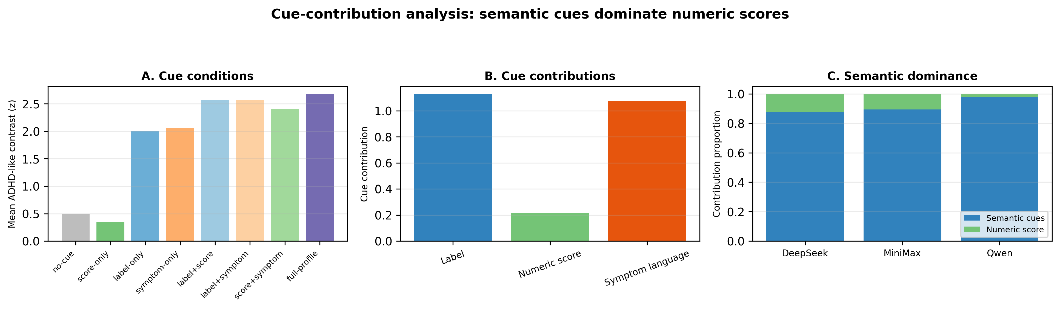
Cue-contribution analysis. Panel A shows pooled ADHD-like contrast across eight cue conditions. Panel B shows label, numeric-score, and symptom-language contributions. Panel C shows model-level semantic dominance indices.
Table 4
Cue-contribution results
Analysis | Result | Interpretation
No-cue mean contrast z | 0.491 | Weak default baseline
Score-only mean contrast z | 0.349 | Anonymized numeric information alone weakly triggers stereotype-oriented output
Label-only mean contrast z | 2.005 | Labels alone strongly trigger stereotype-oriented output
Symptom-only mean contrast z | 2.061 | Symptom language alone strongly triggers stereotype-oriented output
Full-profile mean contrast z | 2.681 | Combined information produces the strongest stereotype-oriented output
Label cue coefficient | 1.130 | Large effect
Quantitative-score coefficient | 0.218 | Weak effect
Symptom-language coefficient | 1.075 | Large effect
Note. The main text reports interpretable cue contributions. The full Shapley-style calculation and factorial-regression sensitivity analysis should be provided in the Supplemental Material.

Study 4: LLMs failed individual-level behavioral prediction
We next tested whether LLMs could predict real individual behavior from anonymized information. For each real participant, prompts supplied age, sex, and anonymized questionnaire scores. In the questionnaire-plus-CPT condition, prompts also supplied CPT-derived profile labels. Task outcomes were withheld from the model, and metadata such as profile identifiers were not sent to the model.
Across DeepSeek, Qwen, and MiniMax, individual-level predictions showed limited predictive validity. Correlations between model predictions and empirical task outcomes were generally weak, and out-of-sample R² values were mostly negative. Adding CPT labels modestly changed model outputs and improved rank correlations for some n-back outcomes, but it did not yield robust predictive validity. Critically, the BART direction error persisted: real CPT I/C participants had lower adjusted pumps than Normal participants, but all three LLMs continued to predict higher pumps for I/C profiles.
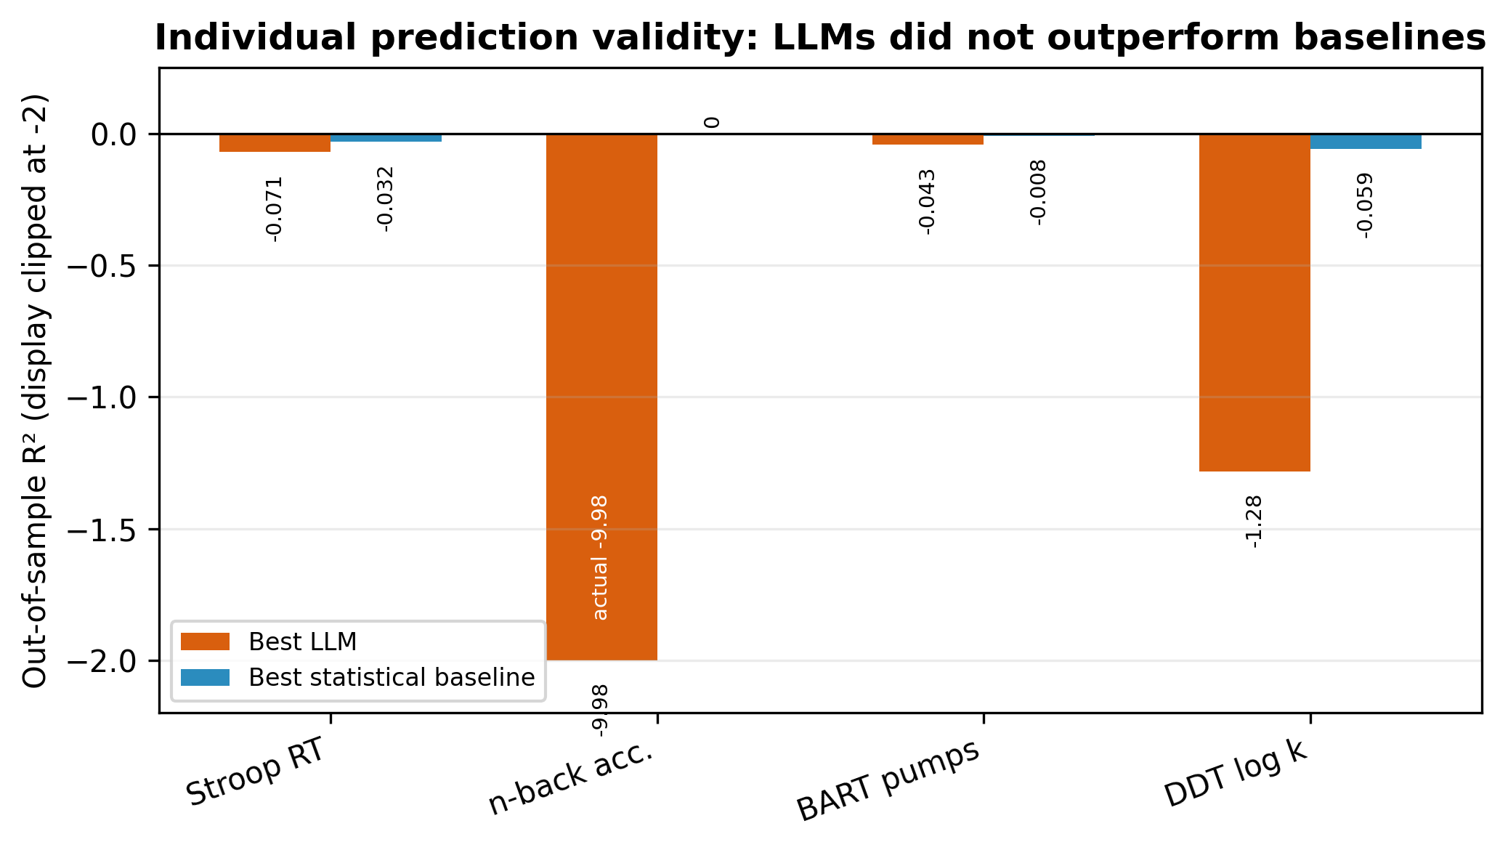
Individual prediction validity. LLM predictions did not outperform simple statistical baselines in the questionnaire-plus-CPT individual-prediction condition.
Table 5
Individual prediction validity in the questionnaire-plus-CPT condition
Task | Outcome | Best LLM | Best statistical baseline | LLM beats baseline?
Stroop | mean RT | -0.071 | -0.032 | No
n-back | overall accuracy | -9.979 | 0.000 | No
BART | adjusted pumps | -0.043 | -0.008 | No
DDT | log discounting k | -1.282 | -0.059 | No
Note. R² values are out-of-sample values relative to the sample-mean baseline. Negative values indicate performance worse than the mean baseline. Full model-specific prediction metrics are reported in the Supplemental Material.
Together, Studies 2-4 show a dissociation between profile-level plausibility and individual-level predictive validity. LLMs generated coherent ADHD-like simulated participants, but these simulations were driven primarily by clinical semantic cues and did not reliably predict real task behavior.

Secondary generalization test: Problematic digital-use profiles showed a parallel cue-dominance pattern
We treated problematic digital-use profiles as a secondary generalization test rather than as a second primary evidence base. The aim was to test whether the ADHD findings reflected a broader simulation mechanism: LLMs may rely more on semantic labels and symptom-language descriptions than on anonymized numerical scores when simulating clinically or behaviorally meaningful participant profiles. The extension used the same task families and interpretive logic, but the ADHD analyses remain the primary stress test.
The secondary PDU extension showed a similar cue-driven amplification pattern. Using the final cleaned dataset and the documented PDU definition (Low PDU = CIAS_total ≤ 59; High PDU = CIAS_total > 59), the empirical BART adjusted-pump contrast was small and nonsignificant, Δ = +1.85, with 49 valid BART observations in the High PDU group and 62 in the Low PDU group, t(106.86) = 0.747, p = .456, Cohen's d = 0.141. By contrast, all three LLMs generated larger positive BART contrasts for high-PDU profiles: DeepSeek = +14.14, MiniMax = +6.86, and Qwen = +1.37. The secondary PDU result therefore indicates effect-size inflation: LLMs exaggerated the association between problematic digital-use cues and risk-taking despite negligible human group differences.
Cue-contribution analyses showed the same qualitative mechanism. Across DeepSeek, MiniMax, and Qwen, semantic cues (labels plus symptom-language descriptions) accounted for approximately 81%-92% of cue-attributed output, whereas numeric-score reliance was smaller. Individual-level prediction remained weak: BART prediction R² values were negative for questionnaire-only prompts in all three models, and adding problematic digital-use labels did not produce reliable behavioral prediction. Because the PDU extension served as a secondary generality check with more uneven condition coverage, we report point estimates rather than bootstrap confidence intervals for semantic dominance, score reliance, and BART prediction R². We interpret this extension as supportive evidence for generality rather than as a parallel primary study.
Table 6
Secondary problematic digital-use extension
Analysis | Human / benchmark | DeepSeek | MiniMax | Qwen
BART adjusted pumps contrast | High PDU - Low PDU = +1.85; d = 0.141; p = .456 | +14.14 | +6.86 | +1.37
Cue contribution: semantic dominance | N/A | 0.921 | 0.814 | 0.921
Cue contribution: score reliance | N/A | 0.079 | 0.186 | 0.079
BART individual prediction R2, questionnaire-only | 0 is mean baseline | -0.046 | -1.163 | -0.844
BART individual prediction R2, + IA label | 0 is mean baseline | -0.705 | -2.105 | -0.786
Note. Values summarize the most interpretable indicators after integrating Qwen, DeepSeek strict reruns, and MiniMax supplementary data. PDU = problematic digital use.
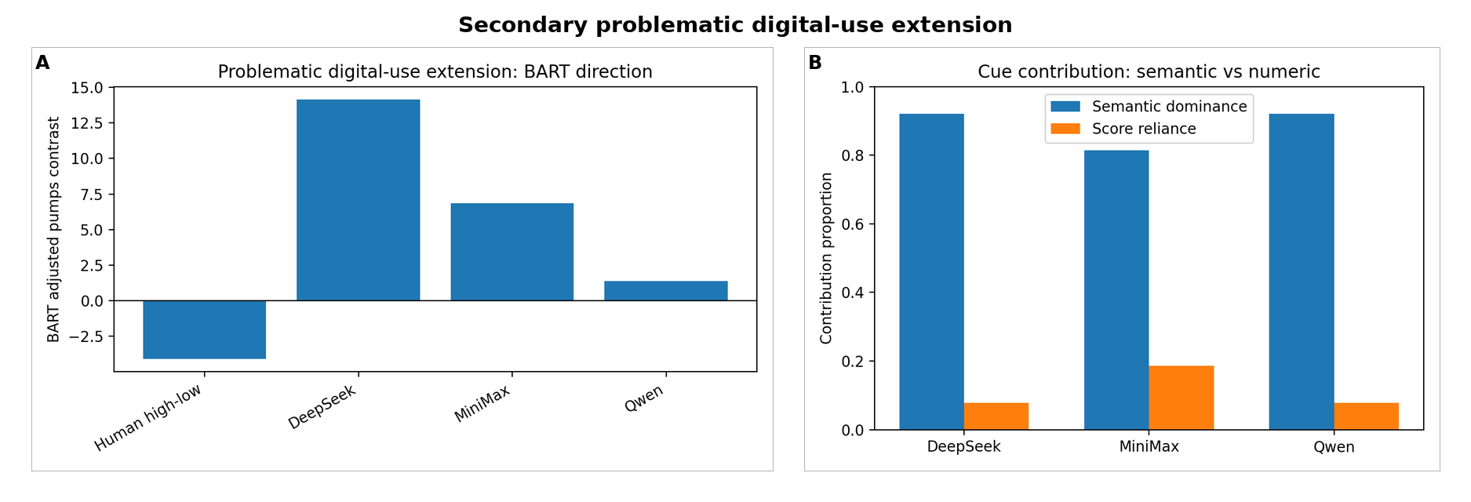
Secondary problematic digital-use extension. Panel A shows BART adjusted-pump contrasts. Panel B summarizes cue contribution as semantic dominance versus score reliance.

Discussion
This study shows that LLM-generated ADHD-like participants can appear psychologically plausible while remaining behaviorally invalid. Across five model families, profile simulations produced coherent ADHD-like outputs: slower and less accurate Stroop performance, lower n-back accuracy, higher BART risk-taking, and stronger immediate-reward preference. The human benchmark, however, was task-specific and heterogeneous. Most notably, CPT-defined I/C participants showed lower BART adjusted pumps, whereas LLMs consistently predicted higher pumps.
The ADHD literature is central to interpreting this dissociation. Executive-function, delay-aversion, and reward-processing theories support expected associations between ADHD-related traits and tasks such as Stroop, n-back, BART, and delay discounting. The same literature also emphasizes heterogeneity, pathway diversity, and measurement limits. LLM outputs often followed an overgeneralized textbook narrative of poorer executive control and greater impulsive risk-taking. By contrast, the empirical benchmark showed task-specific patterns, including the BART direction reversal in the ADHD benchmark and the effect-size inflation in the PDU extension. The BART result is therefore not merely a numerical anomaly. It shows how a semantically plausible clinical narrative can fail as a behavioral prediction.
The cue-contribution analysis identifies a mechanism for this divergence. Diagnostic or profile labels and symptom-language descriptions produced large stereotype-oriented shifts, whereas anonymized quantitative scores had weaker effects. Thus, the LLMs did not simply integrate individual numeric information. They mapped clinical semantic cues onto familiar ADHD-like task expectations.
The individual-prediction results further separate plausibility from predictive validity. Even with real participants' anonymized questionnaire scores, and even when CPT labels were added, LLMs did not reliably predict Stroop, n-back, BART, or DDT outcomes. They also did not outperform simple statistical baselines. Internally coherent clinical personas therefore should not be treated as evidence that LLMs can replace real participants in behavioral research.
These findings contribute to the broader literature on LLM-simulated participants. Prior work has shown that LLMs can reproduce some aggregate human effects, while also warning about effect-size amplification, social desirability bias, identity flattening, prompt sensitivity, and unreliable psychological validity. The present study adds a mechanism: in clinically meaningful simulations, labels and symptom-language descriptions can dominate numeric individual information.
This positioning is especially important in light of Lin's (2026) AMPPS methodological guide, which frames LLMs as psychological simulators and emphasizes validation tiers, prompt sensitivity, implementation artifacts, and ethical constraints. Our study provides an empirical complement to that guide. We instantiate a validation pipeline with real human task benchmarks, cue-contribution decomposition, and individual-prediction tests. We also show that profile-level plausibility can fail precisely where behavioral predictive validity is required.
The problematic digital-use extension broadens the interpretation without changing the evidentiary hierarchy. It suggests that cue-driven stereotype amplification may not be specific to ADHD-like labels. Models exaggerated the association between high problematic digital-use cues and BART risk-taking despite negligible human group differences, and they did not provide strong individual-level prediction. Because this extension was not as uniformly complete across all models and conditions as the ADHD analyses, it should be interpreted as supportive evidence for generality rather than as an equally weighted primary study. Because the PDU extension was not the primary stress test and had more uneven condition coverage, we do not use it to make independent claims about problematic digital-use mechanisms.

Limitations and constraints on generality
The human data came from young adults with ADHD-related traits and CPT-defined attention profiles, not from clinically diagnosed ADHD patients or children. CPT labels were task-derived profile indicators rather than clinical diagnoses. The human benchmark was drawn from one dataset, and an independent validation sample would strengthen generality. Model outputs may also change as model versions are updated. GPT-5.5 and Claude were used as frontier-model replications, whereas complete cue-competition and individual-prediction analyses were conducted in DeepSeek, Qwen, and MiniMax. Finally, the cue-contribution analysis provides a mechanistic account of prompt effects, but it does not identify internal neural mechanisms of LLMs.

Practical implications
LLMs may be useful for pilot testing, prompt design, task prototyping, and hypothesis generation. However, they should not be used as unvalidated substitutes for human participants, especially when clinical, neurodiversity, or educational labels are involved. Researchers using simulated participants should validate aggregate and individual-level outputs against human data, test prompt-cue sensitivity, and distinguish semantic plausibility from behavioral predictive validity.
For AMPPS readers, the practical lesson is procedural. LLM-simulated participants should be treated as outputs requiring validation, not as self-validating substitutes for participants. A minimal validation workflow should include a human benchmark, a prompt-cue sensitivity audit, a directional-validity check for task outcomes, an individual-prediction comparison against simple baselines, and public release of prompts, outputs, exclusions, and analysis scripts.

Author Contributions
Conceptualization: Y.L. and W.Z. Methodology: Y.L., S.T., and W.Z. Data curation: W.Z. and C.Z. Formal analysis: S.T. and Y.L. Investigation: W.Z. and S.T. Writing, original draft: W.Z., S.T., C.Z., and Y.L. Writing, review and editing: W.Z., S.T., C.Z., and Y.L. Supervision: Y.L. and W.Z. Project administration: W.Z. Funding acquisition: W.Z. All authors must read and approve the final manuscript and agree to be accountable for the work.

Conflicts of Interest
The authors declare that there were no conflicts of interest with respect to the authorship or the publication of this article.

Funding
This work was supported by the National Social Science Fund of China (22BSH093).

Artificial Intelligence Disclosure
The authors used AI-assisted tools for programming assistance, formatting, language refinement, and manuscript organization. All data analyses, outputs, interpretations, and final manuscript decisions were checked and verified by the authors. The authors take full responsibility for the manuscript content. The LLMs reported as study objects were not used as authors or autonomous analysts.

Supplemental Material
The Supplemental Material includes human data cleaning and task metrics, prompt templates and JSON schemas, model API settings and run logs, cue-contribution calculations, factorial-regression sensitivity analyses, full model outputs by task and profile, prompt-ablation results, individual-prediction metrics, sensitivity analyses, problematic digital-use extension tables, run-quality checks, supplementary tables, and the codebook and variable dictionary.

Prior Versions
No prior version of this manuscript has been posted or submitted elsewhere.

References
Aher, G. V., Arriaga, R. I., & Kalai, A. T. (2023). Using large language models to simulate multiple humans and replicate human subject studies. In Proceedings of the 40th International Conference on Machine Learning.
Argyle, L. P., Busby, E. C., Fulda, N., Gubler, J. R., Rytting, C., & Wingate, D. (2023). Out of one, many: Using language models to simulate human samples. Political Analysis, 31(3), 337-351. https://doi.org/10.1017/pan.2023.2
Augner, C., Vlasak, T., & Barth, A. (2023). The relationship between problematic internet use and attention deficit, hyperactivity and impulsivity: A meta-analysis. Journal of Psychiatric Research, 168, 1-12. https://doi.org/10.1016/j.jpsychires.2023.10.032
Bai, X., Wang, A., Sucholutsky, I., & Griffiths, T. L. (2025). Explicitly unbiased large language models still form biased associations. Proceedings of the National Academy of Sciences, 122(8), Article e2416228122. https://doi.org/10.1073/pnas.2416228122
Binz, M., Akata, E., Bethge, M., Brändle, F., Callaway, F., Coda-Forno, J., et al. (2025). A foundation model to predict and capture human cognition. Nature, 644(8078), 1002-1009. https://doi.org/10.1038/s41586-025-09215-4
Callan, P. D., Swanberg, S., Weber, S. K., Eidnes, K., Pope, T. M., & Shepler, D. (2024). Diagnostic utility of Conners Continuous Performance Test-3 for attention deficit/hyperactivity disorder: A systematic review. Journal of Attention Disorders, 28(6), 992-1007. https://doi.org/10.1177/10870547231223727
Chen, S. H., Weng, L. J., Su, Y. J., Wu, H. M., & Yang, P. F. (2003). Development of a Chinese Internet addiction scale and its psychometric study. Chinese Journal of Psychology, 45(3), 279-294.
Chiappone, A., et al. (2026). LLM-based neurodivergent psychometric profile simulation. Preprint.
Conners, C. K., Erhardt, D., & Sparrow, E. (2002). Conners' Adult ADHD Rating Scales, Self-Report: Short Version (CAARS-S:S). Multi-Health Systems.
Cui, Z., Li, N., & Zhou, H. (2025). A large-scale replication of scenario-based experiments in psychology and management using large language models. Nature Computational Science, 5(8), 627-634. https://doi.org/10.1038/s43588-025-00840-7
Dillion, D., Tandon, N., Gu, Y., & Gray, K. (2023). Can AI language models replace human participants? Trends in Cognitive Sciences, 27(7), 597-600. https://doi.org/10.1016/j.tics.2023.04.008
Gao, Y., Lee, H. R., Burtch, G., & Fazelpour, S. (2025). Take caution in using LLMs as human surrogates. Proceedings of the National Academy of Sciences, 122(24), Article e2501660122. https://doi.org/10.1073/pnas.2501660122
Gonnermann-Müller, J., Haase, J., Leins, N., Kosch, T., & Pokutta, S. (2026). Maintaining stable personas? Examining temporal stability in LLM-based human simulation. In Proceedings of the Extended Abstracts of the 2026 CHI Conference on Human Factors in Computing Systems (pp. 1-6). https://doi.org/10.1145/3772363.3799334
Harrison, A. G., Nay, S., & Armstrong, I. T. (2019). Diagnostic accuracy of the Conners’ Adult ADHD Rating Scale in a postsecondary population. Journal of Attention Disorders, 23(14), 1829-1837. https://doi.org/10.1177/1087054715625299
Horton, J. J. (2023). Large language models as simulated economic agents: What can we learn from Homo silicus? SSRN Electronic Journal. https://doi.org/10.2139/ssrn.4413859
Hu, T., Kyrychenko, Y., Rathje, S., Collier, N., van der Linden, S., & Roozenbeek, J. (2025). Generative language models exhibit social identity biases. Nature Computational Science, 5(1), 65-75. https://doi.org/10.1038/s43588-024-00741-1
Humphreys, K. L., & Lee, S. S. (2011). Risk taking and sensitivity to punishment in children with ADHD, ODD, ADHD+ODD, and controls. Journal of Psychopathology and Behavioral Assessment, 33(3), 299-307. https://doi.org/10.1007/s10862-011-9237-6
Jackson, J. N. S., & MacKillop, J. (2016). Attention-deficit/hyperactivity disorder and monetary delay discounting: A meta-analysis of case-control studies. Biological Psychiatry: Cognitive Neuroscience and Neuroimaging, 1(4), 316-325. https://doi.org/10.1016/j.bpsc.2016.01.007
Kofler, M. J., Irwin, L. N., Soto, E. F., Groves, N. B., Harmon, S. L., & Sarver, D. E. (2019). Executive functioning heterogeneity in pediatric ADHD. Journal of Abnormal Child Psychology, 47(2), 273-286. https://doi.org/10.1007/s10802-018-0438-2
Kuss, D. J., & Lopez-Fernandez, O. (2016). Internet addiction and problematic Internet use: A systematic review of clinical research. World Journal of Psychiatry, 6(1), 143-176. https://doi.org/10.5498/wjp.v6.i1.143
Lejuez, C. W., Read, J. P., Kahler, C. W., Richards, J. B., Ramsey, S. E., Stuart, G. L., Strong, D. R., & Brown, R. A. (2002). Evaluation of a behavioral measure of risk taking: The Balloon Analogue Risk Task (BART). Journal of Experimental Psychology: Applied, 8(2), 75-84. https://doi.org/10.1037/1076-898X.8.2.75
Lin, Z. (2025). Six fallacies in substituting large language models for human participants. PsyArXiv. https://doi.org/10.31234/osf.io/uqxcb_v2
Lin, Z. (2026). Large language models as psychological simulators: A methodological guide. Advances in Methods and Practices in Psychological Science, 9(1). https://doi.org/10.1177/25152459251410153
Salecha, A., Ireland, M. E., Subrahmanya, S., Sedoc, J., Ungar, L. H., & Eichstaedt, J. C. (2024). Large language models display human-like social desirability biases in Big Five personality surveys. PNAS Nexus, 3(12), Article pgae533. https://doi.org/10.1093/pnasnexus/pgae533
Schröder, S., Morgenroth, T., Kuhl, U., Vaquet, V., & Paaßen, B. (2025). Large language models do not simulate human psychology. Preprint.
Sonuga-Barke, E. J. S. (2003). The dual pathway model of AD/HD: An elaboration of neuro-developmental characteristics. Neuroscience & Biobehavioral Reviews, 27(7), 593-604. https://doi.org/10.1016/j.neubiorev.2003.08.005
Varela, J. L., Magnante, A. T., Miskey, H. M., Ord, A. S., Eldridge, A., & Shura, R. D. (2024). A systematic review of the utility of continuous performance tests among adults with ADHD. The Clinical Neuropsychologist, 38(7), 1524-1585. https://doi.org/10.1080/13854046.2024.2315740
Wang, A., Morgenstern, J., & Dickerson, J. P. (2025). Large language models that replace human participants can harmfully misportray and flatten identity groups. Nature Machine Intelligence, 7(3), 400-411. https://doi.org/10.1038/s42256-025-00986-z
Willcutt, E. G., Doyle, A. E., Nigg, J. T., Faraone, S. V., & Pennington, B. F. (2005). Validity of the executive function theory of attention-deficit/hyperactivity disorder: A meta-analytic review. Biological Psychiatry, 57(11), 1336-1346. https://doi.org/10.1016/j.biopsych.2005.02.006
Wu, X. P., Sun, J. H., Li, Q. Q., & Guo, L. T. (2009). Reliability and validity of the Chinese version of Conners’ Adult ADHD Rating Scales Self-Report. Chinese Mental Health Journal, 23(5), 349-352.
Young, K. S. (1998). Internet addiction: The emergence of a new clinical disorder. CyberPsychology & Behavior, 1(3), 237-244. https://doi.org/10.1089/cpb.1998.1.237

