FATUWR Training Portal
Product Requirements Document
Version 2.2 | April 2026

1. Overview
The FATUWR Training Portal is a web application replacing the existing Glide-based app for the FATUWR underwater rugby club. It handles training session sign-ups, membership management, payment tracking, and administrative functions.
Google Sheets remains the single source of truth for all data. The portal reads from Sheets via public CSV export and writes back via Google Apps Script (GAS) web-app endpoints.

Scope: complete replacement web app including all member-facing screens and a role-gated Admin tab.
Out of scope: the Glide app, the GScript Maybank email parser, and the Payments tab column structure.

2. Two Independent User Dimensions
Every user has two completely independent fields that serve different purposes:

Dimension | Values | Purpose
Membership Status | Non-Member / Trial / Member / Student | Controls training fee tier
Club Role | (blank) / Helper / Admin | Controls app tab visibility and write permissions

These are orthogonal. A committee Admin can be a Non-Member (fee tier). A Student can have no Club Role.

2.1 Membership Status

Status | Fee | Who | Notes
Non-Member | No annual fee | Default | Highest per-session rate (Non-member Fee)
Trial | $10 for 3 months | First-timers only, once ever | One-time only; system detects prior trial via Trial Start Date != 'NA' in Sheets
Member | $80/yr pro-rated | Self-service upgrade | Pays Member Fee per session
Student | $40/yr pro-rated | Committee-verified only | Admin must manually grant; cannot self-upgrade

Note: Pro-ration: annual fee = (fee / 12) x months remaining in calendar year from membership start month.
Note: Trial one-time enforcement: if the User tab col K (Trial Membership Start Date) contains any value other than 'NA' or blank, the Trial option is hidden from the membership upgrade form.

Self-service vs Admin-required upgrades
- Non-Member → Trial: self-service (once only; system blocks repeat attempts)
- Non-Member / Trial → Member: self-service
- Any status → Student: Admin must manually set in the Admin tab after committee verification
- Trial Start and End dates are automatically set by the system when the user submits their Trial sign-up. Admin does not need to set these.

2.2 Club Role

Role | Admin Tab | Write Access
(blank) | Hidden — not visible | None
Helper | Visible — read-only | Cannot edit; view-only for all Admin sections
Admin | Visible — full access | Edit users, create/edit/close sessions, correct payments

3. Data Model — Google Sheets
Sheet ID: 19Vxpj2AoJizVwhkSxEtV70yKDlWMyrfQGDIu6k6RSRM

3.1 User Tab (GID 920623124)
Col | Field | Type | Notes
A | Name | Text | Display name
B | User Email | Email | Primary login identifier
C | Email | Email | Secondary/legacy email
D | Profile Image URL | URL | Google Drive or image link
E | Club Role | Enum | Blank / Helper / Admin
F | Annual Membership Start Date | Date | Used for pro-ration calculations
G | Phone Number (Paynow linked) | Text | Mobile number for PayNow
H | Member ID (PaymentID) | Text | Short unique ID for PayNow reference. Auto-assigned on first registration.
I | Birth Date | Date | Optional
J | Membership Status | Enum | Non-Member / Trial / Member / Student
K | Trial Membership Start Date | Text | 'NA' or blank = never trialled. Any date value = already used trial.
L | Trial Membership End Date | Date | 3 months after K; auto-set on Trial sign-up
M | Date Created | Timestamp | Auto-set on registration

⚠ Column H (PaymentID) is the cross-sheet key used by VLOOKUPs in the Payments tab and the GScript Maybank parser. Must never be empty for a registered user.

3.2 Training Sessions Tab (GID 1672478998)
Col | Field | Type | Notes
A | Training Date | Date | Calendar date
B | Day / Title | Text | Display name in app
C | Training Time | DateTime | Full session start datetime
D | Pool / Venue | Text | e.g. CCAB, MGS
E | Pool Image URL | URL | Google Drive image for session card
F | Training Objective | Text | Optional text on session detail
G | Close? | Text | Non-empty = session closed/finalised
H | Special Adjustment | Number | Fee multiplier (default 1)
I | Base Fee | Currency | Default if no tier-specific rate
J | Member Fee | Currency | Per-session fee for Member-status users
K | Student Fee | Currency | Per-session fee for Student-status users
L | Non-member Fee | Currency | Per-session fee for Non-Member and Trial users

Note: Actual fee charged = (fee for membership tier on training date) x Special Adjustment. Fees are set per session by Admin, not globally.

3.3 Training Sign-ups Tab (GID 1447548009)
Col | Field | Type | Notes
A | Timestamp | Timestamp | Sign-up submission time
B | Name | Text | User's display name
C | Session Date | Date | Date of the training session
D | Activity | Enum | Regular Training / Swims only / Trainer / First-timer / Membership Fee
E | Actual Fee | Currency | Fee calculated at sign-up based on membership status on training date
F | PaymentID | Text | Ref to User tab col H
G | Member on training date? | Text | Snapshot of user's membership status as of the training date
H | Session Name/ID | Text | Reference to the training session

3.4 Payments Tab
Written exclusively by GScript permfix1(). Do not modify column structure.
Col | Field | Type | Notes
A | Timestamp | Timestamp | When notification was received
B | Email Subject | Text | Maybank email subject
C | Amount | Currency | Extracted via \$(\d+\.\d{2})
D | OTHR Message | Text | Extracted PaymentID via ref-OTHR-(.*?)\)
E | PaymentID Match | Text | VLOOKUP of col D against User col H
F | Email Body | Text | Full Maybank notification text

4. Debt System
Debt = SUM(Training Sign-ups.Actual Fee WHERE PaymentID = user)
- SUM(Payments.Amount WHERE PaymentID Match = user)

Positive debt = user owes money. Negative = user has credit.

Threshold | Debt Amount | Behaviour
Warning | >= $26.00 | Yellow banner on Training Sessions list and sign-up form. User can still sign up.
Block | >= $54.00 | Red banner. Sign-up submit button disabled until debt drops below $54.

5. Navigation & Tab Structure
Tab | Visible To | Contents
Announcements | All users | Club announcements (read-only)
Training Sessions | All users | Session grid; sign-up form; session detail with roster and Splits
Payments | All users | Personal payment ledger
Admin | Helper & Admin only | Members mgmt, Payments view, Session mgmt, PnL analytics
Profile | All (via avatar) | Profile detail; membership status; sign-up history

On first login (Name absent from User tab), the user is redirected to a Profile Setup screen before accessing other tabs.

6. Member-Facing Features

F1 — Profile Setup (Screen C — First Login)
Triggered on first login when the user has no Name in the User tab. Mandatory before accessing other tabs.

F1.1 Fields collected
- Name (required)
- Profile photo (optional)
- Phone number / PayNow-linked mobile (optional)
- Birth date (optional)

F1.2 PaymentID auto-assignment
- On submit, a short unique PaymentID is generated (e.g. first 4 chars of name, de-duplicated if taken).
- Written to User tab col H via GAS endpoint.
- Displayed prominently on the profile page after setup.

F2 — Training Sign-up

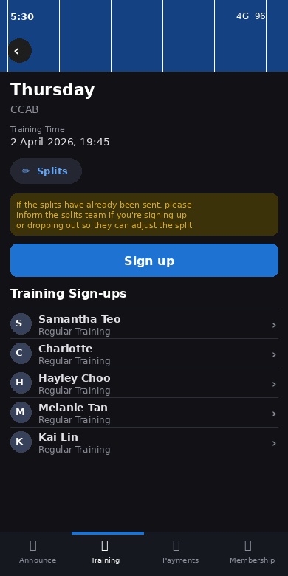
Screen: Session detail page showing Splits button, Sign up button, and sign-ups roster

Shown on the session detail page for any open (non-closed) future session. Users may sign up or view the existing roster.

F2.1 Four activity types
Activity | Sheet Value | Fee
Regular Training | Regular Training | Membership-tier fee x Special Adjustment
Swims only | Swims only | Membership-tier fee x Special Adjustment
Trainer | Trainer | $0 — trainers are not charged
First-timer | First-timer | Non-member Fee; only for users who have never attended

F2.2 Fee calculated based on training DATE, not sign-up date
The fee shown and charged is determined by the user's membership status as of the training session date, not the date they signed up.

Scenario | System Behaviour
User is Non-Member on training date | Charged Non-member Fee
User is Member on training date | Charged Member Fee
User has Trial membership, but Trial expires before training date | Charged Non-member Fee + warning shown
User upgrades to Member after sign-up but before training date | Fee recalculates to Member Fee

Expiry warning: if the user's Trial Membership End Date (col L) falls before the training session date,
the sign-up form displays a yellow banner:
"Your Trial membership expires before this session. You will be charged the Non-member rate ($X).
Consider upgrading to a Full Membership."
The user can still sign up at the Non-member rate, or navigate to the Membership page to upgrade first.

F2.3 Debt check
- Debt >= $26: yellow warning banner on session list and sign-up form. User can still sign up.
- Debt >= $54: red banner; submit button disabled.

F2.4 Write to Sheets
- On submit, a GAS endpoint appends a row to the Training Sign-ups tab.
- Fields written: Timestamp, Name, Session Date, Activity, Actual Fee, PaymentID, Member on training date, Session Name.
- Duplicate check: user cannot sign up twice for the same session (same PaymentID + Session Date).

F2.5 Edit own sign-up
Users can edit or delete their own sign-up entries for a session. This is the only editable content a regular user has.

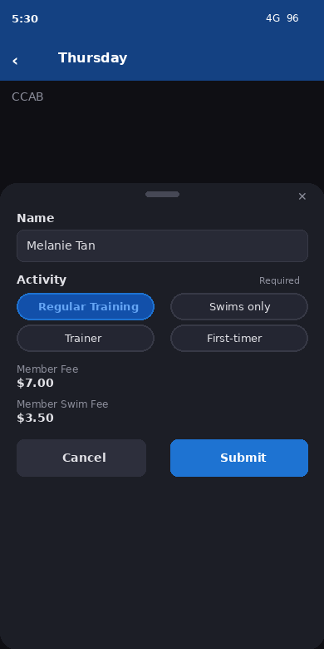
Screen: Sign-up form — user selects Activity; fee auto-displayed; Cancel and Submit

Field | User Can Edit? | Notes
Name | No | Read-only; shown for reference
Member on training date | No | Computed from training date; read-only
Payment ID | No | Read-only; cannot be changed by user
Actual fees | No | Auto-recalculated when Activity changes; not directly editable
Activity | Yes | User can switch between the 4 activity types; fee recalculates automatically
Delete sign-up | Yes | Removes the sign-up row from Sheets via GAS endpoint

Note: Editing is only available for open sessions. Once a session is closed (Close? field non-empty), the edit and delete options are hidden.

F3 — Training Sessions List

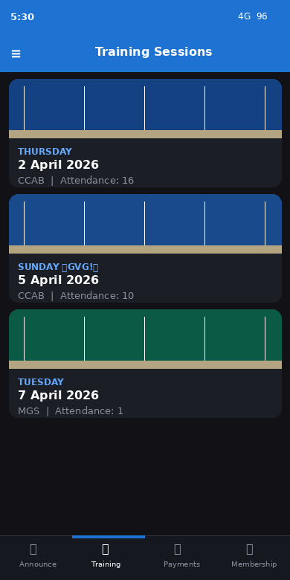
Screen: Training Sessions list showing session grid and non-member membership prompt

Grid of upcoming sessions, each showing pool photo, day/date, venue, and attendance count. If the user is a Non-Member or has an expiring Trial, a blue banner appears at the top prompting them to become a member.

F4 — Splits

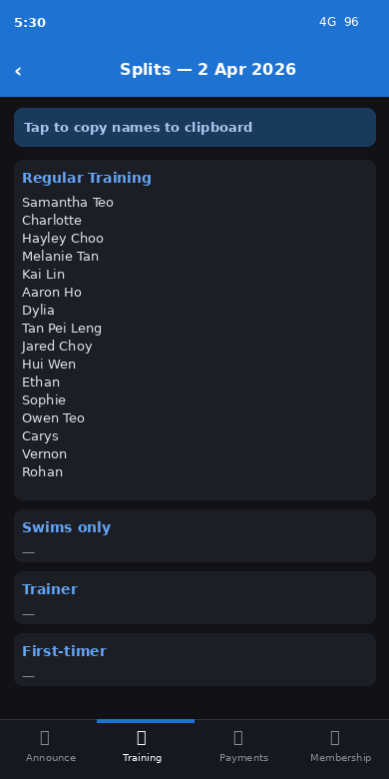
Screen: Splits view — sign-ups grouped by activity type with tap-to-copy

The Splits button is visible to all logged-in users on any session detail page. It opens a summary screen grouping sign-ups by activity type (Regular Training, Swims only, Trainer, First-timer).

F4.1 Behaviour
- All four activity-type groups are shown, even if empty.
- Tapping / clicking a group section copies all names in that group to the clipboard.
- A 'Tap to copy names to clipboard' instruction banner is shown at the top.
- Available to all logged-in users — not restricted to Admin or Helper.
Note: This replaces the need for admins to manually compile name lists for swim lane splits.

F5 — Membership Sign-up
Accessible from the Profile page and from the Announcements membership prompt. Allows a user to upgrade their membership status.

F5.1 Options shown
- Trial ($10, 3 months) — shown ONLY if the user has never trialled before (Trial Start Date = 'NA' or blank in Sheets)
- Member ($80/yr, pro-rated from current month) — always shown to Non-Member and Trial users
- Student ($40/yr, pro-rated) — NOT self-service; Admin must manually grant this status

F5.2 On Trial sign-up submit
- Membership Status updated to 'Trial' in User tab via GAS
- Trial Membership Start Date (col K) set to today
- Trial Membership End Date (col L) set to today + 3 months
- Annual Membership Start Date (col F) set to today
- A 'Membership Fee' row ($10) appended to Training Sign-ups tab

F5.3 On Member sign-up submit
- Membership Status updated to 'Member' in User tab via GAS
- Annual Membership Start Date (col F) set to today
- Pro-rated fee calculated and a 'Membership Fee' row appended to Training Sign-ups tab

F5.4 Student status
- Not available via self-service form
- Admin manually changes Membership Status to 'Student' and sets Annual Membership Start Date in the Admin tab
- A 'Membership Fee' row at Student rate may be added manually by Admin

F6 — Payments Ledger (User-Facing)

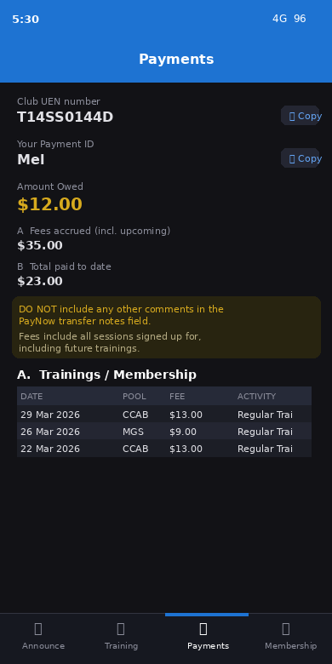
Screen: Payments tab showing Club UEN, Payment ID, Amount Owed, and itemised A/B tables

Read-only personal financial summary for the logged-in user.

F6.1 Content
- Club UEN number (with copy-to-clipboard button) — for PayNow transfers to the club
- User's Payment ID (with copy-to-clipboard) — must be entered as transfer reference
- Amount Owed = A minus B (colour-coded: green <$26, amber $26–$53, red >= $54)
- A: Fees accrued — all Training Sign-ups Actual Fee rows for this user, including upcoming sessions
- B: Total paid to date — all Payments tab Amount entries matched to this user
- Section A table: Date of Training, Pool, Actual Fees, Activity
- Section B table: Date, Amount

Note: Amount Owed only displays once the user has made their first payment. Before that, only A and B individually are shown.

7. Admin Tab
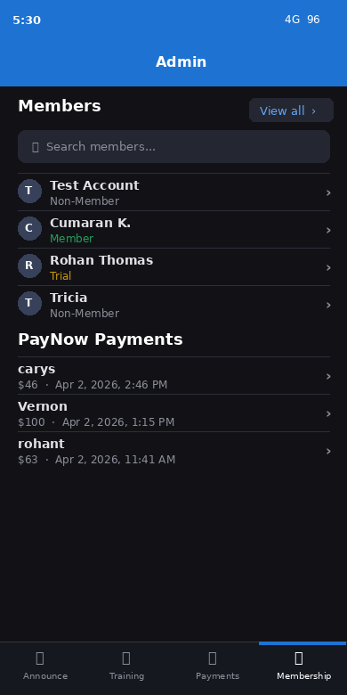
Screen: Admin tab showing Members list, Membership chart, and Paynow Payments

Visible only to users with Club Role = 'Helper' or 'Admin'. Renders as a single long-scrolling page. Helper can view all sections; Admin has full read/write access.

A1 — Members
Searchable, filterable, paginated list of all users showing Name and Membership Status.

A1.1 Member detail view
- Name + Club Role (shown under name)
- User Email, Payment ID, Membership Status
- Total sum owed, Total sum paid, Outstanding Amount Owed

A1.2 Edit user (Admin only)
Field | Input | Notes
Name | Text
User Email | Email | Primary login
Email | Email | Secondary
Profile Image | Upload
Club Role | Dropdown | Blank / Helper / Admin
Annual Membership Start Date | Date | For pro-ration
Phone Number (Paynow linked) | Text
Member ID | Text | PaymentID — must stay unique; changing breaks payment matching
Birth Date | Date
Membership Status | Dropdown | Non-Member / Trial / Member / Student — this is the only way to grant Student status
Trial Membership Start Date | Date | Normally auto-set; Admin can correct if needed
Trial Membership End Date | Date | Normally auto-set
Date Created | Date | Auto-set; correctable
Delete user | Button | Permanently removes user row from Sheets

⚠ Changing Member ID / PaymentID will break payment matching for all past and future PayNow transfers.

A2 — Membership Chart
Bar chart of user counts by Membership Status (Member / Non-Member / Student / Trial). Read-only.

A3 — Paynow Payments
Searchable, paginated list of all Payments tab entries. Shows PaymentID, amount, date. Detail view shows full Maybank email body, OTHR Message, PaymentID Match.
- Admin can correct mismatched payment records via GAS endpoint.
- Helper can view but not edit.

A4 — Edit Training Sessions
Searchable list of all sessions. Clicking through shows the session detail view plus an Edit button (Admin only).

A4.1 Create new session (Admin only)
- Required: Training Date, Day/Title, Training Time, Pool/Venue, Special Adjustment
- Fee fields: Base Fee, Member Fee, Student Fee, Non-member Fee
- Optional: Pool Image URL, Training Objective

A4.2 Edit session fields
Field | Input | Notes
Training Objective | Text
Close? | Text | Any non-empty value = session closed; prevents new sign-ups
Training Date | Date
Day / Title | Text | Display name in app
Training Time | DateTime | Full start datetime
Pool / Venue | Text | e.g. CCAB, MGS
Pool Image URL | Text | Google Drive URL
Special Adjustment | Number | Required; fee multiplier; default 1
Base Fee | Currency | Default fee if no tier match
Member Fee | Currency | Fee for Member-status users
Student Fee | Currency | Fee for Student-status users
Non-member Fee | Currency | Fee for Non-Member and Trial users

A5 — Overall PnL
Summary: PnL (= Total Fees − Cost), Total Fees, Cost. Read-only.

A6 — PnL by Session
Table: session name/date, PnL, Total Fees, Cost, Attendance. Read-only.

A7 — Financial Charts
- PnL and Attendance over time — dual-axis: SUM of PnL and MAX attendance per session
- Attendance Trend — single-axis attendance over time

8. Apps Script (GAS) Write Endpoints
Endpoint | Tab | Payload Fields
registerUser | User | name, userEmail, paymentID, dateCreated
updateUserProfile | User | rowKey(email), name, phone, birthDate, profileImageUrl
updateUserAdmin | User | rowKey(email), clubRole, membershipStatus, annualMembershipStartDate, trialStartDate, trialEndDate, memberID
updateTrialSignup | User | rowKey(email), membershipStatus='Trial', trialStartDate, trialEndDate, annualMembershipStartDate
updateMemberSignup | User | rowKey(email), membershipStatus='Member'/'Student', annualMembershipStartDate
deleteUser | User | rowKey(email)
submitSignup | Training Sign-ups | timestamp, name, sessionDate, activity, actualFee, paymentID, memberOnDate, sessionName
editSignup | Training Sign-ups | rowKey, activity, actualFee (recalculated)
deleteSignup | Training Sign-ups | rowKey
submitMembershipFee | Training Sign-ups | paymentID, activity='Membership Fee', actualFee, sessionDate
createSession | Training Sessions | all session fields
updateSession | Training Sessions | rowKey(date), all editable fields incl. closeFlag
updatePayment | Payments | rowKey(timestamp), corrected OTHR / amount

Note: All endpoints verify a shared secret header. Endpoint URL stored in GAS_ENDPOINT_URL env variable.

9. GScript Preservation
permfix1() parses incoming Maybank PayNow notification emails and writes to the Payments tab.

Key behaviour:
- Triggered on new Gmail message from Maybank
- Extracts amount via: \$(\d+\.\d{2})
- Extracts PaymentID via: ref-OTHR-(.*?)\)
- Writes: timestamp, subject, amount, OTHR, VLOOKUP match, body

DO NOT rename or reorder Payments tab columns.
DO NOT change col H values (PaymentID) without updating the PayNow reference.

10. Gap Analysis — Manus Build vs Required
Feature | Manus Status | Action Required
OTP email delivery | Broken (sent to admin) | Fixed: Resend SDK sending to user's email
Login crash (getLoginUrl) | Broken | Fixed: removed undefined URL reference
4 activity types in sign-up | Only 2 | Add Trainer and First-timer activity options
Write sign-ups to Sheets | Not implemented | Build GAS endpoints + wire up signups router
Profile setup screen (Screen C) | Not implemented | First-login profile completion flow
PaymentID auto-assignment | Not implemented | Generate + write PaymentID on profile complete
Fee based on training date | Not implemented (hardcoded) | Read per-session fees; compute from training date
Trial expiry fee warning | Not implemented | Detect expiry before session date; show warning
One-trial enforcement | Not implemented | Check col K != 'NA' before showing Trial option
Edit/delete own sign-up | Not implemented | Allow Activity change + delete; auto-recalculate fee
Membership sign-up flow | Not implemented | Auto-set Trial dates; Member pro-ration; GAS writes
Payments ledger (user-facing) | Not implemented | Build personal P&L view from Sheets data
Debt enforcement ($26/$54) | Not implemented | Warn/block logic on sign-up form
Splits for all users | Not implemented | Build activity-grouped roster with tap-to-copy
Admin tab — Members | Not implemented | Searchable list, detail, edit form with all 14 fields
Admin tab — Payments view | Not implemented | List + detail + admin correction
Admin tab — Session management | Not implemented | Create/edit/close session with per-session fees
Admin tab — PnL analytics | Not implemented | Overall PnL, PnL by session, charts
Club Role tab gating | Not implemented | Hide Admin for blank role; restrict Helper to read-only
Manus OAuth/analytics leftovers | Present (causes warnings) | Remove VITE_ANALYTICS_ENDPOINT + OAuth init

11. Out of Scope
- Glide app modifications
- GScript permfix1() — Maybank email parser
- Payments tab column structure
- Push notifications or SMS
- In-app chat or messaging
- Splits lane assignment logic (only sign-up roster grouping is in scope)
- 'More' dropdown static pages (Club policies, Videos, Resources etc.) — informational only

