word = input(“Your word: ”)
print(“\nAll letters in order:”)
for letter in word:
print(letter)
input(“\n\nEnter for end”)

range(10) = [0,1,2,3,4,5,6,7,8,9]

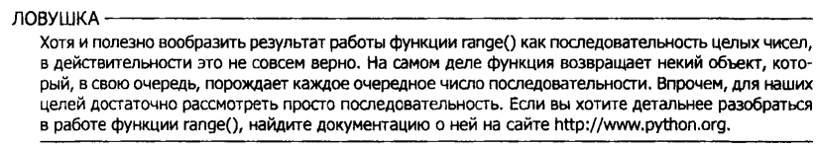

message = input(“your text: ”)
print(“\nLength: ”, len(message))
if “a” in message:
print(“here is \\a\\ in your text!”)
else:
print(“no a”)
input(“\n\nEnter for end”)

print(message[0])

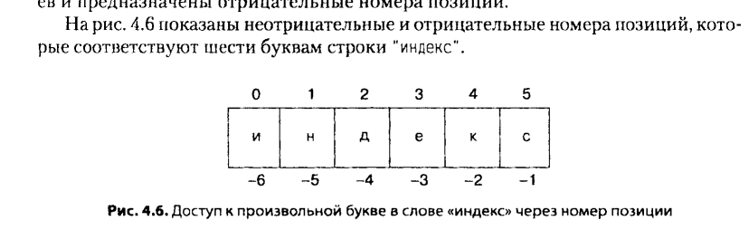

word = input("Enter your word: ")

jumble = ""
while word:
position - random.randrange(len(word))
jumble +=word[position]
word = word[:position]+word[(position+1):]

