Integrated model

Development and testing

Author: Davide Capuzzo

Author: Alessandro Luppi

Last revision on 06/07/2020

# Introduction

After the development of a virtual differential system and of an ESP control, for an all-wheel drive electric vehicle, it is fundamental to integrate the two, to study the combined effect when on a vehicle. The integrated system also requires integration with the complete vehicle model, devised appositely to support testing and validation of the developed system.

The integration requires special care, in order to {TODO}

The objective of this dissertation is to introduce the procedure used to integrate the subsystems and test the integrated model.

In the following there will be introduced:

* input signals used to interface with subsystems;
* output signals provided by the integrated system;
* interconnection between blocks;
* testing of the integrated system.

## System requirements

In order to interface with the model, the following software modules are required:

* MATLAB R2019b and Simulink
* Powertrain Blockset
* Vehicle Dynamics Blockset

# Input and output signals

The input signals use for interface subsystem are:

* **AccelPdl**: provide by the Predictive Driver block is the percentage of throttle pedal inclination.
* **WhlAng**: provide by the steering is the absolute rotation around vertical axis of each wheels.
* **Xdot**: provide by vehicle feedback loop is the speed of the vehicle in earth frame refence frame along X axis.
* **Ydot**: provide by vehicle feedback loop is the speed of the vehicle in earth frame refence frame along Y axis.
* **YawRate**: provide by vehicle feedback loop is the angular speed along the vertical axis of the vehicle
* **MotSpd**: provide by vehicle feedback loop is the speed of each motors

The input signals use for interface subsystem are:

* **TrqCmd**: is the input torque reference for each motor.

# Integration of subsystems

The scheme of the integrated subsystem is shown below. In figure, green block is the virtual differential, orange block is the translation of vehicle’s status to state space variables, blue block is ESP controller.

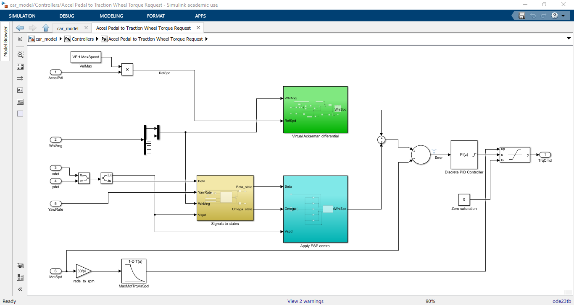

**Virtual differential block**

Virtual differential block requires front wheels’ angles and reference vehicle’s speed as input.

* Wheels’ angles are directly provided from the steering mechanism, which computes them starting from the steering angle on the steering wheel controlled by driver.
* Reference speed is computed from the throttle pedal position. The throttle pedal opening (in percentage) is multiplied by maximum vehicle speed to provide the reference speed as a fraction of the maximum vehicle speed. Therefore, throttle pedal linearly relates to the desired vehicle speed.

Virtual differential block provides the required wheels’ speeds in ideal driving conditions.

* The wheels’ speeds are computed according to ideal Ackerman steering geometry model and assumes ideal driving conditions. They are used to determine the torques required to on-wheels motors.

**Signals to states block**

The signals-to-states block determines the vehicle’s states as required by the ESP control system. Indeed, ESP control system applies optimal control on delta variables, computed as the difference between vehicle’s state variables and states at equilibrium condition.

The block requires some inputs for the correct computation of the states.

* Beta, current side-slip angle, angle between vehicle’s speed vector and vehicle’s longitudinal axis. It is provided by on-vehicle sensors.
* Yaw rate, current angular speed of the vehicle with respect to vertical axis passing through vehicle’s center of gravity. It is provided by on-vehicle sensors.
* Wheels’ angles are directly provided from the steering mechanism, which computes them starting from the steering angle on the steering wheel controlled by driver. They are required for the computation of the equilibrium condition.
* Current vehicle speed is directly provided by sensors. It is required for the computation of the equilibrium condition.

The block returns delta states as required by the ESP control system.

* Delta beta, computed as the difference between side-slip angle, from sensors, and the same angle at equilibrium according to current driving conditions.
* Delta yaw rate, computed as the difference between yaw rate, from sensors, and the same angular speed at equilibrium according to current driving conditions.

**ESP control block**

The ESP control block applies an optimal control strategy, based on the current state of the vehicle, to increase global stability of the car. This system helps in avoiding skidding when cornering or due to bad road conditions (i.e. ice on road).

The ESP control block requires the knowledge of the state of the vehicle.

* Beta is current side-slip angle, compared to current equilibrium condition. It is a state for the ESP control; therefore, it is multiplied by a gain to compute the control action.
* Omega is current yaw rate, compared to current equilibrium condition. It is a state for the ESP control; therefore, it is multiplied by a gain to compute the control action.
* Current vehicle speed is required to choose the proper gain to apply optimal control. It thus determines the gain matrix that will be multiplied by state vector.

The ESP control block provides the required wheels’ speeds difference due to non-ideal driving condition.

* Delta wheels’ speeds are determined, applying optimal control, as the angular speeds which should be added/subtracted to current angular speeds to compensate move a skidding vehicle back to a stable driving condition. They are used to determine the torques required to on-wheels motors.

**Wheels’ torques controller**

The on-wheels motors are torque-controlled. An outer control system is necessary to provide the control torque based on required wheels’ speeds.

A feedback control system is used to enhance the stability. A discrete PID is used to compute the requested torque.

The input for the controller is the difference between required and current wheels’ speeds (input vector with four elements). The output from the controller is the required torque to electric motors (output vector with four elements).

The design requirements for the controller are:

* Fast reaction to variations, to quickly actuate controls required by ESP for increased stability and safety;
* Small admissible overshoot and low ringing, to avoid unwanted accelerations/decelerations of the vehicle;
* Saturation on the torque according to maximum torque deliverable by the motors;
* Only positive torque, as braking torque is eventually handled by a regeneration system when braking;
* No requirements on settling time, as control system is ultimately in feedback with human driver who can adjust speed as wished.

For the above reasons, the PID has been designed having:

* High proportional gain, to fast react to variations in requested speed;
* Low integral gain, to have zero steady state error while reducing overshoots;
* No derivative gain, to reduce ringing;
* Saturation having maximum motor’s torque as upper limit, with anti-windup method;
* Saturation having zero torque as lower limit, with anti-windup method;
* Dynamic saturation to saturate torque according to current maximum torque delivered by the electric motor, with no anti-windup method since integral gain is small.

# Testing of the integrated system

{TODO}