8.3 Web Browsers
Not so long ago, people had separate pieces of software that they used for different purposes on their computer. They checked their email with Thunderbird or Outlook, edited documents on Word or Libreoffice, and viewed PDFs with Adobe Acrobat or evince. Today, most people perform most of these tasks using one piece of software: their web browser.
Web browsers are different from most other normal programs. Because web browsers are meant to take in resources from remote, untrusted areas of the Web and render or run them on the local machine, access control was a central issue to creating Web browsers. In many ways we can think of a web browser as being analogous to operating systems. In the same way that operating systems have system calls to interact with trusted code, the web browser uses the DOM to allow subjects to interact with different web content. In the same way that operating systems manage storage on the disk, and allow or disallow access based on certain policies, the web browser has local storage in cookies, and allows or disallows access to cookies based on certain policies we will learn about later. A visual summary of this comparison can be seen below.
 | Operating System | Web Browser
Primitives | System calls  Processes  Disk | Document object model  Frames  Cookies / localStorage
Principles: Users | Discretionary access control | Mandatory access control
Vulnerabilities | Buffer overflow  Root exploit | Cross-site scripting  Universal scripting
In this video we will explore the similarities and differences between browsers and operating systems, and focus in on how one browser, Google Chrome, does access control and sandboxing differently than the rest. By focusing on strong isolation, Chrome provides good security along with the convenience of not crashing the entire browser when an error is encountered.

Chromium Security Architecture
As mentioned in the video, Chromium has an interesting security architecture compared to other browsers. The browser has a kernel, which is trusted code that is considered privileged, and runs with the full rights of the user that is running the browser. Each tab is run in a rendering engine, which is sandboxed and can run up to 20 processes. If a rendering engine crashes, it only affects the tab(s) that were relying on it. In addition, browser plugins are run in their own process, but are given the full privileges of a browser, almost like a device driver for the browser.
The architecture is demonstrated in the graphic below.
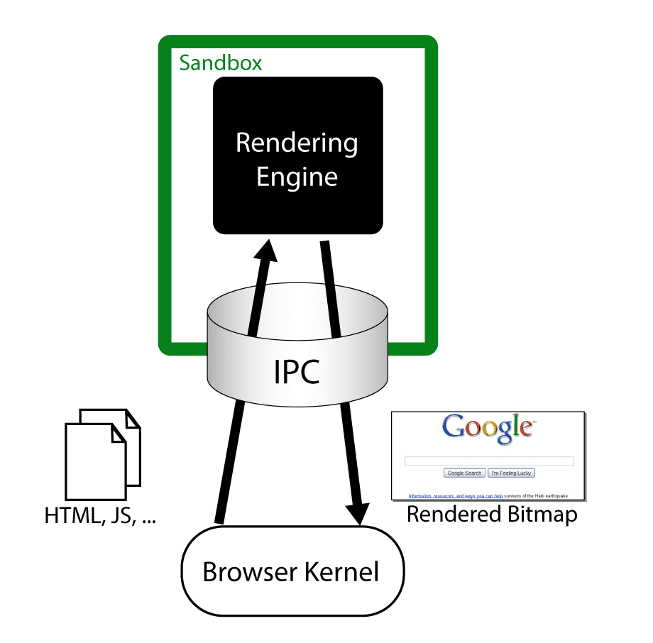

Chromium Threat Model
As mentioned in the previous video, Chromium sandboxes the render engines and plugins so that when one has issues, these issues don't bleed over to the rendering of other sites. However, this is not the only protection Chromium has. In this video we will learn about how Chromium uses capabilities on Windows to minimize what a rendering engine process can do, effectively making it that if the rendering engine is compromised it can not perform too many negative actions on the machine.

Leverage of OS Isolation
As mentioned in the video above, the sandboxing done in Chromium leverages four OS mechanisms. On windows, these include a token with restricted rights, the Windows job object, the Windows desktop object, and integrity levels. Specifically, the rendering engine adjusts the security token by converting SIDs to DENY_ONLU, and adding a restricted SID, and adjusting the token privileges. The rendering engines then run in a Windows job object that restricts the ability to create new process, to read from or write to the clipboard. It also runs on a separate desktop, which mitigates the lax security checking of some Windows APIs.
Since the processes are sandboxed, data sharing between them becomes less trivial. The way data sharing works is that a broker has a Policy engine that feeds into an IPC Service. If the data that is going to be shared is acceptable under the policy, it sends information to the sandbox IPC client, thus making data sharing possible, but still adhering to the policy. This is demonstrated graphically below.
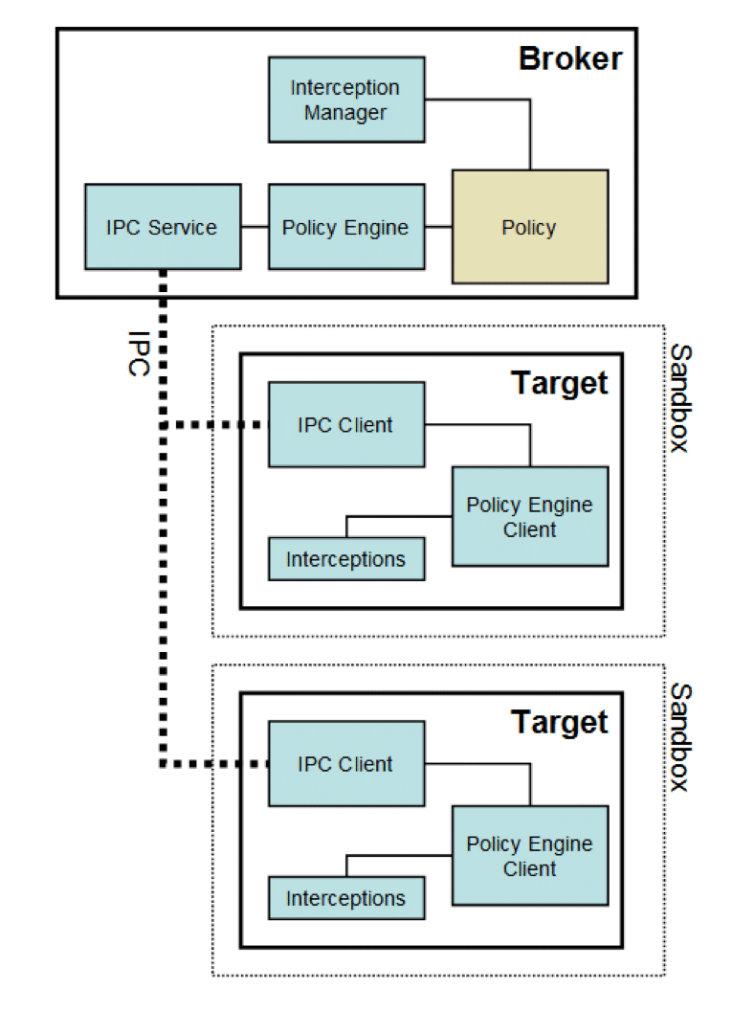

Components of Browser Security Policy
While sandboxing and access control are the mechanisms that keep the browser secure, they are only as strong as the security policy that protect. Browsers create interesting questions for security policy, since we are often running code from untrusted web sites and entities that embed content on those web sites.

Frame-frame relationships
Recall that isolation can be done on a process level in an operating system, and on the frame level in a browser. However, like processes sometimes want to interact with each other on an operating system, we sometimes have frames that want to interact with each other on the browser. There are a few ways that frames can interact with each other, but for the purpose of keeping it brief and focusing on parts of the security policy, we will discuss CanScript and CanNavigate.
Imagine you have two frames, FrameA and FrameB. We say CanScript(FrameA, FrameB) is true if the policy allows FrameA to execute a script that manipulates arbitrary DOM elements of FrameB. We need to be very careful with the CanScript relationship, since running arbitrary scripts on other frames can lead to compromise of accounts, unwanted actions, and other undesirable outcomes.
The CanNavigate relationship is a little different. One important element of a frame is its origin, that is, where it came from. Some security mechanisms rely on the origin in order to make access control decisions. So, being able to change the origin of another frame is something we would want to do only in the most rare of circumstances. For this, we have the CanNavigate check. We say CanNavigate(FrameA, FrameB) is true if FrameA is allowed to change the origin of content for FrameB.
In addition to the frame-to-frame relationships above, a browser also needs to check how a frame can interact with a principle like storage through cookies. Imagine a frame called F and a site called S. Sometimes the frame should be able to read or write cookies from the given site. Sometimes it should not. In order to handle this, we have the ReadCookie and WriteCookie checks. These are fairly intuitive, but formally we say that ReadCookie(F, S) is true if the Frame F is allowed to read cookies from the site S. We say that WriteCookie(F, S) is true if we are allowed to write cookies for site S from frame F.

Good Design Decisions
There are many good design decisions that were made when developing Chromium. Primarily, Chromium decided to follow the principle of least privilege, both to sandboxed code and to the code that controls the sandbox. Sandboxes, and the code inside them, were given minimal privileges to do what they needed to do. Part of the reason for this is because of a good assumption: that code that's running in the sandbox is malicious code. Besides some early code to set up the sandbox, code that starts executing from the moment the untrusted code arrives should be considered to be malicious. Following this assumption, it is only natural, then, that the principle of least privilege be observed to avoid further compromise.
In addition to the privilege of least privilege, the development team of Chromium decided not to re-invent the wheel, and instead let the operating system apply its security to the objects it controls. In addition, it created some application-level objects that have a custom security model, but they did not extend the OS kernel with a different security model.
In addition, Chromium attempts to be nimble. The sandbox is designed to impose near-zero performance impact, but accepts performance penalties for exceptional cases when a sensitive resource needs to be handled in a controlled manner. This is aided by proper use of the OS security mechanisms.
Last, Chromium does not attempt to achieve security by needlessly emulating. Emulations and virtual machines don't inherently provide security by themselves. Instead, Chromium provides sandboxing that does not rely on code emulation, translation, or patching to provide the security desired.

