8.4 Information Flow Control
One proposed system of access control is the thought of Information Flow control. The idea of this is very simple. Imagine we have some sensitive information like a credit card number C. We want to be able to share that credit card number C with entities that need it, such as a store S, but we also want a guarantee that the entity we share it with will not then share it with other untrusted entities, or accidentally leak it to other untrusted entities, like a data broker B. Under information flow control, we would share the information with S freely, without constraint. However, we would then monitor all communications coming from S to any other entity, and ensure that C or information about C are not sent over to other entities. Thus, using this monitoring we get an assurance that the information has not been shared to an untrusted party.
This can be done by tagging the data C and setting rules that we expect S to not violate. For example, we can say that S is not allowed to let C be transmitted on the network. We can then search for this tag among network communications and raise an alert should we find it, and block this communication.
Now that we understand what information flow control is, we may have some questions about its practicality. How can one ensure that all communication of information is being monitored? Are there other ways that attackers can pass messages besides the content that exists in a message? In this video we will reiterate the concept of information flow control, then focus on its limitations in practice.

Data Labels
Now that we understand the basics of information flow control, let's take some time to dive into one of the important aspects of the system: labeling data.
In order for information flow control to work, we need to label each piece of data to indicate permitted information flows, like where data is from, and where it's allowed to flow to. This labeling specifies a set of policies. Among the things these policies address are confidentiality constraints: given a piece of data, who may read it? A label like {Alice: Bob, Eve} specifies that Alice owns a given set of data, and Bob and Eve are permitted to read it. A label such as {Alice: Charles; Bob: Charles} specifies that this data is jointly owned by Alice and Bob, but only Charles may read it.
Another aspect of the labeling of these policies are the integrity constraints. This seeks to address the question who may write this data? A labeling like {Alice ? Bob} means that Alice owns the data, and Bob is permitted to change it.
During computation, an entity can rewrite their own part of the label. For example, let's say Alice (A) and Bob (B) own a piece of data. Originally Alice specified that Retailer 1 (R1) and Retailer 2 (R2) can access this data. Bob only specified Retailer 2 (R2). However, Bob has found a new favorite store, Retailer 3, and wants to add this retailer to the list of entities that can read this data. Bob can then rewrite his portion of the label, as shown below.
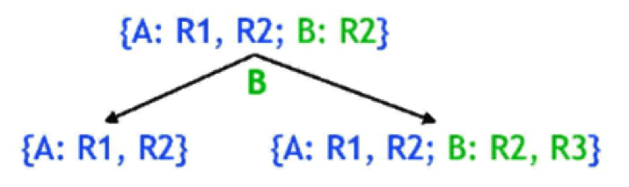
In the following video we will go over labeling in more detail, and discuss how labeling helps in an Information Flow Control example regarding proprietary information about taxes. Though this looks promising at a high level, when we start to look into smaller details about how some of the steps of the example are accomplished, we see that the details are messier than the high level idea demonstrates.

Web Tax Example
Here we provide the graphic of the Web Tax example from the previous video for your convenient reference.
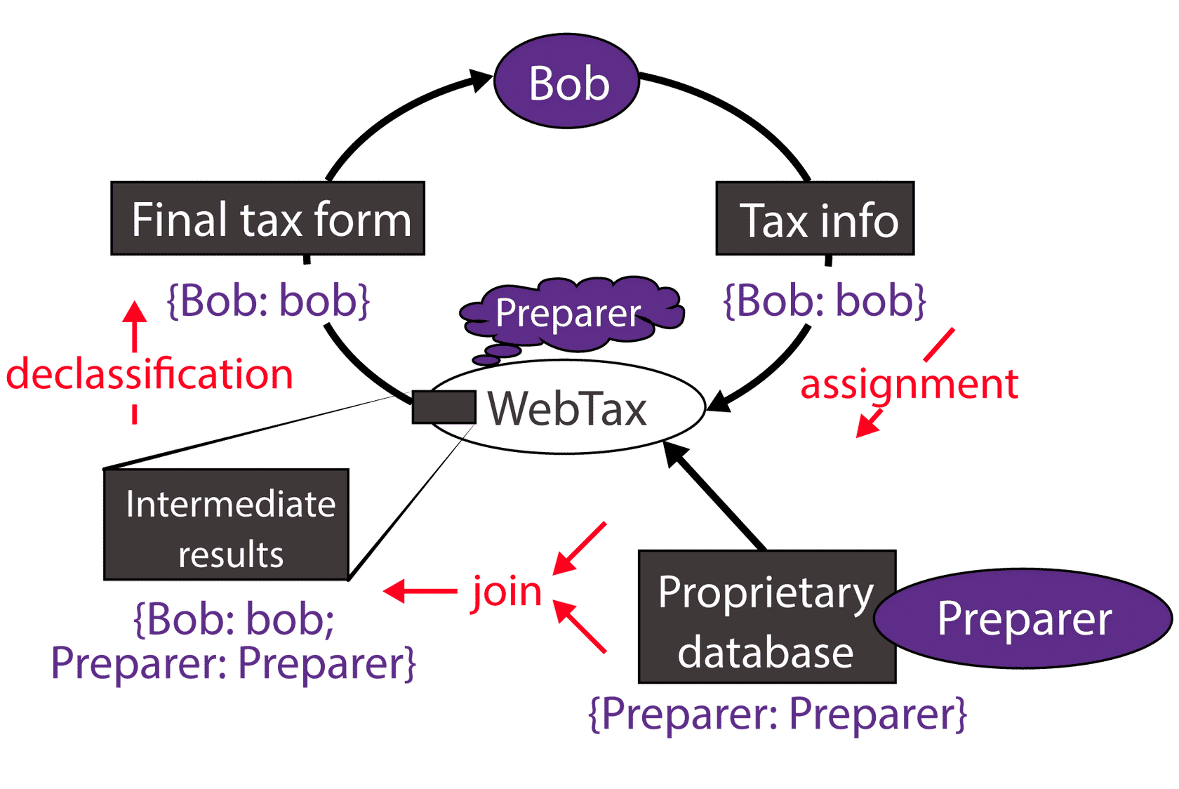

Taint Analysis
Though information flow control is not very usable for access control in practice, there different areas that use information flow control or techniques inspired by information flow control to solve some problems. One example of this is the field of program analysis, which has a technique called taint analysis. In taint analysis, all input controlled by a user is tagged, like data in information flow control systems would be tagged. This user input is then followed through the program to see what functions (seen as entities as we discussed in information flow control) have gotten access to this user controlled information. This allows a team to see what potentially vulnerable functions deal with user information, and identify areas that may deal with malicious input from a user. If a tagged piece of user supplied information is passed to a function without first being sanitized, this is considered a vulnerability.

