8.2 Custom Reference Monitors
Imagine that we are considering writing a custom reference monitor for our system. What should we use, capabilities or ACLs? As a reminder, a reference monitor is a piece of software that sits between a subject and the object it wants to access. It takes as input a policy and a request for an object and decides to grant that request or reject that request. This process is shown graphically below.

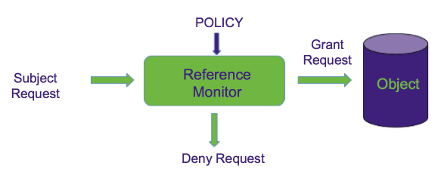

As a reminder, reference monitors must always sit between the subject and the object they want to access. If the subject has a way around the reference monitor, the reference monitor becomes pointless.
In general, we want our reference monitor to be able to make as fine-grained decisions as possible when it comes to access. Coarse-grained rights can lead to granting too many permissions, which is a violation of the principle of least privilege. So which system allows for easier granting of fine-grained permissions?
Well, as the diagram below shows us, the introduction of userids to this equation makes things more difficult, not less. If we have capabilities we do not need to concern ourselves with who is making a request, or who owns an object. We simply need to check if the access is valid based on the capability that's passed. Indeed, we can begin to see that avoiding ACLs makes things simpler in most cases.
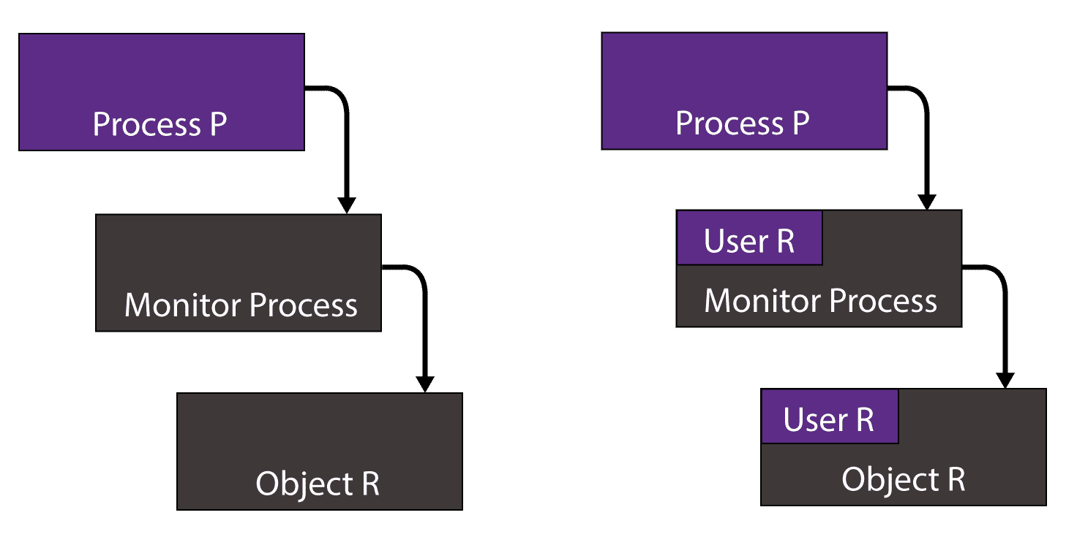

In the following video we will explore the trade-offs for capabilities and ACLs in custom reference monitors more fully, and discuss why capabilities are a better choice.

In the following video we will explore how capabilities allow better chaining of multiple reference monitors without adding trusted code into the system.

Custom Reference Monitor Summary

