Private/public crypto: lol just google it
- open design is better than closed design (kerchoff’s principle)
- don’t reuse XOR keys since you can recover XOR key from ciphertext
> this is how russians made a mistake

------------------------------------

private key cryptop

- DES
- old
- made by IBM
- NSA helped (and was spooky)
- don’t use DES, use aes

DES uses a feistel structure, has s-boxes, key schedule, permut, shift, etc
- does a bunch of simple bit shifting, XOR, etc
- IDGAF about impl, what is DES properties?

---

5.1 Cryptography

What is cryptography?
In contemporary times, we most frequently connect cryptography with programming, but it has quite a long history, dating back to Classical Greece. It’s etymology is actually Greek: Secret (Crypt, from Greek ‘κρύπτος’); Writing (Graph, from Greek 'γράφω'). Before the 20th century, cryptography was largely concerned with language patterns.
Currently, cryptography refers to the study of mathematical techniques to achieve various goals in information security, such as confidentiality, authentication, integrity, non-repudiation, etc. The word does not refer to the means of providing information security, but rather a subset of techniques. In this lesson we will explore some of these techniques and learn about their strengths and weaknesses as security mechanisms.

Open vs Closed Design
As you work though this cryptographic lesson keep in mind our earlier exploration of the principle of open design and the principle of minimizing secrets. As a reminder we summarize these ideas below.

Closed Design (as in military communication during the World War I/II)
When we work with closed design we are deciding to keep the actual algorithm used a secret. However, as we have studied earlier, secrecy is not the same as security, and it is very possible (and even probable) that details about the algorithm will leak over time. This is why proprietary design of crypographic algorithms is considered insecure. If people cannot see it, it cannot be audited to know whether or not it is safe.

Open Design (Kerckhoffs' principle)
The better solution is to have an open design. To do this we can have the algorithm rely on a secret input, called a key, that is required for encryption and decryption. This allows us to publish the algorithm without allowing anyone to decrypt data that has been encrypted with this algorithm previously. This is considered good practice, since it allows many individuals and organizations to audit the code or algorithm and report issues they find back.

Brute Force Attacks: Key Recovery
When we rely on a secret input for the security of our data, we need to make sure that it is very difficult to guess that secret input. One potential type of attack to figure out the key is called cryptanalysis. During one type of cryptanalysis the attacker has both the plaintext and the ciphertext of a message and attempts to figure out the key that turns the plaintext into the ciphertext. One way they can do that is using a brute force attack, or checking all possible keys.
To defend against a brute force attack, the key space, or the number of possible keys, should be very large. This will be discussed in more detail as we continue on, but it is important to realize that computers speed up over time. What is considered very large today may not be so in 10 years, so these parameters will change over time. Our goal should be to make it impractical for the adversary to be able to check every single key, and to adjust whenever the attack speeds up.
Organizations such as NIST provide guidelines on reasonable key sizes. These are good guidelines to follow to ensure your key size is safe.

In order to discuss cryptography we use a standard set of characters in our discussions. These characters represent different things and different capabilities for our communicating parties or their adversaries. These characters are outlined below.
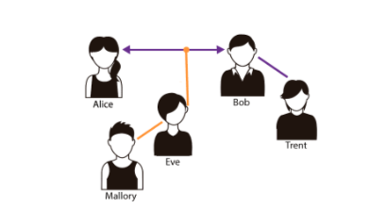
Alice (A), Bob (B) and sometimes Charlie (C) are communicating parties, that is, people who want to speak to each other privately and therefore want to use cryptography.
Eve (E) is a passive eavesdropping adversary, or one who does not alter communications, but just listens and potentially stores them for later analysis.
Mallory (M) is an active adversary performing a man-in-the-Middle attack. This attack allows Mallory to place herself in the middle of the communicating parties, pretending to Bob that she is Alice and pretending to Alice she is Bob. This active attack can include altering messages, delaying messages, and more.
Trent (T) is a trusted third party (TTP). This trusted third party can be used for multiple reasons, depending on the cryptosystem.

Symmetric/Private Key
The first type of encryption we will discuss is symmetric key cryptography. In this type of cryptography the sender and the receiver share a common secret key that is known to only them. Encryption and decryption are then performed using this single key. Sometimes this is referred to by different names, such as private key cryptography (though this can be confusing, more on that later), shared-key cryptography, conventional cryptography, or single-key cryptography.
In this video we will explore the concept of symmetric key cryptography and discuss some historical examples as well as one method of symmetric cryptography that's unbreakable when done correctly: the one time pad.

Symmetric / Private key model
Here we provide a graphical depiction of how symmetric cryptography works, for your quick reference. In this diagram the key is labeled K, the message is labeled X, and the ciphertext is labeled Y. The adversaries guesses at the key are labeled K with an A on top.
As we can see here, the key needs to be shared between parties through a secure channel. If they channel they use to share the key is not secure, an adversary may intercept that key, causing encryption to be pointless. Therefore, when dealing with encryption secrets make sure they are only discusses or transmitted over a secure channel.
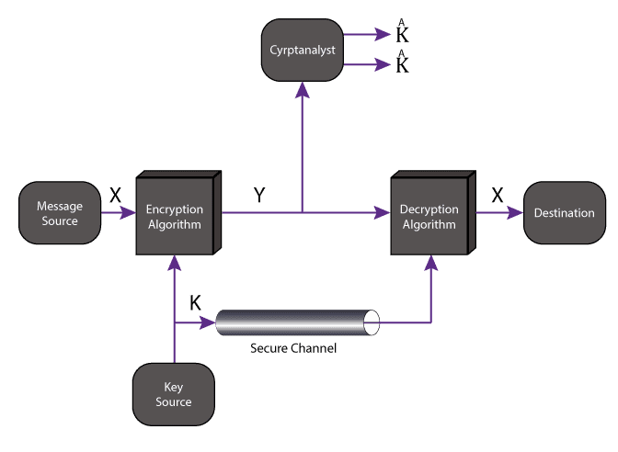

Private Key Encryption: Main Functions
As we could see in the previous video, a cryptographic system is much more than just an encryption algorithm. In symmetric cryptography the cryptosystem is composed of at least three algorithms, each listed below.
A Key Generation algorithm KeyGen(L) -> K where L is a security parameter that represents the length of the key.
An Encryption algorithm Enc(K,M) -> C that takes a key K and a message M and returns a ciphertext C.
A Decryption algorithm Dec(K,C) -> M that takes the same key K and a ciphertext C and returns a message M.

Caesar Cipher (or Shift Cipher)
As discussed in the video, the Caesar cipher is one of the earliest known and simplest ciphers. It is a type of substitution cipher in which each letter in the plaintext is 'shifted' a certain number of places down the alphabet. Details on how this algorithm works is included below.

Substitution
Replace each letter in the plaintext by a letter some fixed number of positions down the alphabet
Example - left shift of 3/right shift of 23:
Plain: ABCDEFGHIJKLMNOPQRSTUVWXYZ
Cipher: XYZABCDEFGHIJKLMNOPQRSTUVW
Ciphertext: QEB NRFZH YOLTK CLU GRJMP LSBO QEB IXWV ALD
Plaintext: THE QUICK BROWN FOX JUMPS OVER THE LAZY DOG

Encryption
Let messages be all lower case from a through z (no spaces or punctuation).
Represent letters by numbers from 0 to 25.
Encryption function: Ci = E(Pi ) = Pi + K (mod 26), where K is secret key

Decryption
Decryption function: Pi = D(Ci ) = Ci - K (mod 26)
Security of Caesar Cipher: Easy to brute force: size of key-space is 26

Private Key Encryption
Now that we know a little bit about symmetric cryptography, we may want to know what algorithms we can use in order to perform it. In this video we discuss two algorithms that were used in the past and phased out of practice today: DES and Triple-DES. We then discuss the algorithm of choice for symmetric cryptography today: AES.

DES Cracking Machine
Deep Crack was designed by Cryptography Research, Inc., Advanced Wireless Technologies, and the EFF. The principal designer was Paul Kocher, president of Cryptography Research. Advanced Wireless Technologies built 1856 custom ASIC DES chips (called Deep Crack or AWT-4500), housed on 29 circuit boards of 64 chips each. The boards were then fitted in six cabinets and mounted in a Sun-4/470 chassis.
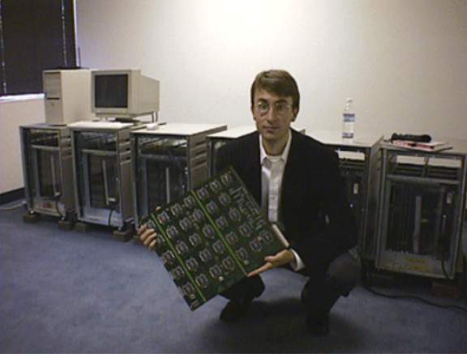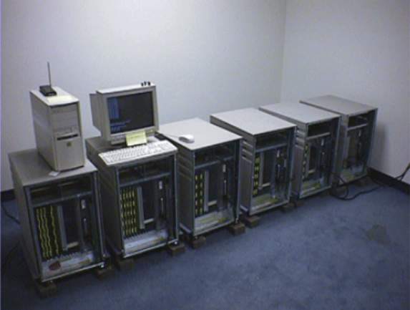

Triple-DES
As mentioned in the video, Triple-DES is a modification of DES that allowed people to continue using the DES algorithm in a more secure way after the original DES had been cracked. The following sections outline how Triple-DES works.

Encryption
Triple-DES encryption applies DES three times to each "block" of the message. It takes a key bundle of 3 DES keys, K1, K2, and K3, and calculates the ciphertext as such:
Ciphertext = Enc(K3, Enc(K2, Enc(K1, plaintext)))

Decryption
When we decrypt this ciphertext we need to decrypt using the keys in the reverse order as encryption, as such:
plaintext = Dec(K1, Dec(K2, Dec(K3, ciphertext)))
If all three keys are independent they together form a 168-bit long key, which makes brute-force attacks more difficult than traditional DES.

Symmetric / Private key Ciphers and their applications
There are many symmetric key ciphers that exist today. Here is a list of them, along with where they are used.
IDEA (used in PGP)
Blowfish (password hashing, which is discussed later, in OpenBSD)
RC4 (used in WEP), RC5
Double DES, Triple DES
SAFER (used in Bluetooth)
AES (pervasive)

Symmetric key cryptography

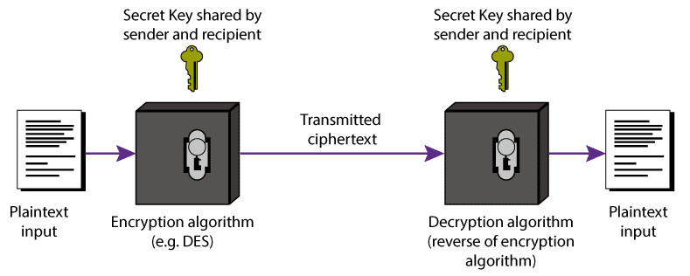
Good: Efficient
Bad: Key distribution and management is a serious problem – for N users O(N2) keys are needed

asymmetric crypto

Problem with symm crypto – how do you transmit the priv key?
Asymm crypto solves this issue – but is slower than symm.
This is related to properties of modular arithmetic, and prime numbers.

Crypto hashes
Collisions are improbable (duh)
- can be used for validation of large pieces of data, by hashing them
“fingerprint”
- malware analysis
- fixed width output
- fast and efficient
- deterministic for I+O

properties
- hash gives no info about input (lol md5 reversing or rainbow tables)
- weak collision resistance property
- strong collision resistance property

