8.1 Capability Based Access Control
In the last lesson we discussed various methods and techniques for access control across different operating systems, and described differed techniques for storing access control information, including access control matrices (ACMs) and access control lists (ACLs). In this lesson we will continue with the theme of access control, starting with the idea of capabilities.
So far when discussing access control we have taken a look at a given object and asked ourselves the question "which subjects can access this, and how?" However, when discussing capabilities we will flip the context of this question around, and instead consider a subject. When looking at a subject we will begin to ask "What can this subject access, and how?"
In the following video we will refresh the concept of access control matrices and access control lists, and introduce the idea of capabilities. This should frame the discussions to come, and help you understand how capabilities differ from the ACLs we have been discussing.

Access Control Lists vs. Capabilities
As discussed briefly above, there are many differences between access control lists and capability systems. In ACLs the system must authenticate the source of a request before it can determine authorization; to see if access to an object is valid the system must first see if the subject is on the list of allowed subjects before a decision can be made. In capability based systems, however, authorization can be done without determining the identity of the subject that wishes to access the object; instead, the subject passes along some proof (given by a trusted party) that they have the permission to access some object to the system. These differences have some implications for how access control can work.
The first implication to consider is the narrowing of permissions when spawning children processes. Under ACLs, each child a process spawns has the same uid as the parent process. Thus, the child has the same access as the parent, even if it only needs a subset of these permissions. To narrow the permissions of the child would require a call to setuid, which is a messy and complicated process. On the other hand, in a capability based system passing on a subset of capabilities is extremely easy: the parent process simply needs to pass to the child the "proof" that it has that it is allowed to access a resource. If the child does not need to access a given resource, the parent does not need to pass along the "proof" associated with that resource.
This concept is depicted graphically below. The left-hand side of the image shows an ACL where the capabilities of the user are inherited by the process. The right-hand side of the image shows a Capability-based system. In the Capability-based system, the delegation can be more fine-grained in the permission child process receive.
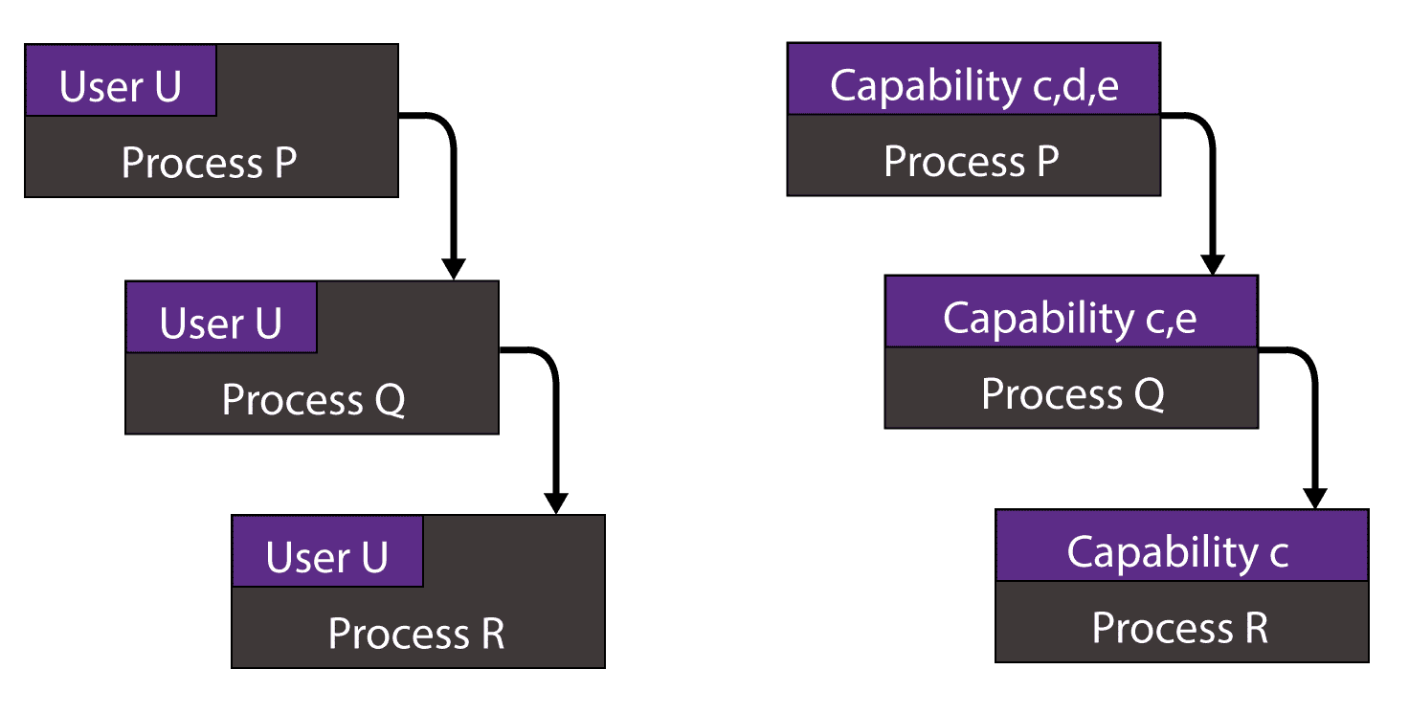

Delegation and Revocation
The discussion above can be seen more generally as an issue of delegation. Under capability-based systems it is easier to delegate either all or some of your responsibilities to other entities, be them child processes or different processes all together. However, there is a flip side to this story. Though capability based systems are better at delegation, revocation of already-granted permissions is very difficult to do unless a large amount of book-keeping is done. If a system does not remember which proofs it provided to which users, how can it instruct the reference monitor to deny certain proofs from a potentially compromised account? Doing this in ACLs, however, is very easy. Since access is dependent on identification, if a subject attempts to access an object that they are no longer allowed to access, the reference monitor will be able to detect and stop this immediately.
In the following video we will explore these trade-offs in more detail, and discuss how capability systems may be able to overcome the revocation shortcoming.

Amoeba OS Mechanisms
As we had discussed in the previous video, capabilities are especially good for distributed environments, where constant authentication of a subject would be a large burden on the system. In this section we will take a look at a distributed OS called Amoeba, and how it used capabilities to allow for access control in a distributed environment.

Amoeba Features
Ameoba was a distributed operating system that worked on a series of computers that were connected via a network. When a new process was started, it could start on a different machine entirely without the user even being aware of which machine his or her process was running on. However, constant authentication on different machines in this environment would be burdensome and would slow the system down, but access control still needed to be performed. Instead, Ameoba OS used capabilities to avoid this issue. Each object in Ameoba OS resides on a server. To perform an operation on an object, a subject would send a message to the server, which would contain the proof of capability, the object, and the operation that the subject wished to perform, as well as a check to ensure that capabilities could not be modified.
In the video below we introduce the concept of Ameoba OS, and discuss how it works in general. We save more detailed explanations of its capability system for a later video.

Amoeba Capabilities
Now that we know some general information about Amoeba, we can begin to jump into some of the technical details. The most important part of this system from a security perspective is how it handles capabilities, and how those capabilities can be verified while remaining unforgable. The way this works is that when a server creates an object, it returns the owner capabilities to the owner. All of the permission bits on the owner capabilities are set to one, meaning everything is allowed. Then it generates a check field which contains a random 48-bit number that is stored server-side and sent to the owner.
When the owner wants to grant capabilities for an object to another subject, they can set some of the rights bits to zero, and calculate a new check field. The server can verify the rights and the check field. Without the owner capability, you cannot forge a derived capability. But how does this work?
Well, the secret is in the check field. When the owner creates a new capability ticket, they generate a new check field using the new rights, XORed together with the old check field using a one way hash function. Said more formally:
checkn = H(checkn-1 XOR rightsn)
The owner can then send this new rights string (rightsn) and the new check string (checkn) over to the subject they want to grant access to. That subject can then send it to the server, who has the old check field. The server can then XOR the new rights string with the old check field, and hash that value. If it matches the new check field, access is granted.
In the following video we will explore how Amoeba capabilities work more thoroughly.

