- attack tree
  - good way to conceptualize all the potential routes that an attack could take place in

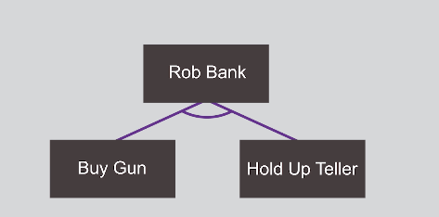

In order to rob bank, you need to buy a gun AND hold up teller.

Without the little circle/connection, it would be an OR.

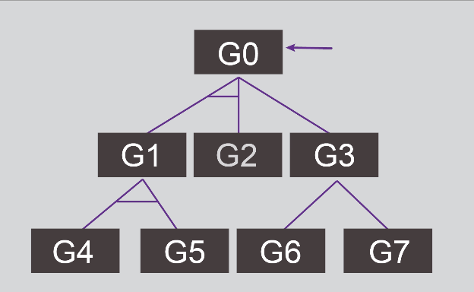

Here, we need to accomplish G0.

We can do:
G3, G7
G3, G6
G2 and G1, G4 and G4

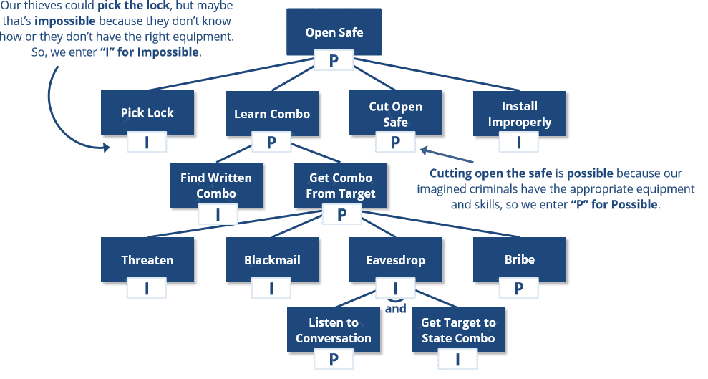
Above, we see boolean attributes (“possible/impossible”) to modify nodes in an attack tree.

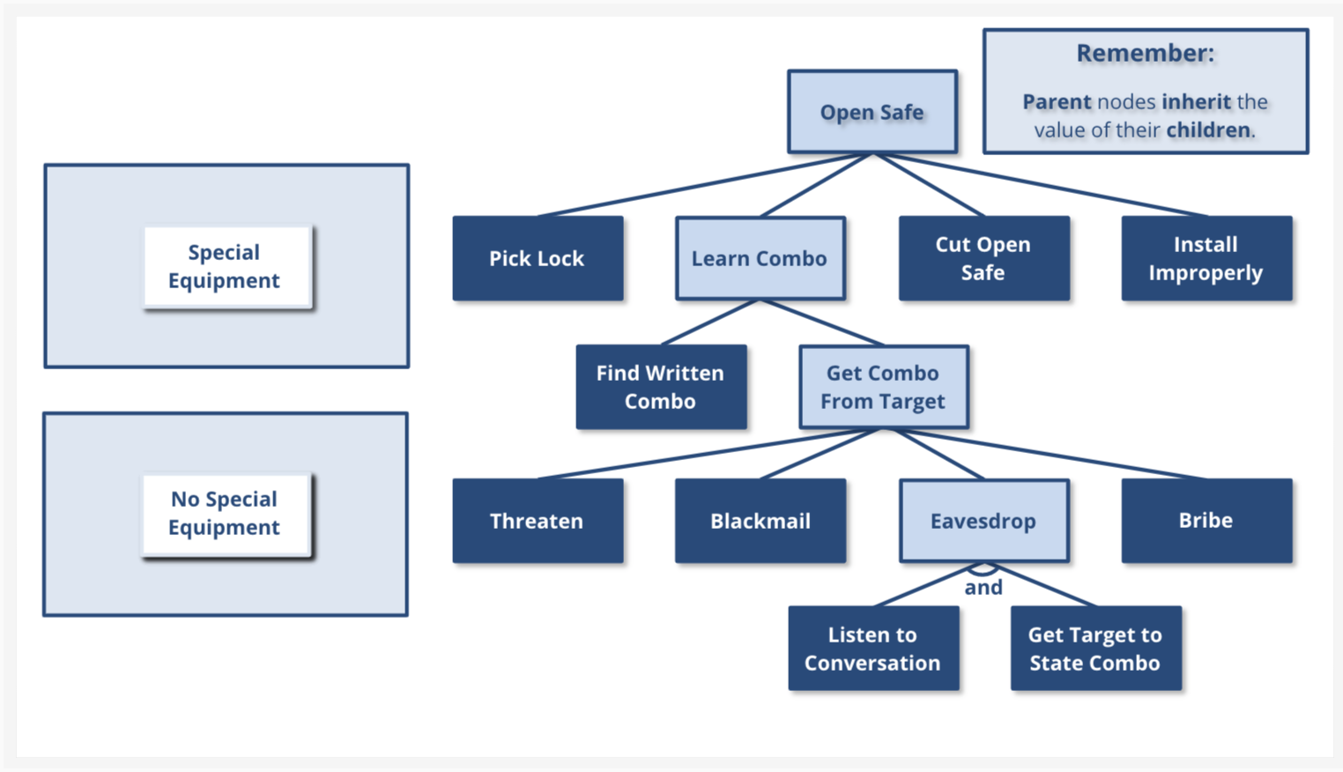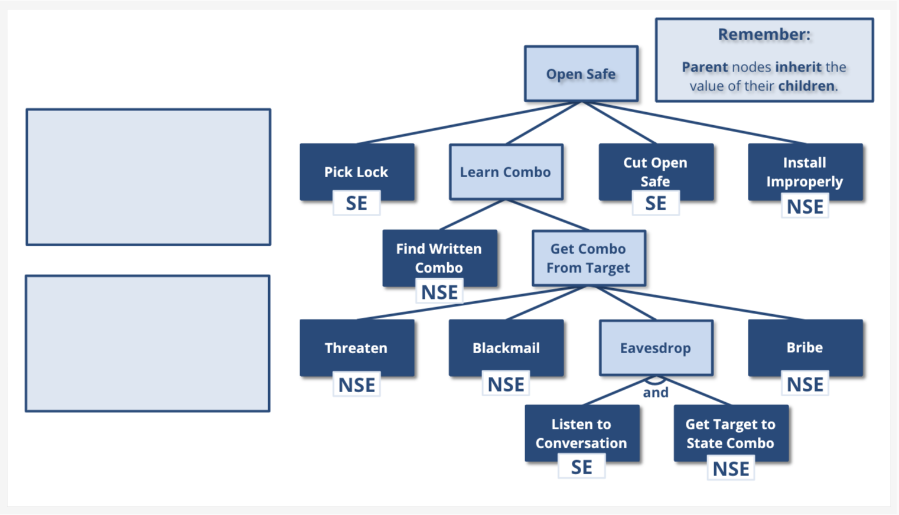

You can also use different labeling schemes where you sum values, only if they’re AND, or just use `min()` on values if they’re OR.

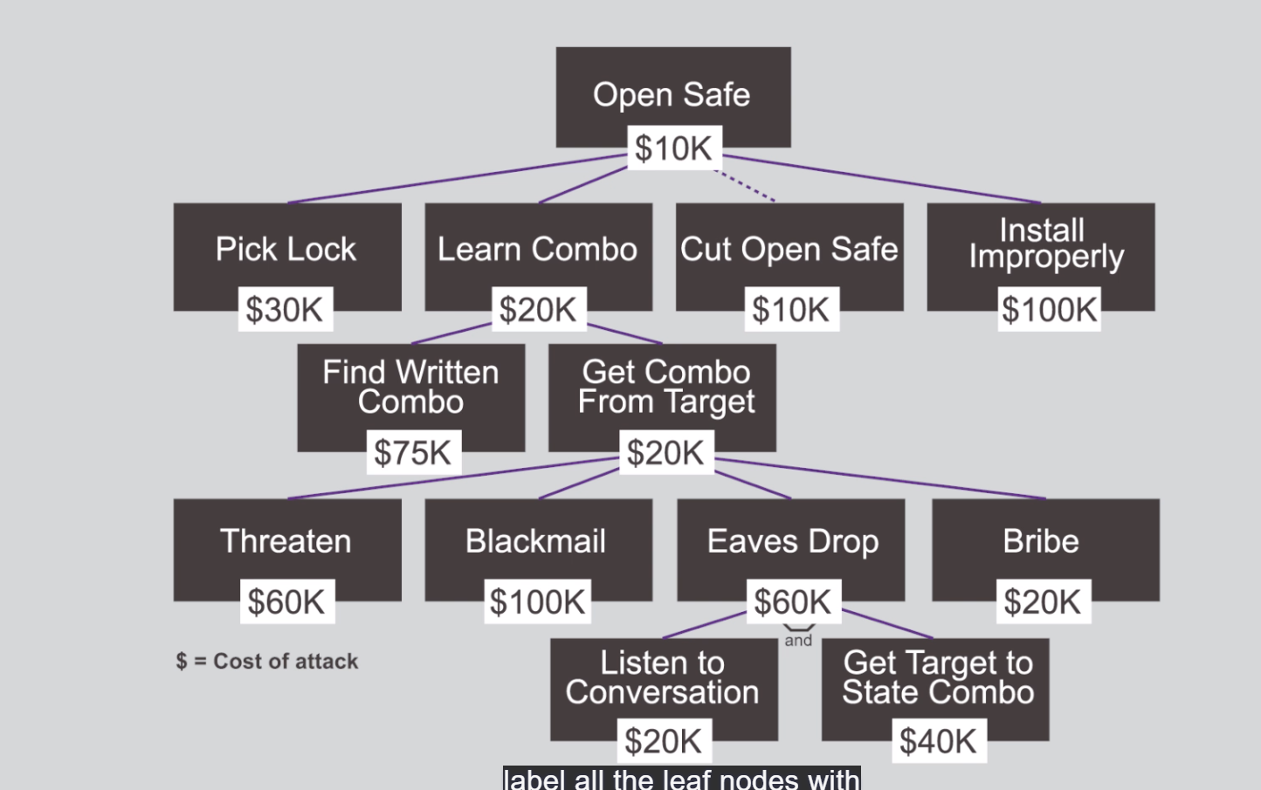

you can also combine both methods. This can be useful to determine which attacks are going to most likely occur.
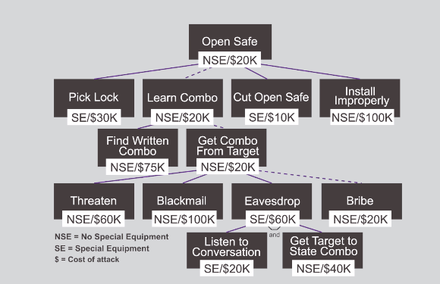

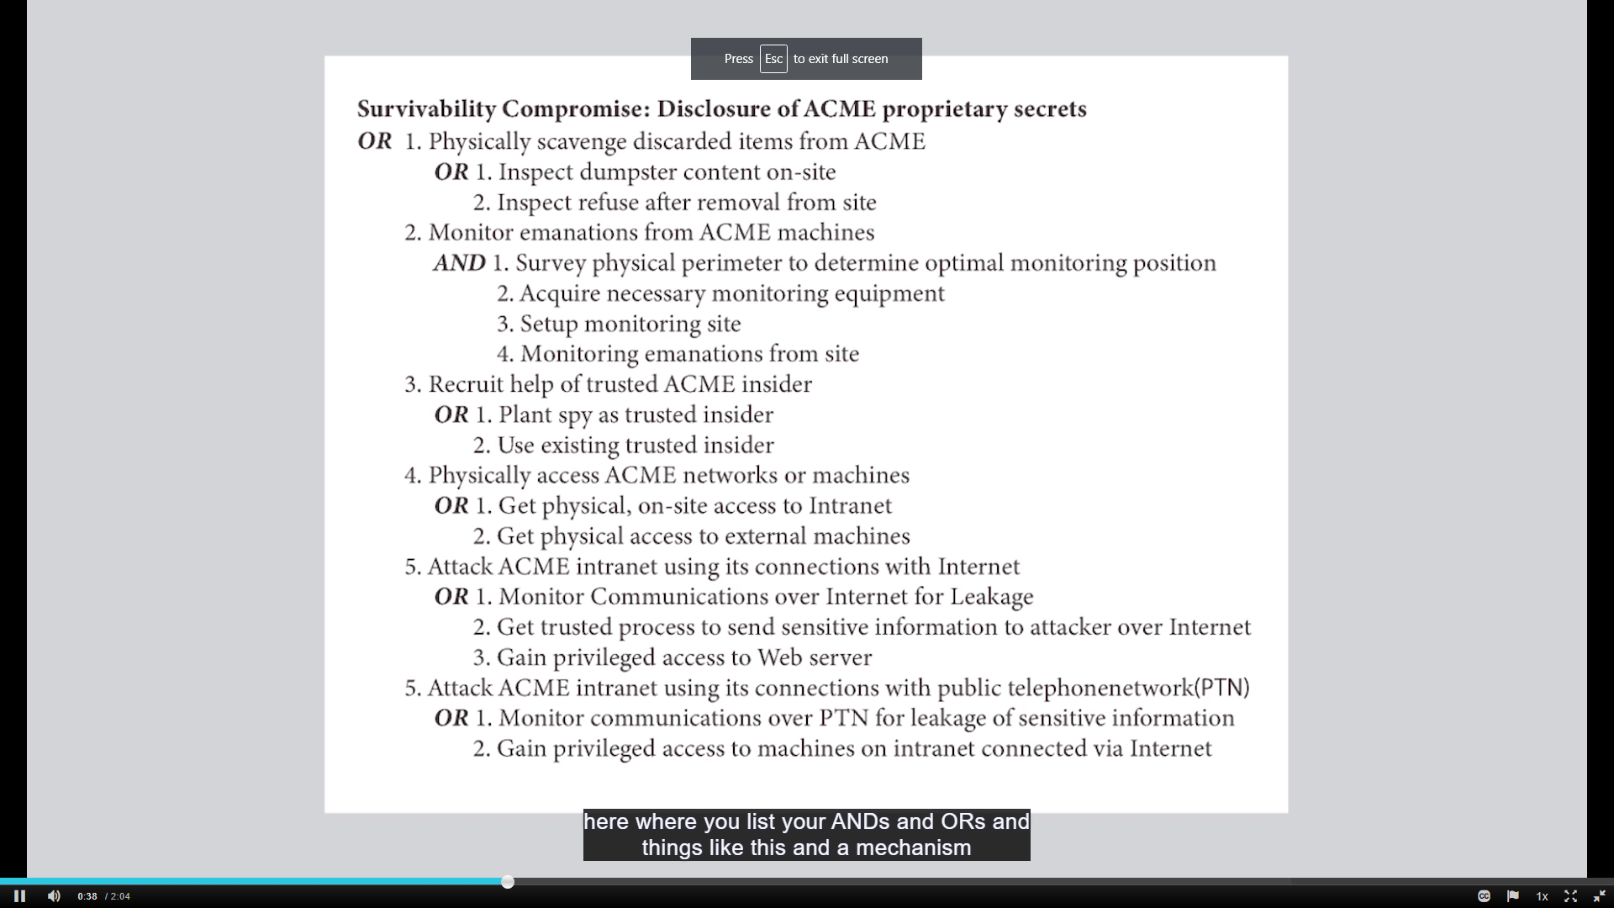

bike lock attack:

- Steal bike
  - Break lock
    - Use cutting tools
  - Wait until lock is unlocked
    - Attack me after I unlock the bike
    - Distract me
  - Get me to willingly unlock the lock
    - Threaten me
      - With physical force
      - With a gun
      - With a knife

---

Risk = p(Attack) x c(attack)
p=probability
c=consequence (aka impact)

---

Assignments and Assessments

Readings & Resources
Threat Modeling as a Basis for Security Requirements
Read: "Attack Trees" by Bruce Schneier
Think: How might you get a copy of a 'do-not-duplicate' key?
Purpose: Think about threat modeling! How Facial Recognition Technology Can Be Used to Get Your Social Security Number
Read about the Cyber Killchain in the original white paper by Lockheed-Martin.

Labs
Please complete the following labs on the Immersive Labs platform to reinforce some of the topics discussed in this week's lecture. Students should submit a screenshot of their completed lab to NYU Classes under the menu item "Assignments".
Immersive Bank – Episode One: Open Source and Credentials
Welcome to episode one of the Immersive Bank lab series.
In this lab you’ll need to identify the service and credentials needed to access the CEO’s corporate remote desktop.
Immersive Bank – Episode Two: Gaining Access
Welcome to episode two of the Immersive Bank lab series.
In this lab you’ll need to use the credentials and details identified in episode one to access the CEO’s corporate remote desktop.

