# 2.1: How to design security?

- Banks giving out small amounts of free money ("round up" for free)
- What can go wrong?
- Couldn't I buy a bunch of stuff for a penny and get free cash??
- someone went and pumped a penny's worth of gas, over and over again, and was able to get a bunch of free money
- lesson: Make a cap on how much money you can earn from this program...
- This is ultimately a security problem
- "Who really lost money"? - Not the bank -- the gas station was the loser. The gas station had to lose money from the credit card processing fees...

## Formative assessment

> Imagine a printer that allows for remote printing with a smart phone app. What could possibly go wrong?

### Draft

1. unencrypted connection

1a. snooping of documents being sent to printer

1c. modifying documents in transit

2. lack of/poor access control on who is able to print documents

2a. remote printing

2b. attackers can cause lack of ink, paper

3. lack of/poor access control on viewing already-printed documents

3a. others can view your printed documents (this is probably the largest risk, imagine if your SSN got downloaded by some random person!)

### Short Answer

1. Unencrypted connection

If the connection is not encrypted between the phone and the printer, a variety of MiTM-like attacks could take place.

a. Snooping on documents sent to the printer
b. Modification of documents sent to the printer

2. Lack of or poor access control on who is able to print documents

If there are not restrictions placed on who is able to print documents, then users could print arbitrary documents, use arbitrary pages or ink. Stealing paper, or causing ink/paper to be wasted could occur.

3. Lack of or poor access control on who is able to view already-printed documents

If these are not restrictions placed on who can view which printed documents, users could view your printed documents. This becomes very dangerous when you print documents with sensitive info, like SSNs or tokens/passwords.

2.2: Fundamental Design Principles

Fundamental Design Principles
Though computer systems are a new thing for a large portion of society, we have still built up a starting amount of expertise in how we can design computer systems to work most efficiently, and with minimal issues for the user. In this section we will be discussing the principles of computer system design, which you can learn about here.

Four Fundamental Design Principles
In this section we will be considering four design principles that we consider fundamental, and that, while not related to security, do aid with computer security.
1. Principle of open design
The concept of the principle of open design is simple: get others to comment on your design. Perhaps the motivation of this idea is best summarized by Linus Torvalds:
“Given enough eyeballs, all bugs are shallow”
2. Principle of sweeping simplifications
The motivator behind the principle of sweeping simplifications, also called the KISS1 principle, is easy to understand: the less complicated something is, the less likely it is that someone made an error in its design or implementation. Therefore we should make designs and interactions easy and simple, so this way it is easy to understand and easy to prove that it is safe. By extension of this principle, it is easy to see that complexity is the enemy of security.
But what if we have to design a system that is inherently complex in order to achieve a goal? This is where layering comes in. The idea is that we split our design into layers, and each layer only communicated with adjacent layers, and preferably having only one role or capability. We can then apply the principle of sweeping simplifications to each layer, and keep the layers simple. We therefore form a hierarchy of layers, each that are easy to audit and analyze.
1: KISS principle: Keep It Simple Stupid!
3. Principle of design for iteration
In many organizations, priorities evolve over time. Sometimes there is a change in the focus of a software project. Sometimes attackers demonstrate new attacks that you have not considered, but that now need to be plugged. The principle of design for iteration is a way to address these situations. It comes down to one simple idea: design your software to ensure you can change parts of it in the future. Abstraction and modular design are powerful tools for applying this principle, and should be considered for all software.
4. Principle of least astonishment
Ultimately, software is written to solve a problem for a user. Therefore, when we are designing a system, we must have the user in mind and create an experience that follows what they user thinks should happen in a given situation. When our software encounters an error, for example, we should present that error in a way that makes sense to the user, and does not seem out of place for the software that they are using.
In the video below we will explore some of these fundamental design principles through examples to get a better understanding of how they can be applied during software development.

Examples

Cipher Machines
Various cipher machines were developed and used during the two World Wars. For example, Enigma, Schlusselzusatz, Purple, etc. It was believed that keeping secret the design of the machines will help boost the security.
Which principle is being violated? You will answer this question in the 2.2 Formative Assessment.

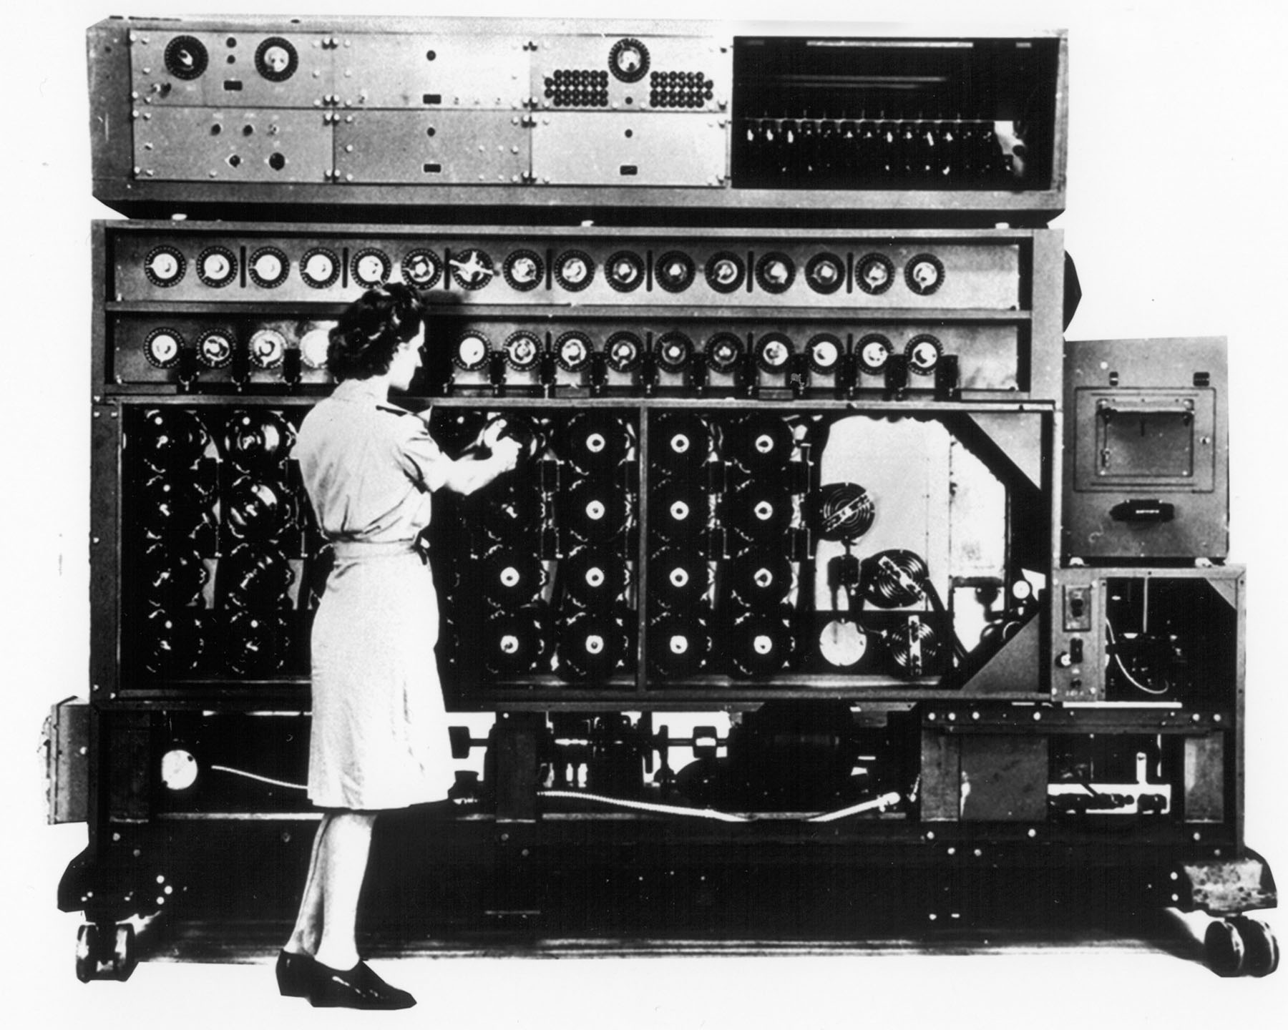

Plug & Socket
In the early days of electricity, someone would run a new wire from the electrical box to each new device. Eventually, the electrical plug / socket was invented (US version in 1904).
What principle does a plug and socket embody? You will answer this question in the 2.2 Formative Assessment.
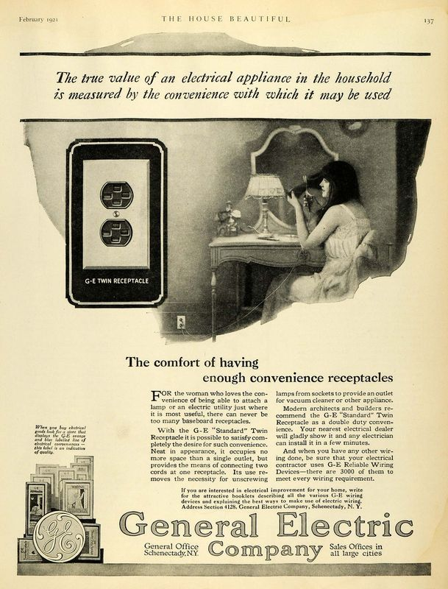

Stock Viewer
The image shows a GUI application for viewing stock market information. Unfortunately in the image an unhelpful error message is displayed to the user.
What principle is being ignored? You will answer this question in the 2.2 Formative Assessment.

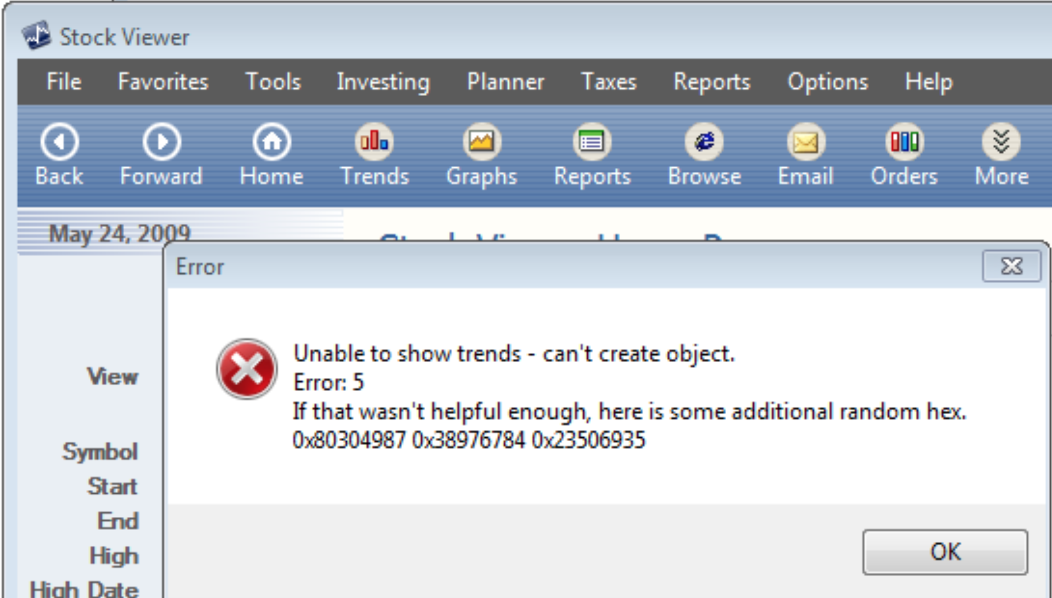

Dieter Rams (Braun, 20th C) & Sir Jonathan Ive (Apple, 21st C)
When you look at the Braun products by Dieter Rams—many of them at New York's MoMA—and compare them to Ive's work at Apple, you can clearly see the similarities in their philosophies way beyond the sparse use of color, the selection of materials and how the products are shaped around the function with no artificial design, keeping the design "honest."

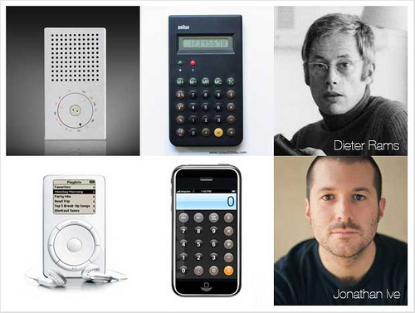

Read this article: Dieter Rams: 10 Principles for Good Design.

