Dennis Chase
Henry Post
John "Cody" Balsamo
Reshma Jabeen
Shephalika Shekhar
Sridhar Srinivasan
Sunil Rai

ITMS 428
Table of contents
Preamble 2
Other work/setup 2
Database Setup Scripts 2
Flask Webserver 4
Database Structure 5
Users 5
Tables 6

Preamble
All of the implementations and controls described here are designed to be replicated by any moderately tech-savvy reader.

The long and short of the steps to set it up is:
- Install Python
- Install WAMP, a simple web server
- Run a few commands

There exists a GitHub repository for this class that contains well-documented cross-platform setup instructions and supplementary materials.

This allows you, the reader, to set up and interact with every single control implementation that we have described.

Other work/setup
We have made some Python scripts that set up a database, as well as a Python webserver to allow the rest of the team to implement their controls in.

Database Setup Scripts
We have created a series of Python scripts that connect to a MySQL database and set up a database environment for our team to play with.

It includes 13 tables and 5 MySQL users, and the script is robust in that it will work regardless of:
- Any amount of tables missing
- Any amount of users missing
- The database does not exist

It also provides helpful error messages that alert the user of:
- No login credentials
- Wrong login credentials
- MySQL server not running

It is also verbose about creating tables and users, giving output to the console on the status of the tables and users.

Below is an excerpt from said console output:

Using the following credentials from 'login_info.txt':
root:<PASSWORD>

<_mysql.connection open to '127.0.0.1' at be2ad578>
If you see some stuff in angle brackets above, IT WORKED! CONGRATULES!

DB 'itms428' exists.

You have the farmer_payment table. Not modifying it.
You have the user_types table. Not modifying it.
You have the productlines table. Not modifying it.
You have the employees table. Not modifying it.
You have the customers table. Not modifying it.
You have the payments table. Not modifying it.
You have the offices table. Not modifying it.
You have the orders table. Not modifying it.
You have the products table. Not modifying it.
You have the orderdetails table. Not modifying it.
You have the test_table table. Not modifying it.
You have the stats_table table. Not modifying it.
You have the users_table table. Not modifying it.

Flask Webserver
We have made a web server using Flask, a very lightweight web server framework.

This means that we can implement the access controls using a server-side scripting language.

As an example, below is an excerpt from the login page’s function that updates the user’s ‘last-logged-in’ time to ‘right now’ if they successfully login.

if login_valid(username=form.username.data, password=form.password.data, connection=connection):
flash("Login is correct. Welcome, {}!".format(form.username.data))
update_login_time_to_now(form.username.data, connection)
return redirect(url_for('main'))

I have highlighted the line which is responsible for performing the updating.

You can see how short and succinct this is, compared to implementing (if you even can?) this single access control using MySQL routines/triggers.

Database Structure
The database our group has made consists of 13 tables and 5 users:
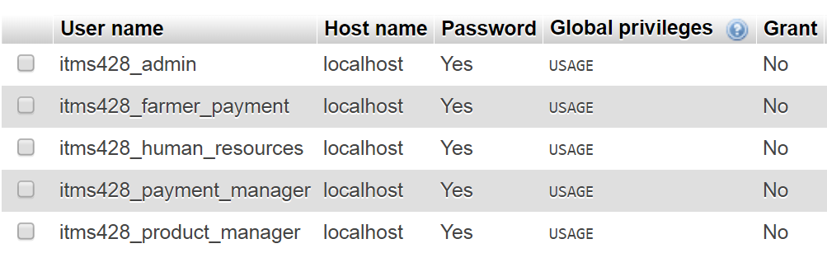

Users
Each user is denied global privileges, and instead, is given a specific set of privileges on a set of tables.

The console output below is quite simple in describing what user has what privileges:

GRANT ALL ON itms428.* TO 'itms428_admin'@'localhost';

GRANT SELECT, CREATE, UPDATE ON itms428.farmer_payment TO 'itms428_farmer_payment'@'localhost';

GRANT SELECT, CREATE, UPDATE, DELETE ON itms428.productlines TO 'itms428_product_manager'@'localhost';
GRANT SELECT, CREATE, UPDATE, DELETE ON itms428.products TO 'itms428_product_manager'@'localhost';
GRANT SELECT ON itms428.offices TO 'itms428_product_manager'@'localhost';

GRANT SELECT, CREATE, UPDATE ON itms428.payments TO 'itms428_payment_manager'@'localhost';
GRANT SELECT, UPDATE ON itms428.orders TO 'itms428_payment_manager'@'localhost';
GRANT SELECT, UPDATE ON itms428.orderdetails TO 'itms428_payment_manager'@'localhost';
GRANT SELECT ON itms428.customers TO 'itms428_payment_manager'@'localhost';
GRANT SELECT ON itms428.farmer_payment TO 'itms428_payment_manager'@'localhost';

GRANT SELECT, CREATE, UPDATE, DELETE ON itms428.customers TO 'itms428_human_resources'@'localhost';
GRANT SELECT, CREATE, UPDATE, DELETE ON itms428.employees TO 'itms428_human_resources'@'localhost';
GRANT SELECT ON itms428.offices TO 'itms428_human_resources'@'localhost';

For example, from the last line we can see that the 'itms428_human_resources' user is given SELECT, CREATE, UPDATE, DELETE on the customers and employees tables, and only SELECT on the offices table.

Tables
Below is a screenshot of MySQL workbench’s relationship editor showing all of the tables in an ER diagram-style format.

