Note IT: A Shareable Notes Mobile Application
Mobile Application Technology Case Study
Course: ITWS-07 · Section: BSIT-4D · Instructor: Gel Cunanan · Date submitted: November 14, 2026
Members: Avila, John Rico S. · Cajucom, Mark Danielle D. · Pajarillaga, Thomas Emmanuel R. · Palaris, Dan Meluin M.

1. Project Information
Note IT is a mobile notes app where users store personal notes in categories and share a note, view-only, with another user by username.
Item | Details
App name | Note IT
Framework | Ionic with Angular, packaged with Capacitor
Backend and database | PHP REST API with a MySQL database
Mobile capability | Haptics (the phone vibrates in confirmation dialogs)
Data operations | HttpClient requests to the PHP API for login, registration, and notes
Target platform | Android (APK)
Source code | github.com/melu-dev-neust/ionic-notes
Installable APK | github.com/melu-dev-neust/ionic-notes
Video presentation | github.com/melu-dev-neust/ionic-notes

2. Problem and Solution
Students and small groups can keep notes in most apps, but passing one note to a specific person usually means copying it into a chat, where it gets buried and the sender cannot control whether it is edited or forwarded.
Problem. Most notes apps are built for a single user. When someone needs to hand a note to a classmate or teammate (a reminder, a schedule, a list), the usual workaround is to paste it into a messaging app. The note is then mixed into the conversation and is hard to find later.
Intended users. Students and small groups who keep short notes and sometimes need to give one to a specific person.
Solution. Note IT is a simple notes app with a small, focused feature set. Users register and log in, write notes shown as cards, and organize them into their own categories (called folders in the app). To share, the user enters the recipient's username. The note arrives in the recipient's separate Shared Notes tab, labeled with who sent it, and the recipient can only read it. Keeping the feature set small was deliberate: every feature is complete and the app is easy to learn.

3. Features
Note IT has fifteen screens and dialogs, shown in Figures 1 to 15 after the descriptions.
Register and log in (Figures 1–2). A new user creates an account with a username, email, and password. Returning users log in with their email and password. The two screens link to each other.
My Notes (Figures 3–4). Notes appear as cards in a two-column masonry layout, similar to Google Keep, each showing the title, an excerpt, and the date. The round button at the bottom right adds a note. The top bar switches between My Notes and Shared Notes and opens account settings. The category chips filter the cards, and the folder button opens category management. Notes cannot be selected in bulk.
Create and view a note (Figures 5–6). The add button opens a blank note with a title and a writing area. The check mark at the top right saves it. Tapping a card opens the note, with Share, Move to folder, and Delete buttons in the top bar. Tapping the back button and there is an unsaved note, the note will automatically save. When opening a saved note and clicking the note text area or title, the note will become automatically editable.
Categories (Figures 7–10). Users create their own categories from the Folder screen and can move a note into any category, or back to No Category. Several folders can be selected and deleted at once, and the app warns that deleting a folder also deletes the notes inside it.
Delete a note (Figure 11). Deleting a note asks for confirmation first, because it cannot be undone.
Sharing and Shared Notes (Figures 12–14). The Share button in an opened note asks for the recipient's username. The note then appears in the recipient's separate Shared Notes tab, labeled with who sent it, and the recipient can only read it. The sender has no list of the notes they shared, and a shared note cannot be unshared.
Account Settings (Figure 15). Settings shows the user's username and email and has a Log Out button

Fig. 1 Register | Fig. 2 Log in | Fig. 3 My Notes | Fig. 4 Category filter
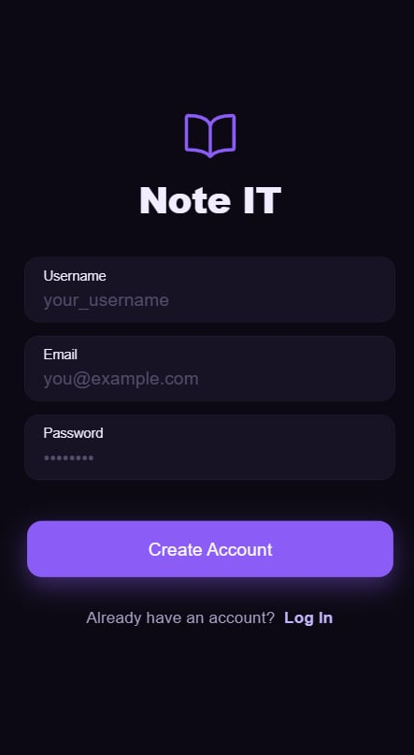 | 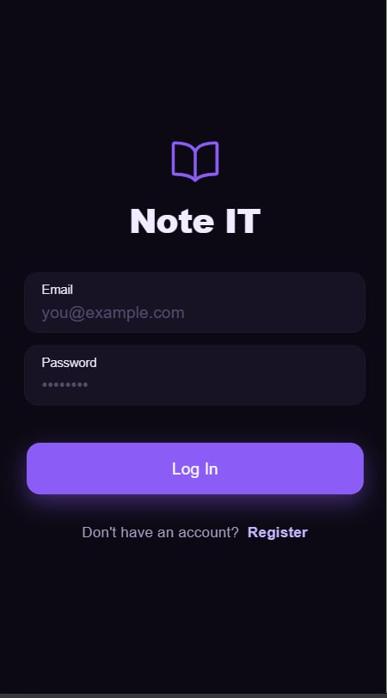 | 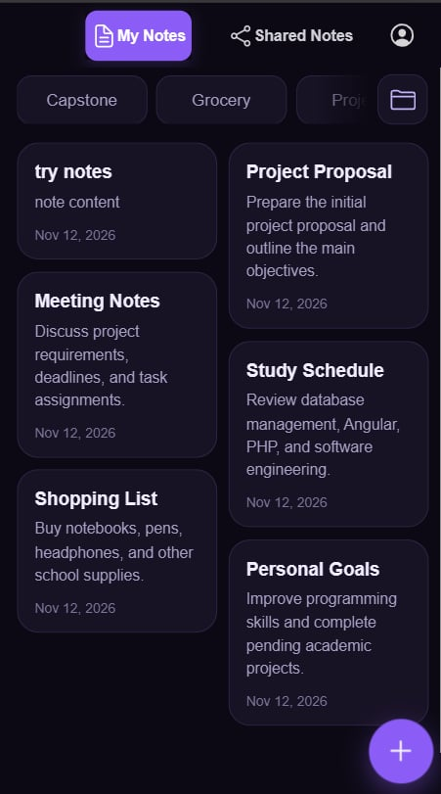 | 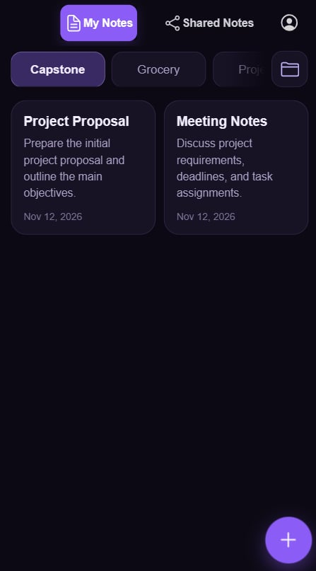

Fig. 5 New note | Fig. 6 Opened note | Fig. 7 New folder | Fig. 8 Folder list
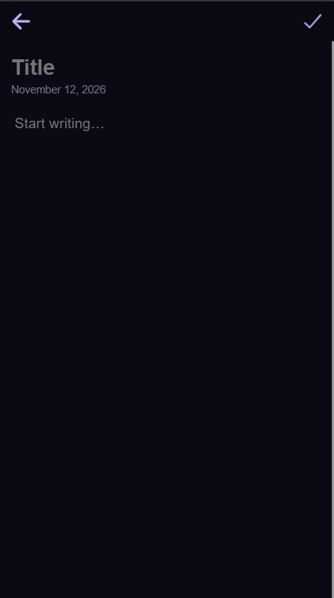 | 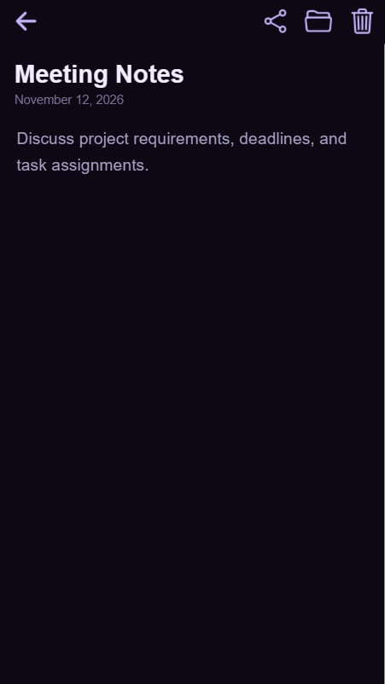 | 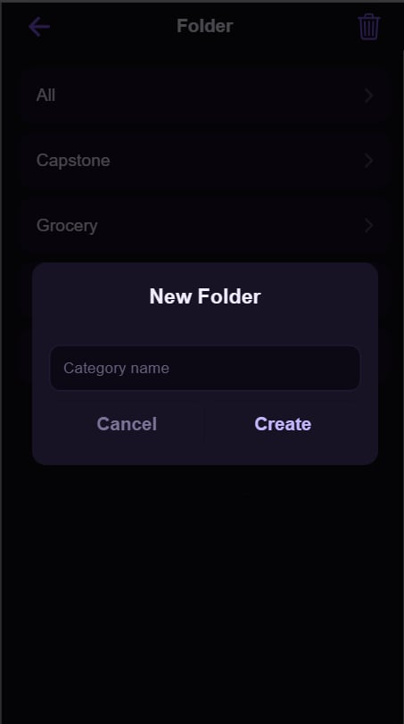 | 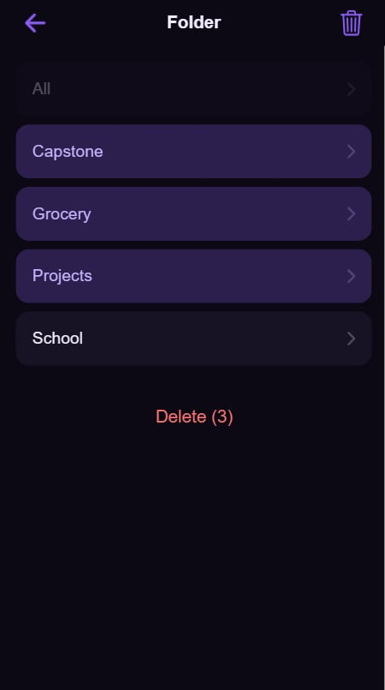

Fig. 9 Delete folders | Fig. 10 Move to folder | Fig. 11 Delete note | Fig. 12 Share note
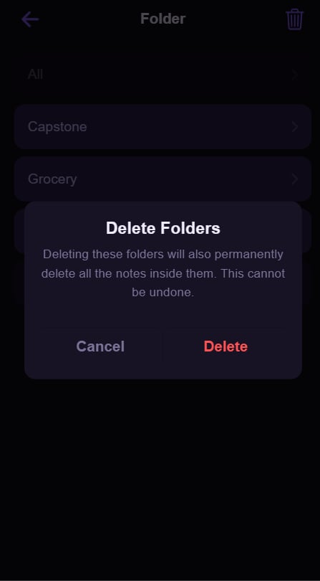 | 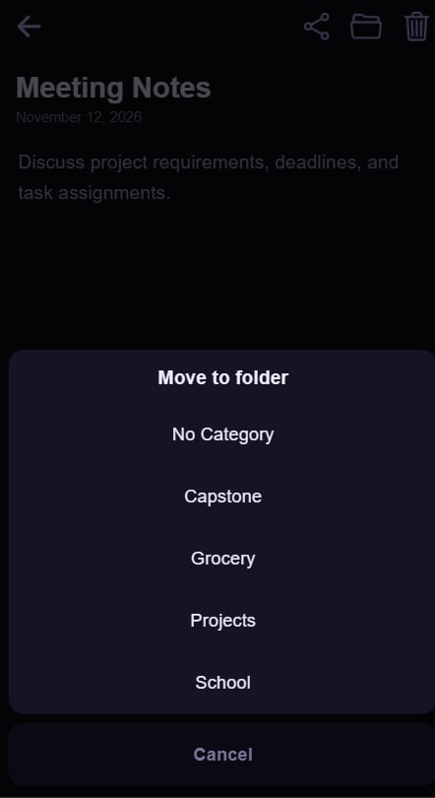 | 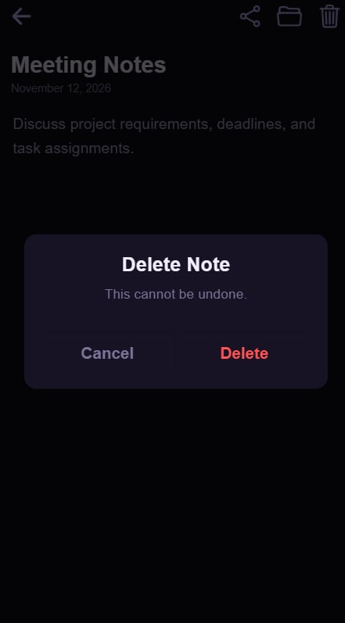 | 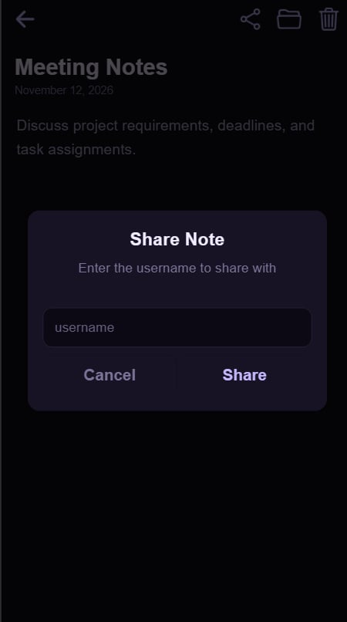

Fig. 13 Shared tab | Fig. 14 Received note | Fig. 15 Settings
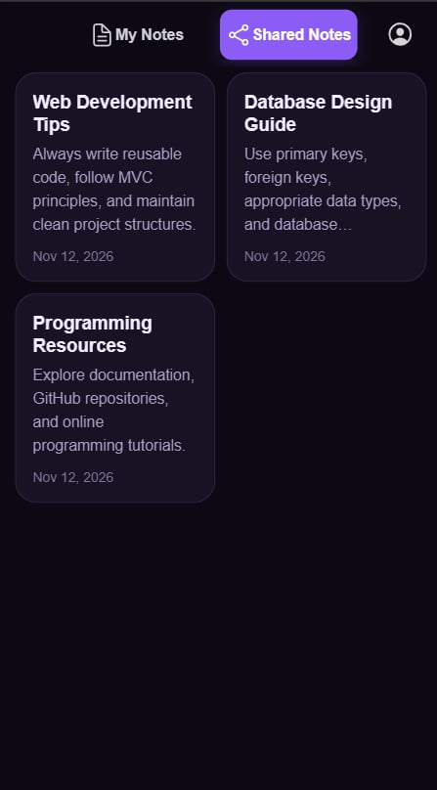 | 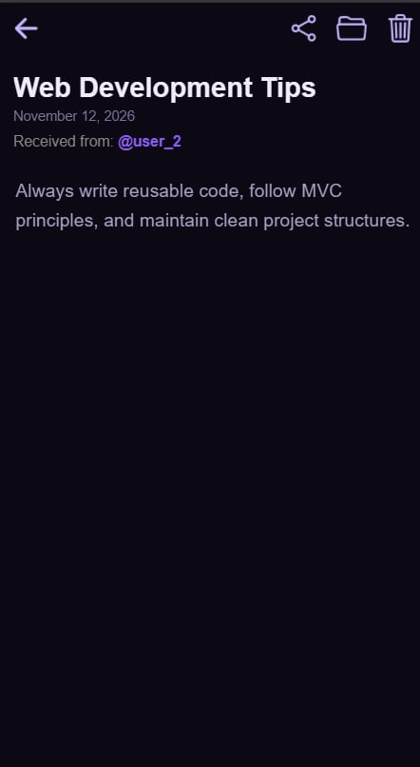 | 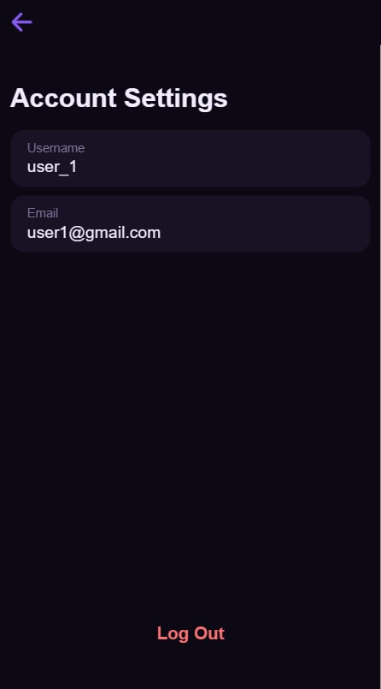

4. Technical Implementation
The Ionic Angular app calls a PHP REST API over HTTP, and the API reads and writes a MySQL database.

4.1 Architecture
- The Ionic Angular app sends HTTP requests through Angular's HttpClient.
- The PHP API (auth.php and notes.php) checks the user's token and runs the request.
- MySQL stores users, notes, categories, shared notes, and login tokens.
- The app updates its screens from the response. Note data is held in RxJS BehaviorSubject streams so the screens update when notes change.

4.2 API Endpoints
Endpoint | Purpose
http://localhost/api/ionic-notes-api/api/auth.php | Registration, login, and token handling
http://localhost/api/ionic-notes-api/api/notes.php | Notes, categories, and sharing

4.3 Database Tables
Table | Purpose | Columns
users | User accounts | user_id, username, email, password
notes | A user's personal notes | note_id, user_id, category_id, note_title, note_content, created_at
categories | Folders created by users | category_id, user_id, category_name
shared_notes | Notes shared between users | sharedNote_id, user_id (recipient), received_from_id (sender), source_note_id, sharedNote_title, sharedNote_content, created_at
auth_tokens | Login tokens | token_hash, user_id, created_at, expires_at
Sharing works by saving a copy of the note's title and content in shared_notes, with the recipient's user_id and the sender's received_from_id. Because the recipient only ever queries rows with their own user_id, a user sees notes shared with them but never notes they shared with others. The copy is a snapshot taken at the time of sharing.

4.4 Mobile Capability: Haptics
The app uses Capacitor Haptics. The phone vibrates in the app's confirmation dialogs, such as Delete Note and Delete Folders, so the user feels the warning before an action that cannot be undone.

4.5 Key Code Snippets
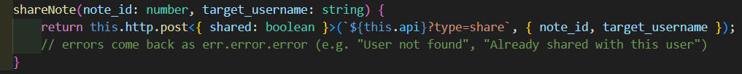
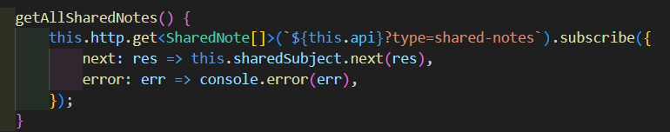
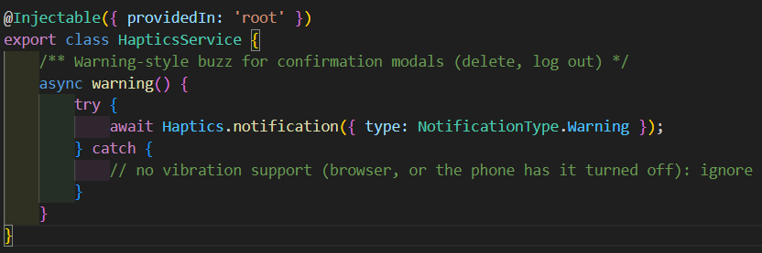

5. Testing, Limitations, and Improvements
We tested the main user flow from registration to sharing. The results below are from our own test run on the app.
Feature tested | Expected result | Actual result | Status
Register with username, email, and password | Account is created | Account was created | Pass
Log in with correct and wrong credentials | Correct credentials open My Notes; wrong ones show an error | Worked as expected | Pass
Add, edit, and delete a note | Card appears, changes are saved, and delete asks for confirmation first | Worked as expected | Pass
Create a category and assign a note | Note appears under that category chip | Worked as expected | Pass
Share a note to a valid username | Note appears in the recipient's Shared Notes tab | Worked as expected | Pass
Share to a username that does not exist | Error shown and nothing is shared | Worked as expected | Pass
Recipient tries to edit a shared note | Editing is not possible | Worked as expected | Pass
Sender looks for notes they shared | Not visible to the sender | Worked as expected: the sender cannot see the notes they shared | Pass

Limitations
- A shared note cannot be unshared.
- Notes cannot be selected or deleted in bulk.
- There is no password reset.

Improvements
- Add a shared-with list so senders can see who has a note.
- Add search across notes.
- Add password reset by email.

6. AI Usage Disclosure
Tool used: Claude Desktop App.
What we used it for:
- Debugging errors.
- Getting help to properly implement and use the RxJS BehaviorSubject class in an Ionic Angular application.
- Designing the masonry layout algorithm for the note cards.
How we handled the output. We read the generated code, tested it in the app, and changed what did not fit our project. No passwords or private keys were included in prompts or in the submitted code.
Example of a change we made. In the main screen (my-notes.page.html), the card list was written with the older *ngFor directive. We changed it to Angular's newer @for control flow, which tracks each note by note_id directly in the template instead of through a separate trackBy function.
Before:
<div class="masonry">
<div class="masonry-col" *ngFor="let col of columns">
<ion-card
class="note-card ion-activatable"
*ngFor="let note of col; trackBy: trackByNoteId"
(click)="openNote(note)">
<ion-card-header>
<ion-card-title>{{ note.note_title }}</ion-card-title>
</ion-card-header>
<ion-card-content>
<p class="excerpt">{{ note.note_content }}</p>
<p class="date">{{ note.created_at | date:'MMM d, y' }}</p>
</ion-card-content>
</ion-card>
</div>
</div>

After:
<div class="masonry">
@for(col of columns; track $index){
<div class="masonry-col">
@for(note of col; track note.note_id){
<ion-card class="note-card ion-activatable" (click)="openNote(note)">
<ion-card-header>
<ion-card-title>{{ note.note_title }}</ion-card-title>
</ion-card-header>
<ion-card-content>
<p class="excerpt">{{ note.note_content }}</p>
<p class="date">{{ note.created_at | date:'MMM d, y' }}</p>
</ion-card-content>
</ion-card>
}
</div>
}
</div>

References
- Ionic Framework documentation
- Angular documentation
- Capacitor Haptics API
- RxJS BehaviorSubject

