Melvin Ngure

Melvinngure07@gmail.com

Abstract

[Draw your reader in with an engaging abstract. It is typically a short summary of the document.   
When you’re ready to add your content, just click here and start typing.]

Campaign and advisers’ performance analysis

Contents

1. Executive Summary 1

Objective 1

Scope of Analysis 2

2. Methodology 4

3. Key Findings 6

Campaign Effectiveness 6

Adviser Performance 7

Key Drivers of Success 7

4. Recommendations 7

5. Conclusion 8

## 1. Executive Summary

Objective

The primary objective of this project is to conduct a comprehensive analysis of marketing campaign effectiveness and adviser performance, focusing on key metrics such as Marketing Spend, Applications Generated, Customers Converted, Interest Rate, and Conversion Rate. By examining these metrics, we aim to uncover insights into the efficiency of each campaign and the performance of advisers, highlighting factors that drive customer interest, optimize conversion, and improve the overall return on marketing investment.

This analysis will include:

1. Evaluating Campaign Effectiveness:

* Campaign Comparison: Assess the performance of each campaign in terms of interest generated, applications received, and customer conversions. This will identify high-performing campaigns and those requiring adjustments.
* Conversion and Interest Analysis: Investigate the Interest Rate and Conversion Rate metrics to understand which campaigns most effectively capture interest and convert leads into customers. Special attention will be given to variations in these rates to reveal any underlying factors driving conversions.

1. Adviser Performance Analysis:

* Individual Adviser Metrics: Review each adviser’s handling of applications, interest rates, and conversion rates to determine their impact on the success of campaigns.
* Comparative Adviser Analysis: Compare adviser performance across different call centers or groups to identify best practices, training needs, and areas for improvement in customer conversion efficiency.

1. Identifying Key Drivers of Success:

* Correlation Analysis: Perform a correlation analysis between critical variables such as Marketing Spend, Applications Generated, Customers Converted, and the Average Value of Customers. This will help to identify relationships and determine which factors most strongly influence campaign outcomes and ROI.
* Cost Efficiency: Calculate and analyze metrics such as Cost per Conversion and Return on Marketing Spend (ROMS) to evaluate financial efficiency. These insights will guide future budgeting and spending strategies.

1. Providing Strategic Recommendations:

Based on findings from the analysis, provide actionable recommendations to optimize marketing campaigns and adviser practices. This will include suggestions for reallocating resources, focusing on high-conversion campaigns, improving adviser performance, and enhancing overall marketing effectiveness.

The ultimate goal is to enable data-driven decisions that enhance campaign results, improve adviser efficiency, and maximize return on investment. The findings will guide strategic adjustments, supporting the organization in achieving higher customer acquisition and conversion rates while maintaining or reducing marketing costs.

Scope of Analysis

This project will focus on a thorough analysis of the marketing campaign data and adviser performance metrics to provide actionable insights. The scope of analysis is divided into several key areas to ensure a comprehensive understanding of campaign effectiveness and adviser contributions. The following outlines the main areas of analysis:

1. Campaign Performance Analysis

* Marketing Spend Efficiency:

Evaluate the distribution and impact of marketing spend across campaigns.

Analyze the cost-effectiveness of each campaign by calculating metrics such as Cost per Application and Cost per Conversion to understand where marketing funds yield the best return.

* Application and Conversion Trends:

Examine the number of applications generated by each campaign to identify those that successfully attract potential customers.

Analyze the Conversion Rate (percentage of applications that convert to customers) for each campaign, highlighting campaigns with high conversion rates as models for effective practices.

* Interest and Engagement Analysis:

Study the Interest Rate generated by each campaign as an indicator of initial customer engagement.

Compare interest rates with conversion rates to determine if campaigns effectively maintain customer interest through to conversion, or if they experience drop-offs.

2. Adviser Performance Analysis

* Individual Adviser Metrics:

Evaluate each adviser’s performance based on their ability to handle applications, generate interest, and convert potential customers.

Metrics such as Conversion Rate per Adviser and Interest Rate per Adviser will be calculated to identify high-performing advisers as well as those who may benefit from additional training.

* Comparative Adviser Analysis:

Perform a comparative analysis of advisers across different locations, teams, or call centers.

Identify trends, similarities, and outliers within adviser groups, providing insights into which strategies or practices are most successful across different regions or teams.

3. Correlation and Relationship Analysis

* Factor Analysis of Key Metrics:

Conduct a correlation analysis between critical metrics such as Marketing Spend, Applications Generated, Customers Converted, and Average Value of Customers.

Explore relationships between these factors to identify which variables most strongly influence campaign and conversion success.

* Impact of Marketing Spend on Conversion and Interest Rates:

Investigate how variations in marketing spend impact interest and conversion rates. Determine if higher spending directly correlates with higher interest and conversions or if there are diminishing returns.

4. Financial Metrics and ROI Analysis

* Cost Efficiency Analysis:

Calculate Cost per Conversion and Cost per Application to assess the financial efficiency of each campaign.

Analyze Return on Marketing Spend (ROMS) by comparing the customer value generated to the marketing costs, providing insights into the financial impact of each campaign.

* Average Customer Value Assessment:

Review the Average Value of Customers metric to determine if high-spending campaigns attract high-value customers.

Identify campaigns that generate high customer value relative to spend, allowing for a prioritization of these campaigns in future marketing strategies.

#### Analysis Tools and Techniques

The analysis will employ statistical and data visualization techniques, including:

Descriptive Statistics to understand central tendencies and variations in campaign metrics.

Correlation Analysis to evaluate relationships between key factors.

Data Visualization to illustrate trends, comparisons, and correlations through bar charts, line graphs, dual-axis charts, and scatter plots.

Calculations for Derived Metrics such as cost-efficiency ratios and return on marketing spend to quantify financial outcomes.

Tools: Python (Pandas, NumPy, Matplotlib, Seaborn, Scipy) , Microsoft Excel, SQL, Power BI, Jupyter Notebook, Microsoft PowerPoint , Microsoft Word.

## 2. Methodology

#### Data Preparation

**1. Data Loading and Inspection:**

Importation of necessary libraries like NumPy, Pandas, Matplotlib, and Seaborn.

Loading of the two datasets: 'Campaigns.xlsx' and 'Advisers.xlsx', representing campaign and advisor performance data, respectively.

Using `.shape` and `.columns` , pandas functions to get the dimensions and column names.

Checking for null values using `.isnull().sum()` and data types using `.info()`.

**2. Derived Metrics:**

**Interest Rate:** Measures campaign effectiveness in generating interest.

*Interest Rate (%) = (Applications interested / Applications generated) * 100*

**Conversion Rate**: Indicates the campaign's success in converting leads into customers.

*Conversion Rate (%) = (Customers converted / Applications generated) * 100*

**Return on Marketing Spend (ROMS):** Shows the financial return on each dollar spent on a campaign.

*ROMS = Total Revenue from Campaign / Marketing Spend*

**Cost per Application:** Assesses the efficiency of marketing spend in generating applications.

*Cost per Application = Marketing Spend / Applications generated*

**Cost per Conversion:** Determines the average marketing spend needed to convert one customer.

*Cost per Conversion = Marketing Spend / Customers converted*

**Revenue per Customer:** Indicates the average revenue generated from each customer.

*Revenue per Customer = Total Revenue from Campaign / Customers converted*

**Net Profit:** Calculates the profit of each campaign by subtracting marketing spend from the total revenue generated.

*Net Campaign Profit = Total Revenue from Campaign - Marketing Spend*

**3. Data Normalization:**

Normalizing the 'Conversion Rate' and 'Interest Rate' columns of the `campaigns_pd` DataFrame using `MinMaxScaler` from `sklearn.preprocessing`. This ensures that these features have a similar range and helps prevent features with larger values from dominating the analysis.

The normalized data is saved to a new Excel file ('Campaigns_normalized.xlsx').

#### Analysis

Creation of histograms for various campaign performance metrics (e.g., 'Applications generated', 'Applications interested') to understand their distribution and identify potential outliers or skewness.

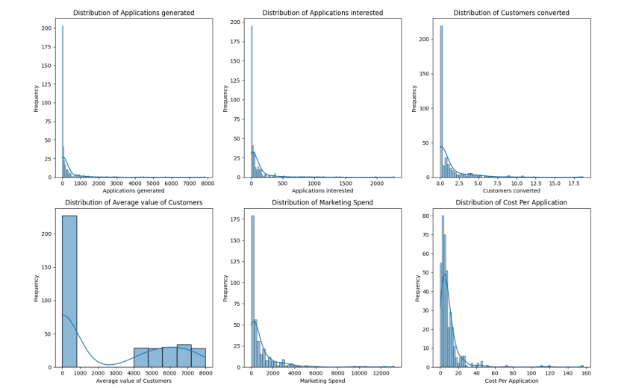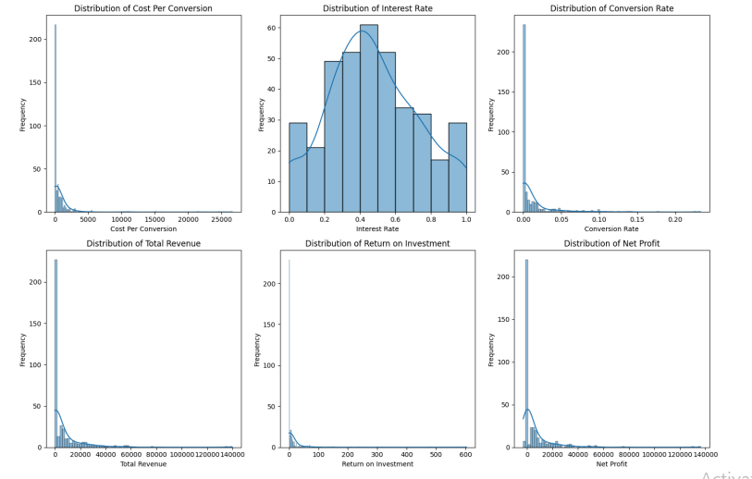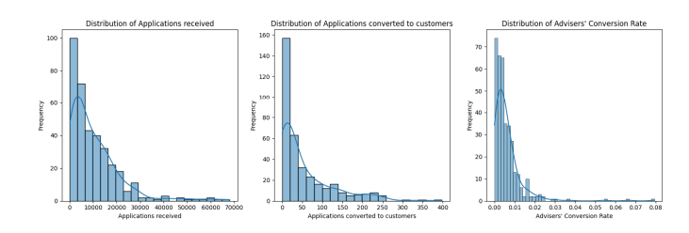

Generation of box plots for the same metrics, providing a visualization of the central tendency, spread, and potential outliers of the data.

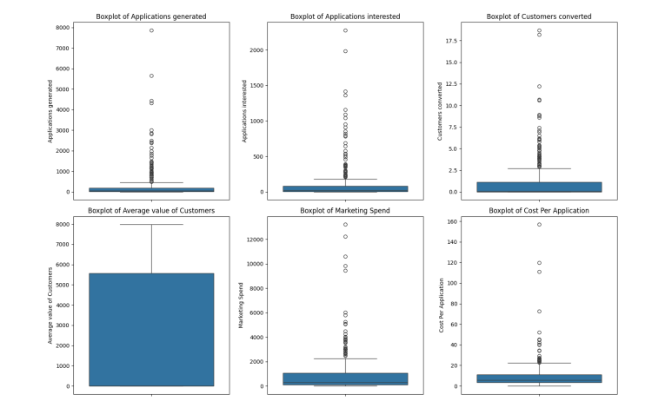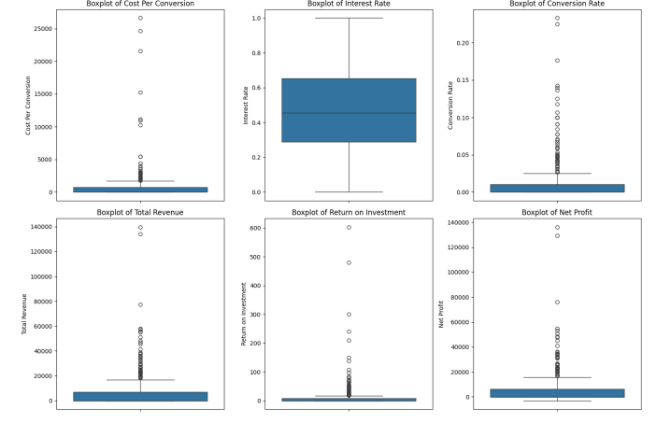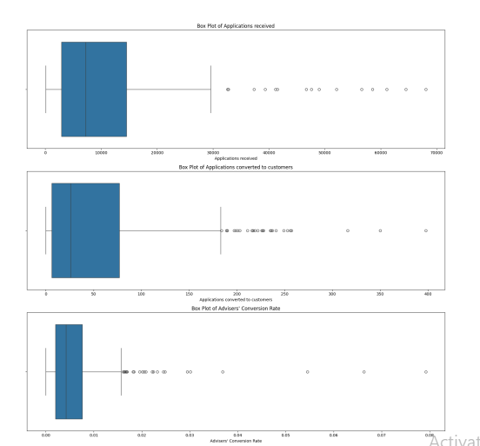

Correlation Matrix to calculate and visualize the correlation matrix using a heatmap to examine the relationships between different campaign performance indicators (e.g., 'Applications generated' and 'Customers converted'). This helps identify potential dependencies and collinearity.

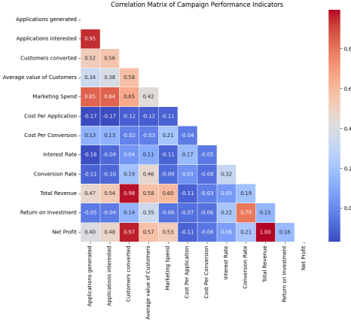

Descriptive Statistics: Use of `describe()` to calculate summary statistics (mean, standard deviation, quartiles, etc.) for the campaign and advisor datasets.

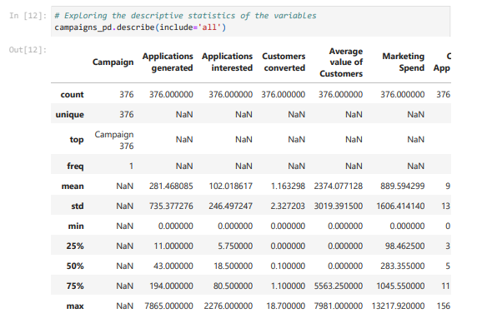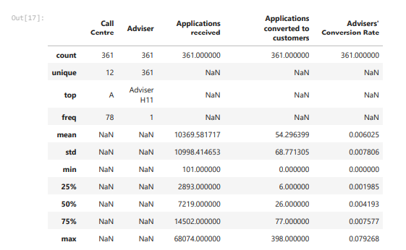

## 3. Key Findings

### Campaign Effectiveness

**High Rate of Unprofitable Campaigns:** With over 60% of campaigns generating a negative net profit, the current marketing strategy is not effectively translating spend into conversions and profitability. This may point to issues in targeting, messaging, or the overall campaign approach, as a large number of campaigns fail to generate sufficient interest or conversions to cover costs.

**Conversion Variability:** Some campaigns showed high interest rates but low conversion rates, indicating that while they attract interest, they struggle to convert leads into customers. This suggests potential issues in messaging alignment or follow-up processes within these campaigns.

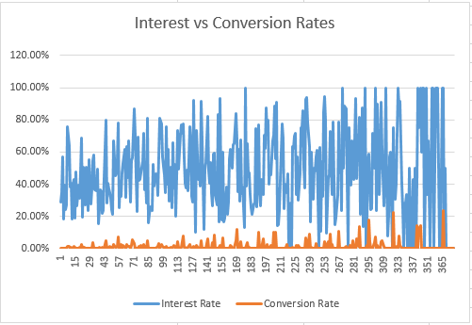

**Marketing Spend Impact**: High marketing spend correlates with high conversion rates. However, a campaign such as Campaign 366 with a low marketing spend of € 5.05 had the highest conversion rate of 23.33%, suggests that strategic spending in targeted campaigns can outperform high-expenditure campaigns with broader reach.



### Adviser Performance

**Low Mean Conversion Rate:** The average conversion rate of 0.006025 (or 0.6%) indicates that, on average, advisers convert a very small percentage of their leads. This low baseline may suggest several factors, such as:

* Possible misalignment between campaign targets and audience expectations.
* Potential challenges in the conversion process, such as lead quality or adviser approach.

**High Variability:** With a standard deviation of 0.007806, there’s considerable spread in individual adviser performance relative to the mean. Since this standard deviation is larger than the mean, it indicates:

* Significant differences among advisers in terms of conversion effectiveness.
* The presence of both high and low performers, where some advisers are likely converting far more effectively than others.

### Key Drivers of Success

**High Correlation Between Applications and Conversions**: Analysis revealed a strong positive correlation of 0.52 between the number of applications generated and the number of customers converted, suggesting that campaigns generating more applications have a higher chance of conversion success.

**Low Correlation Between Marketing Spend and Conversions**: The weak correlation of -0.09 between marketing spend and customer conversions indicates that simply increasing budget allocation does not guarantee higher conversion rates, highlighting the importance of targeted and strategic marketing approaches.

**Cost Efficiency and Return on Marketing Spend (ROMS)**: Campaigns with high ROMS delivered strong conversion results while maintaining budget efficiency. This indicates that these campaigns were able to attract and convert customers with minimal expenditure, serving as benchmarks for efficient budget allocation.

## 4. Recommendations

**Focus on High-Converting Campaigns:** Reallocate resources towards campaigns that consistently show high conversion rates. By investing in top-performing campaigns, the organization can maximize conversions while maintaining cost efficiency.

**Adjust Messaging for Low-Conversion Campaigns**: For campaigns with high interest but low conversions, conduct A/B testing to refine messaging and better align with customer needs. This could involve altering the campaign’s value proposition, visuals, or targeting criteria to improve lead-to-customer conversion rates.

**Strategic Budgeting Based on ROMS:** Prioritize budget allocation to campaigns with high ROMS, as these deliver a better return on each dollar spent. Campaigns with high conversion rates but moderate spend levels should be considered as primary candidates for additional funding.

**Limit Spending on Low-Yield Campaigns:** For campaigns with low ROMS, consider reducing budget allocation or re-evaluating campaign strategies. Reallocate these funds to support campaigns that generate more efficient customer conversions.

**Segmentation**: With more data, we would be able to segment the audience based on demographics, preferences, and past engagement to ensure that campaigns are relevant to specific groups. This can help tailor messages and increase interest rates by focusing on well-defined audience subsets.

**Targeted Campaigns**: For each segment, develop targeted campaigns that address specific needs or interests. A more personalized approach may enhance relevance and improve both interest and conversion rates.

**Training Opportunities**: Advisers with below-average conversion rates indicate possible gaps in skills or engagement techniques. Adviser Y, for example, had one of the lowest conversion rates despite handling a substantial number of applications, pointing to a potential need for targeted training or support.

**Targeted Performance Enhancement:** Focus on subtle improvements in conversion techniques rather than extensive overhauls. Training sessions could involve fine-tuning specific skills, such as objection handling, personalized customer engagement, or improving product knowledge to increase overall effectiveness slightly.

**Peer Learning and Coaching:** Encourage advisers to share their approaches in a collaborative setting, leveraging the team’s overall consistency to implement small yet effective performance adjustments. This can foster an environment of continuous learning where advisers can adopt proven, minor refinements to boost conversion rates across the board.

## 5. Conclusion

This analysis aimed to optimize marketing campaign and call center advisor performance for improved customer acquisition and return on investment (ROI). It involved exploring campaign and advisor data, identifying key performance indicators (KPIs) such as conversion rates, interest rates, and marketing spend, and examining their correlations.

By implementing recommendations herein this document, the company can:

* Increase Customer Acquisition: More efficient and targeted campaigns coupled with improved advisor performance can lead to a higher number of converted customers.

* Improve ROI on Marketing: Refining campaigns and allocating resources strategically can improve the return on marketing investment.

* Enhance Advisor Productivity: Training and coaching initiatives can lead to increased advisor productivity and customer satisfaction.

* Gain a Competitive Advantage: Optimized marketing and operational processes can give the company a competitive edge by acquiring more customers and improving customer lifetime value.

Implementing these recommendations will require collaborative effort and continuous monitoring. However, the potential benefits of enhanced customer acquisition, improved ROI, and a stronger competitive position make these efforts worthwhile.