# AISC2013 - Deployment of AI Solutions

# FINAL EXAM SPECIFICATIONS

**Assignment Guidelines:** Application Development with Version Control and Docker

Name: Melvin Raju :500223500

**App.py**

**Requirement.txt file**

**Model.ipynb**

**Dataset.csv file**

**Index.html file**

**Java.json file for front end**

**Docker file**

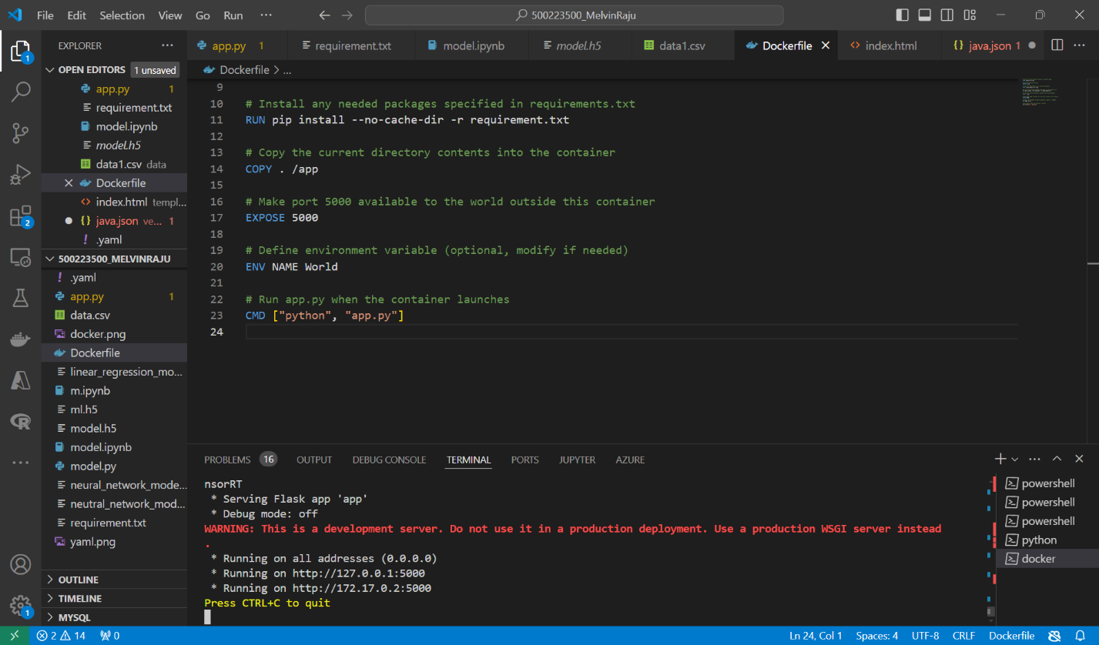

**Docker code**

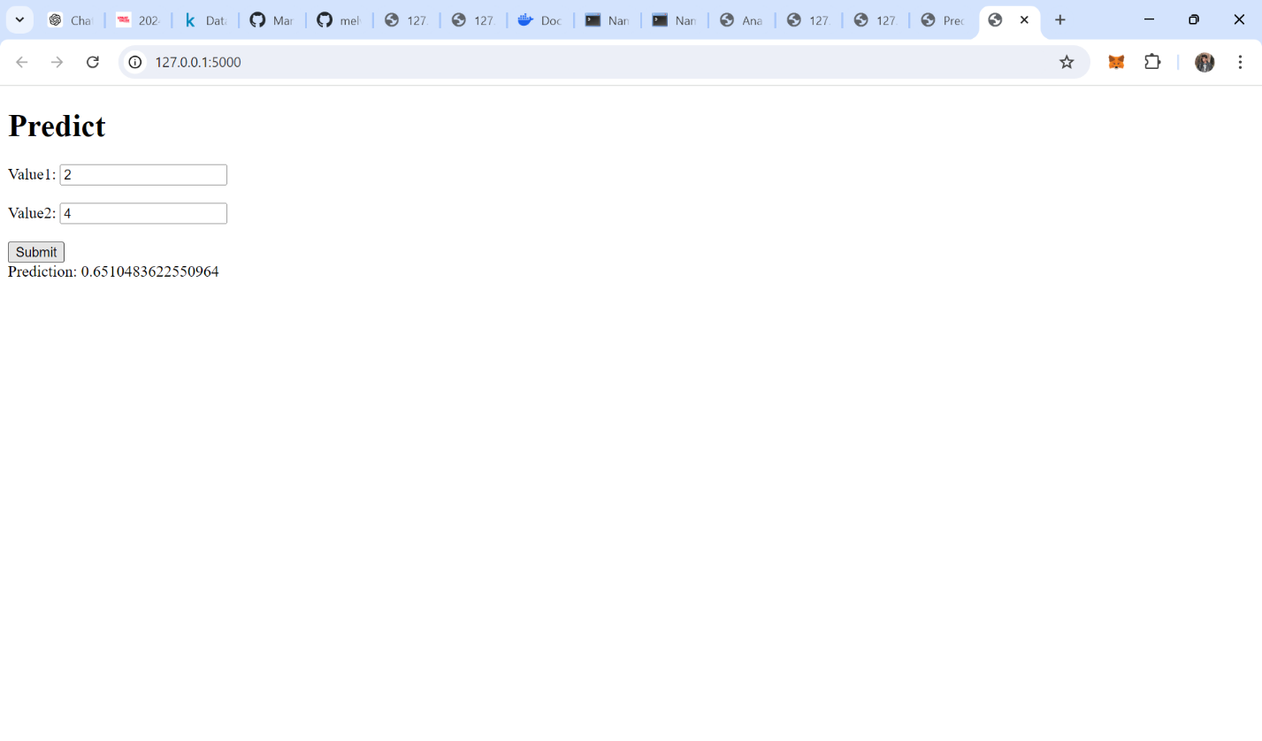**Docker Front end -Output**

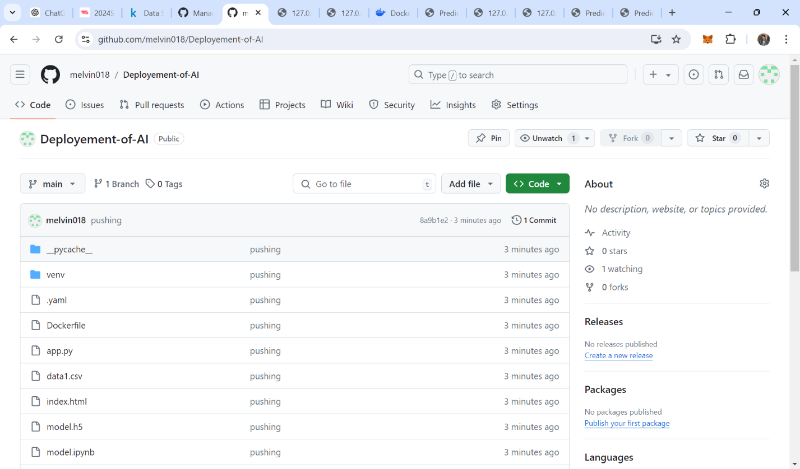

**Git hub repository By Melvin Raju :** **https://github.com/melvin018/Deployement-of-AI.git**