IndiePy

Joyce Cai   
*Bachelor of Science in Computer Engineering*  
*De La Salle University*Manila, Philippines  
joyce_yuenlam_cai@dlsu.edu.ph

Eugene Reyes  
*Bachelor of Science in Computer Engineering*  
*De La Salle University*Manila, Philippines  
eugene_cedric_reyes@dlsu.edu.ph

Daine Jadman  
*Bachelor of Science in Computer Engineering*  
*De La Salle University*Manila, Philippines  
daine_jadman@dlsu.edu.ph

Personalized learning is a learning system wherein it caters to the user's specific needs, skills, and interests to provide education that ensures proficiency. The study aims to design a program that utilizes Python and incorporate personalized learning to educate users who are inexperienced in Python’s programming language. Python is a programming language with structures that are neat and simple. In addition, it is also flexible and friendly. Being open-source and integrated, it is freely available online and comes with its own independent programming environment. The program was made using Spyder, a Python integrated developer environment. Furthermore, it mainly utilized the Tkinter module to create a graphical user interface program. The final output yielded a positive result wherein there are several lessons and exercises that are interactable. It has successfully become user optimized and the users’ pace in learning is up to their discretion.

Keywords—personalized learning, Python, programming

# Introduction (*Heading 1*)

“In an age where standardized tests are the norm, personalized learning offers a different perspective on education -- one that puts the student first” [1].

From the word personalized, meaning “to make personal or individual” from Merriam-Webster Dictionary, personalized learning is a learning system that is tailored for an individual’s specific interests, needs, skills, and background to provide versatility and ensure proficiency [2] [3]. Essentially, it focuses on the student wherein the teaching pace and approach are optimized for the student’s prior capabilities and background knowledge. "That means students drive their learning and are the ones responsible and accountable for their learning," expounded Barbara Bray and Kathleen McClaskey, co-founders of Personalize Learning and members of the International Society for Technology in Education (ISTE) [5]. Students choose when, where, how, and what they will learn[5]; thus, allowing them to learn at their own pace without worrying about getting left behind[1]. They contribute to their learning with the choices and efforts they make. They are free to set their own goals and collaborate with others. Dreambox Learning shows that 93% of educators agreed that students benefit more when learning at their natural pace[1].

When compared to traditional learning that is focused on the majority, personalized learning is focused on individualization to ensure a sure chance at mastery[1]. Moreover, personalized learning encourages students to look up sources, often online, for furthering their understanding. Unlike traditional learning where almost everything came from either the teacher or “predetermined course materials” [1]. According to Dreambox Learning, 94% of the educators stated that students responded better with a technology-integrated curriculum [1].

According to Pane, Steiner, Baird, & Hamilton (2015), “personalized learning has four key attributes: learner profiles, personal learning paths, competency-based progression, and flexible learning environments” [2].

Motivation is a key factor in a personalized learning environment.

Personalized learning is based on the concept of experiential learning [9]. Experiential learning is the grounds that learning is best done through experience [9]. It involves students moving from theory to pure practice, and making them see and experience them in real life. Students would then need to think and reflect [9].

In a traditional classroom setting, students are sometimes disconnected from the instructor [7]. The traditional approach is a linear process in which a teacher introduces a new material to the class, followed by the teacher giving out handouts for students to reinforce their learning and finally, a quiz, to assess their understanding [7]. The problem with this method is that the class moves on regardless of how many students master the material [7]. Some students tend to be left out, while some may sit idly by because they already mastered the material beforehand [6].

Salman Khan, the founder of the massive online learning platform khanacademy.com, argued that a student should be remediated or be accelerated if they can in that scenario [6]. He argued that students should strive for mastery over the subject matter rather than being proficient at it. Personalized Learning solves this problem by meeting the student’s individual learning needs while incorporating their interests and preferences [6]. This model considers individual student interests, learning needs and level of ability [6][7]. This inspires academic excellence as well as promotes student independence and personal growth.

Personalized learning is expensive and difficult to implement, but the emergence of technology has made it easier. Technology has made it more convenient for educators to develop and implement such learner-centered lessons [7]. Technology could solve the historic constraints of one to many teachings. Various algorithms could be developed and implemented to numerous mediums and provide the same learning environment as a classroom setting [7].

A study was conducted by Pane et al. to assess the effectiveness of personalized learning in several high schools in America [8]. The respondents were schools that started or had already implemented personal learning in their curriculum. Results show that the schools of those students gained better performance and achieved student achievement compared to when personalized learning was not implemented. Results showed that students had a better disposition towards learning, personal growth, and responsibility post-implementation.

This project aims to design a program that employs personalized learning system to teach Python programming language. The program will gauge the student’s programming skills with a set of questions and teach Python programming according to the level of expertise.

“Python is powerful... and fast; plays well with others; runs everywhere; is friendly & easy to learn; is Open” [10]. It is a general-purpose, high-level, object-oriented, interpreted programming language with simple and neat structures [10] [11]. With an easy to learn and readable syntax and fast edit-test-debug cycle, Python is a great language to get into programming [12]. Unlike conventional languages like C++ and Java that are designed for large-scale programming focusing on structure and discipline, Python is flexible and friendly [10]. It makes exploring and experimenting easy without being a “toy language” [10]. Being open-source and integrated, it is freely available online and comes with its own independent programming environment.

# Methodology

## The program is written in Python and made using Spyder, a Python integrated developer environment (IDE). It mainly utilized the Tkinter module to create a graphical user interface program. Lessons, quizzes, and challenge exercises are created as text files for optimization then parsed by the program to output.

## The conceptual framework of the program will be shown and discussed in this section. The hierarchy chart of the modules present in the program will also be presented in this section. The program’s logic and flow will be presented through its flowcharts and pseudocodes, along with a brief explanation for each flowchart.

## Conceptual Framework

# Fig. 1 illustrates the general conceptual framework of the program. The input of the program would be the user’s input data, specifically, his/her answers to the initial assessment and succeeding quizzes. The data obtained would then be processed to evaluate the user’s knowledge on programming and used to recommend lessons. Students can choose the recommended lesson or a different one to learn. The program would teach the chosen lesson and administer a test on it. Answers would then be processed to scores and used to determine the advancement to next topics or the reinforcement of previous topics.

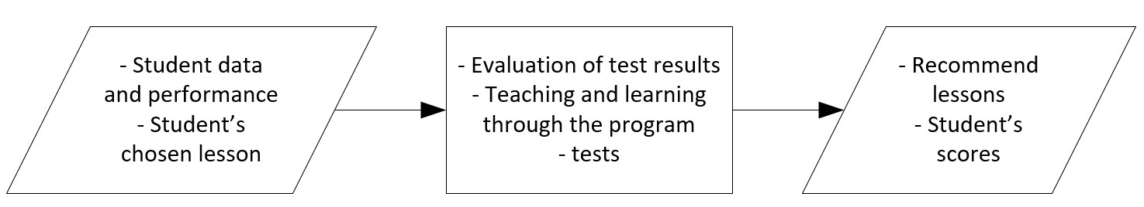

1. IPO Chart (*Input-Process-Output-Chart*)

## Hierarchy chart

Fig. 2 shows the hierarchy chart for the main module, index.py. The index.py module has three functions as follows:

* on_configure() function that makes the content section scrollable;
* on_configure_table() function that makes the table of contents section scrollable;
* update() function that refreshes the content section and loads the respective contents for the content section.

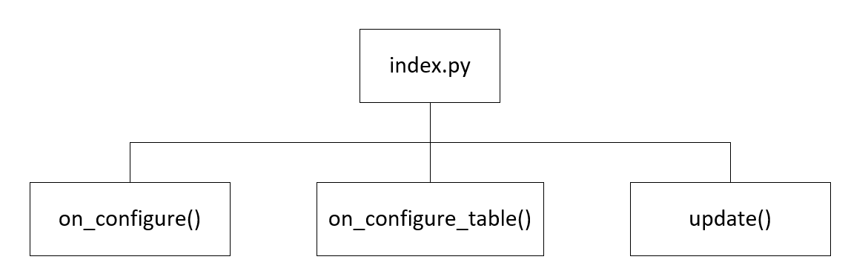

1. Index.py Hierarchy Chart

Fig. 3 shows the hierarchy chart of sampleoutput.py. The sampleoutput.py file is a separate module that consists of two functions as follows:

* basicHtmlParse() function that parses the lessons and challenges text files. It has a sub-function called hint() that generates a button that displays a hint if clicked.
* quizHtmlParse() function that parses the assessment and quizzes text files. It has three sub-functions namely:
  + check() function that checks the answers and adds the scores;
  + next() function that clears the content section and updates the flag for next question;
  + ask() function that asks the question by displaying the question and the choices or entry widget.

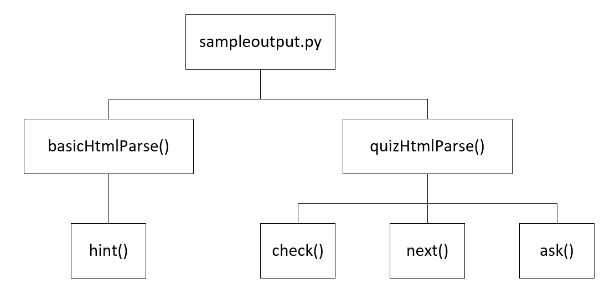

1. Sampleoutput.py Hierarchy Chart

# Results

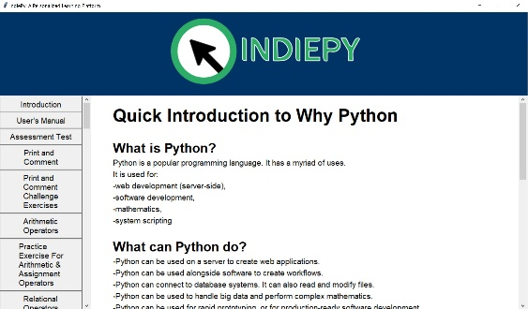

1. Default Page of the Program Upon Execution

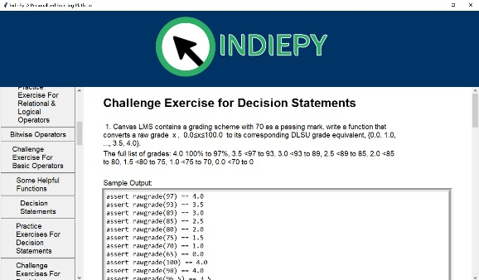

1. Example of Challenge Exercise

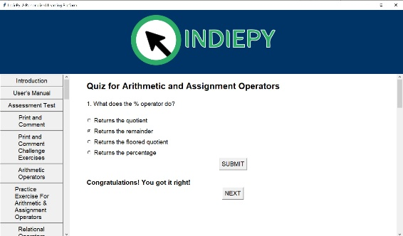

1. Example of Practice Exercises

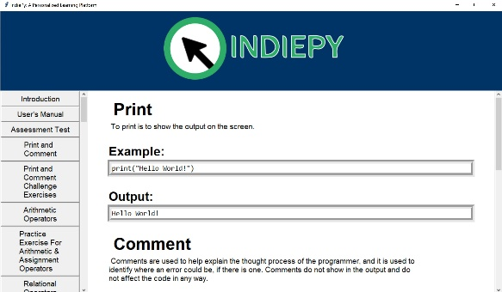

1. Sample of Lecture Page

# Discussion of Results

The program was made possible by using python and the Tkinter library. This project made use of text files, labels, photo image widget, scrollbar widgets, buttons, radio buttons, message boxes, and a configure event function.

A clickable table of contents is displayed at the left and the contents to be read by the user is displayed to the right. Users will have to click on a button to jump from one page to another. They both have a scrollbar to navigate through. In the practice exercises, there is a submit button to check if the user inputs the correct answer.

# Analysis, Conclusion and Future Directives

## Analysis

As this project has demonstrated, learning at one’s pace is important especially for students. Personalized learning is becoming more useful since it is the type of learning that caters to the student.

Learning efficiently and achieving better outcomes is the best output a student can make. Specific needs can be targeted, and creativity would increase since the learning process is more personal.

## Conclusion

In conclusion, a python based personalized learning management and tutorial system may be able to guide its users to learn the topics they desire. In addition, they can learn the lessons at their own pace and have a self-directed approach to their learning. The program covers many topics in python and it can help a beginner in programming by using these lessons as a foundation for advanced Python programming.

## Future Directives

For future programmers, aspects in the project that can be improved on would be the difficulty of the tests and its interface. In this project there are only two levels of difficulty for a topic at most. It would be better if there are more levels since it would help the user comprehend the topic more efficiently. Another directive that would be helpful is a better interface. The interface is not very comfortable at first, and it takes time for the user to adapt to it. An example that would demonstrate a better interface is the addition of a next and previous lesson buttons.

# User manual

User’s manual in using the program.

* How to Use This Program?
* First install and launch Spyder, a Python IDE. See https://www.spyder-ide.org/ for more information.
* Open index.py and run the script. Shortcut key is f5.
* Read each content carefully
* Navigate by clicking on the buttons located on the table of contents. The order of lessons is from top to bottom
* Answer each sample tests by choosing the right choices or by correctly writing the asked term
* Submit the final answer by clicking the submit button
* Retake the sample tests upon the user’s choice
* Develop and test codes as specified in the challenge exercises
* Take note of the Sample Outputs

##### Acknowledgment

First and foremost, we would like to express our deepest gratitude to God Almighty for keeping us safe and healthy in this hard time and for letting us finish our project. Secondly, we would like to thank our parents for their unwavering support and guidance in this hard time. We would also like to express gratitude to our friends for their sharing their encouragement and help in this project. Lastly, we would like to thank our professor for sharing his knowledge in Python.

##### References

1. DreamBox_Learn. (2013, September 24). How personalized learning can benefit students. Retrieved from https://www.dreambox.com/blog/personalized-learning-benefit-students
2. Personalized Learning: The Present and Future of Education. (n.d.). Retrieved from https://www.edelements.com/personalized-learning
3. Personalized Learning. (2015, May 14). Retrieved from The Glossary of Education Reform https://www.edglossary.org/personalized-learning/
4. Pane, J. F., Steiner, E. D., Baird, M. D., & Hamilton, L. S. (2015, November). Continued Progress: Promising Evidence on Personalized Learning. RAND Corporation. Retrieved from Bill & Melinda Gates Foundation https://k12education.gatesfoundation.org/download/?Num=2342&filename=Gates-ContinuedProgress-Nov13.pdf.
5. Douglas, T. (2014, June 23). Putting the student-centric approach in focus. Retrieved from https://www.iste.org/explore/entrsekt/Putting-the-student-centric-approach-in-focus?articleid=66
6. Kamenetz, A. (2018, November 16). The Future Of Learning? Well, It's Personal. Retrieved from https://www.npr.org/2018/11/16/657895964/the-future-of-learning-well-it-s-personal
7. Saint Mary’s University of Minnesota. The Benefits of Personalized Learning Through Technology. Retrieved from https://onlineprograms.smumn.edu/meldt/masters-of-education-in-learning-design-and-technology/resources/benefits-of-personalized-learning-technology
8. Paine J., Steiner E., Baird M., Hamilton L., & PaneJ. (2017). Informing Progress: Insights on Personalized Learning Implementation and Effects. RAND Corporation. Retrieved from https://www.rand.org/pubs/research_reports/RR2042.html
9. UNESCO. (2017). Personalized Learning. Retrieved from <https://unesdoc.unesco.org/ark:/48223/pf0000250057>
10. Python. (n.d.). Retrieved from https://www.python.org/about/
11. Zelle, J. (2004). Python Programming: An Introduction to Computer Science. Franklin, Beedle & Associates Incorporated. Retrieved from https://books.google.com.ph/books?hl=en&lr=&id=aJQILlLxRmAC&oi=fnd&pg=PR9&dq=python+programming&ots=CBbIyCWaWB&sig=AQkfWU27kbYux6ubE8s7lTElnqA&redir_esc=y#v=onepage&q=python%20programming&f=false
12. What is Python? Executive Summary. Retrieved from https://www.python.org/doc/essays/blurb/