Personalized E-Learning

line 1: Jon Leonard S Mananghaya   
line 2: *Gokongwei College of Engineering*   
line 3: *De La Salle University*line 4: Manila, Quezon City  
line 5: Jon_Mananghaya@dlsu.edu.ph

line 1:John Pyro Belicena  
line 2:*Gokongwei College of Engineering*   
line 3:*De La Salle University*line 4:Manila, Quezon City  
line5:john_pyro_belicena@dlsu.edu.ph

line 1:Matthew Charles Llenos  
line 2:Gokongwei College of Engineering   
line 3:De La Salle University  
line 4:Manila, Quezon City  
line5:matthew_llenos@dlsu.edu.ph

***Abstract*—This electronic document is a “live” template and already defines the components of your paper [title, text, heads, etc.] in its style sheet. *\*CRITICAL: Do Not Use Symbols, Special Characters, Footnotes, or Math in Paper Title or Abstract*. (***Abstract***)**

***Keywords—component, formatting, style, styling, insert (****key words****)***

# Introduction (*Heading 1*)

Traditional learning assumes that every student will learn things at the same pace through similar methods, but this doesn’t work for every student, does not learn at the same pace and, prefer different methods of learning. Being flexible and adaptive is the primary attribute of personalized learning. We aim to develop a system that observes and asks the user about their individual strengths and weaknesses. By knowing these we change the content to fit the student and not the other way around.

The researchers will also implement progression systems that keep track and record necessary information regarding time spent, scores, and etc. This will be shown to the student and reported to the teacher. Afterwards this data would be evaluated and interpreted regarding the students condition or if the student needs help or intervention. Students don't move to the next topic until they have fully grasped the concepts and apply it in various problems.

The aim is to create a program that is not only educational but also entertaining.

The researchers do this by utilizing various game systems of progression such as levels, itemization, and etc. We would divide the module into different levels and limit the user from progressing if they have not completed the level. Questions will pose as quests that reward the user with power ups or cosmetic changes to their character

# Review of related literature

## Selecting a Template (Heading 2)

**Four Models of Personalized Learning**

**1.Learner Profiles**

Has a record of student's learnings, strengths and weaknesses, and also their individual progress. These profiles are often updated in order to help the teacher with the student's learning.Helps the students know about their progress, teachers are able to know if there are problems or what changes should be made in their teaching approach.

**2.Personalized Learning Paths**

Helps students customize their learning path according to their progress. A personalized learning path enables the students to learn different skills at different paces.

**3.Competency Based Progression**

Allows students to monitor their progress that has specific goals. Lets students know what they need to master. Lets students work on different competencies at the same time,moving on to the next for each complete task. According to Morin(2018)the emphasis isn't about taking a test and getting a passing or failing grade. Instead, it's about continuous learning and having many chances to show knowledge.

**4.Usage of Flexible Learning Environments**

This type of learning adapts to the learning based on the students strengths.An example is how the classroom is set up or how the school day is structured.The type of design thinking can change the student's learning environments based on their needs.

# III. Methodology

The user is asked several questions in order to assess the user’s skills and experience programming.

**Assessment Questions:**

1. Have you ever tried coding?

2. What skill level would you describe you have in

programming?

3. Can you differentiate other programming languages?

4.Do you have any experience with programming in python?.

5. What is your goal at the end of this course?

Sub questions:

1.What languages have you used?

2. How long have you been programming

## C. Flowchart

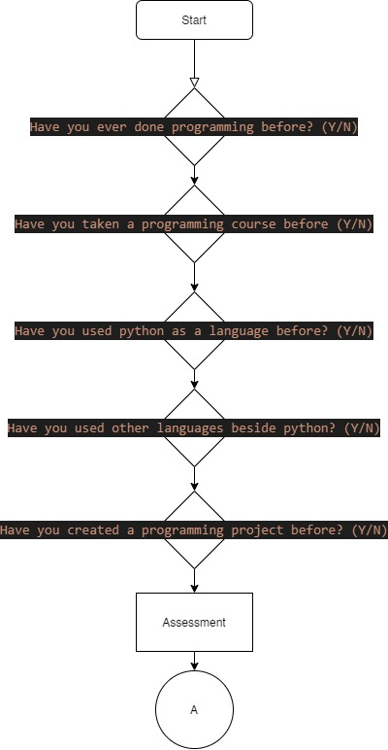

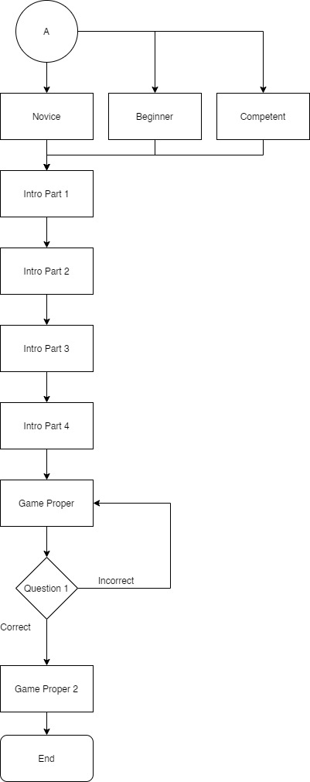

IV. RESULTS AND DISCUSSIONS

In this section we will present the GUI of the program. The researchers as mentioned before ,The Tkinter module is used in the formation of this Program.

Main Menu

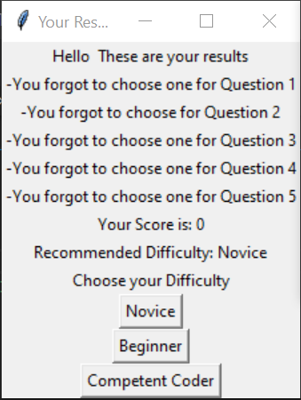

Introduction



Introduction 2

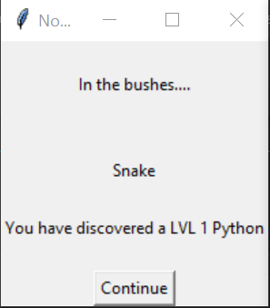

Tutorial

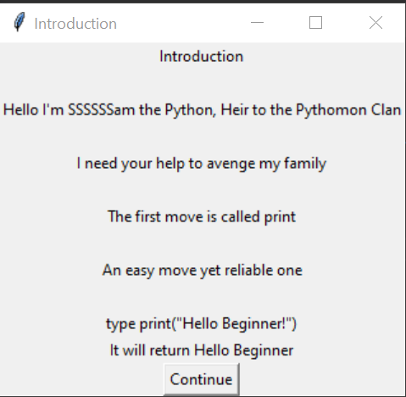

Tutorial 2

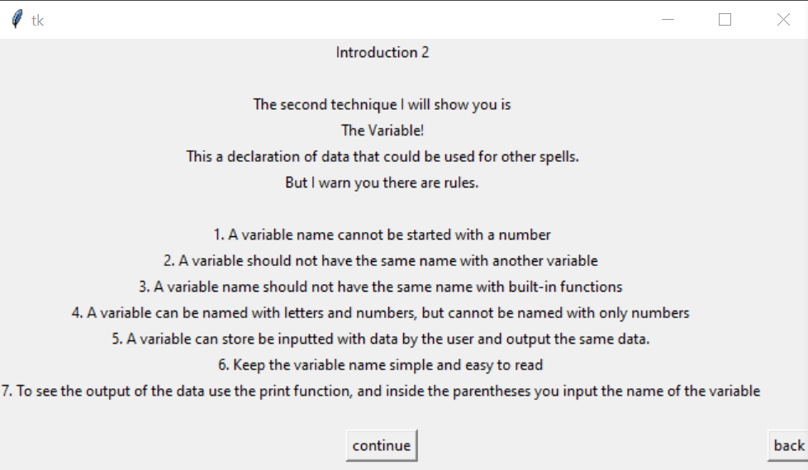

Tutorial 3

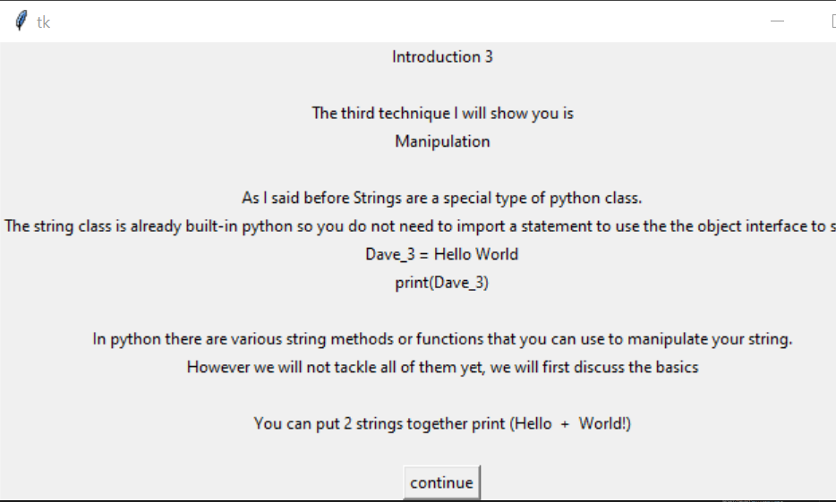

Tutorial 4

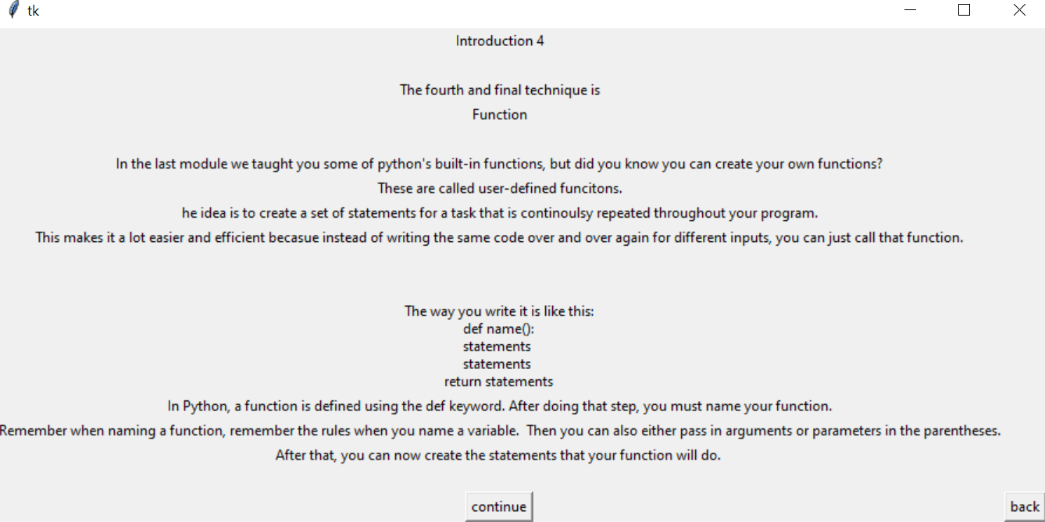

Main Game

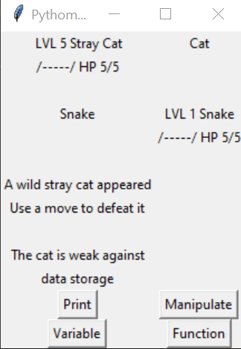

Winner Screen

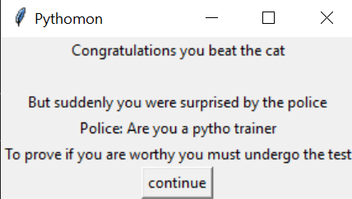

Game Main 2

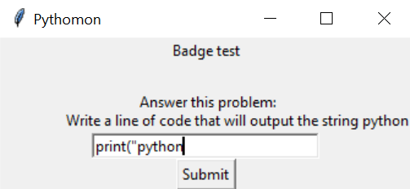

Winner Screen 2

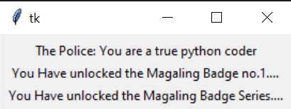

It is in the nature of video games to have multiple branching paths and possibilities. Choice is an important aspect as the player is in control of the outcome. The researchers have prepared and plotted every possible outcome that the player will choose. A simple narrative is also added to further enhance player experience.

##### References

1. What Is Personalized Learning? (2016). Retrieved from https://www.youtube.com/watch?v=6oLNLCO0vfI
2. Brooke, J., Sauro, J., Bangor, K., & May, M. (n.d.). *System Usability Scale (SUS)*. Retrieved from Usability.gov: https://www.usability.gov/how-to-and-tools/methods/system-usability-scale.html
3. .Berthrong, B. (n.d.). *How Coding Promotes Personalized Learning*. Retrieved from BSD Education: https://bsd.education/how-coding-promotes-personalized-learning/
4. Lynch, M. (2018, March 21). *Here’s Everything You Need to Know About Learner Profiles*. Retrieved from The Edvocate: https://www.theedadvocate.org/heres-everything-need-know-learner-profiles/
5. Vesin, B., Klašnja-Milićević, A., Ivanović, M., & Budimac, Z. (2013). Applying recommender systems and adaptive hypermedia for e-learning personalization. *Computing and informatics*, *32*(3), 629-659.
6. Henze, N. (2005, May). Personal Readers: Personalized Learning Object Readers for the Semantic Web. In *AIED* (Vol. 5, pp. 274-281).
7. Liu, J., Wong, C. K., & Hui, K. K. (2003). An adaptive user interface based on personalized learning. *IEEE Intelligent Systems*, *18*(2), 52-57.
8. Ahku, V. C., & Panchoo, S. (2019). Implementing Personalised Learning For Mixed Ability Students For Computer Programming In A Learning Environment. *2019 Conference on Next Generation Computing Applications (NextComp), Next Generation Computing Applications (NextComp), 2019 Conference On*, 1–8. <https://doi.org/10.1109/NEXTCOMP.2019.8883447>
9. Laksitowening, K. A., & Hasibuan, Z. A. (2015). Personalized e-learning architecture in standard-based education. *2015 International Conference on Science in Information Technology (ICSITech), Science in Information Technology (ICSITech), 2015 International Conference On*, 110–114. <https://doi.org/10.1109/ICSITech.2015.7407787>
10. D. Xu, Z. Wang, K. Chen and W. Huang, "Personalized Learning Path Recommender Based on User Profile Using Social Tags," *2012 Fifth International Symposium on Computational Intelligence and Design*, Hangzhou, 2012, pp. 511-514.