Python based Personalized Learning Management and Tutorial System for Programming Introduction(WIP)

Kalvin Don C. Gamboa   
Gokongwei College of Engineering De La Salle UniversityManila, Philippines  
kalvin_gamboa@dlsu.edu.phTyrone Ashley B. Go  
Gokongwei College of Engineering De La Salle UniversityManila, Philippines  
tyrone_go@dlsu.edu.phDaniel John A. Lemi  
Gokongwei College of Engineering De La Salle UniversityManila, Philippines  
daniel_lemi@dlsu.edu.ph

*Abstract*—This research paper is a “tutorial program” geared towards personalized learning that teaches the users about the python programming language. The program also provides interviews, tests and exercises to match the intended level needed to be taught to the user.

Keywords—personalised learning, python programming

# Introduction

The project provides learners a python-based tutorial system for programming. With the rapid emergence of virtual learning communities (or VLCs) as a new generation of learning spaces. The shift from old-fashioned/predetermined learning to just-in-time/collaborative learning needs to be characterised by a blended learning strategy in which the principle of 'personalisation' plays a strategic role. [1] A python based tutorial system is a good way to implement the personalized way of learning for learners. Personalised Learning is teaching and learning focused on the background, needs, potential and perception of the learner. It is also a powerful statement that has as goal the student taking ownership of the learning process to become a lifelong learner. [2]

In this project we implement personalised learning by creating a user-friendly python tutorial program that applies what we have learned from the course. Python is an interpreted, interactive, object-oriented programming language. It provides high-level data structures such as list and associative arrays (called dictionaries), dynamic typing and dynamic binding, modules, classes, exceptions, automatic memory management, etc. It has a remarkably simple and elegant syntax and yet is a powerful and general purpose programming language. [3]

According to Gaeta in his research on the implementation of adaptive and personalised learning, The case of study has been successfully executed and has given us a proof of our assumptions related to the added value of the service oriented grid mainly in terms of the learners’ high level of dynamicity and adaptiveness in the creation and delivery of a personalised learning experience. [4] The main objective of this project is to ensure that the learner will be able to acquire knowledge and understanding on python programming using personalised learning; as well as, target that the user will learn accordingly at their own pace.

The researchers chose python because according to a book by Miller (2004) “Although there are many computer languages from which to choose, there are few designed with the beginning programmer in mind. One language so designed is Python,…” [5] This statement holds more importance due to the fact that the world is ever increasing in technological development [6], as such learning programming that caters to the beginner programmers is important.

Personalized learning is important for this; however, it is important to consider if the recommendations made by the device truly helps the user. If by chance the device made an error in recommending a certain course to a user, it would be devastating to the development of the learner [7] although such an occurrence is terrifying, the current system that is based on rewarding students that do better and discriminating upon those that do poorly is even worse. [8] Dynamic learning if implemented properly would mean the inclusion of everyone and would truly call for a "no child left behind" system. [9]

To sum it all up, a program that is able to foster a learners’ educational development specifically to what they need is a good option for teaching programming especially when the pace of the lessons is too slow or too fast. [10]

# Methodology of the program

## Creating the Program

Jupyter Notebook is an open-source web application that allows the users to create and share documents that contain their code, equations, visualizations and narrative text. Uses includes data cleaning and transformation, numerical simulation, statistical modeling, data visualization, machine learning, and more.

In order to create the tutorial program, the group will be creating their code using Jupyter Notebook. The main reason for this is that this program can easily be distributed online as well as being the application all the researchers are acquainted with.

## Overview of the Program

The program will be specifically designed to guide and teach the user about the Python Programming Language based on their current knowledge on the topics. The program is designed to track the learnings that the user has went through using their desired name. The program includes an interview to know whether the user is a beginner, intermediate or an expert in programming. the program will give a python tutorial based on their prescribed knowledge taken from the interview. It will also include quizzes and exams per tutorial to know, whether or not they learned something on the module and if they are ready to move on the next tutorial. The user can also track their progress in the program and can pick up right where they left off when they reopen the program.

## Flowchart of the Program

In order to properly put together a proper structure for the program and easily identify and solve problems that might come up during the creation of the code. The group decided to create a flowchart for the program.

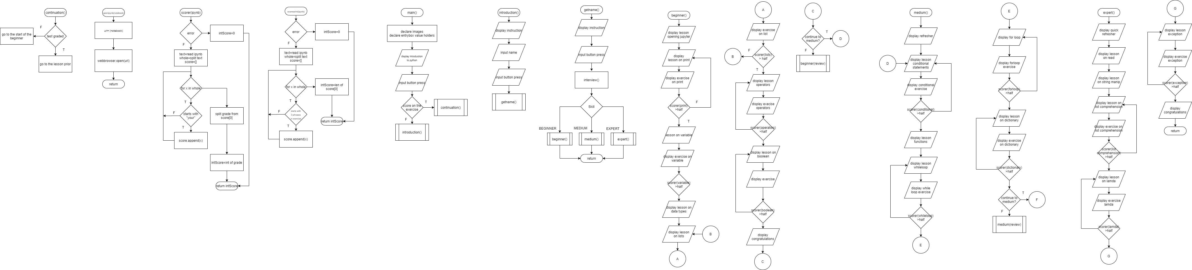

The program will introduce the user to python in a general sense. This would be a light introduction in which upon inputting a button press the program would diverge into two paths. If the user had already answered an exercise before it would ask the user if he wanted to continue or not. If the user never answered an exercise before it would start the interview.



This part of the program will ask the user for his name in order for the user to feel more as if someone is talking to him while taking the interview.



Through the interview the program would determine whether the user is a beginner, medium, or an expert, depending on the skill level the program would either go into the beginner, medium, or expert functions

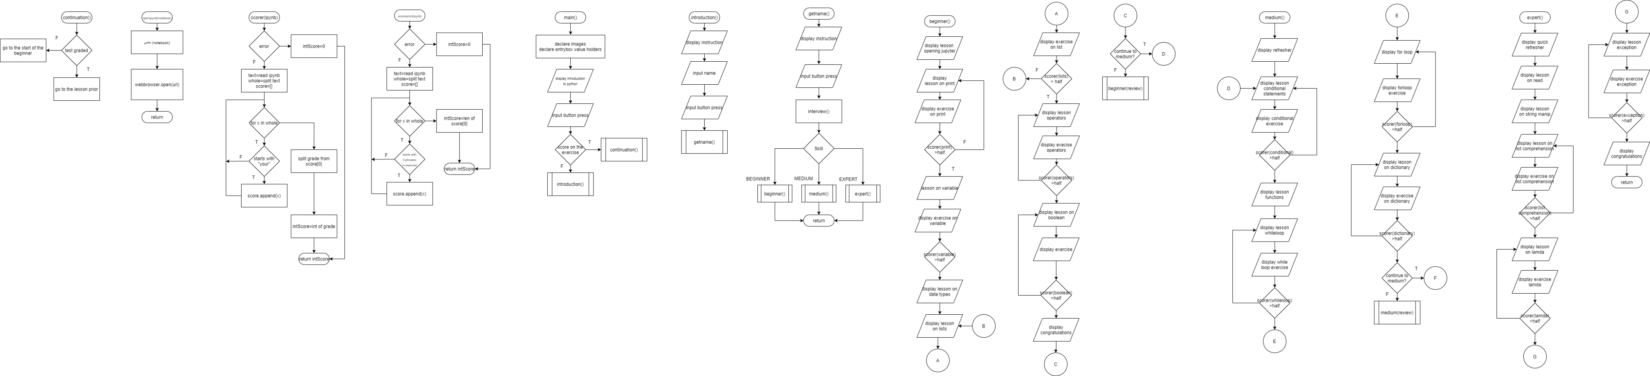

This is the flowchart of the beginner, if the user is deemed a beginner, a set of beginner courses would introduce him on the fundamentals of python. After every lesson the program would use the open ipynb function to open the ipynb file for the user to answer. Upon saving the ipynb file, the scorer function would check the score of the user, if the user scored below half, they would have to repeat the lesson and take the exercise again. Once the user finishes the course he/she would then be asked whether they wanted to review the course again, if they did they would then repeat the course, otherwise they can continue to the medium course.

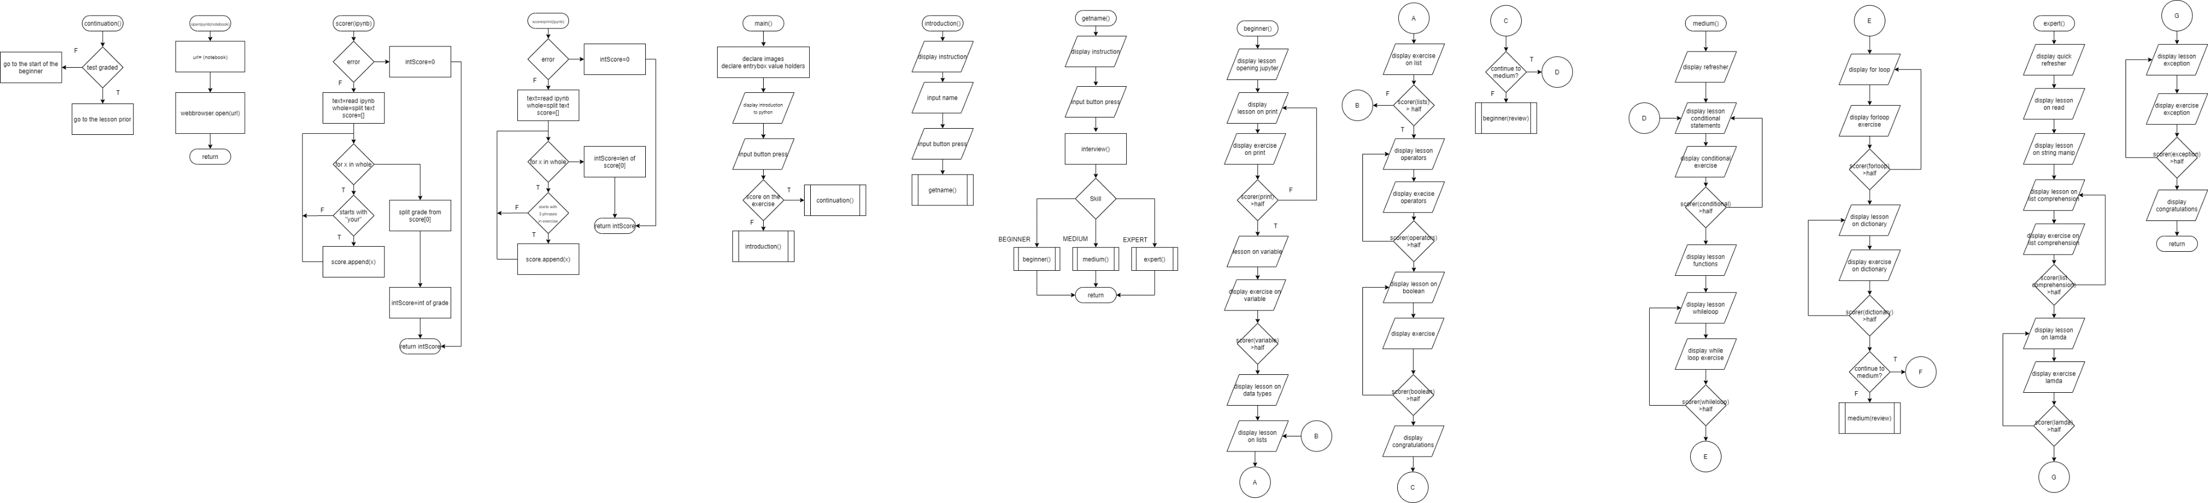

This is the medium function for the medium course, if the user is deemed as medium by the interview, then he/she would first undergo a refresher of the beginner course, then proceed with the new lesson and exercise along with them. If the user came from the medium course he would directly go to the new lessons. The same goes for when the user ends the medium course, he would be prompted as to whether or not he would want to study again or proceed with the expert course.



In the expert function, if the user came from either the beginner or medium course they would skip the refresher for the expert, otherwise if the user was deemed an expert, he/she would first have to finish the refresher course then proceed with the expert lessons. Upon finishing a congratulation message would appear.



This left function is only used in the beginning of the program to tell whether the user has taken the exercise before or not. The right function will first get the working directory of the notebook and then use the webbrowser module to open the notebook

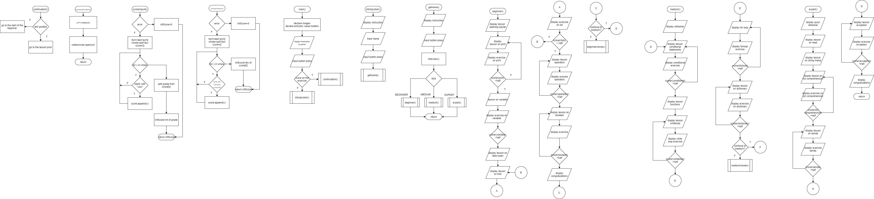

These are the two functions used to grade the notebooks while using the program. The ipynb notebook is designed such that the score would appear at the end of the notebook, the function would check and find for that text and would extract the grade from it using for loops and starts with.

Fig. 1. Flowchart Diagram for the Program

## Maintaining the Integrity of the Specifications

The program is used to tutor or teach the user the python programming language with the basis on giving the user a personalized way of learning. Introduction to python, Basic input and output methods Data types and structures, Boolean and logical operations, as well as the use of function and the different modules on the python language are included in this program. Other python features are not yet included in the program. The program will always start with asking for the name of the user, the program saves the previous work of the user. In order to make sure the user does not open the progress of another, it is advised that they input their full name in the main menu of the program. It is also important that the user inputs their honest response on the interview for it will be the basis on what the program would teach the user. Quizzes and exercises will also be included in the program to test if the user really has learned enough for them to move on. The program also requires that it would be opened alongside the pictures included in the file in order for the program to read and open the photos used on the lectures.

# Result & Discussions

After the coding for the program has been completed, the user is ready for the program The program file is to be saved on the Jupyter Notebook and. In this newly saved file, run all the cells on the kernel until the GUI for the program opens. The program is now successfully running.

## Screenshots

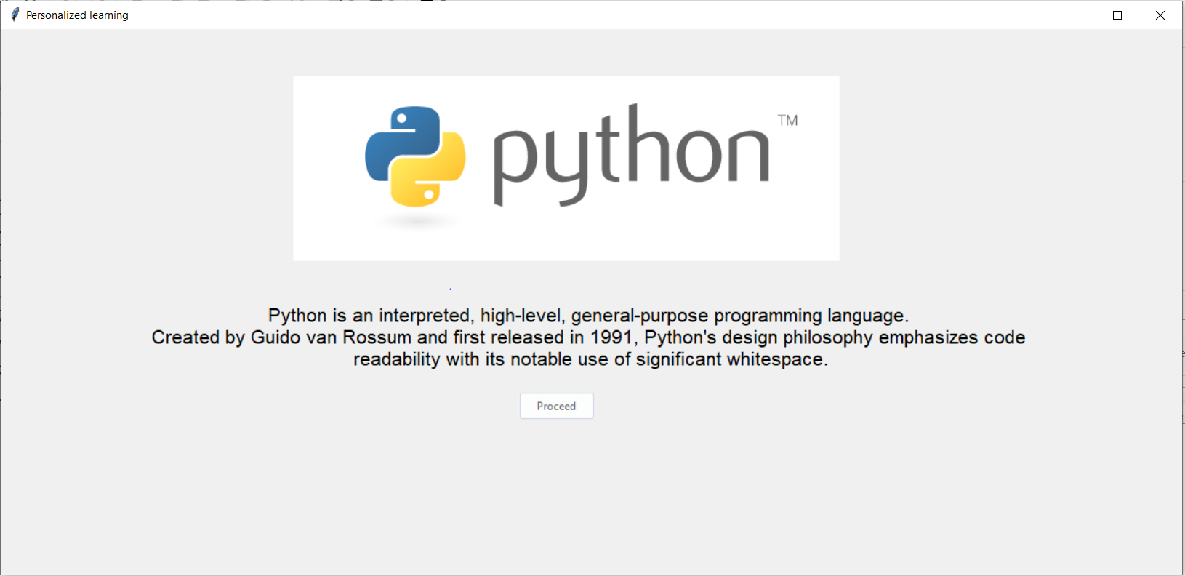

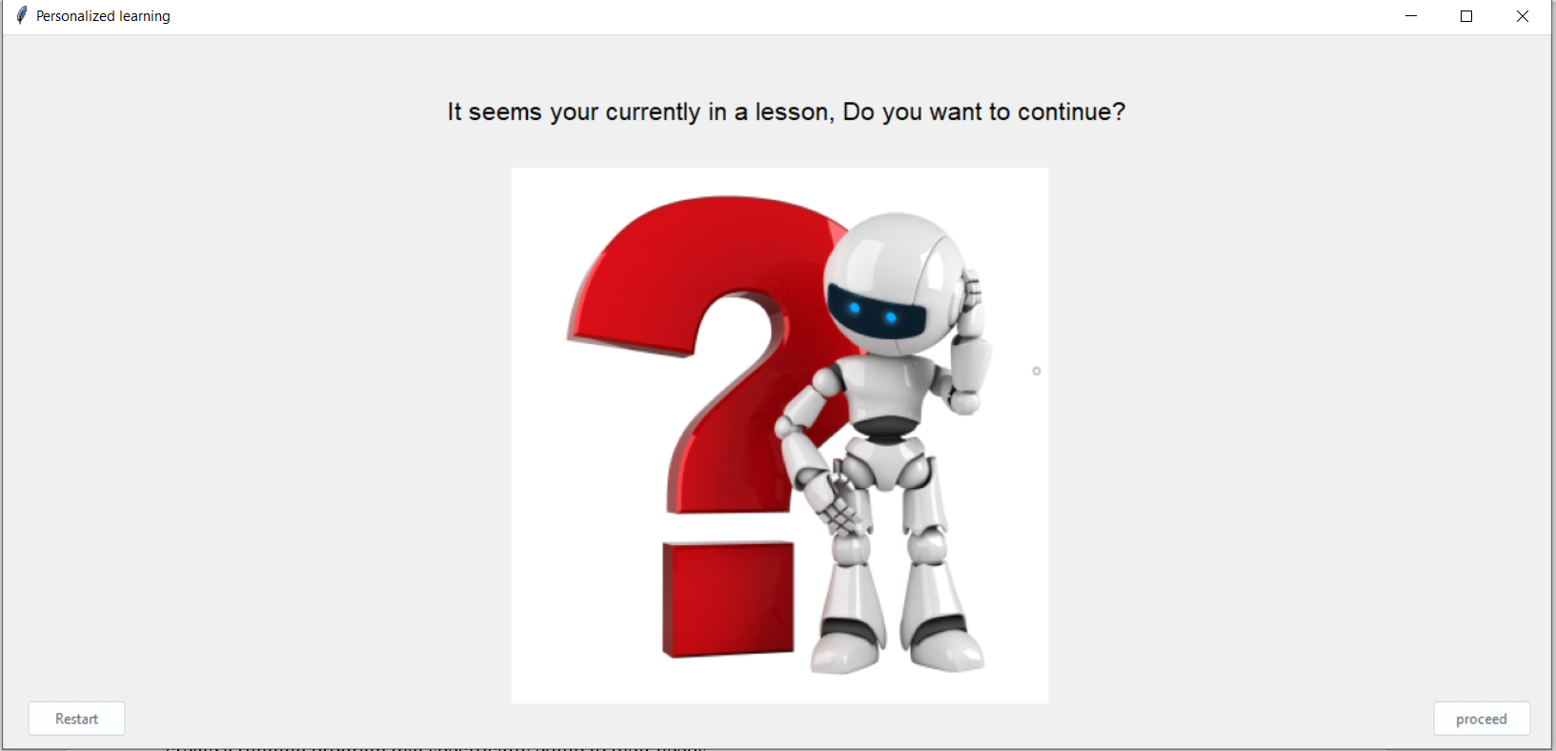

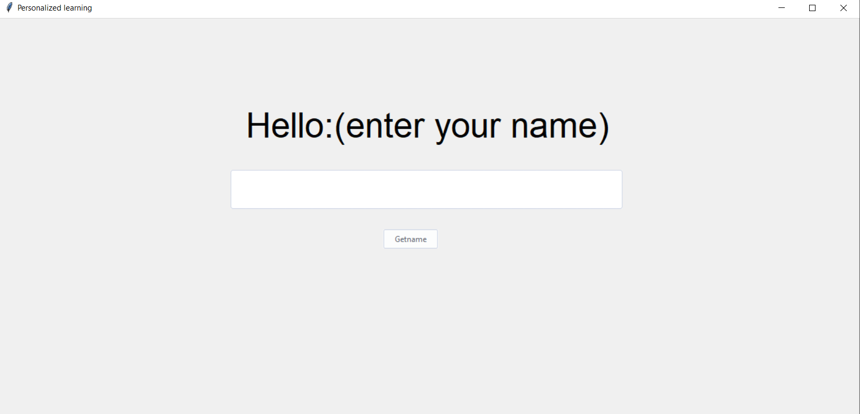

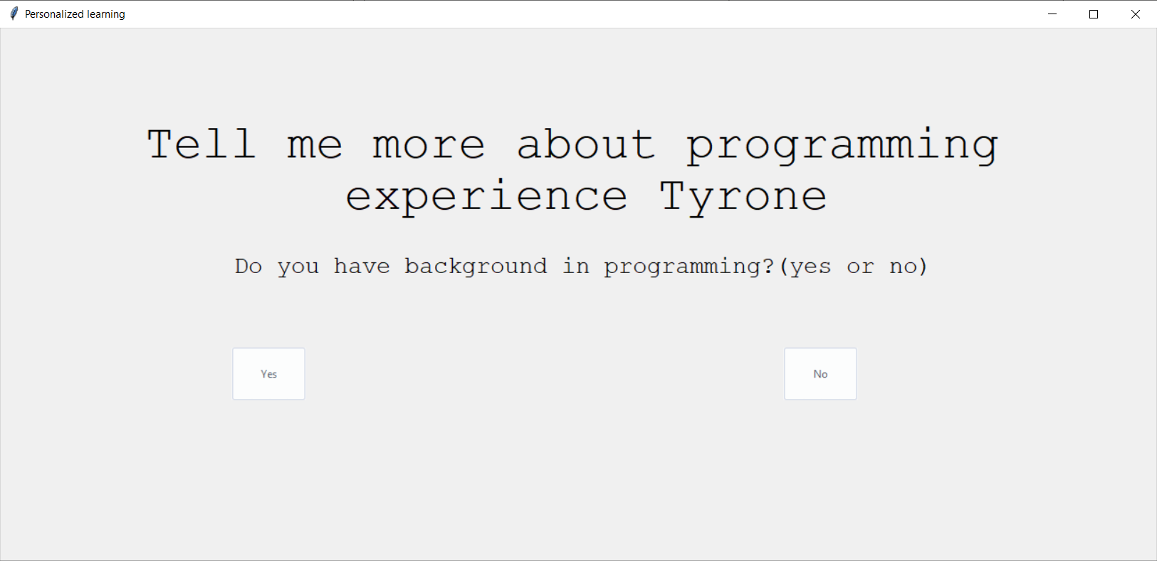

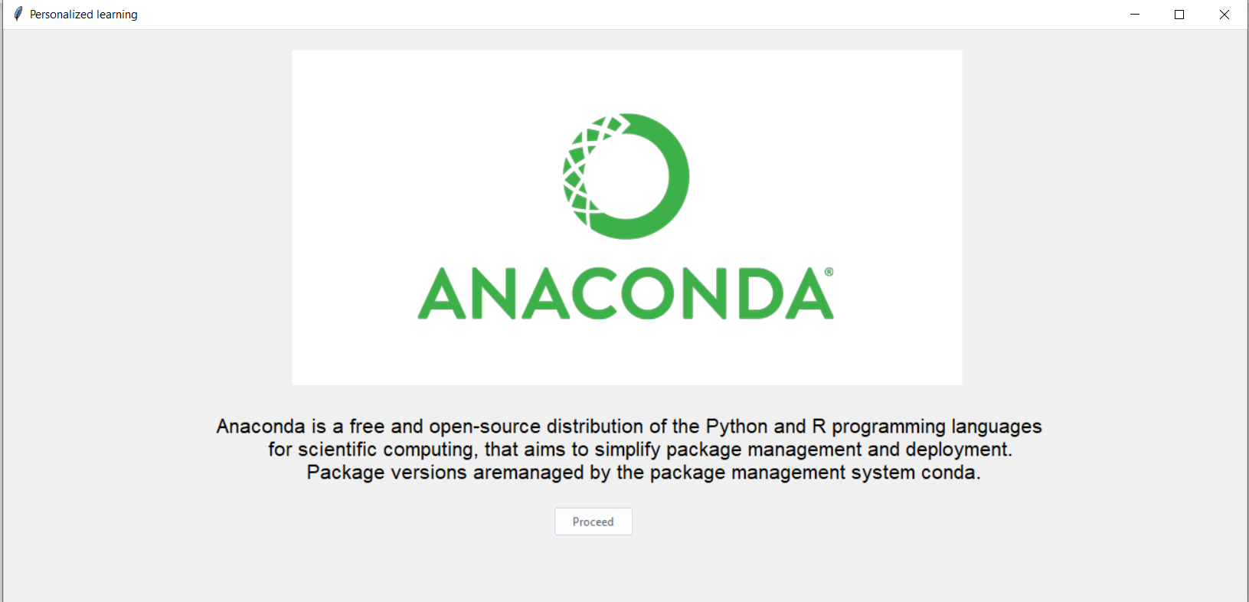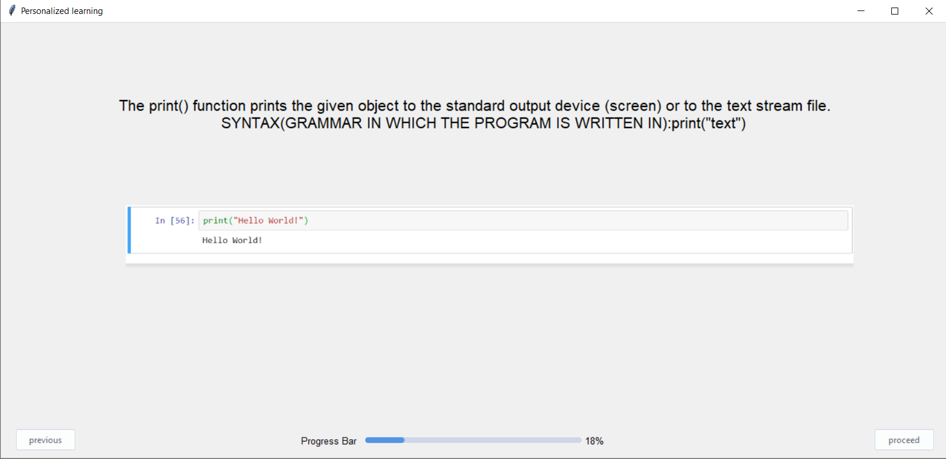

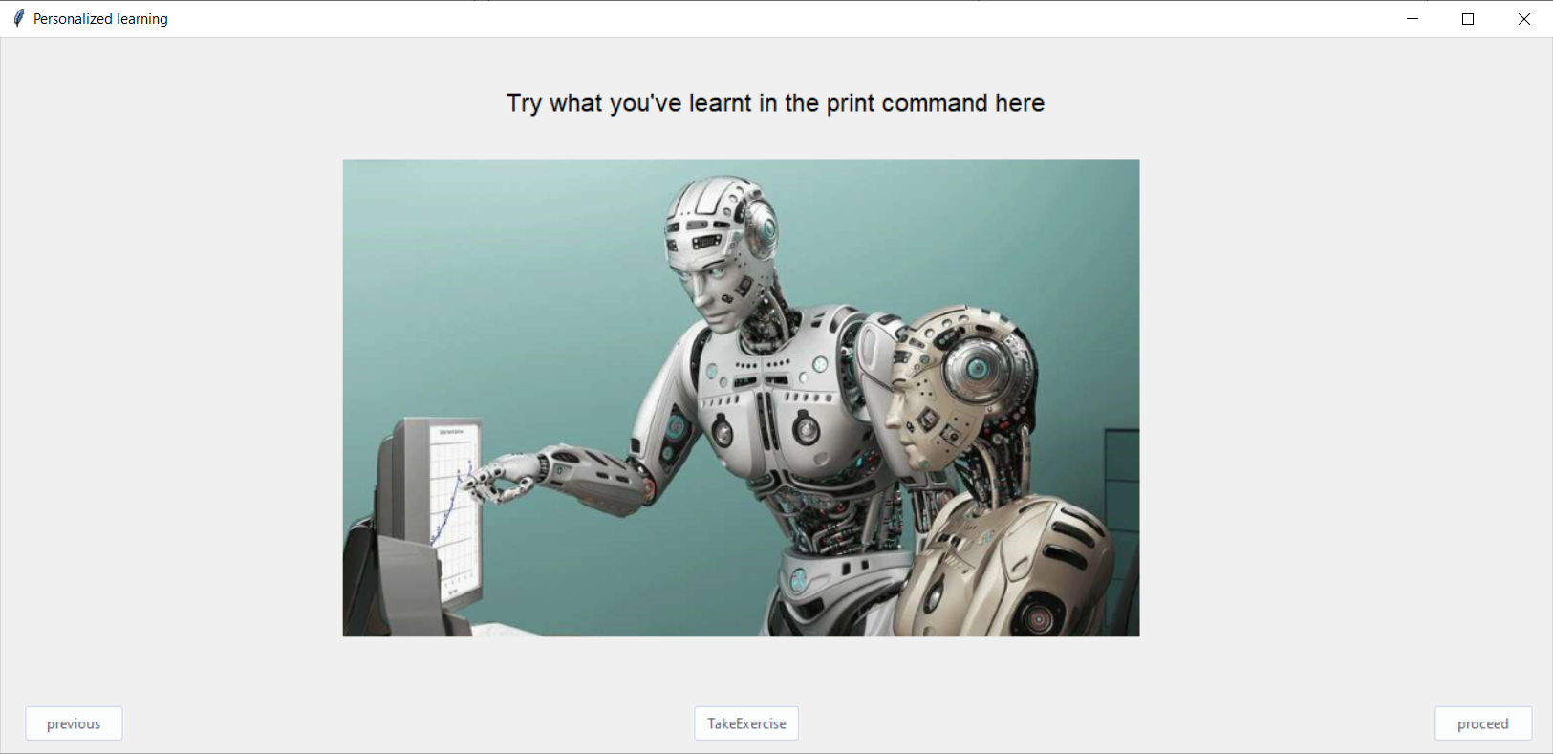

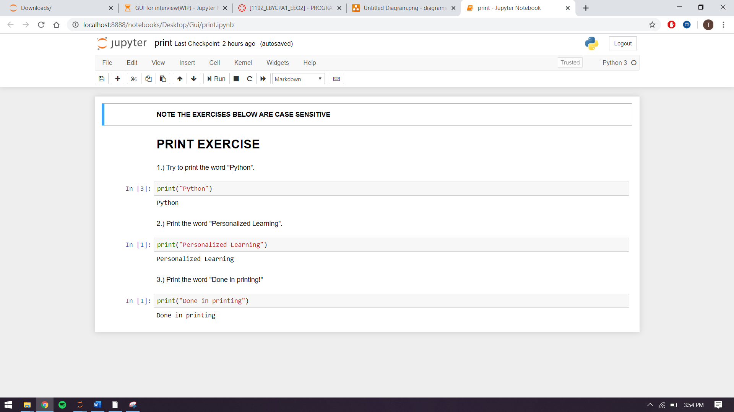

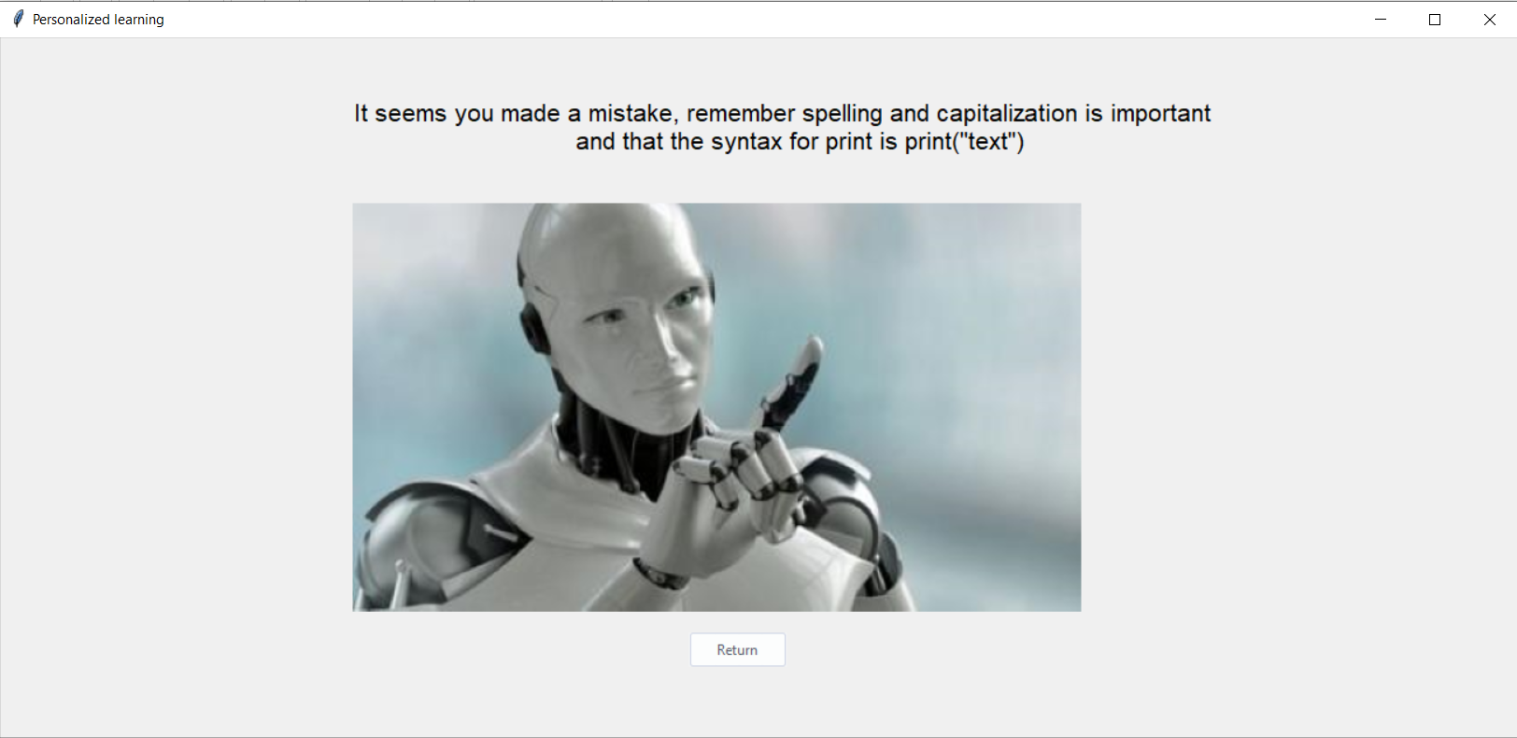

## Discussion

For most students today, Personalised Learning is becoming more and more useful and a fundamental option to be used in teaching topics for their subjects. due to these extraordinary measures, everyone is experiencing at the moment, personalized learning as the means of studying seems to be the best option for students to continue their studies and in this project, that is the goal of the group. To create a running program that specifically equip to their needs and is able to further advance a student’s knowledge on a specified topic, in this program it will teach python programming language.

The program was done using Jupyter Notebook and was finished last May 5, 2020. The program can interview the user and classifies the user’s aptitude on the topics that will be taught in the program. After the interview and the program was able to classify the user, the program will teach the user topics based on the user’s skill on the topic, using lectures, examples, and tests until the user finishes the last topic on the highest level of the topics. The features of the program are all running well. The program can go back and forth to the lesson. It directly opens the ipynb when the exercises begins and the user can continue the lesson after they closed the program.

The group has found no errors that could affect the learner’s development in learning the course. It can be concluded that the project was successfully created and achieved the objective to create a program that integrates personalised learning to the course.

# Analysis, Conclusion, & Future Scope

As this project has demonstrated, learning at our own pace is important for us. Personalized learning itself is becoming more popular since it is arguably the best type of learning. We can learn more, learn faster, and achieve better outcomes. By making our learning more personal, we can target our specific needs and be more creative in learning about it. It aligns with each learner’s strengths and interest. Making a program that enables the users to learn python personally is great. In whatever circumstances, we must always find a way to learn and have the opportunity to learn at our full potential. We must have the ability to understand ourselves so that we can know what ways we can learn effectively.

In conclusion, a python based personalized learning management is able make the learners more engaged longer. They can choose their own specific learning path and have a self-directed approach to their learning. Learning python personally has an edge since the learner has unique ways of learning. By this, we can learn to the fullest and be flexible in mastering it.

##### References

1. Assaf, W., Elia, G., Fayyoumi, A., & Taurino, C. (2009). Virtual eBMS: a virtual learning community supporting personalised learning. International Journal of Web Based Communities, 5(2), 238-254.
2. IBE., (2017), “Personalised Learning” Retrieved From: <https://unesdoc.unesco.org/ark:/48223/pf0000250057>
3. Sanner, M. F. (1999). Python: a programming language for software integration and development. J Mol Graph Model, 17(1), 57-61..
4. Gaeta, A., Gaeta, M., & Ritrovato, P. (2009). A grid based software architecture for delivery of adaptive and personalised learning experiences. Personal and Ubiquitous Computing, 13(3), 207-217.
5. Miller, J. A. (2004). Promoting computer literacy through programming Python (pp. 1-288). University of Michigan.
6. Huang, A. (2015, March). Comparison of programming performance: Promoting STEM and computer science education. In 2015 IEEE Integrated STEM Education Conference (pp. 123-125). IEEE.
7. Chen, C. M. (2008). Intelligent web-based learning system with personalized learning path guidance. Computers & Education, 51(2), 787-814.
8. Zhai, J. H., Xu, H. Y., & Wang, X. Z. (2012). Dynamic ensemble extreme learning machine based on sample entropy. Soft Computing, 16(9), 1493-1502.
9. Bulger, M. (2016). Personalized learning: The conversations we’re not having. Data and Society, 22.
10. Milne, I., & Rowe, G. (2002). Difficulties in learning and teaching programming—views of students and tutors. Education and Information technologies, 7(1), 55-66.