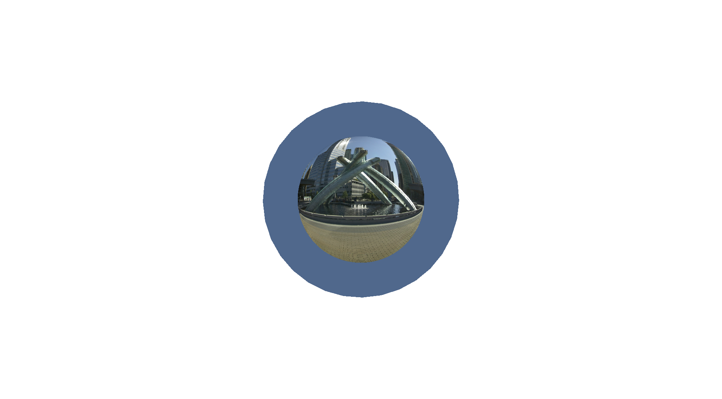
Refraction eta 1.52 with not reflection

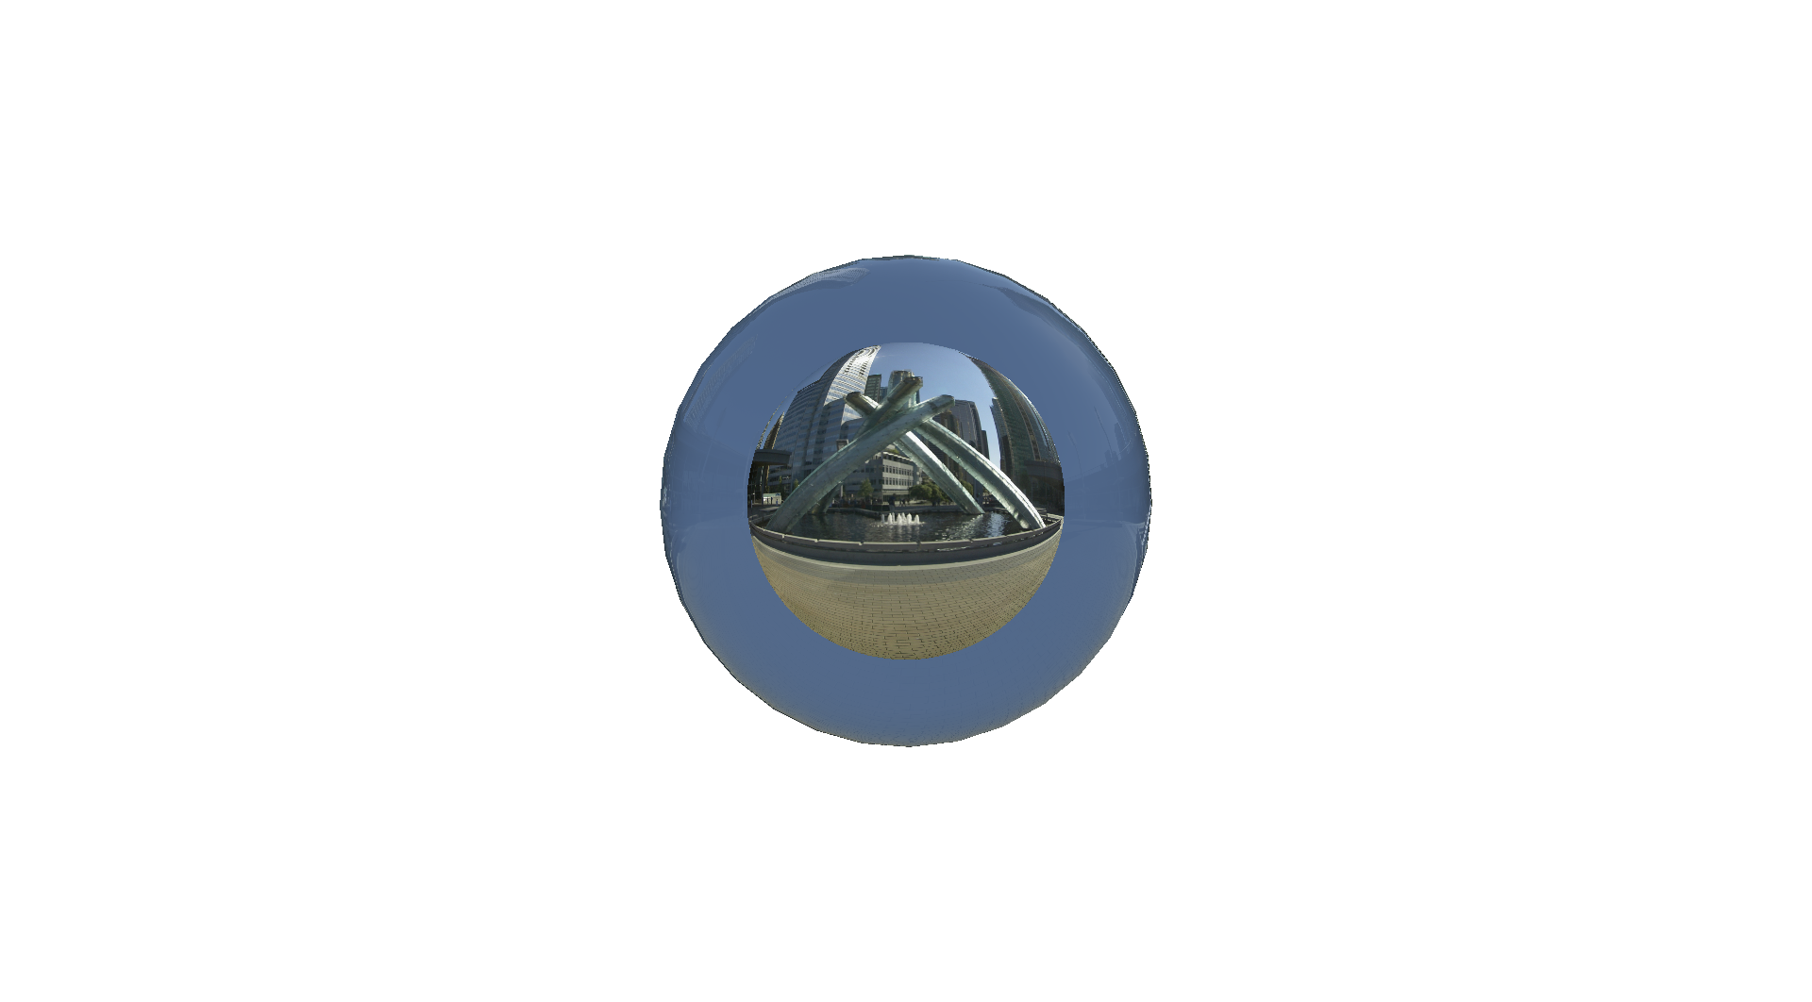
Refraction with eta 1.52 and reflection
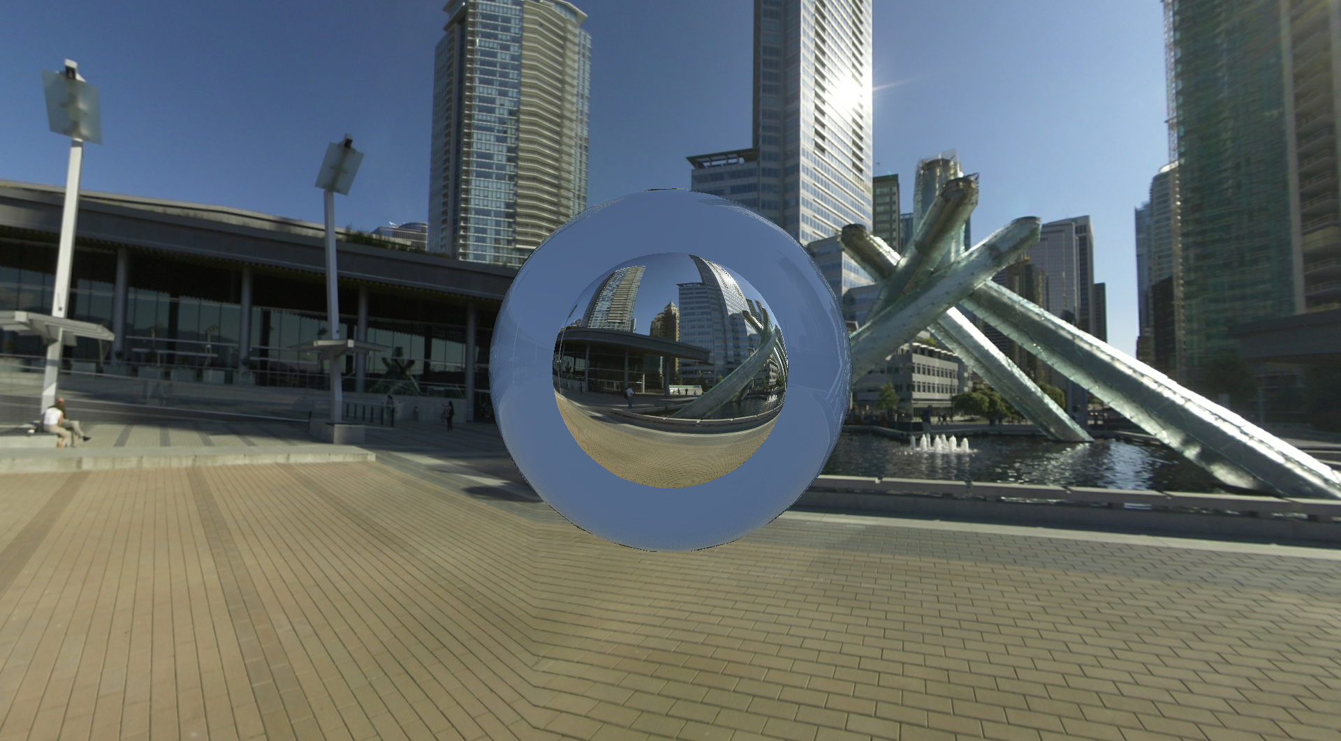
Cube map on cube as background
Sphere with refraction and reflection

