**Measurement system Manual**

Table of Contents

Components 1

Procedures 2

Clean yourself 2

Turn on laser and warm-up 3

Choose suitable interferometer lens 3

Calibration 4

Starts interferometer software μShapeProfessional 5

Starts control software SSI300 6

Lens alignment 7

Start measurement 7

Save data 8

## Components

Major components:

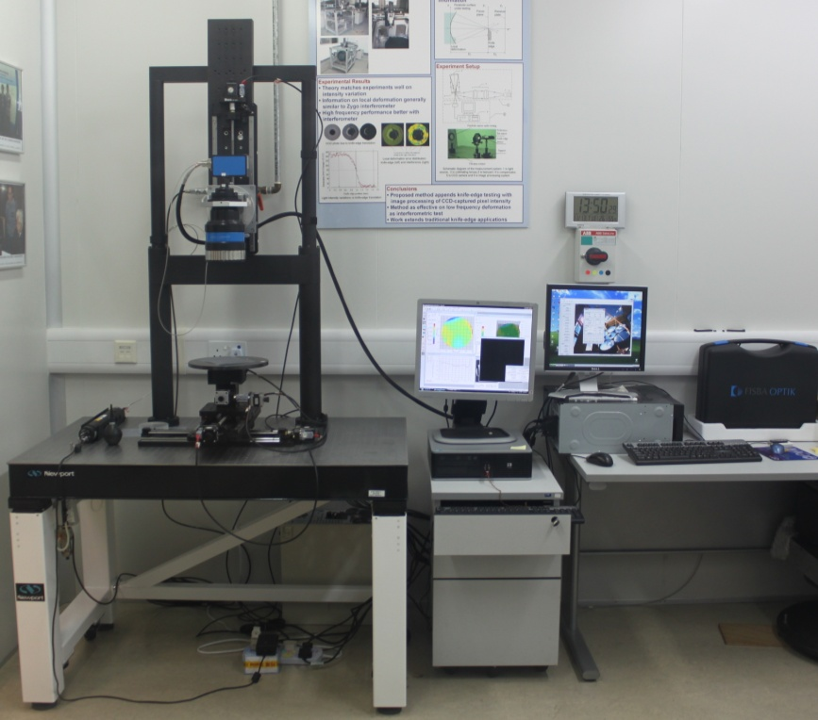

Interferometer control computer

Axes control computer

interferometer

Platform

Laser

Optical table

X and Y axis

Z-axis

A more detailed description about Fisba phase-shifting interferometer system can be found in its official user manual.

## Procedures

Here are the basic procedures on using the measurement system.

### Clean yourself

To keep the measurement equipment from being contaminated, you should always first wash yourself before using it. The procedures and reasons are listed here,

Practical procedures before using interferometer

1. Wash your face
   1. This is the greasiest part that you may accidentally touch during the measurement
2. Wash your forearms
   1. You need to coat face cream on the test piece in some cases. You may need to wipe away excess face cream from your hands by your forearm.
3. Wash your hands
   1. Wash it with soap solution. A video of how surgeons wash their hands before surgery may help.  
      The video: <http://www.youtube.com/watch?v=XtSdg76tQ9Y>

### Turn on laser and warm-up

Turn on laser first. It requires 15 minutes to warm-up to a steady state. The power light (red) on laser tube will be lit up first. Wait until the stable light (green) also light up before starting measurement.

Note: Extra care must be taken when using laser. Since the radiant power density in the laser beam is extremely high, never stare into the beam or its reflections, or directly view the beam or its reflections using optical instruments.

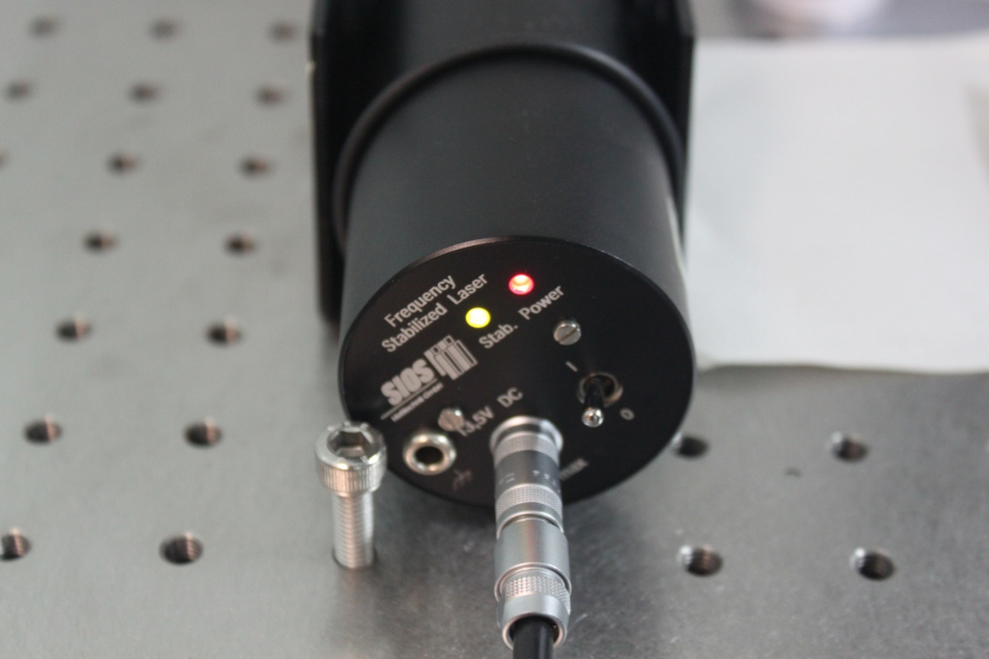

Stable light (green)

Power light (red)

Laser tube

### Choose suitable interferometer lens

For different testpieces, different interferometer lens must be used in measurement. For example, plano lens should be used when measuring plane lens. Spherical lens should be used when measuring spherical or aspherical lens.

### Calibration

Calibration of interferometer can help reduce its own system error. Calibrate the interferometer by using the standard reference lens with surface deviation 1/20λ to perfect. Do it every day or in other condition specified in official user manual to ensure accurate measurement.

### C:\Users\MJ\Desktop\MJP\for manual\calibration.png

### Starts interferometer software μShapeProfessional

Double click desktop: 

Interferometer software main screen: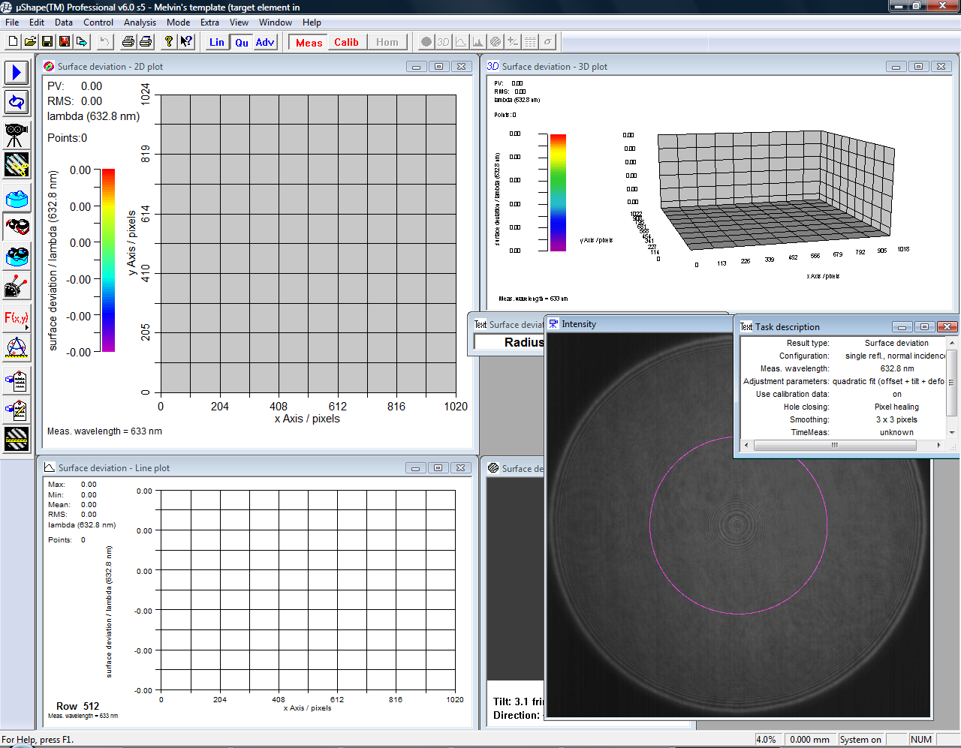

### Starts control software SSI300

Double click desktop: 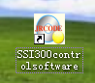

SSI300 main screen:



### Lens alignment

In the screen of μShapeProfessional, a window shows the live view of interferometric pattern. You should adjust the alignment of the testpiece until the resultant pattern has the minimum number of fringes.

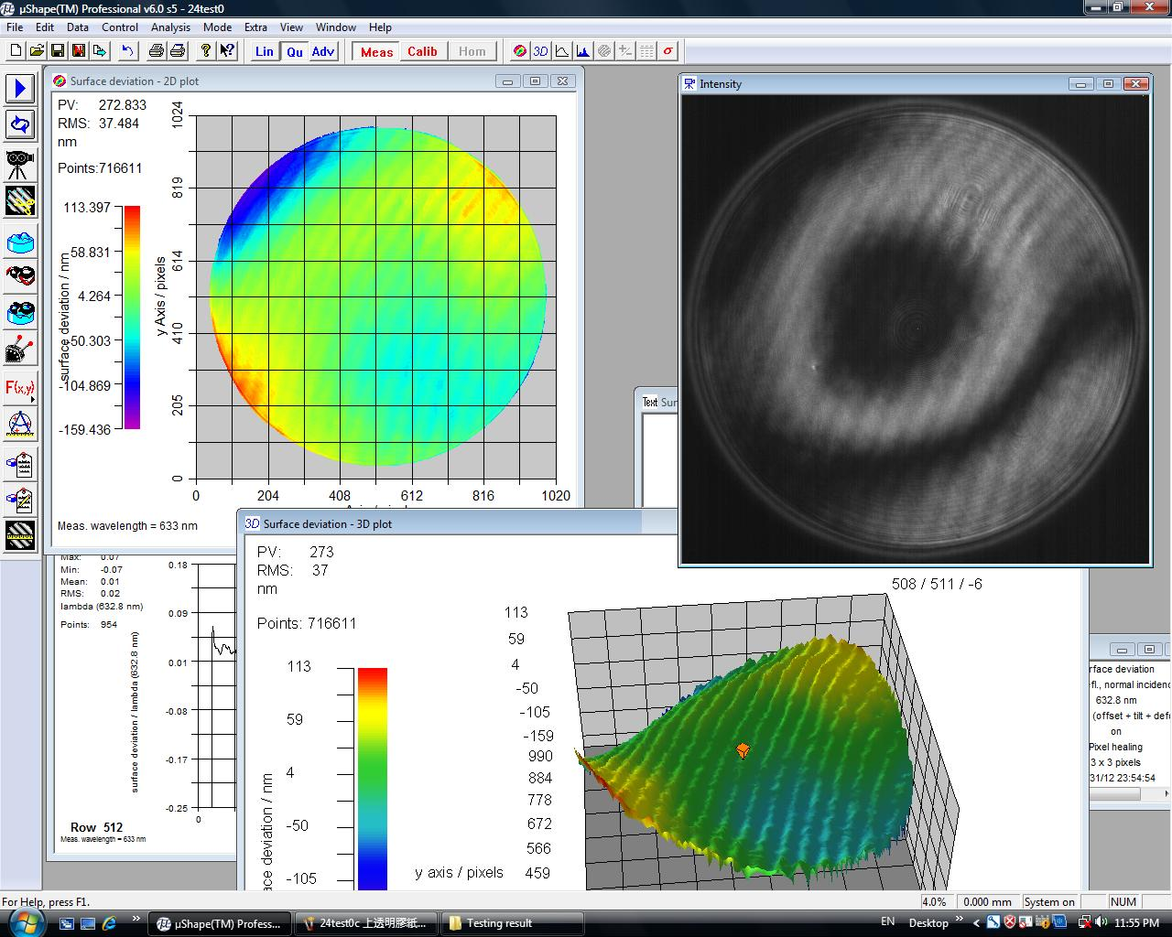

### Start measurement

Press ‘start measurement’ 

to capture data. Analyzed surface plots and some parameters (e.g. PV, RMS) are computed as shown below.

### F:\Testing result\24test0.jpgSave data

In file>save, you may save the measured data with a given file name. You may further export the saved data to other format so that you can further process the data. In our case, we export it to .xyz file and generate polishing path afterward.