**Microprocessor and Computer Architecture**

**UE21CS251B**

**4th Semester, Academic Year 2022-23**

Date:

|  |  |  |
| --- | --- | --- |
| Name: | SRN: | Section |

Week#____1_______ Program Number: ____1___

Title of the Program

**Write an ALP using ARM instruction set to check if a number stored in a register is even or odd. If even, store 00 in R0, else store FF in R0**

1. ARM Assembly Code

mov r1,#20

ands r2,r1,#1

mov r3,#0

cmp r2,r3

bne odd

mov r0,#0x00

b ending

odd:

mov r0,#0xFF

ending:

.end

1. Output Screen Shot (Two)

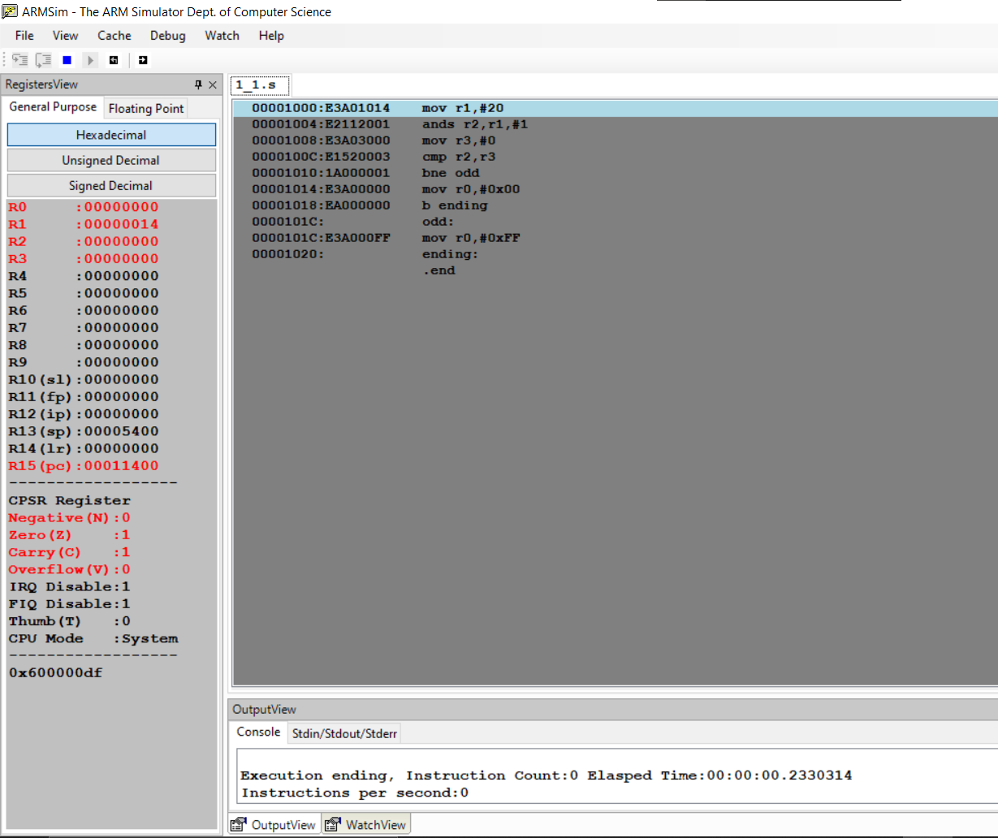

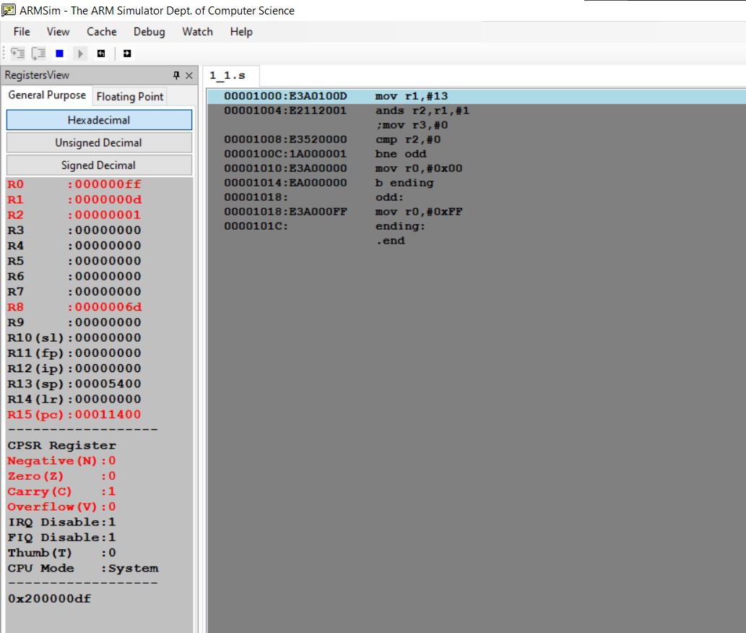

**Microprocessor and Computer Architecture**

**UE21CS251B**

**4th Semester, Academic Year 2022-23**

Date:

|  |  |  |
| --- | --- | --- |
| Name: | SRN: | Section |

Week#____1_______ Program Number: ____2___

Title of the Program

**Write an ALP to compare the value of R0 and R1, add if R0 = R1, else subtract**

I.ARM Assembly Code

mov r0,#14

mov r1,#14

cmp r0,r1

beq l1

sub r2,r1,r0

b ending

l1:

add r2,r1,r0

ending:

.end

II. Output Screen Shot (Two)

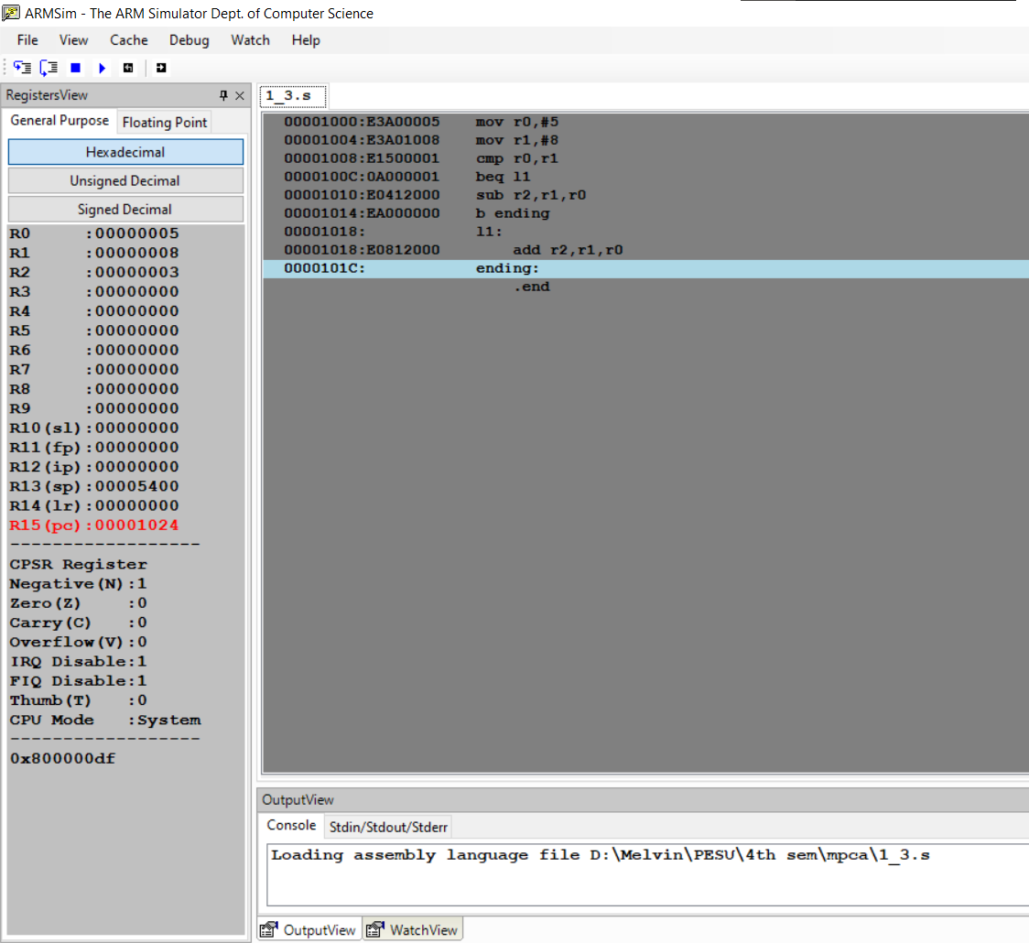

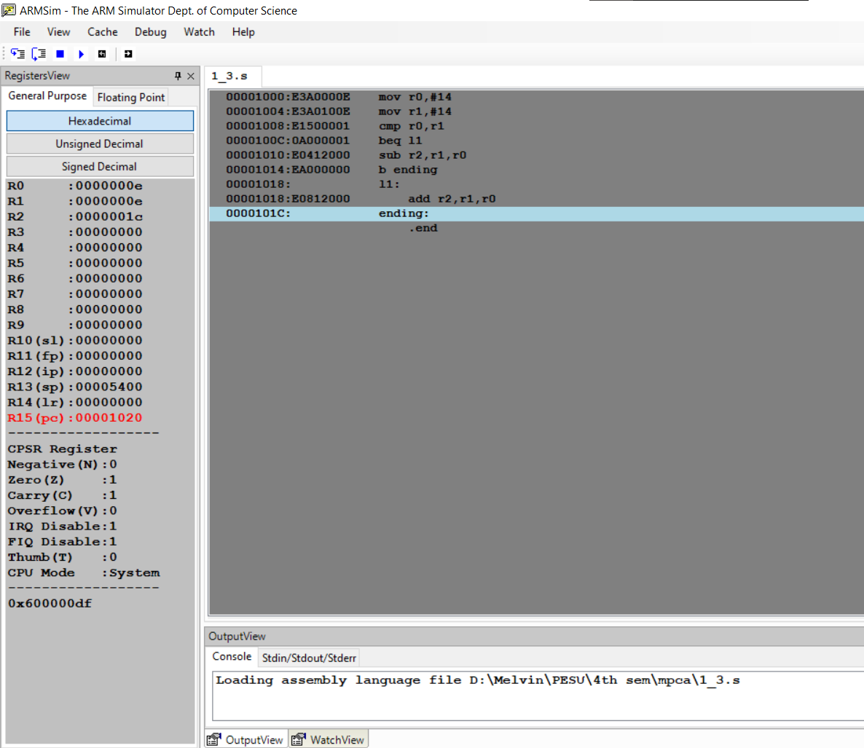

The output should be verified for both equal and nor equal values

**Microprocessor and Computer Architecture**

**UE21CS251B**

**4th Semester, Academic Year 2022-23**

Date:

|  |  |  |
| --- | --- | --- |
| Name: | SRN: | Section |

Week#____1_______ Program Number: ____3___

Title of the Program

**Based on the value of the number in R0, Write an ALP to store 1 in R1 if R0 is zero, Store 2 in R1 if R0 is positive, Store 3 in R1 if R0 is negative. (Program shown in class)**

I.ARM Assembly Code

mov r0,#-3

cmp r0,#0

beq zero

cmp r0,#0

bgt pos

mov r1,#3

b ending

pos:

mov r1,#2

b ending

zero:

mov r1,#1

ending:

.end

1. Output Screen Shot (Three)

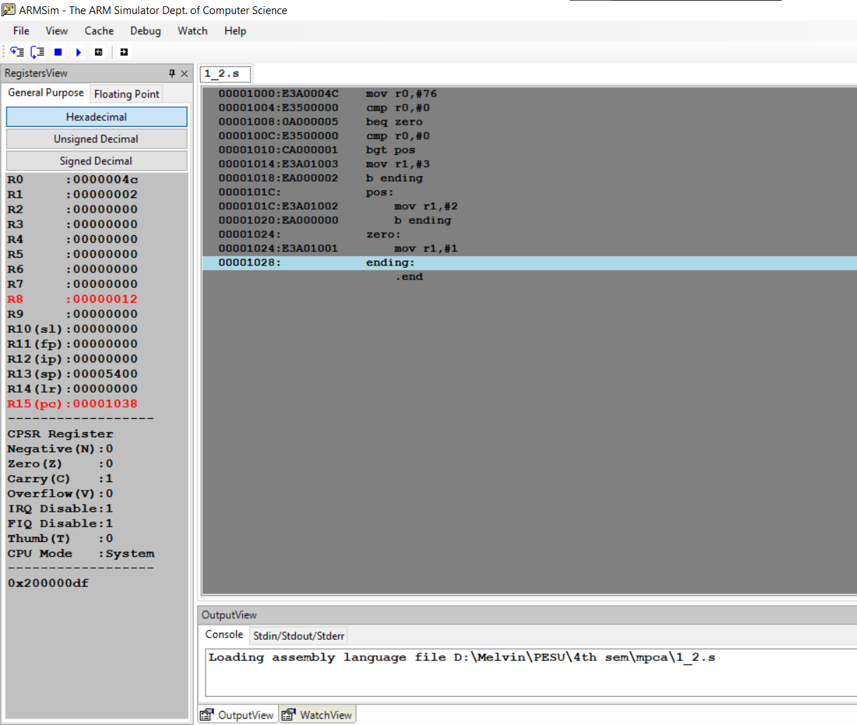

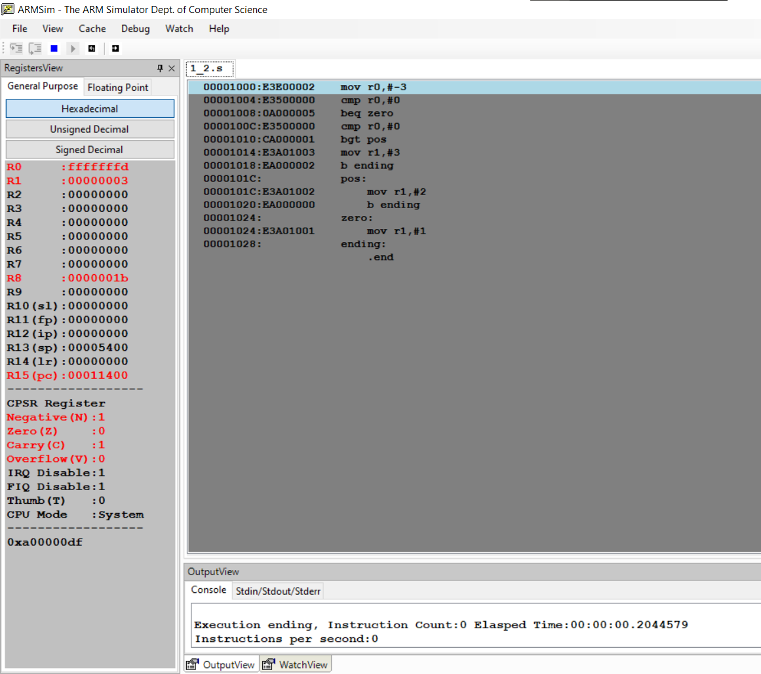

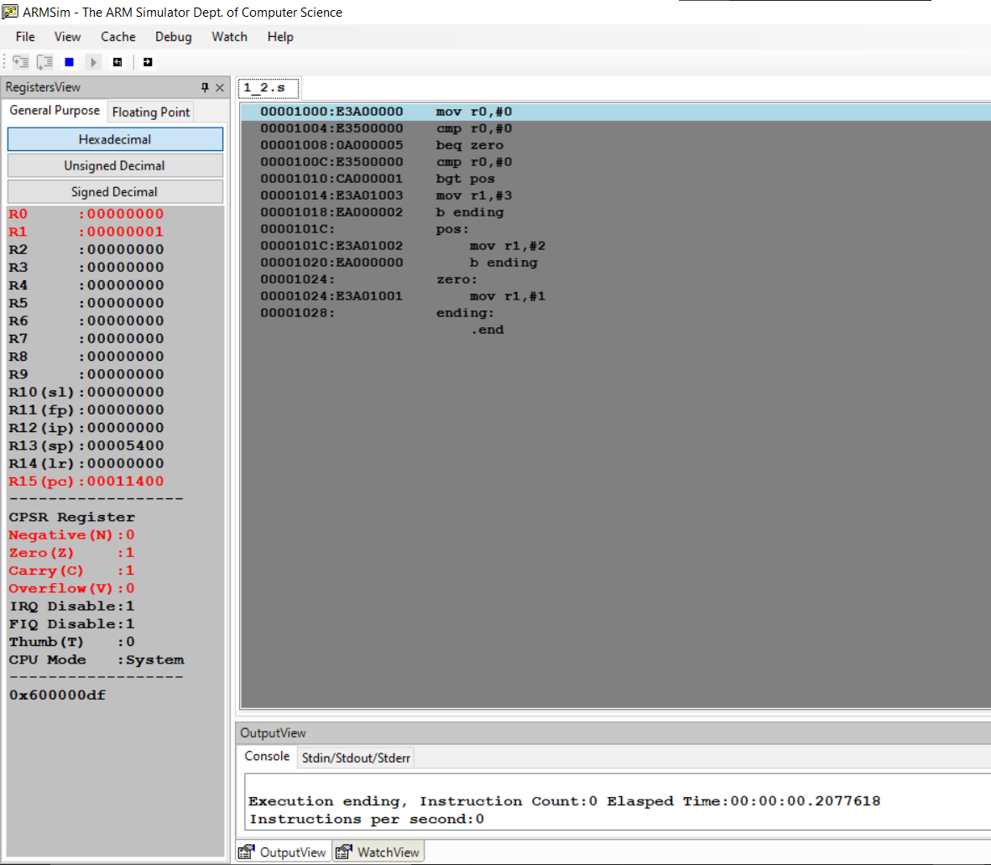

The output should be verified for zero, positive and negative cases.

**Disclaimer:**

* The programs and output submitted is duly written, verified and executed by me.
* I have not copied from any of my peers nor from the external resource such as internet.
* If found plagiarized, I will abide with the disciplinary action of the University.

Signature:

Name:

SRN:

Section:

Date: