**Microprocessor and Computer Architecture**

**UE21CS251B**

**4th Semester, Academic Year 2022-23**

Date:

|  |  |  |
| --- | --- | --- |
| Name: | SRN: | Section |

Week#____2_______ Program Number: ____1___

Title of the Program

**Write a program in ARM7TDMI-ISA to copy a block of N data items from Location A to Location B.**

**a. Use Full word (.word directive)**

**b. Use Half word(.hword directive)**

**c. Use Byte wise (.Byte directive)**

1. ARM Assembly Code

a.

.data

a: .word 53,72,13,38,62

b: .word 0,0,0,0,0

.text

ldr r0,=a

ldr r1,=b

mov r3,#5

loop: ldr r4,[r0]

add r0,r0,#4

str r4,[r1]

add r1,r1,#4

subs r3,r3,#1

bne loop

.end

b.

.data

a: .hword 21,53,11,7,4

b: .hword 0,0,0,0,0

.text

ldr r0,=a

ldr r1,=b

mov r3,#5

loop: ldrh r4,[r0]

add r0,r0,#2

strh r4,[r1]

add r1,r1,#2

subs r3,r3,#1

bne loop

.end

c.

.data

a: .byte 21,53,11,7,4

b: .byte 0,0,0,0,0

.text

ldr r0,=a

ldr r1,=b

mov r3,#5

loop: ldrb r4,[r0]

add r0,r0,#1

strb r4,[r1]

add r1,r1,#1

subs r3,r3,#1

bne loop

.end

1. Output Screen Shots (Three)

The output should be verified for word, half word, byte

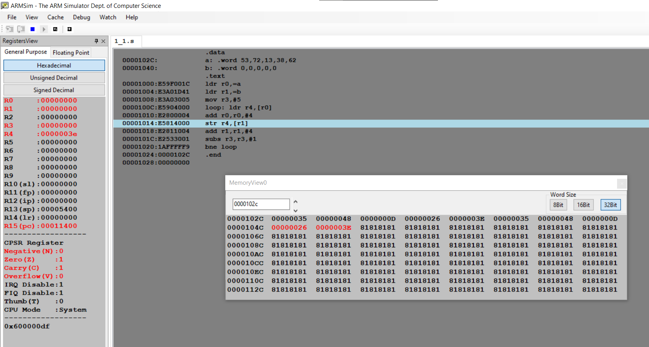

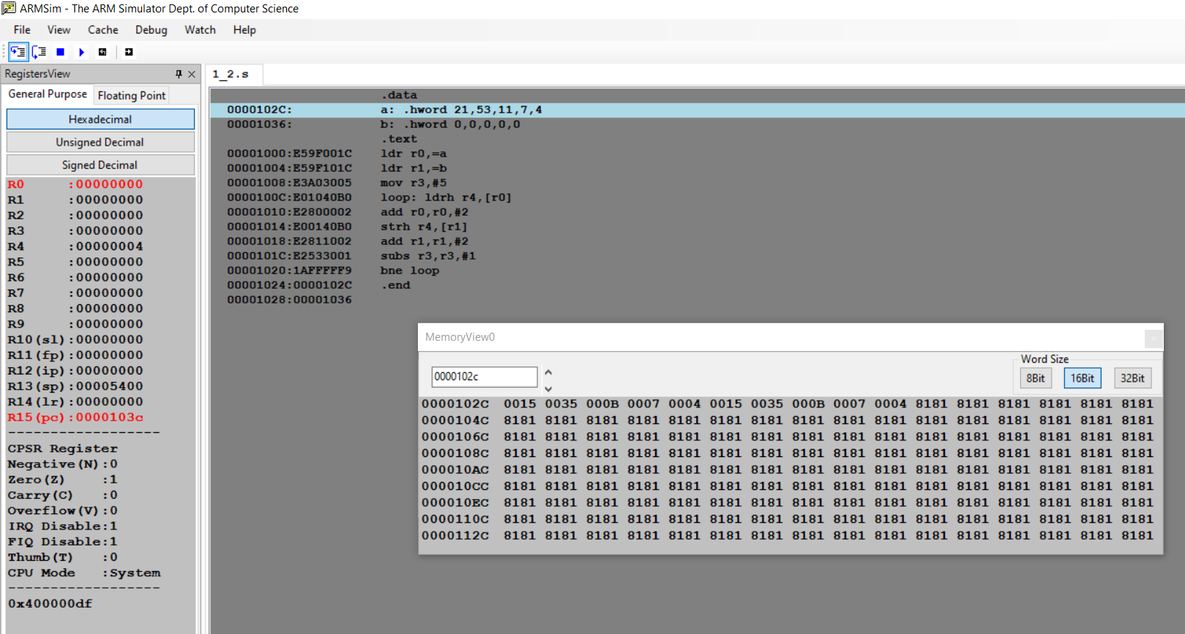

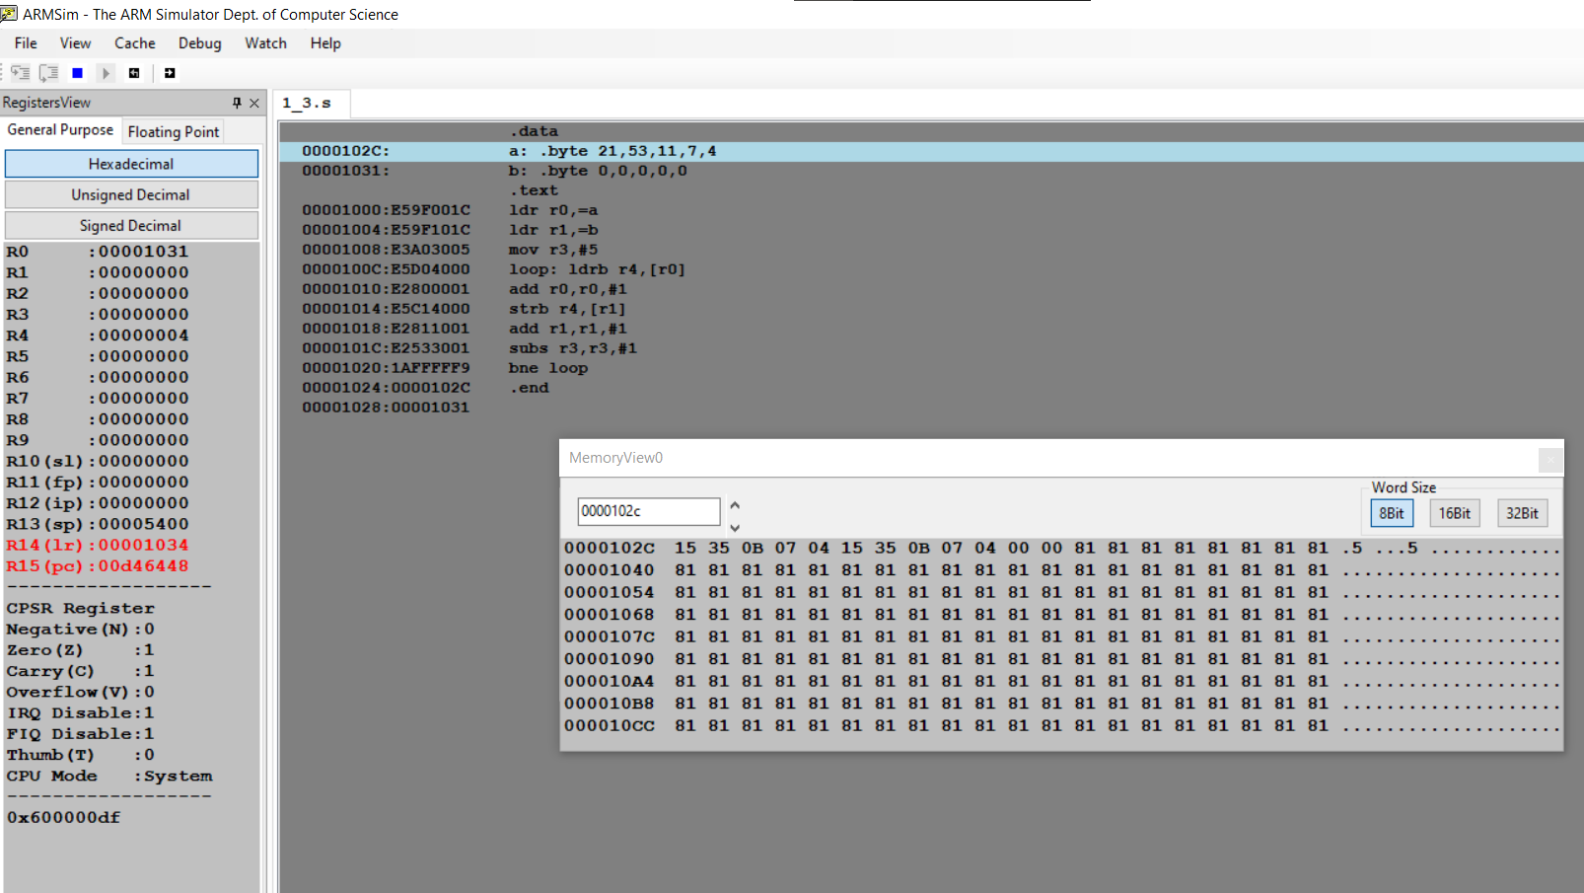

**Microprocessor and Computer Architecture**

**UE21CS251B**

**4th Semester, Academic Year 2022-23**

Date:

|  |  |  |
| --- | --- | --- |
| Name: | SRN: | Section |

Week#____2_______ Program Number: ____2___

Title of the Program

**Write a program in ARM7TDMI-ISA to find the sum of N data items in the memory. Store the result in the memory location.**

**a. Use Full word (.word directive)**

**b. Use Half word(.hword directive)**

**c. Use Byte wise (.Byte directive)**

I.ARM Assembly Code

a.

.data

a: .word 23,53,32,54,21,43,76,32,56,11

sum: .word 0

.text

ldr r0,=a

ldr r4,=sum

mov r1,#10

mov r3,#0

loop:

ldr r2,[r0]

add r3,r3,r2

add r0,r0,#4

sub r1,r1,#1

cmp r1,#0

bne loop

str r3,[r4]

swi 0x11

b.

.data

a: .hword 22,12,10,23,76,4,35,32,59,87

sum: .word 0

.text

ldr r0,=a

ldr r4,=sum

mov r1,#10

mov r3,#0

loop:

ldrh r2,[r0]

add r3,r3,r2

add r0,r0,#2

sub r1,r1,#1

cmp r1,#0

bne loop

str r3,[r4]

swi 0x11

c.

.data

a: .byte 43,12,4,21,14,22,15,2,8,28

sum: .word 0

.text

ldr r0,=a

ldr r4,=sum

mov r1,#10

mov r3,#0

loop:

ldrb r2,[r0]

add r3,r3,r2

add r0,r0,#1

sub r1,r1,#1

cmp r1,#0

bne loop

str r3,[r4]

swi 0x11

II. Output Screen Shots (Three)

The output should be verified for word, half word, byte

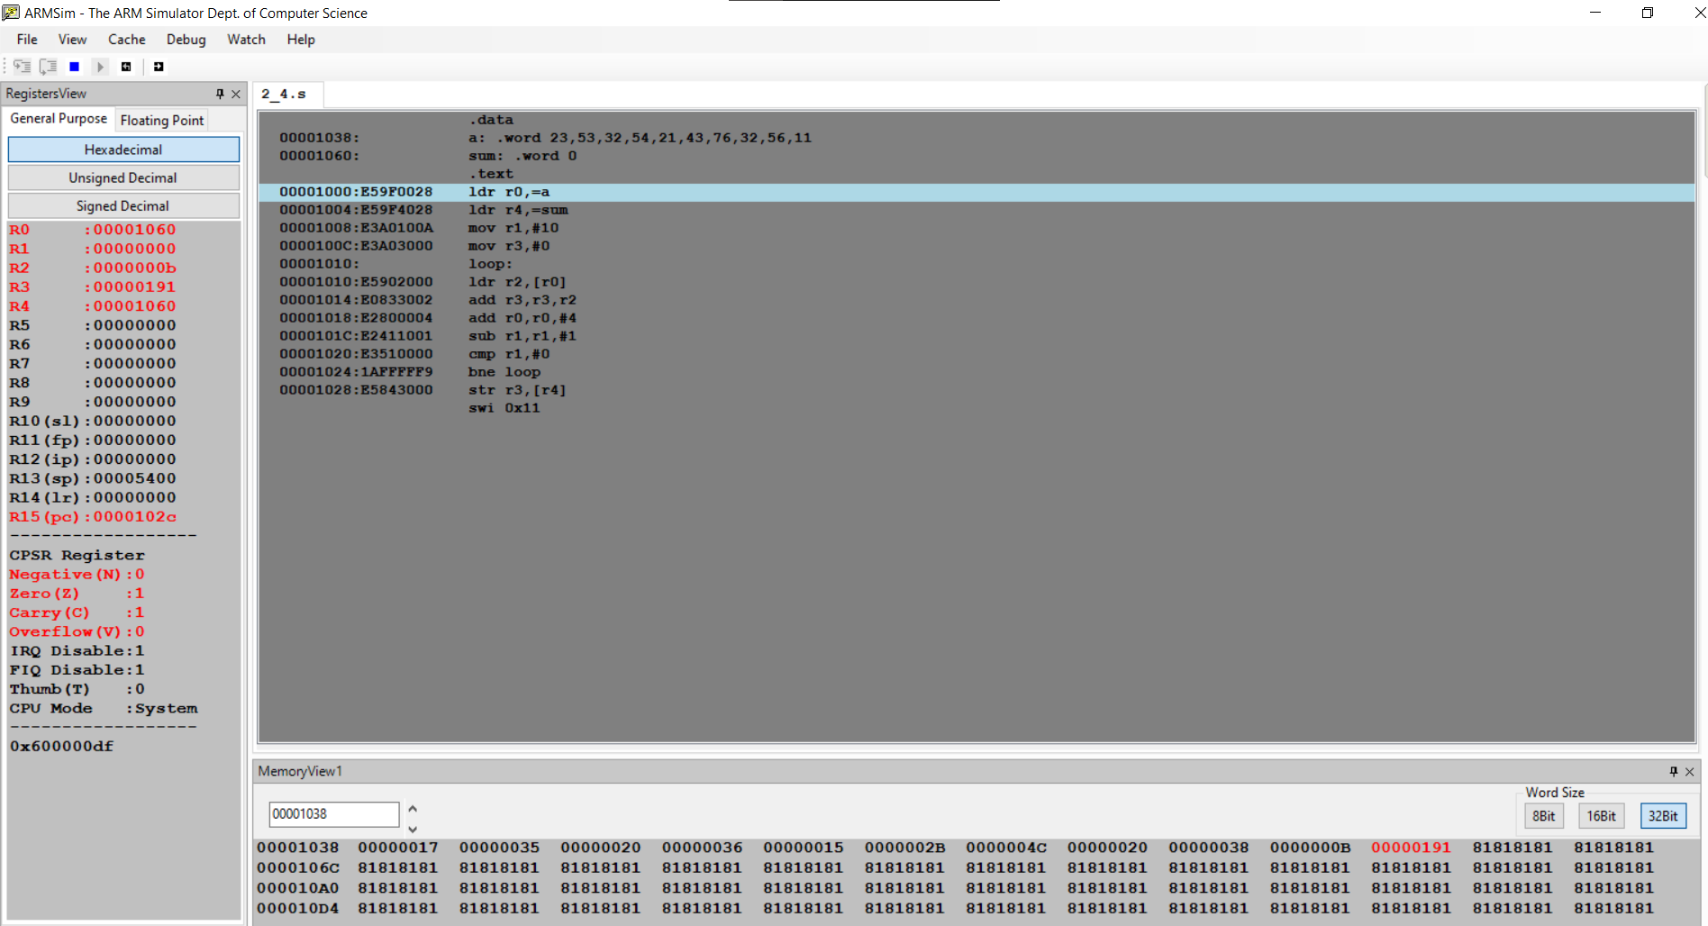

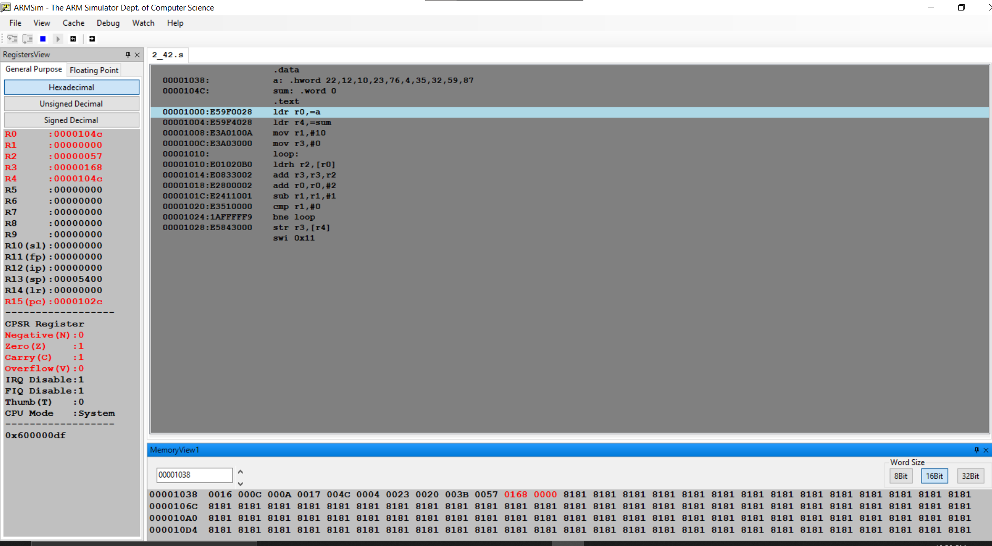

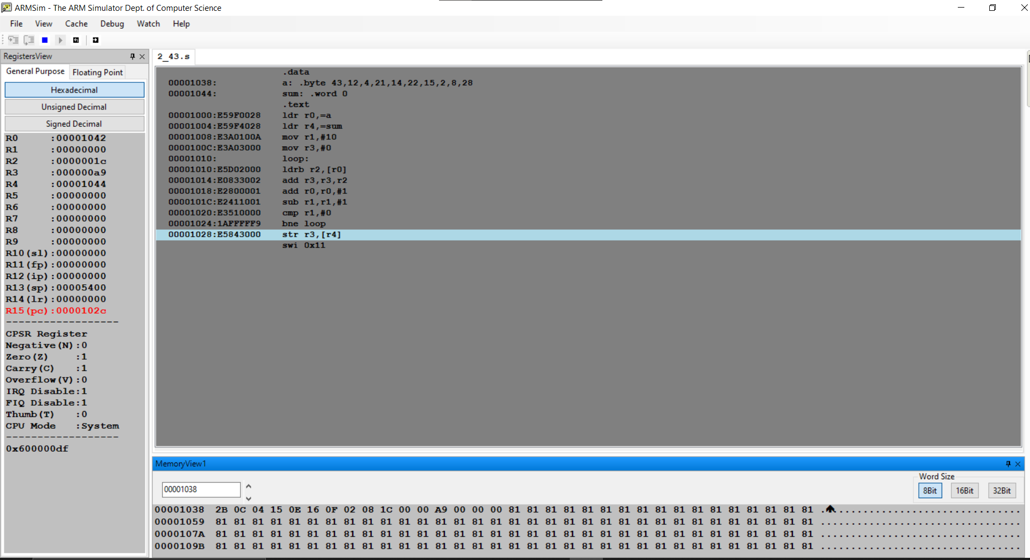

**Microprocessor and Computer Architecture**

**UE21CS251B**

**4th Semester, Academic Year 2022-23**

Date:

|  |  |  |
| --- | --- | --- |
| Name: | SRN: | Section |

Week#____2_______ Program Number: ____3___

Title of the Program

**Write a program in ARM7TDMI-ISA to find the sum of N natural numbers. Store the result in the memory location.**

I.ARM Assembly Code

.data

a: .word 0

.text

ldr r2,=a

mov r1,#13

mov r0,#0

mov r3,#1

loop:

add r0,r0,r3

add r3,r3,#1

cmp r3,r1

bne loop

str r0,[r2]

swi 0x11

II. Output Screen Shots (One)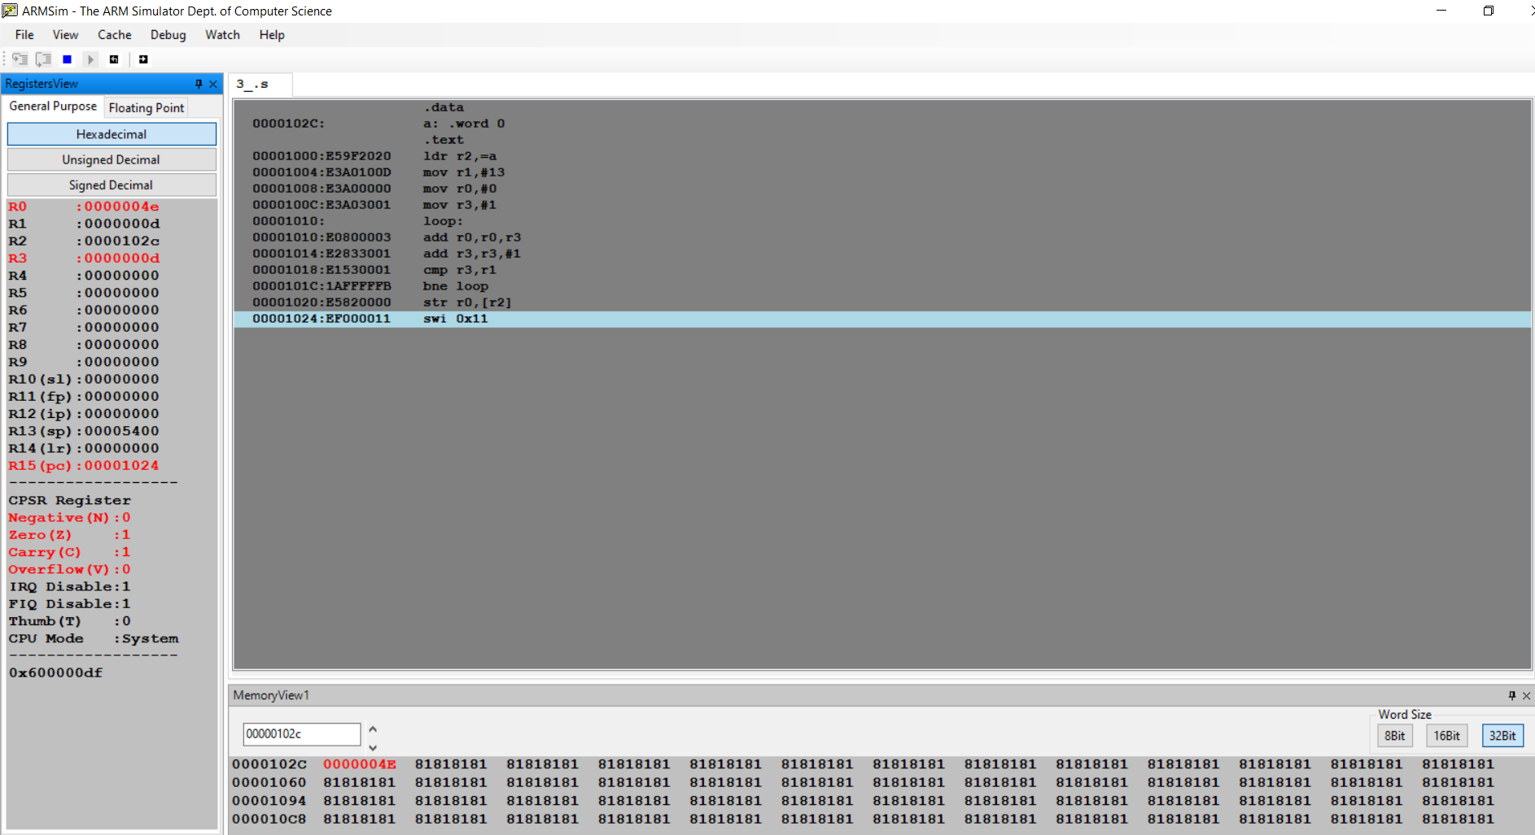

**Microprocessor and Computer Architecture**

**UE21CS251B**

**4th Semester, Academic Year 2022-23**

Date:

|  |  |  |
| --- | --- | --- |
| Name: | SRN: | Section |

Week#____2_______ Program Number: ____4___

Title of the Program

**Write a program in ARM7TDMI-ISA to find the product of two 32bit numbers using barrel shifter.**

I.ARM Assembly Code

Code to multiply a number by 25

mov r0,#100

mov r1,r0,lsl#5

rsb r0,r0,r0,lsl#3

sub r0,r1,r0

II. Output Screen Shot (One)

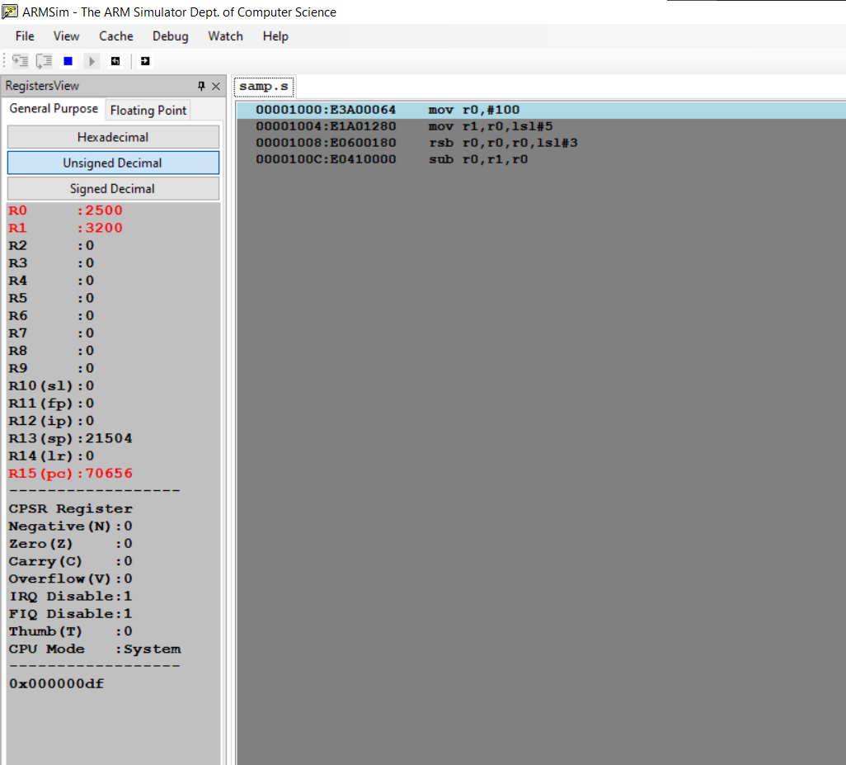

**Microprocessor and Computer Architecture**

**UE21CS251B**

**4th Semester, Academic Year 2022-23**

Date:

|  |  |  |
| --- | --- | --- |
| Name: | SRN: | Section |

Week#____2_______ Program Number: ____5___

Title of the Program

**Convert the following statement in C language into an ALP using ARM7TDMI – ISA.**

**IF([A]==[B]) then C=[A]+[B];**

**ELSE IF ([B]==[C]) D=[A]-[B];**

**ELSE E=[A]*[B]**

**Where A,B C, D & E are memory locations.**

I.ARM Assembly Code

.data

a: .word 23

b: .word 23

c: .word 13

d: .word 37

e: .word 21

.text

ldr r0,=a

ldr r1,=b

ldr r2,=c

ldr r3,=d

ldr r4,=e

ldr r6,[r0]

ldr r7,[r1]

ldr r11,[r2]

cmp r6,r7

beq addi

cmp r7,r11

beq subt

mul r5,r6,r7

str r4,[r5]

swi 0x11

addi:

add r8,r6,r7

str r8,[r3]

swi 0x11

subt:

sub r9,r0,r1

str r9,[r3]

swi 0x11

II. Output Screen Shot (One)

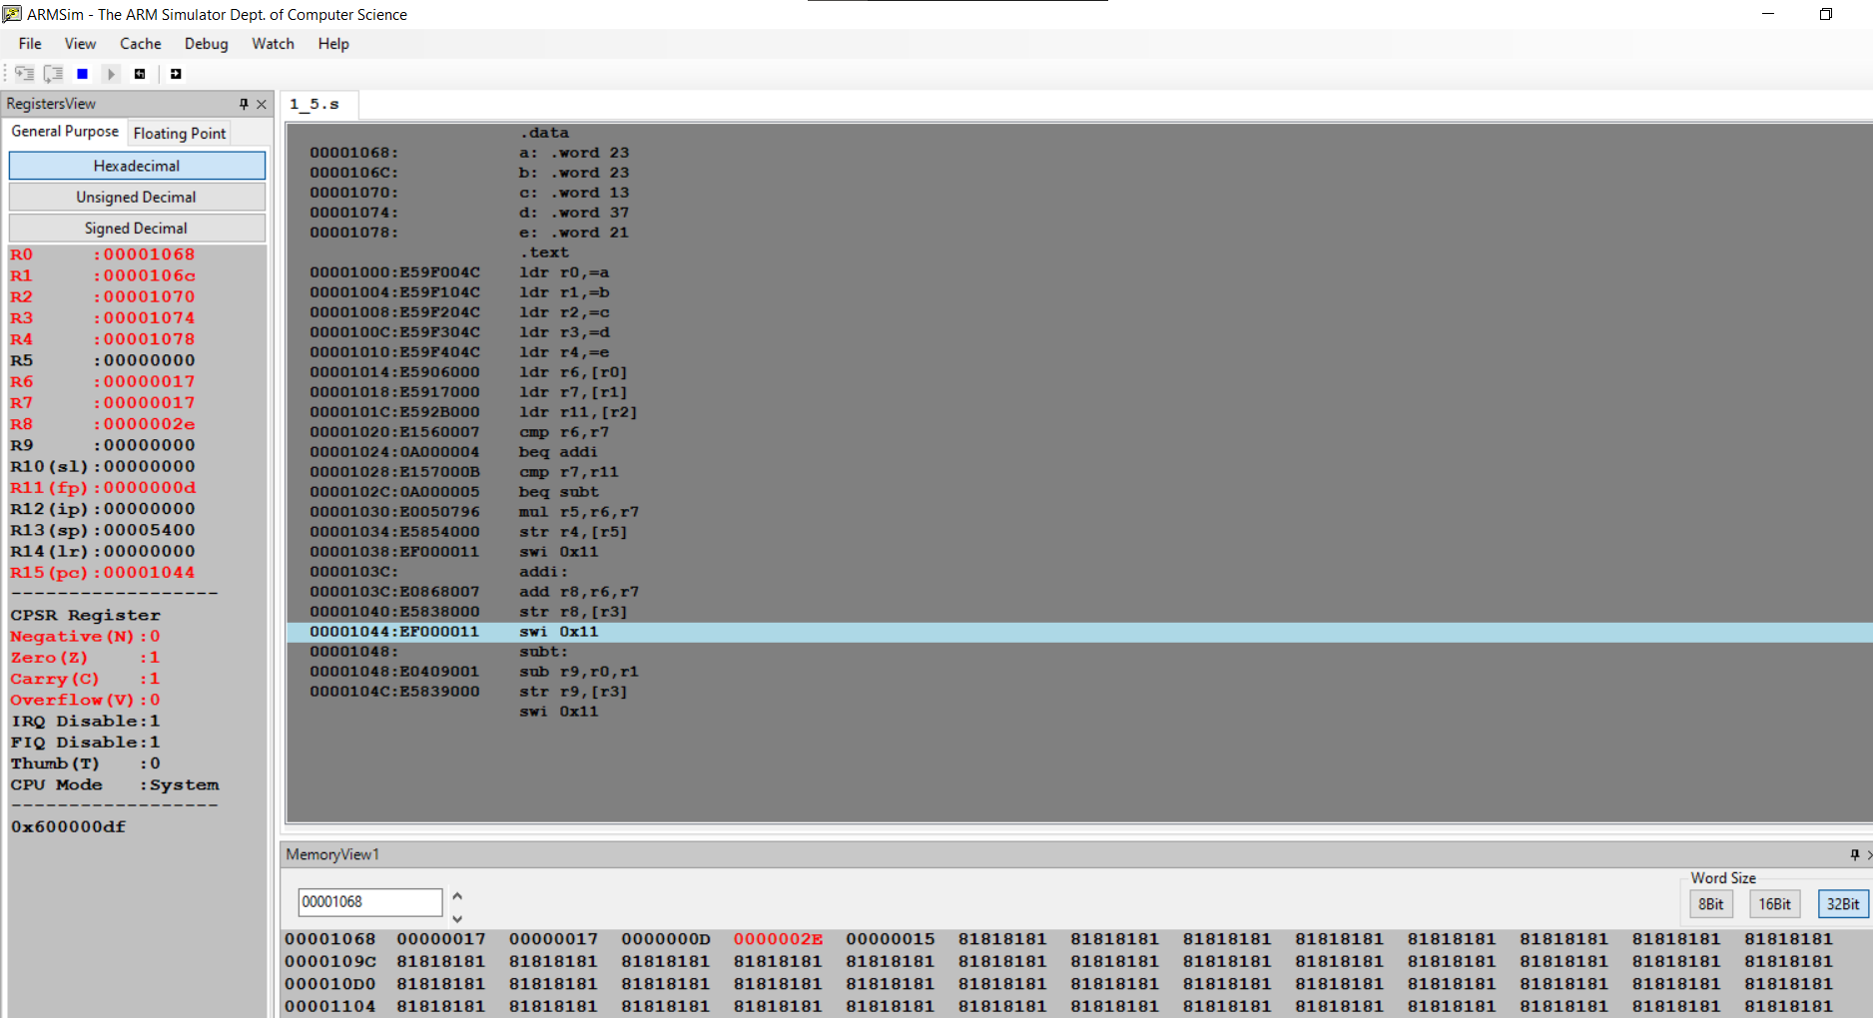

**Microprocessor and Computer Architecture**

**UE21CS251B**

**4th Semester, Academic Year 2022-23**

Date:

|  |  |  |
| --- | --- | --- |
| Name: | SRN: | Section |

Week#____2_______ Program Number: ____6__

Title of the Program

**Write a program in ARM7TDMI-ISA to find the factorial of a number.**

I.ARM Assembly Code

.text

mov r0,#8

mov r1,r0

loop:

sub r0,r0,#1

mul r2,r0,r1

mov r1,r2

cmp r0,#1

bne loop

swi 0x11

1. Output Screen Shot (One)

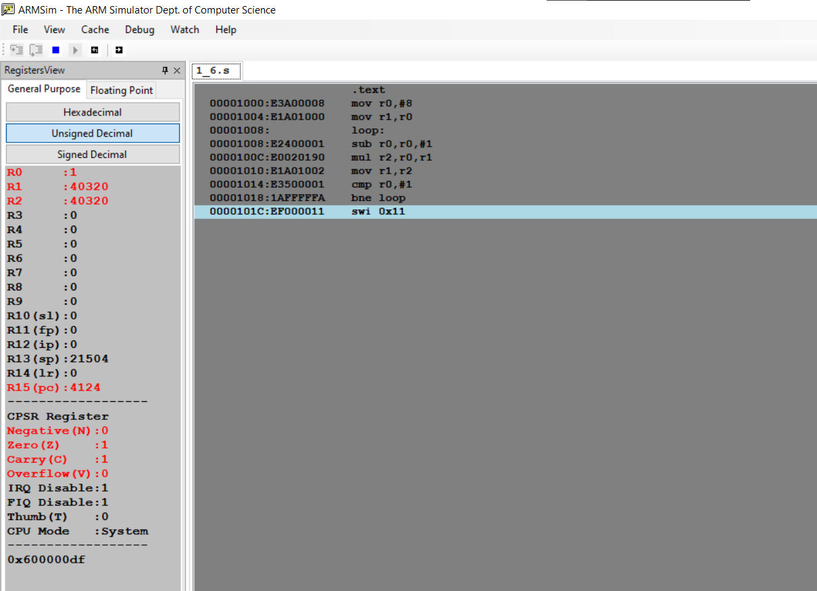

**Disclaimer:**

* The programs and output submitted is duly written, verified and executed by me.
* I have not copied from any of my peers nor from the external resource such as internet.
* If found plagiarized, I will abide with the disciplinary action of the University.

Signature:

Name:

SRN:

Section:

Date: