**Microprocessor and Computer Architecture**

**UE21CS251B**

**4th Semester, Academic Year 2022-23**

Date:

|  |  |  |
| --- | --- | --- |
| Name: | SRN: | Section |

Week#____3_______ Program Number: ____1__

Title of the Program

**Generate Fibonacci Series and store them in an array.**

I.ARM Assembly Code

.data

a:.word 0,0,0,0,0,0,0,0,0,0

.text

ldr r0,=a

mov r1,#0

mov r2,#1

mov r3,#8

str r1,[r0],#4

str r2,[r0],#4

loop:

add r4,r1,r2

mov r1,r2

mov r2,r4

str r4,[r0],#4

subs r3,r3,#1

cmp r3,#0

bne loop

.end

II. Output Screen Shots (One)

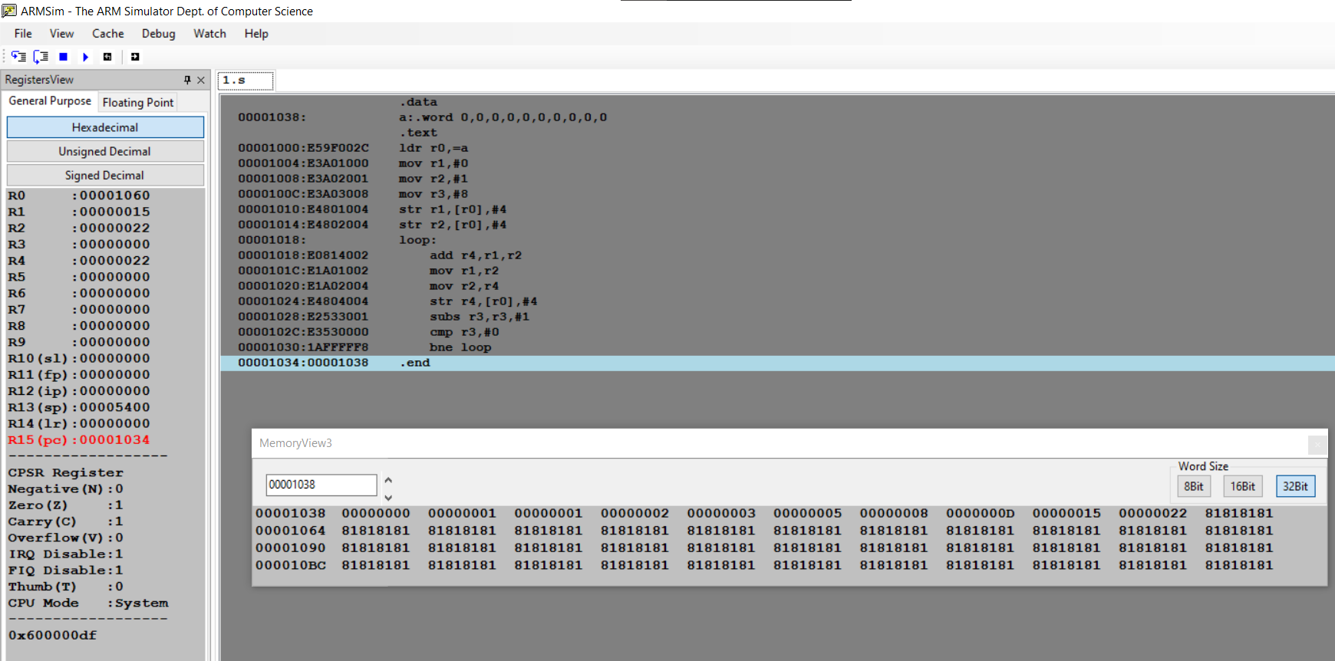

**Microprocessor and Computer Architecture**

**UE21CS251B**

**4th Semester, Academic Year 2022-23**

Date:

|  |  |  |
| --- | --- | --- |
| Name: | SRN: | Section |

Week#____3_______ Program Number: ____2___

Title of the Program

**Write an ALP to find smallest number in an array of n 32-bit numbers**

I.ARM Assembly Code

.data

array: .word 43,13,87,54,32,13,98,21,65,6

.text

ldr r0,=array

mov r1,#9

ldr r2,[r0]

loop:

ldr r3,[r0,#4]

cmp r2,r3

blt skip

mov r2,r3

skip:

add r0,r0,#4

sub r1,r1,#1

cmp r1,#0

bne loop

mov r0,r2

swi 0x11

.end

II. Output Screen Shots (One)

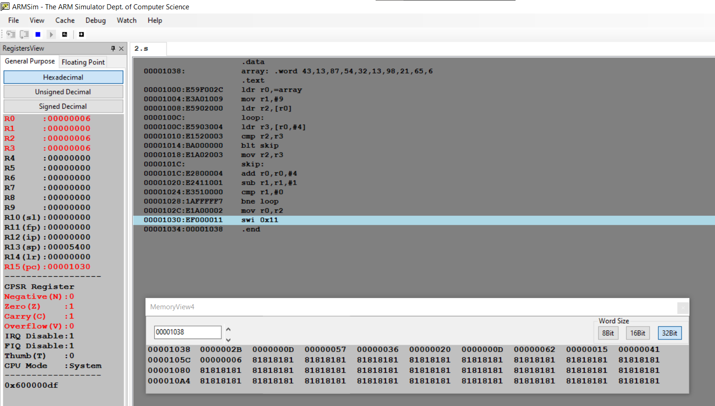

**Microprocessor and Computer Architecture**

**UE21CS251B**

**4th Semester, Academic Year 2022-23**

Date:

|  |  |  |
| --- | --- | --- |
| Name: | SRN: | Section |

Week#____2_______ Program Number: ____3__

Title of the Program

**To perform Convolution using MUL instruction (Addition of multiplication of respective numbers of loc A and loc B)**

I.ARM Assembly Code

.data

a: .word 21,33,54,2,5,3,24,2,8

b: .word 13,12,11,10,9,8,7,6,5

c: .word 0

.text

LDR r0,=a

LDR r1,=b

LDR r2,=c

MOV r5,#0

MOV r6,#1

loop:

LDR r3,[r0],#4

LDR r4,[r1],#4

MUL r7,r3,r4

ADD r5,r5,r7

ADD r6,r6,#1

CMP r6,#10

BNE loop

B exit

exit:

STR r5,[r2]

swi 0x11

.end

II. Output Screen Shot (One)

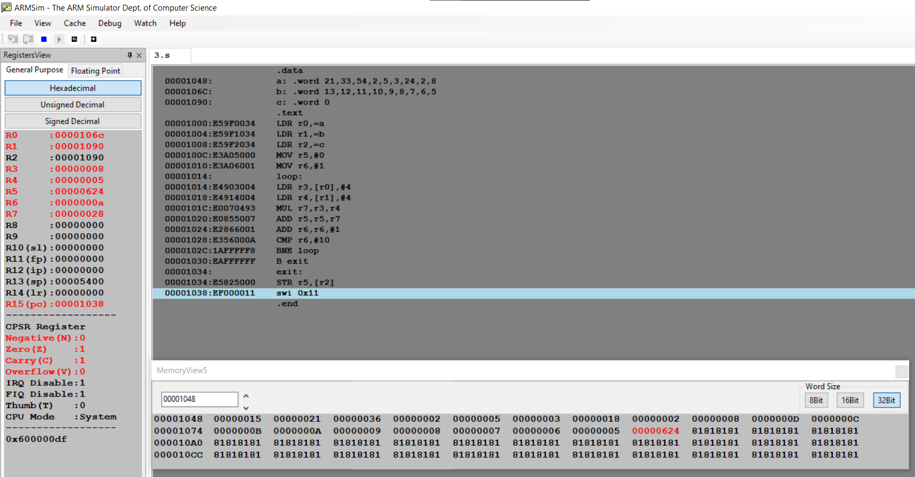

**Microprocessor and Computer Architecture**

**UE21CS251B**

**4th Semester, Academic Year 2022-23**

Date:

|  |  |  |
| --- | --- | --- |
| Name: | SRN: | Section |

Week#____2_______ Program Number: ____4___

Title of the Program

**To perform Convolution using MLA instruction (Addition of multiplication of respective numbers of loc A and loc B).**

I.ARM Assembly Code

.data

a: .word 42,12,2,5,11,23,17,7,6,1

b: .word 22,12,3,2,6,15,32,16,8,4

c: .word 0

.text

LDR r0,=a

LDR r1,=b

LDR r2,=c

MOV r5,#0

MOV r6,#1

loop:

LDR r3,[r0],#4

LDR r4,[r1],#4

MLA r5,r3,r4,r5

ADD r6,r6,#1

CMP r6,#10

BNE loop

B exit

exit:

STR r5,[r2]

swi 0x11

.end

II. Output Screen Shot (One)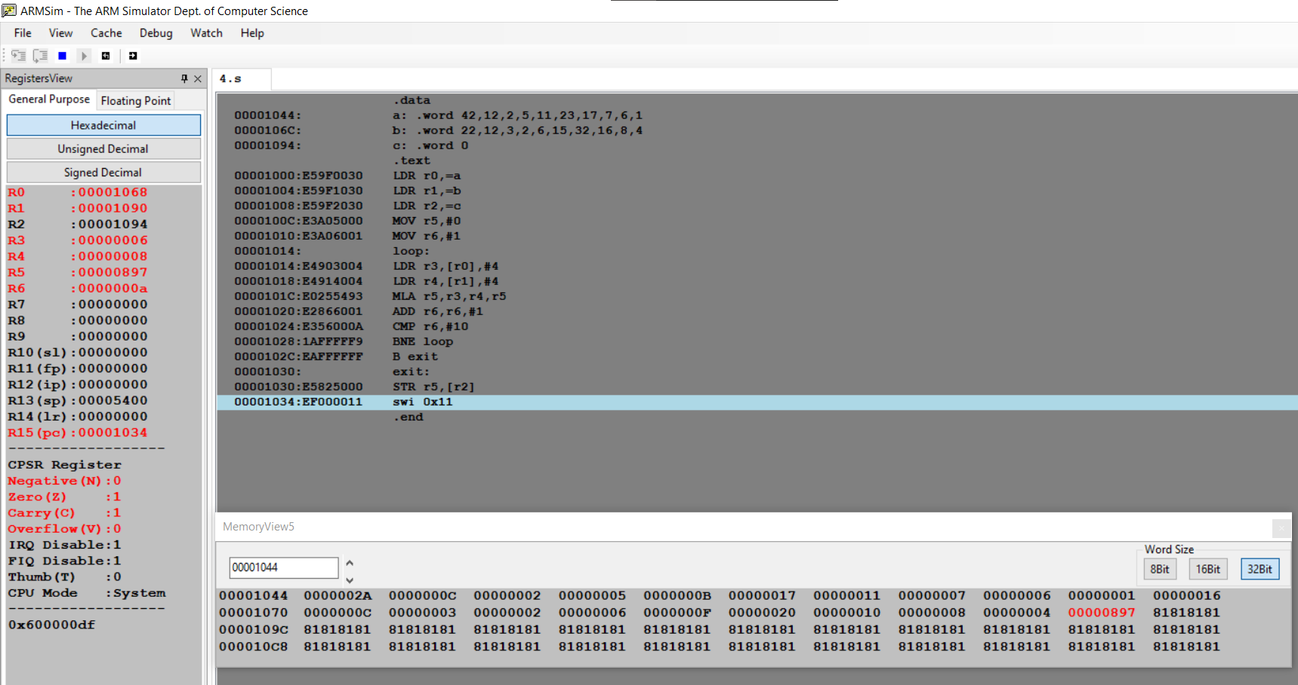

**Microprocessor and Computer Architecture**

**UE21CS251B**

**4th Semester, Academic Year 2022-23**

Date:

|  |  |  |
| --- | --- | --- |
| Name: | SRN: | Section |

Week#____2_______ Program Number: ____5__

Title of the Program

**Write an ALP to find mul (add( a,b),c)**

I.ARM Assembly Code

.data

a: .word 0

stk: .word 0

.text

LDR r0,=a

MOV r1,#15

MOV r2,#25

MOV r3,#30

BL mulADD

STR r6,[r0]

B exit

mulADD:

LDR r4,=stk

STR LR,[r4]

BL add

MUL r6,r5,r3

LDR LR,[r4]

MOV PC,LR

add:

ADD r5,r2,r1

MOV PC,LR

exit:

SWI 0x11

.end

II. Output Screen Shot (One)

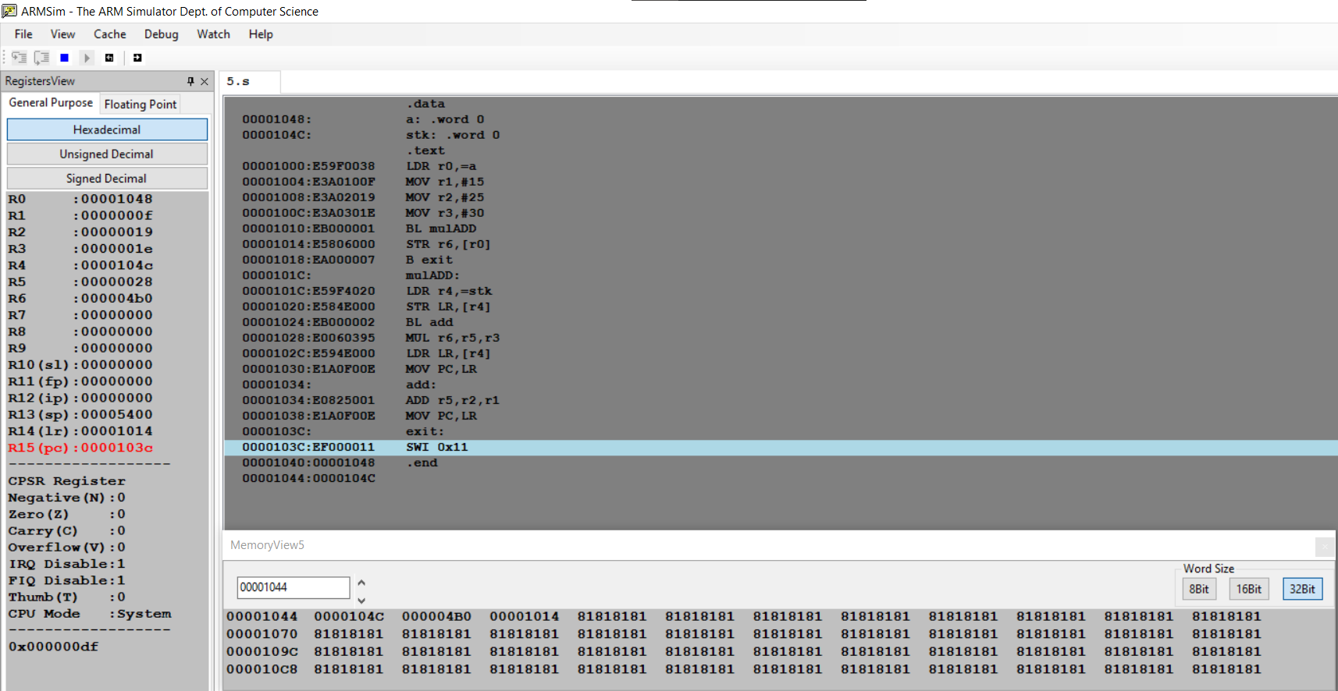

**Microprocessor and Computer Architecture**

**UE21CS251B**

**4th Semester, Academic Year 2022-23**

Date:

|  |  |  |
| --- | --- | --- |
| Name: | SRN: | Section |

Week#____2_______ Program Number: ____6__

Title of the Program

**Write an ALP to find factorial using subroutine**

I.ARM Assembly Code

.text

mov r1,#7

mov r2,#1

bl fact

fact:

cmp r1,#0

beq end

mul r3,r2,r1

mov r2,r3

sub r1,r1,#1

b fact

end:

swi 0x11

.end

II. Output Screen Shot (One)

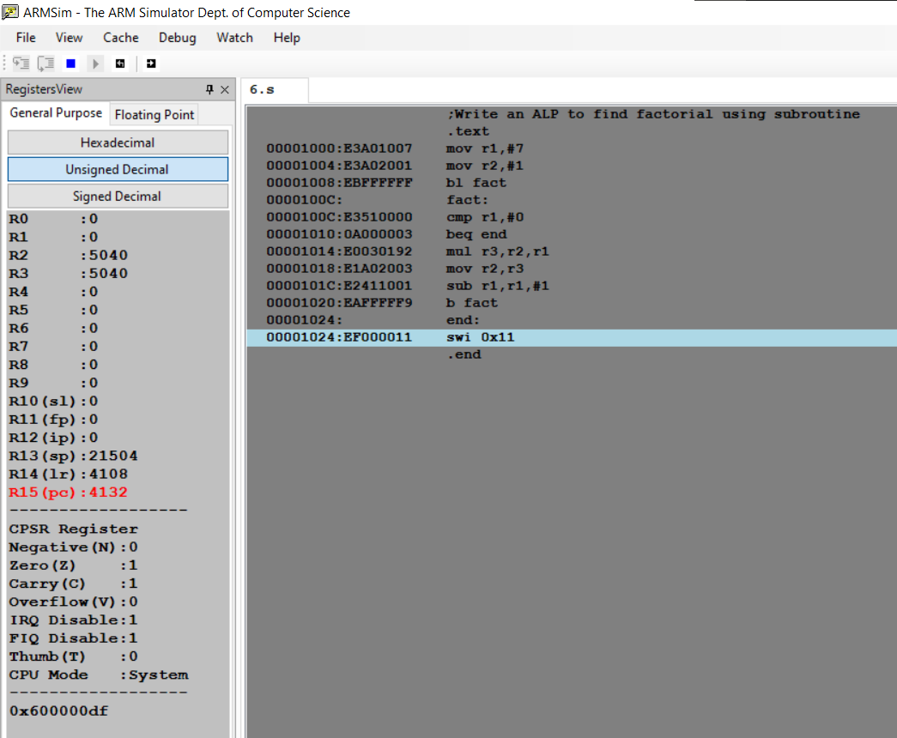

**Microprocessor and Computer Architecture**

**UE21CS251B**

**4th Semester, Academic Year 2022-23**

Date:

|  |  |  |
| --- | --- | --- |
| Name: | SRN: | Section |

Week#____2_______ Program Number: ____7__

Title of the Program

**Write an ALP to perform multiplication using shift method (without using MUL)**

I.ARM Assembly Code

Code to multiply a number by 25

mov r0,#100

mov r1,r0,lsl#5

rsb r0,r0,r0,lsl#3

sub r0,r1,r0

II. Output Screen Shot (One)

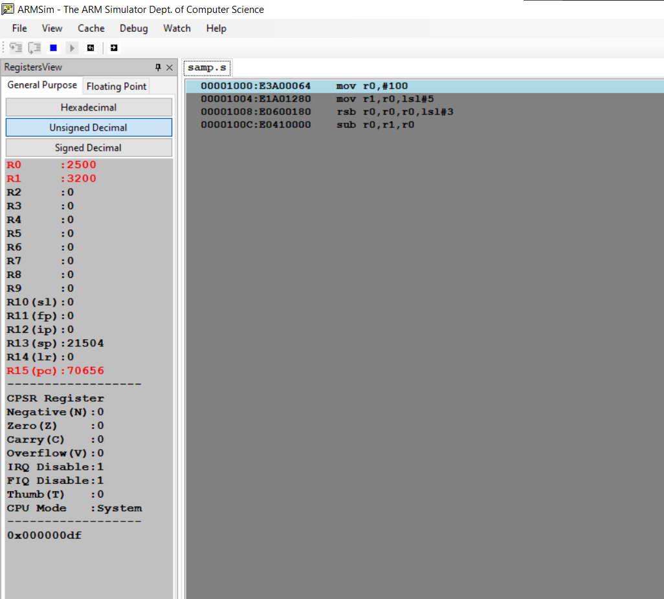

**Disclaimer:**

* The programs and output submitted is duly written, verified and executed by me.
* I have not copied from any of my peers nor from the external resource such as internet.
* If found plagiarized, I will abide with the disciplinary action of the University.

Signature:

Name:

SRN:

Section:

Date: