**Microprocessor and Computer Architecture Laboratory**

**UE19CS256**

**4th Semester, Academic Year 2020-21**

Date:

|  |  |  |
| --- | --- | --- |
| Name: | SRN: | Section |

Week#____5_______ Program Number: ____1_

**Write an ALP to read from a 2D array such that**

**B=a[i] [j]**

1. ARM Assembly Code (1).

.data

a: .word 11,32,27,84,45,36,31,48,59

b: .word 0,0,0,0,0,0,0,0,0

.text

ldr r0,=a

ldr r1,=b

mov r2,#3

mov r3,#3

mov r4,#0

mov r5,#0

mov r6,#0

for_i:

mov r7,#0

for_j:

ldr r8,[r0,r4]

str r8,[r1,r6]

add r4,r4,#4

add r6,r6,#4

add r7,r7,#1

cmp r7,r3

blt for_j

add r5,r5,#1

cmp r5,r2

blt for_i

mov r0,#0

swi 0x11

.end

1. Output Screen Shot (One Example of your choice)

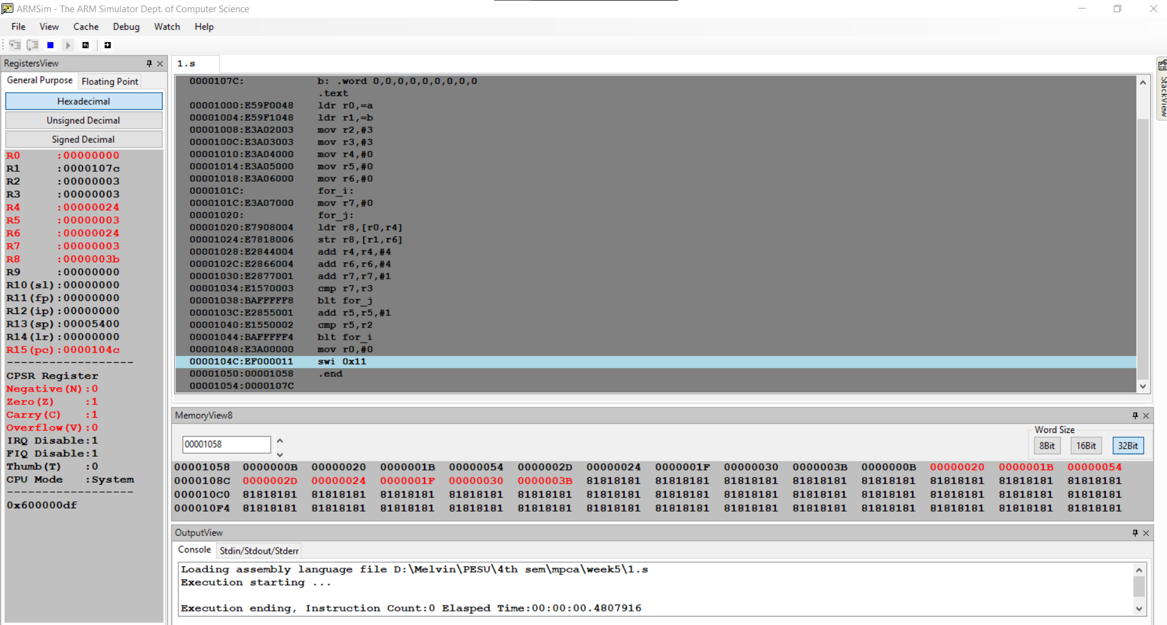

**Microprocessor and Computer Architecture Laboratory**

**UE19CS256**

**4th Semester, Academic Year 2020-21**

Date:

|  |  |  |
| --- | --- | --- |
| Name: | SRN: | Section |

Week#____5_______ Program Number: ____2_

**Write an ALP to implement C[k]=A[i]+B[j]**

1. ARM Assembly Code (1).

.data

a: .word 1, 2, 3, 4, 5, 6, 7, 8, 9, 10

b: .word 17, 23, 18, 14, 16, 8, 2, 4, 5, 12

c: .word 0, 0, 0, 0, 0, 0, 0, 0, 0, 0

.text

ldr r0, =a

ldr r1, =b

ldr r2, =c

mov r6,#10

loop:

ldr r3,[r0],#4

ldr r4,[r1],#4

add r5,r3,r4

str r5,[r2],#4

subs r6,r6,#1

bne loop

swi 0x11

.end

1. Output Screen Shot (One Example of your choice)

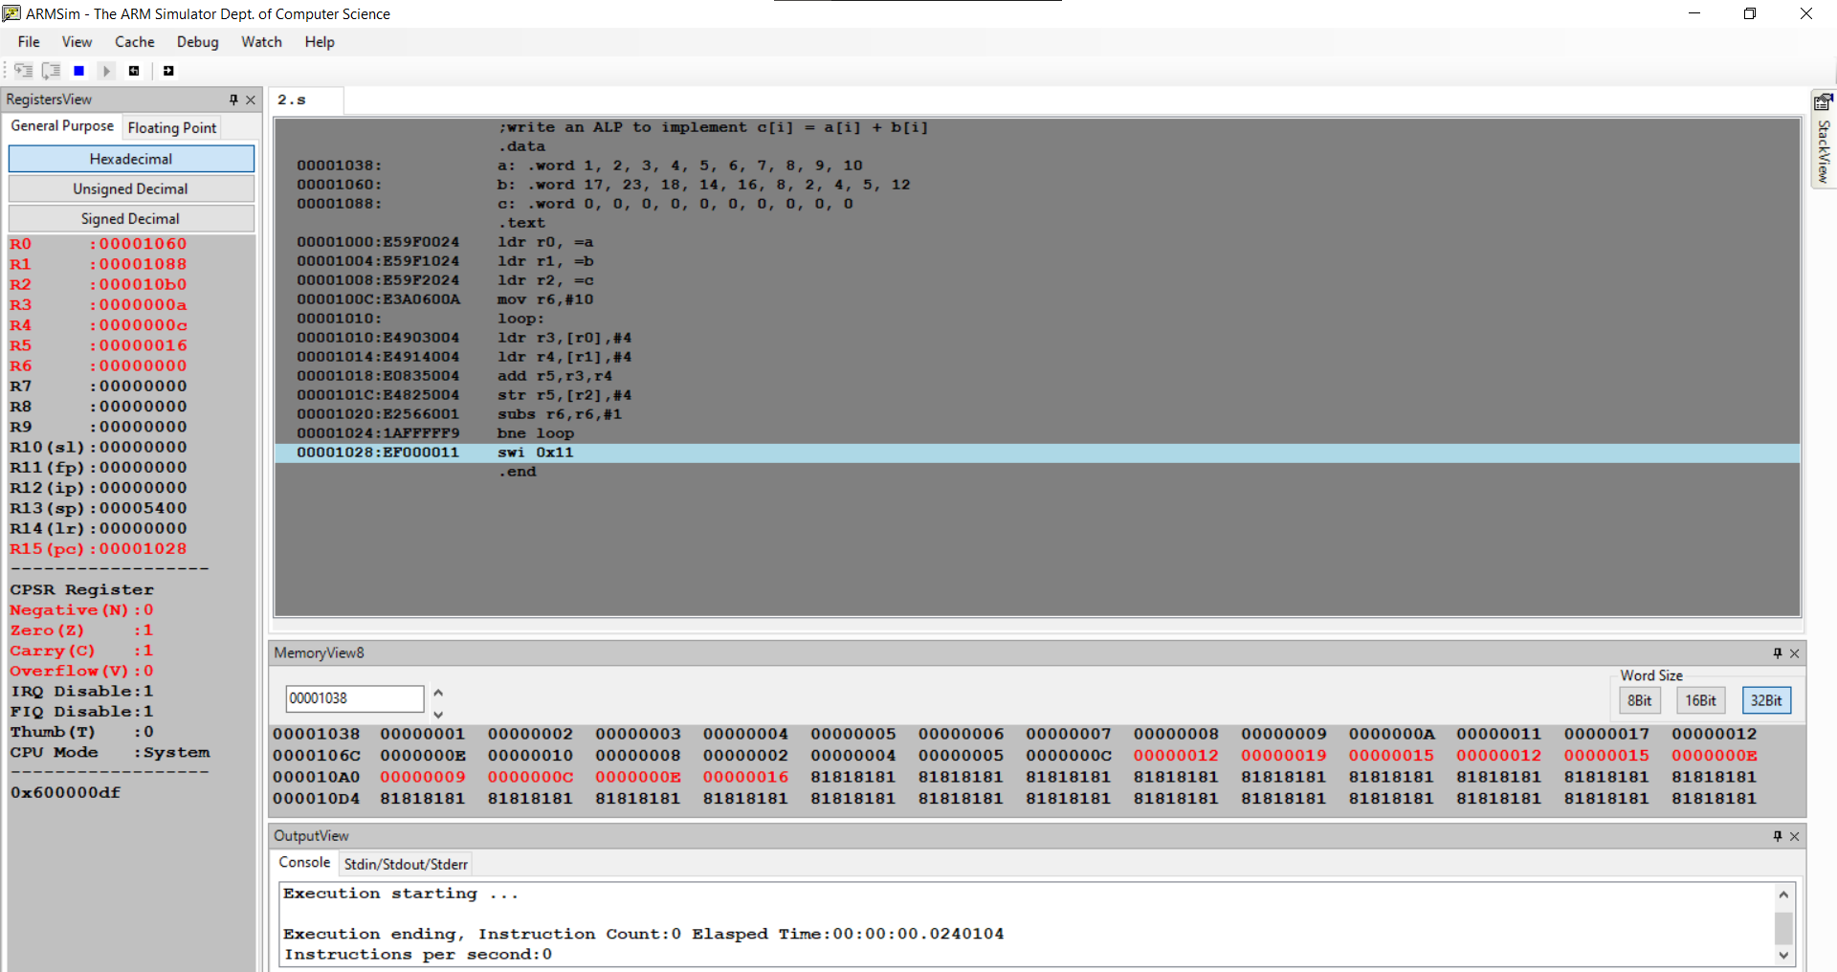

. **Microprocessor and Computer Architecture Laboratory**

**UE19CS256**

**4th Semester, Academic Year 2020-21**

Date:

|  |  |  |
| --- | --- | --- |
| Name: | SRN: | Section |

Week#____5_______ Program Number: ____3_

**Write an ALP to implement Sum[i] +=a[i][j]**

1. ARM Assembly Code (1).

.data

a: .word 1,2,3,4,5,6,7,8,9

.text

ldr r0,=a

mov r1,#0

mov r2,#3

mov r3,#3

mov r4,#0

mov r5,#0

for_i:

for_j:

stmfd r13!,{r4,r5}

bl get_addr

ldmfd r13!,{r4,r5,r6}

add r6,r0,r6

ldr r6,[r6]

add r1,r1,r6

add r5,r5,#1

cmp r5,r3

bne for_j

mov r5,#0

add r4,r4,#1

cmp r4,r2

beq exit

b for_i

get_addr:

ldmfd r13!,{r4,r5}

mla r7,r3,r4,r5

mov r8,#4

mul r6,r7,r8

stmfd r13!,{r4,r5,r6}

bx lr

exit:

swi 0x11

.end

1. Output Screen Shot (One Example of your choice)

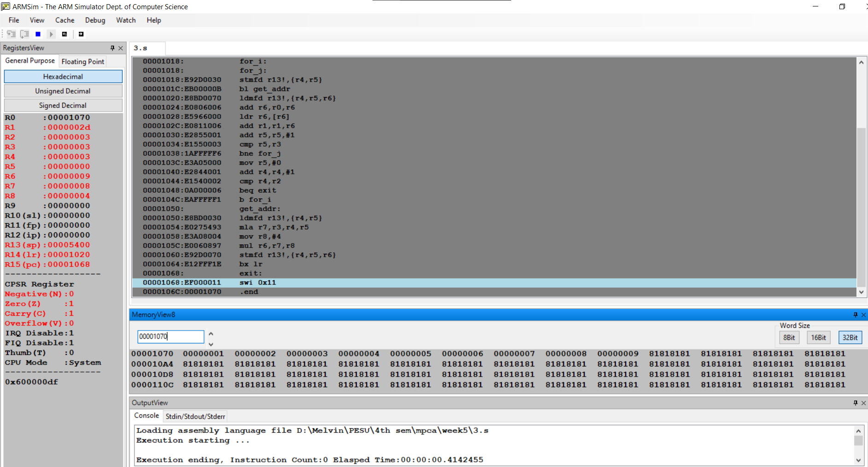

**Microprocessor and Computer Architecture Laboratory**

**UE19CS256**

**4th Semester, Academic Year 2020-21**

Date:

|  |  |  |
| --- | --- | --- |
| Name: | SRN: | Section |

Week#____5_______ Program Number: ____4_

**Write an ALP to implement c[k] = a[i] * b[j]**

1. ARM Assembly Code (1).

.data

a: .word 1,2,3,4,5,6,7,8,9,10

b: .word 1,2,3,4,5,6,7,8,9,10

c: .word 0,0,0,0,0,0,0,0,0,0

.text

ldr r0, =a

ldr r1, =b

ldr r2, =c

ldr r3, =10

loop:

ldr r4, [r0], #4

ldr r5, [r1], #4

mul r6, r4, r5

str r6, [r2], #4

subs r3, r3, #1

bne loop

swi 0x11

.end

1. Output Screen Shot (One Example of your choice)

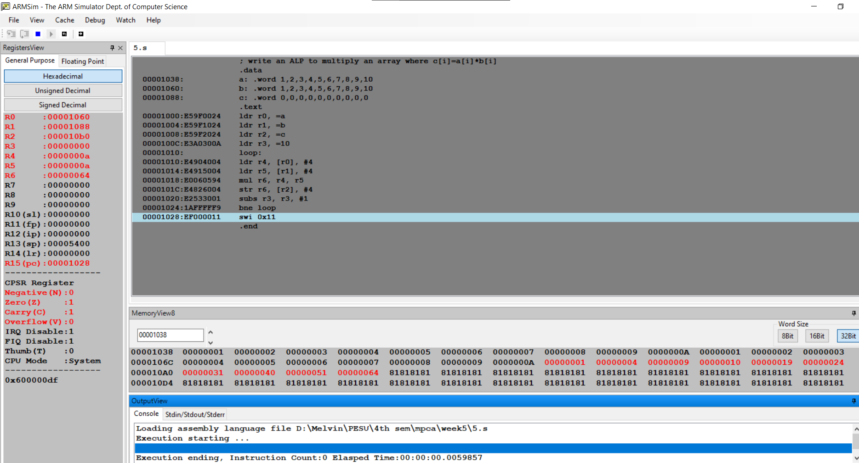

**Microprocessor and Computer Architecture Laboratory**

**UE19CS256**

**4th Semester, Academic Year 2020-21**

Date:

|  |  |  |
| --- | --- | --- |
| Name: | SRN: | Section |

Week#____5_______ Program Number: ____5_

**Write an ALP to implement C[i][j]=a[i][j]+b[i][j]**

1. ARM Assembly Code (1).

.data

a: .word 1,2,3,4,5,6,7,8,9

b: .word 14,11,4,2,17,19,13,6,21

c: .word 0,0,0,0,0,0,0,0,0

.text

ldr r0,=a

ldr r1,=b

ldr r2,=c

mov r3,#3

mov r4,#3

mov r5,#0

mov r6,#0

for_i:

mov r7,#0

for_j:

ldr r8,[r0]

ldr r9,[r1]

add r10,r8,r9

str r10,[r2]

add r0,r0,#4

add r1,r1,#4

add r2,r2,#4

add r7,r7,#1

cmp r7,r4

bne for_j

add r5,r5,#1

cmp r5,r3

bne for_i

mov r0,#0

swi 0x11

.end

1. Output Screen Shot (One Example of your choice)

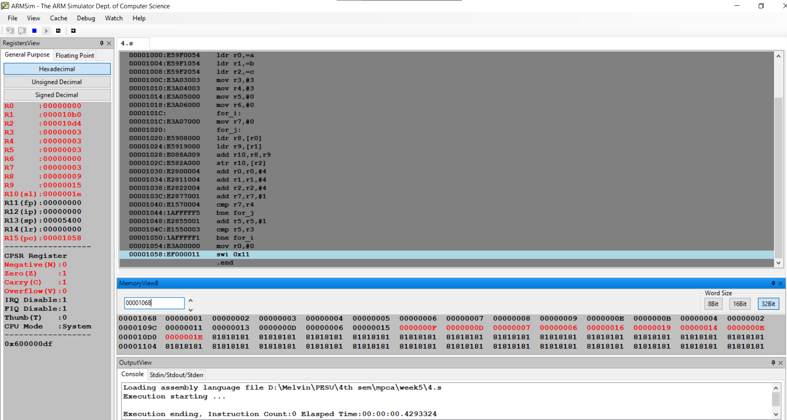

**Disclaimer:**

* The programs and output submitted is duly written, verified and executed by me.
* I have not copied from any of my peers nor from the external resource such as internet.
* If found plagiarized, I will abide with the disciplinary action of the University.

Signature:

Name:

SRN:

Section:

Date: