**Microprocessor and Computer Architecture Laboratory**

**UE19CS256**

**4th Semester, Academic Year 2020-21**

Date:

|  |  |  |
| --- | --- | --- |
| Name: | SRN: | Section |

Week#____6_______ Program Number: ____1__

**Write an ALP to find the length of a given string**

1. ARM Assembly Code (1).

.data

a: .asciz "HELLO WORLD"

.text

ldr r0,=a

mov r1,#0

loop:

ldrb r2,[r0]

add r0,r0,#1

cmp r2,#0

beq end

add r1,r1,#1

b loop

end:

ldr r0,=a

swi 0x02

swi 0x11

.end

1. Output Screen Shot (One Example of your choice)

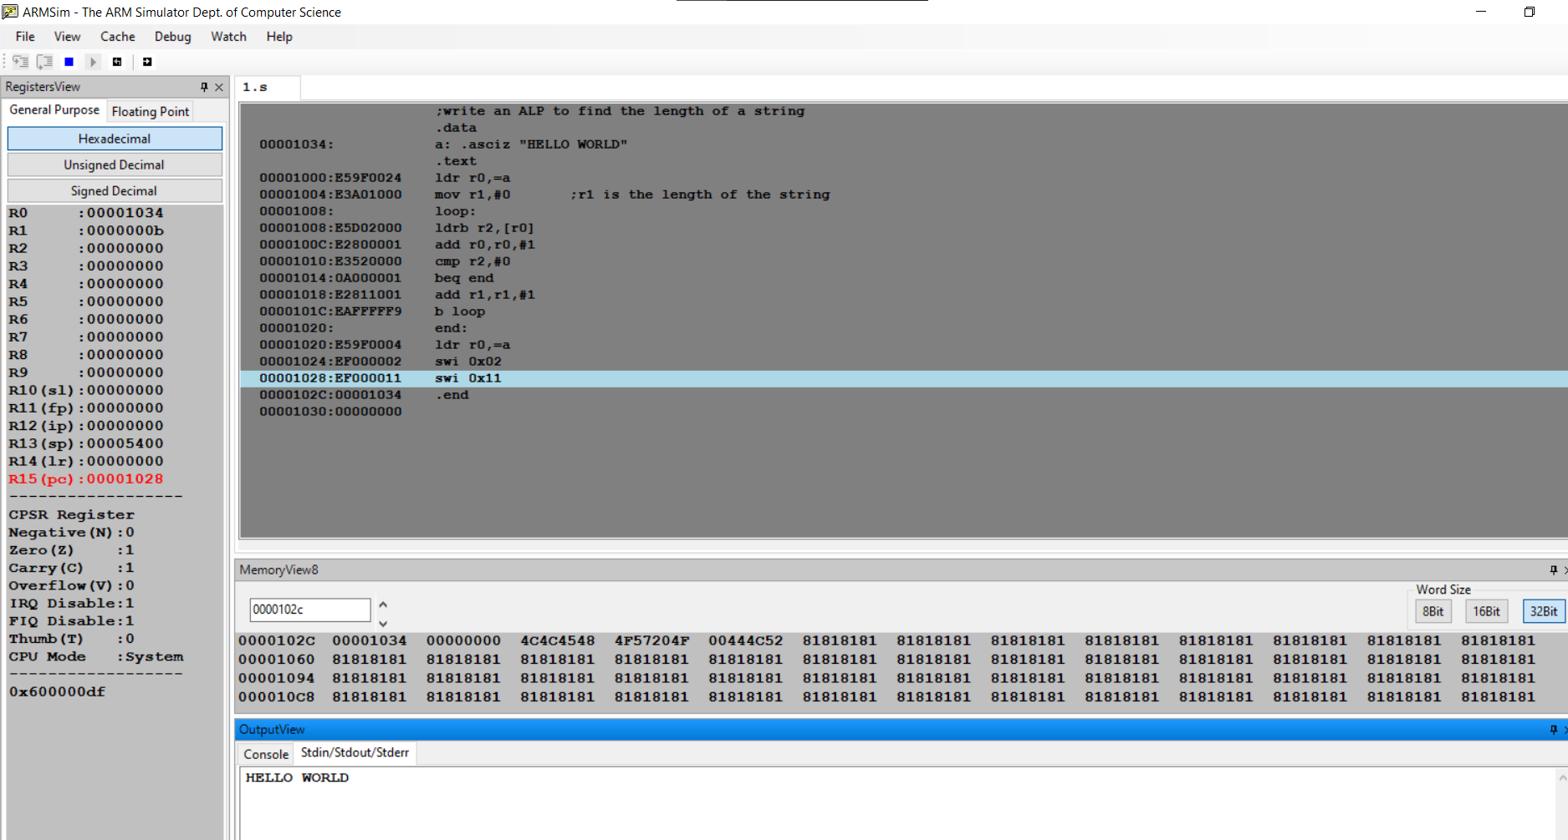

**Microprocessor and Computer Architecture Laboratory**

**UE19CS256**

**4th Semester, Academic Year 2020-21**

Date:

|  |  |  |
| --- | --- | --- |
| Name: | SRN: | Section |

Week#____6______ Program Number: ____2__

**Write an ALP to copy string from one location to another**

1. ARM Assembly Code (1).

.data

a: .asciz "PESU EC CAMPUS"

b: .asciz "aaaaaaaaaaaaaa"

.text

ldr r0,=a

swi 0x02

ldr r0,=b

swi 0x02

ldr r0,=a

ldr r1,=b

mov r2,#14

loop:

ldrb r3,[r0],#1

strb r3,[r1],#1

subs r2,r2,#1

bne loop

ldr r0,=b

swi 0x02

swi 0x11

.end

1. Output Screen Shot (One Example of your choice)

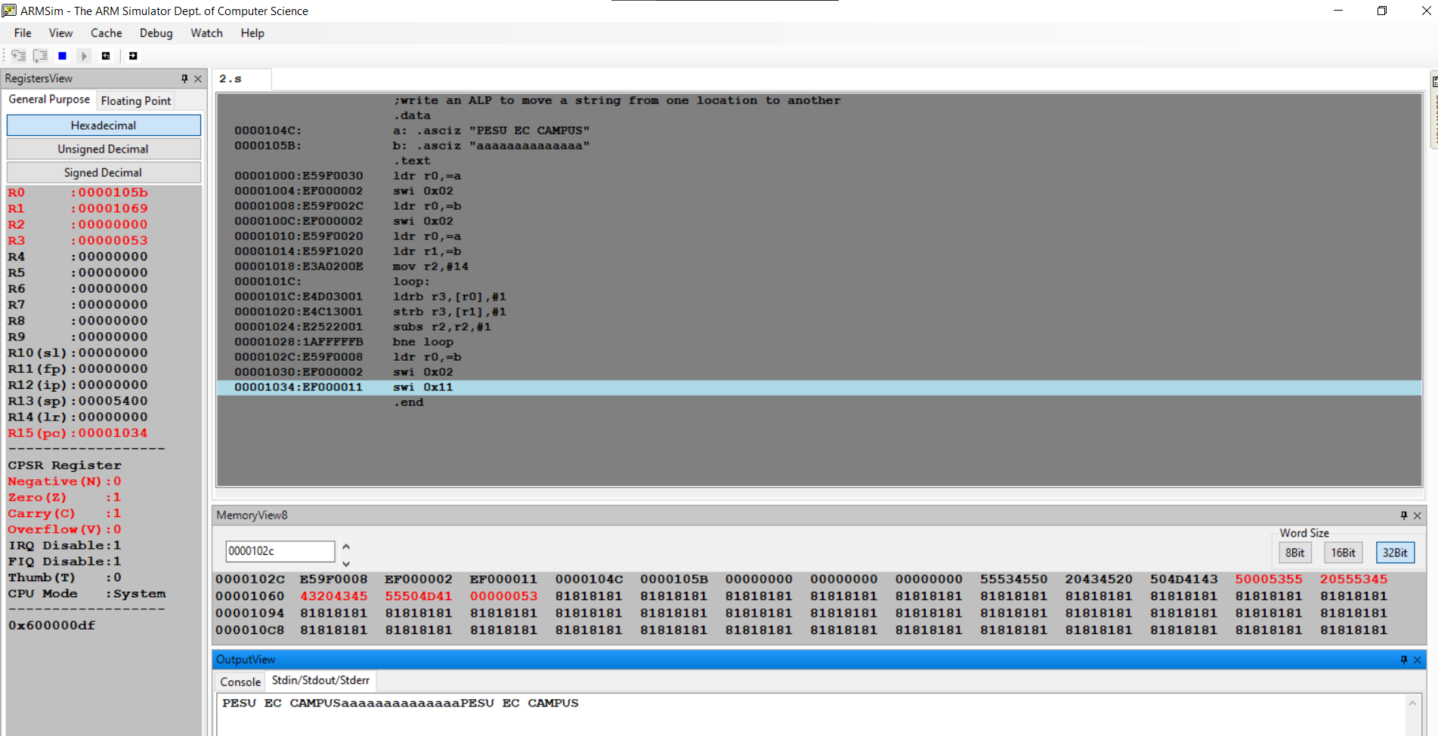

**Microprocessor and Computer Architecture Laboratory**

**UE19CS256**

**4th Semester, Academic Year 2020-21**

Date:

|  |  |  |
| --- | --- | --- |
| Name: | SRN: | Section |

Week#____6_______ Program Number: ____3__

**Write an ALP to find whether a given character is present in a string.**

1. ARM Assembly Code (1).

.data

str: .asciz "World"

char: .asciz "l"

found: .asciz "Character found"

notfound: .asciz "Character not found"

.text

ldr r0, =str

ldr r1, =char

mov r2, #0

loop:

ldrb r3, [r0, r2]

cmp r3, #0

beq end

ldrb r4,[r1]

cmp r3, r4

beq present

add r2, r2, #1

b loop

present:

ldr r0, =found

swi 0x02

swi 0x11

end:

ldr r0, =notfound

swi 0x02

swi 0x11

.end

1. Output Screen Shot (One Example of your choice)

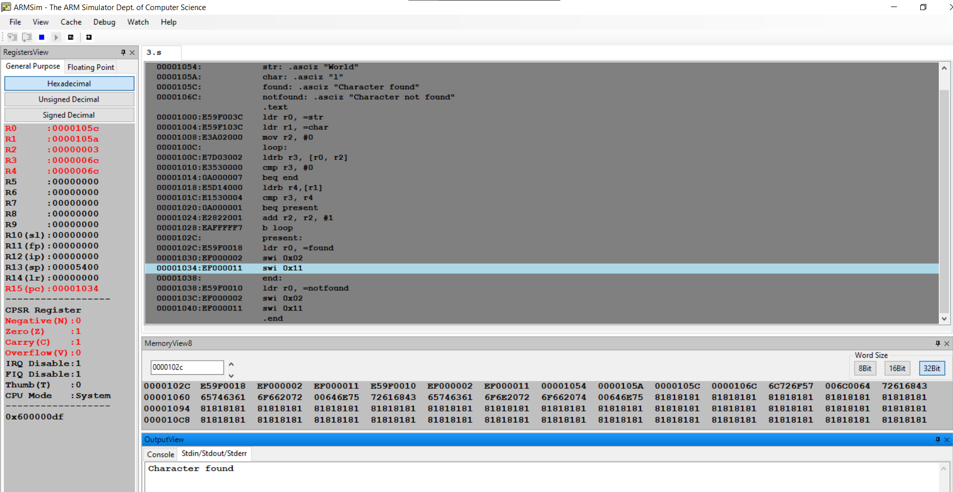

**Microprocessor and Computer Architecture Laboratory**

**UE19CS256**

**4th Semester, Academic Year 2020-21**

Date:

|  |  |  |
| --- | --- | --- |
| Name: | SRN: | Section |

Week#____6_______ Program Number: ____4_

**Write an ALP to find how many times a given character is present in a string**

1. ARM Assembly Code (1).

.data

str1: .asciz "Pes University EC Campus"

char1: .asciz "s"

.text

ldr r0, =str1

ldr r1, =char1

mov r2, #0

mov r3, #0

loop:

ldrb r4, [r0, r2]

cmp r4, #0

beq end

ldrb r5,[r1]

cmp r4, r5

beq count

add r2, r2, #1

b loop

count:

add r3, r3, #1

add r2, r2, #1

b loop

end:

swi 0x11

.end

1. Output Screen Shot (One Example of your choice)

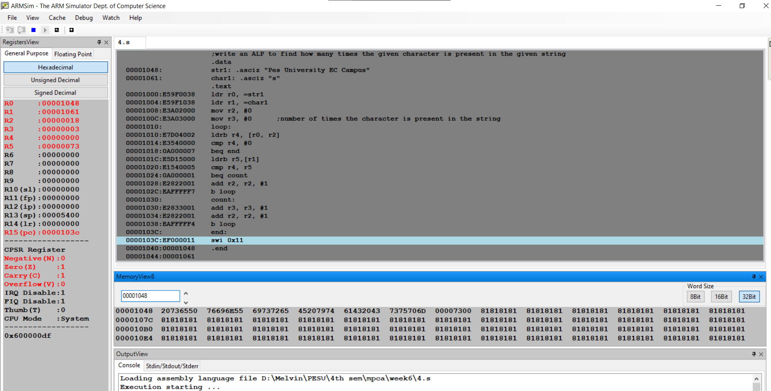

**Disclaimer:**

* The programs and output submitted is duly written, verified and executed by me.
* I have not copied from any of my peers nor from the external resource such as internet.
* If found plagiarized, I will abide with the disciplinary action of the University.

Signature:

Name:

SRN:

Section:

Date: