**Microprocessor and Computer Architecture**

**UE20CS252**

**4th Semester, Academic Year 2021-22**

Date:

|  |  |  |
| --- | --- | --- |
| Name: | SRN: | Section |

Week#____7_______ Program Number: ____1___

**Title of the Program**

Display hexadecimal digits [0-9,A-F] on the 8-segment display. Also display PES on the 8-segment display

**Include in your submission**

ARM Assembly Code(1)

.data

zero: .byte 0b11101101

one: .byte 0b01100000

two: .byte 0b11001110

three: .byte 0b11101010

four: .byte 0b01100011

five: .byte 0b10101011

six: .byte 0b10101111

seven: .byte 0b11100000

eight: .byte 0b11101111

nine: .byte 0b11100011

A: .byte 0b11100111

B: .byte 0b00101111

C: .byte 0b10001101

D: .byte 0b01101110

F: .byte 0b10000111

P: .byte 0b11000111

E: .byte 0b11000111

S: .byte 0b10101011

U: .byte 0b01101100

.text

.global _start

begin:

mov r0,#0

mov r2,#0

again: swi 0x202

cmp r0,#1

beq loop1

cmp r0,#2

beq loop2

b again

loop1: mov r5,#16

ldr r1,=zero

back1: ldrb r0,[r1]

swi 0x200

bl delay

add r1,r1,#1

loop2:

mov r5,#16

ldr r1,=U

back2: ldrb r0,[r1]

swi 0x200

bl delay

sub r1,r1,#1

sub r5,r5,#1

cmp r5,#0

bne back2

b again

delay: mov r4,#64000

loop3: sub r4,r4,#1

cmp r4,#0

bge loop3

mov pc, lr

.end

Output Screen Shots (4)

(upcounter/down counter screenshot)-1

letters P,E,S-3

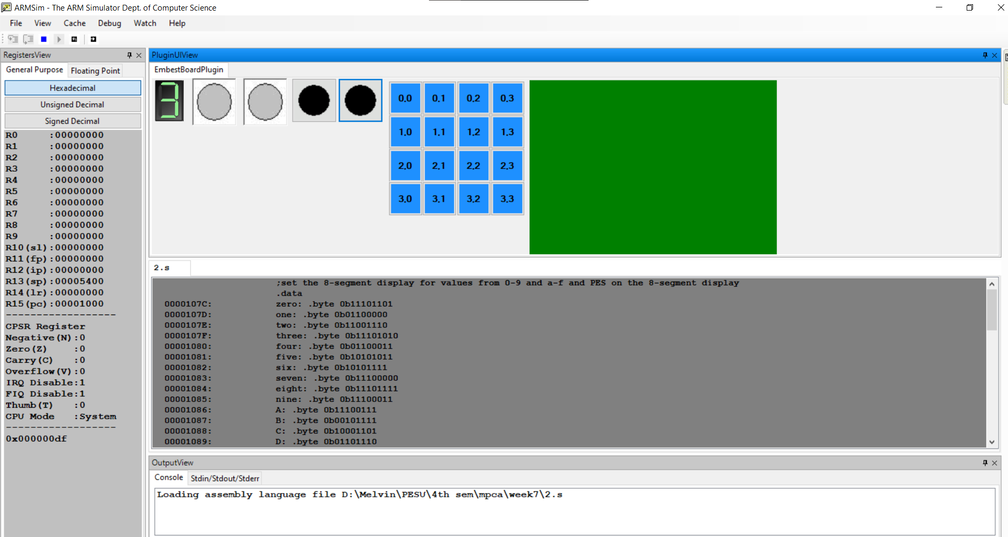

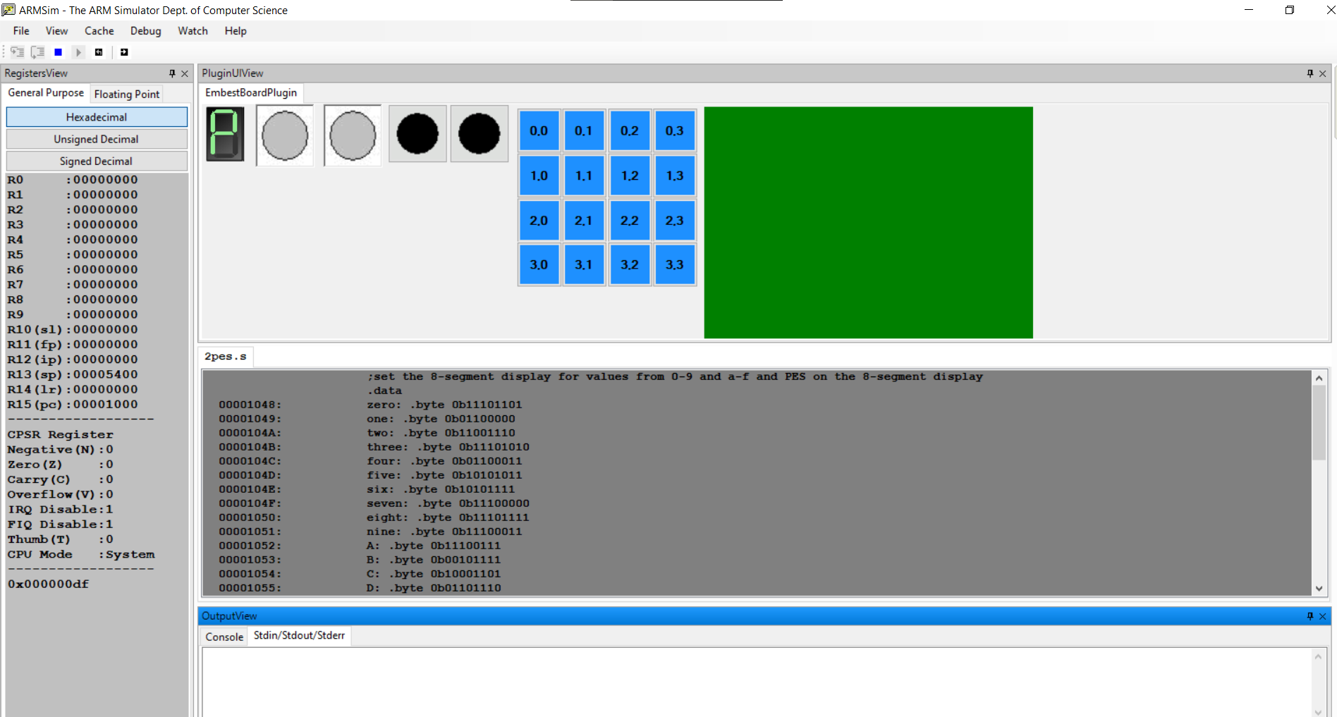

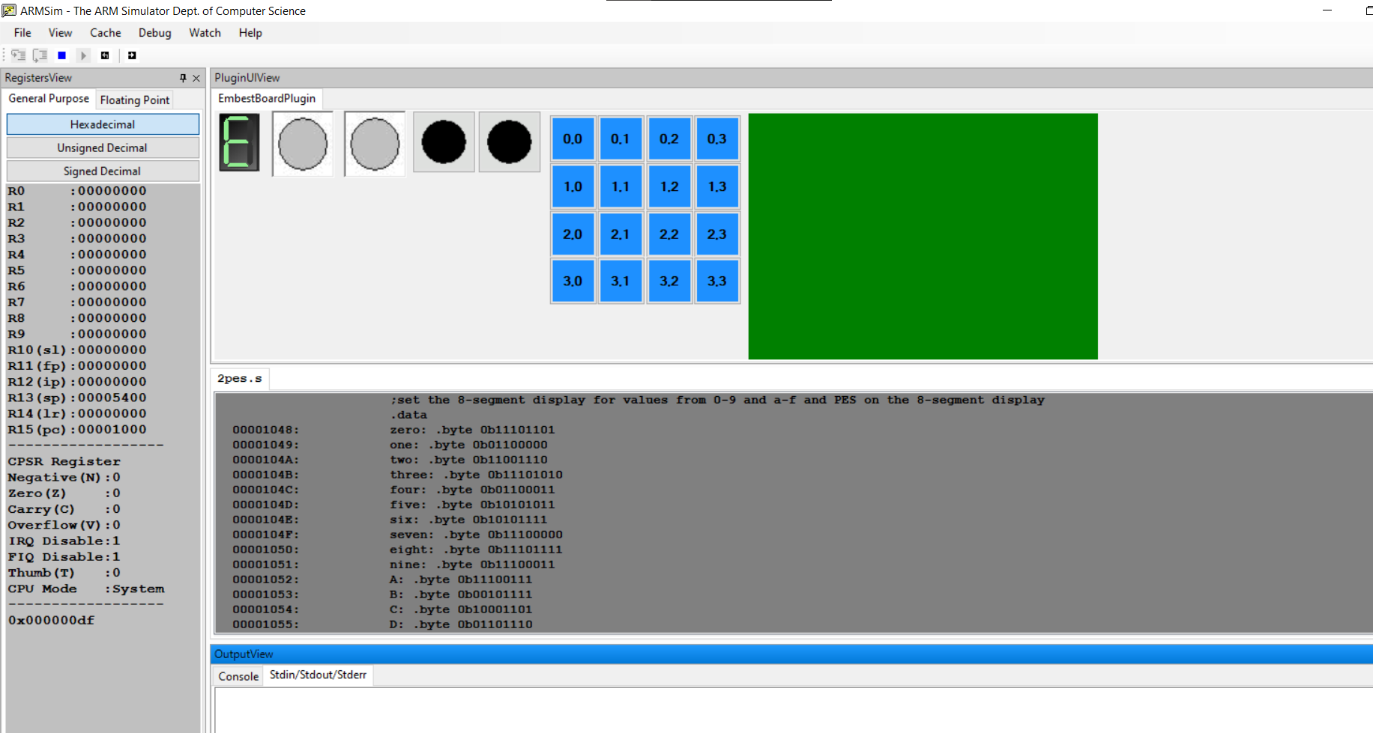

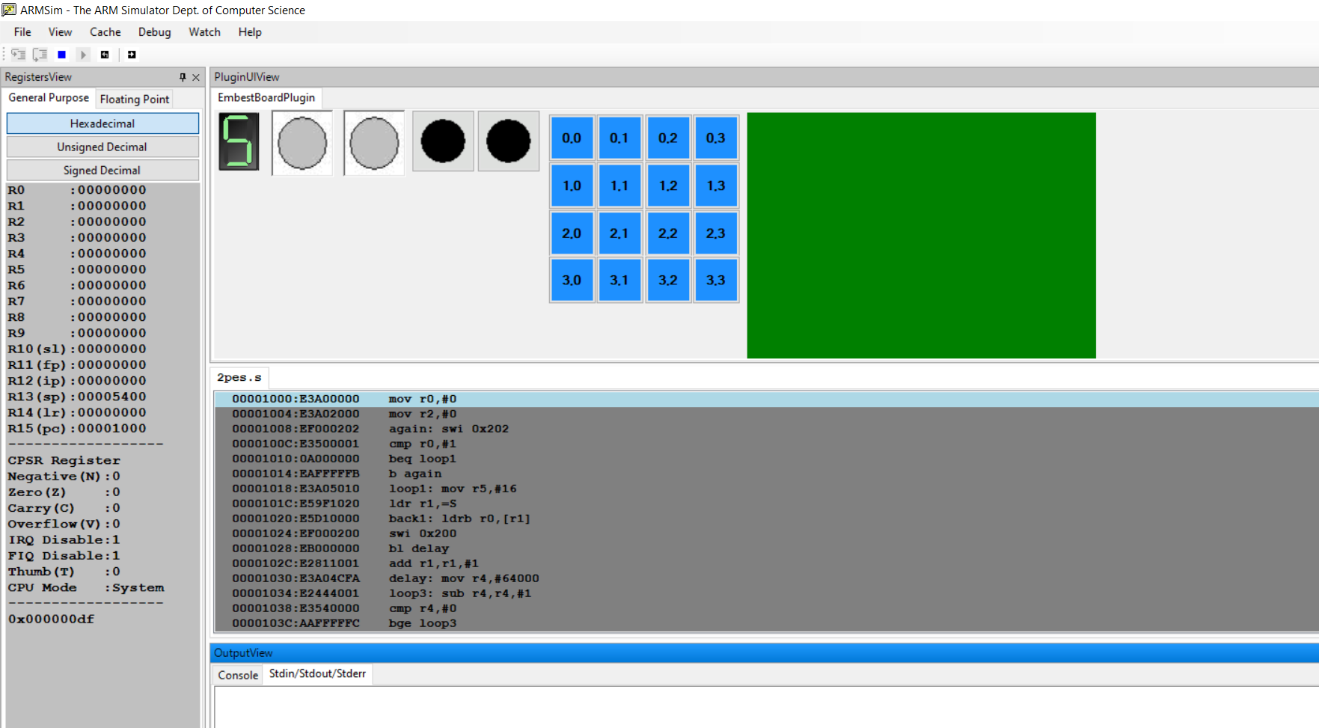

**Microprocessor and Computer Architecture**

**UE20CS252**

**4th Semester, Academic Year 2021-22**

Date:

|  |  |  |
| --- | --- | --- |
| Name: | SRN: | Section |

Week#____7_______ Program Number: ____2___

**Title of the Program**

Move a string from RIGHT to LEFT on the LCD display panel. Display your name on the LCD Panel

**Include in your submission**

ARM Assembly Code(1)

.text

mov r0,#30

mov r1,#7

mov r7,#0

ldr r8, =num

ldr r8,[r8]

ldr r2 ,=str

loop:

swi 0x204

bl sum

cmp r0,#0

subne r0,r0,#1

swieq 0x11

b loop

sum:

cmp r7,r8

addne r7,r7,#1

bne sum

swi 0x206

mov r7, #0

mov pc, lr

.data

str: .asciz "Melvin J PES2UG21CS294"

num: .word 150

.end

Output Screen Shot (1)

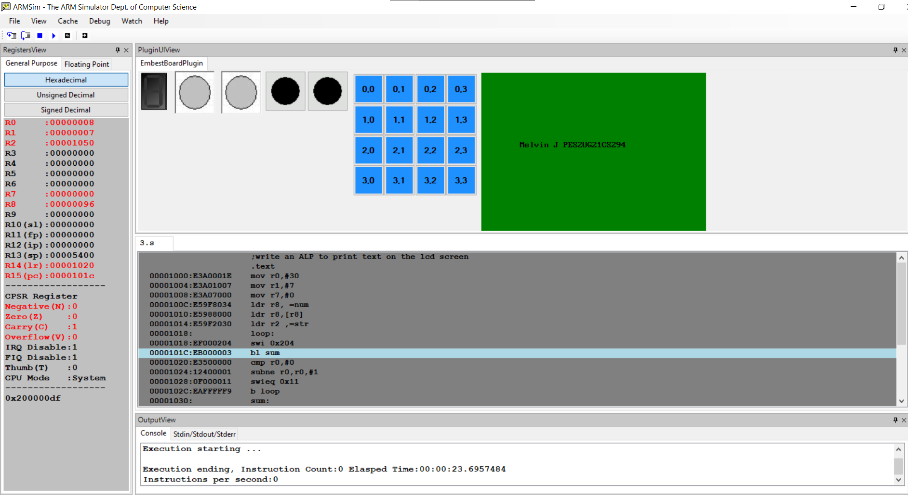

**Disclaimer:**

* The programs and output submitted is duly written, verified and executed by me.
* I have not copied from any of my peers nor from the external resource such as internet.
* If found plagiarized, I will abide with the disciplinary action of the University.

Signature: 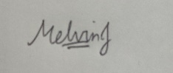

Name: Melvin Jojee Joseph

SRN: PES2UG21CS294

Section: E

Date: 08-03-2023