**Microprocessor and Computer Architecture Laboratory**

**UE19CS256**

**4th Semester, Academic Year 2022-23**

Date:

|  |  |  |
| --- | --- | --- |
| Name: | SRN: | Section |

Week#____9______ Program Number: ____1__

1. **A) Implement a Tinkercad simulation to turn on and off the Arduino’s on-board LED.**

Arduino Code (1).

void setup()

{

pinMode(LED_BUILTIN, OUTPUT);

}

void loop()

{

digitalWrite(LED_BUILTIN, HIGH);

delay(100);

digitalWrite(LED_BUILTIN, LOW);

delay(1000);

}

Output Screen Shot (1)

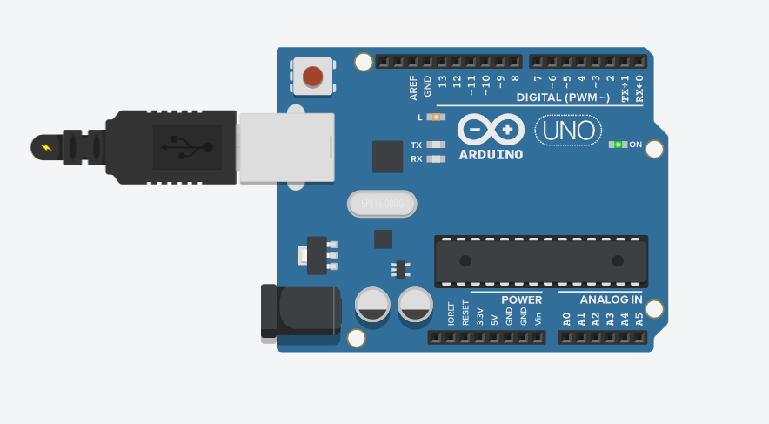

**B) Implement a Tinkercad simulation to turn on and off an external LED connected to the Arduino board**

Arduino Code (1).

void setup()

{

pinMode(13, OUTPUT);

}

void loop()

{

digitalWrite(13, HIGH);

delay(1000); // Wait for 1000 millisecond(s)

digitalWrite(13, LOW);

delay(1000); // Wait for 1000 millisecond(s)

}

Output Screen Shot (1)

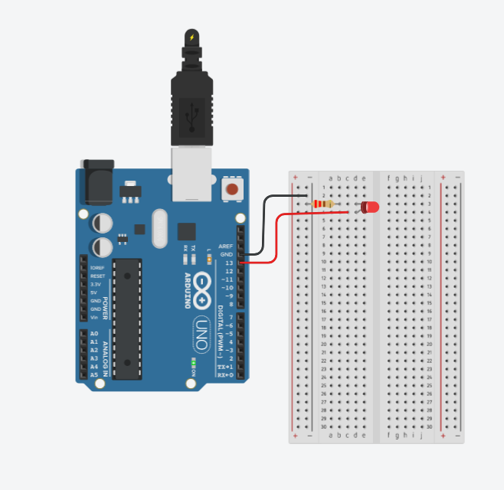

**Microprocessor and Computer Architecture Laboratory**

**UE19CS256**

**4th Semester, Academic Year 2020-21**

Date:

|  |  |  |
| --- | --- | --- |
| Name: | SRN: | Section |

Week#____9_______ Program Number: ____2__

**Implement a Tinkercad simulation to alternately turn on and off two external LEDs connected to the Arduino board**

Arduino Code (1).

void setup()

{

pinMode(7, OUTPUT);

pinMode(8, OUTPUT);

}

void loop()

{

digitalWrite(7, HIGH);

delay(1000);

digitalWrite(7, LOW);

digitalWrite(8, HIGH);

delay(1000);

digitalWrite(8, LOW);

}

Output Screen Shot (1)

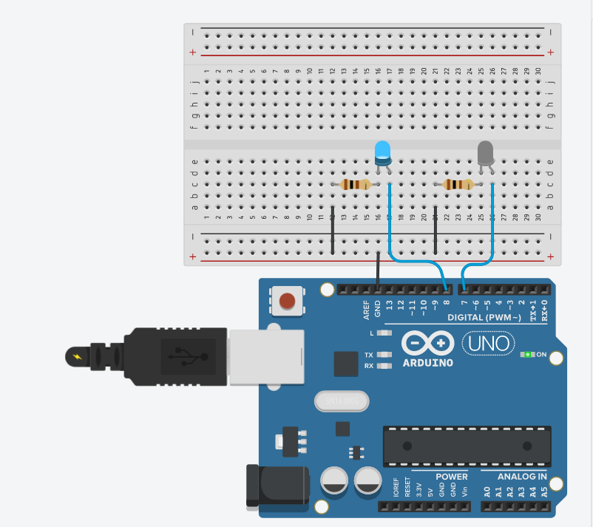

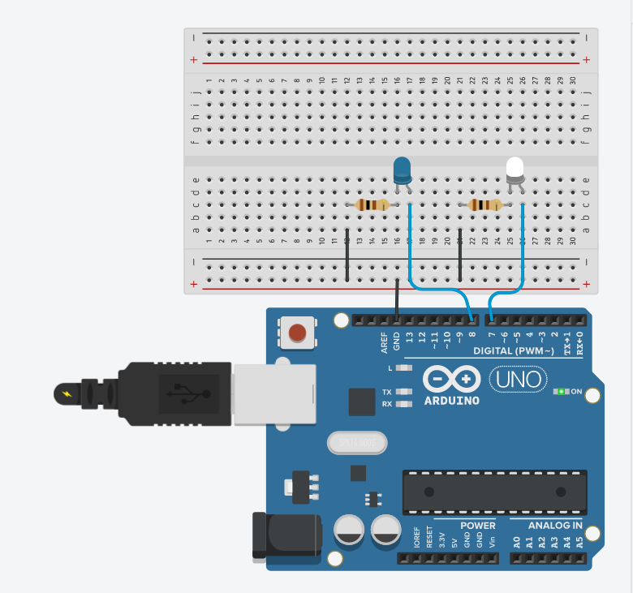

**Microprocessor and Computer Architecture Laboratory**

**UE19CS256**

**4th Semester, Academic Year 2020-21**

Date:

|  |  |  |
| --- | --- | --- |
| Name: | SRN: | Section |

Week#____9_______ Program Number: ____3__

**Implement a Tinkercad simulation to use a ultrasonic sensor to calculate distance from a nearby object.**

Arduino Code (1).

long duration;

int distance;

void setup() {

pinMode(trigPin, OUTPUT);

pinMode(echoPin, INPUT);

Serial.begin(9600);

Serial.println("Ultrasonic Sensor HC-SR04 Test");

Serial.println("with Arduino UNO R3");

}

void loop() {

digitalWrite(trigPin, LOW);

delayMicroseconds(2);

digitalWrite(trigPin, HIGH);

delayMicroseconds(10);

digitalWrite(trigPin, LOW);

duration = pulseIn(echoPin, HIGH);

distance = duration * 0.034 / 2;

Serial.print("Distance: ");

Serial.print(distance);

Serial.println(" cm");

}

Output Screen Shot (1)

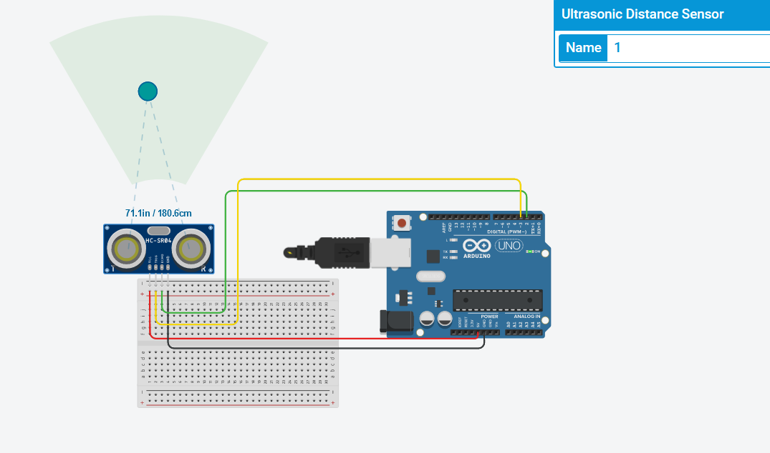

**Microprocessor and Computer Architecture Laboratory**

**UE19CS256**

**4th Semester, Academic Year 2020-21**

Date:

|  |  |  |
| --- | --- | --- |
| Name: | SRN: | Section |

Week#____9_______ Program Number: ___4__

**Implement a Tinkercad simulation to demonstrate fading of an LED (zero to maximum brightness slowly)**

Arduino Code (1).

int brightness = 0;

void setup()

{

pinMode(7, OUTPUT);

}

void loop()

{

for(brightness = 0; brightness <= 255; brightness += 5){

analogWrite(7, brightness);

delay(20);

}

for(brightness = 255; brightness >= 0; brightness -= 5){

analogWrite(7, brightness);

delay(20);

}

}

Output Screen Shot (1)

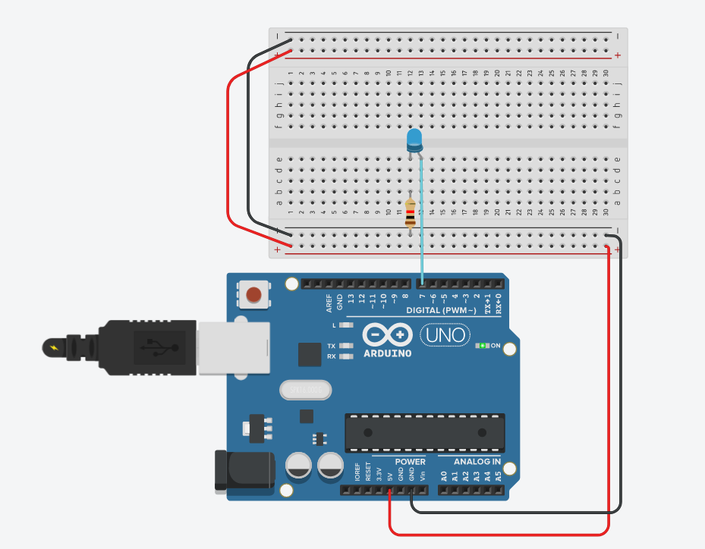

**Disclaimer:**

* The programs and output submitted is duly written, verified and executed by me.
* I have not copied from any of my peers nor from the external resource such as internet.
* If found plagiarized, I will abide with the disciplinary action of the University.

Signature:

Name:

SRN:

Section:

Date: