HBnB

Introduction:
The HbNb project is a simplified version of an AirBnB-like application, where users can register, list properties, manage amenities, and submit reviews. This documentation outlines the system’s architecture and design, serving as a guide during the implementation process. It provides detailed breakdown of the structure, focusing on the high-level architecture, business logic, and key API interactions.

The documents is organized as follows:

- High-Level Architecture: Provides an overview of the application's layered architecture, demonstrating how the presentation, business logic, and persistence layers interact.*

- Business Logic Layer: Offers a detailed breakdown of the entities within the business logic layer; including their attributes, relationships and roles within the system.

- API interaction flows: Explains how the different layers communicate through the system via key API calls, using sequence diagrams to illustrate the flow of information.

High-level Architecture:
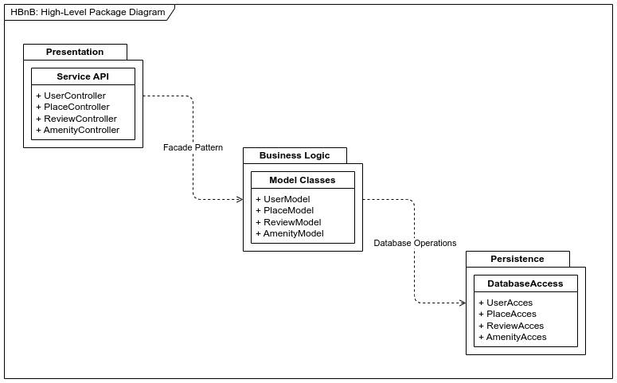
For this part, we will be using a High-Level Package Diagram to demonstrate how the different layers are organized. The application is structured around a three-layer architecture:

- Presentation Layer: This layer handles user interactions through an API. it receives requests from users and forwards them to the business logic layer. The controllers act as intermediaries that validate inputs and manages responses

- Business Logic Layer: This is the core of the application, where all the business rules, validations and operations are handled. It includes services for managing users, places, reviews, and amenities. These services abstract the operations performed in the persistence layer and interact with the presentation layer through the Facade Pattern to simplify the communication.

- Persistence Layer: The persistence layer deals with database operations. It is responsible for storing and retrieving data for users, places, reviews, and amenities. The Database Operations act as a bridge for the business logic into Database.

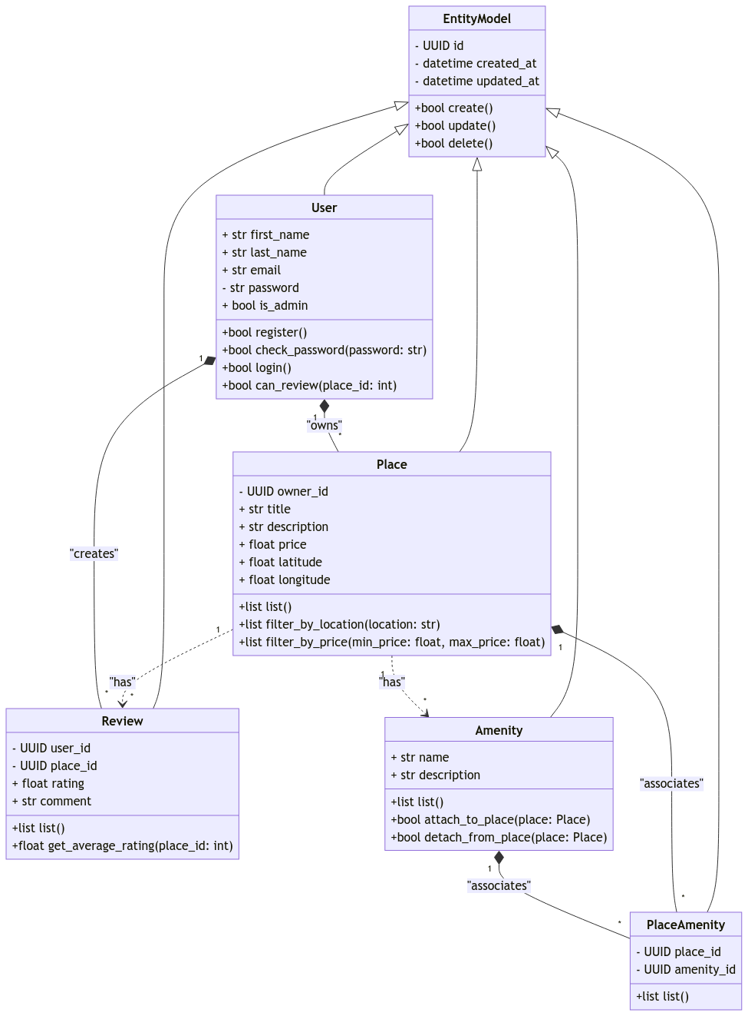
Business Logic Layer:
The following diagram represents the Use, Place, Review, and Amenity entities. Each entity is a key part of the system, with attributes and methods that manage the business logic Operations.

- Entity Model: This base class includes common fields such as id, created_date, and updated_at to track the lifecycle of entities. It also includes generic methods such as create(), update(), and delete().

- User Entity: Represents the users in the system, with attributes like first_name, last_name, email, and password. The is_admin boolean differentiates between regular users and administrators. Users can register, log in, and manage places and reviews. Key methods include:
- register(): Registers a new user.
- check_password(password: str): Verifies the user's password.
- can_review(place_id: int): Determines if a user can leave a review for a specific place.

- Place Entity: Represents properties listed by users, with details like title, description, price, latitude, and longitude. Places are associated with users (owners) and can have multiple reviews and amenities. Key methods include:
list(): Lists all places.
filter_by_location(location: str): Filters places by location.
filter_by_price(min_price: float, max_price: float): Filters places based on price range.

- Review Entity: Represents feedback provided by users for places. Each review includes a rating, comment, and is linked to both a user and a place. Key methods include:
list(): Lists all reviews.
get_average_rating(place_id: int): Gets the average rating for a place based on all user reviews.

- Amenity Entity: Represents the amenities available at places. Each amenity has a name and description. Key methods include:
attach_to_place(place: Place): Attaches an amenity to a specific place.
detach_from_place(place: Place): Detaches an amenity from a place.

Login Sequence Diagram:
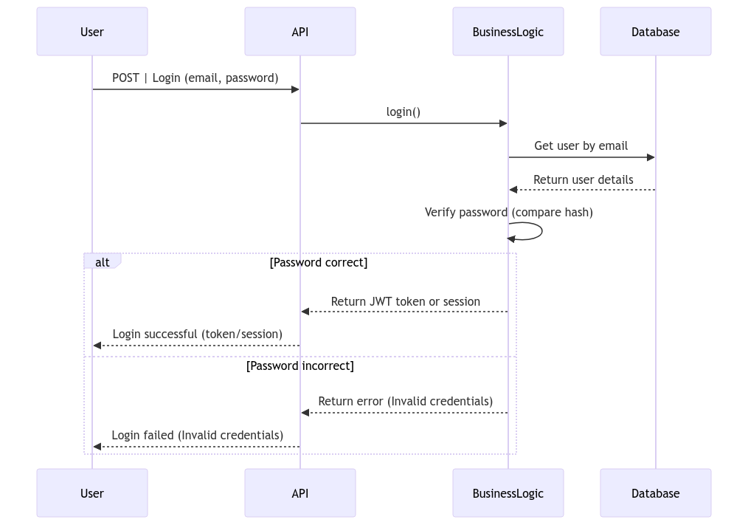
The login process shown in the diagram can be described as follows:
- User submits a login request: The user sends their email and password through a POST request to the API for authentication.
- API calls the BusinessLogic: The API invokes the `login()` method in the BusinessLogic to handle the authentication process based on the user credentials.
- BusinessLogic requests user details: The BusinessLogic sends a request to the Database to retrieve the user details associated with the provided email.
- Database responds: The Database returns the user's information, including the hashed password, back to the BusinessLogic for verification.
- BusinessLogic verifies the password: The BusinessLogic compares the hashed password returned by the database with the password entered by the user.
Password verification result:
- If the password is correct: The BusinessLogic generates a JWT token or session and returns it to the API.
- If the password is incorrect: The BusinessLogic returns an error indicating invalid credentials.
Response to the user:
- If the login is successful, the API returns the token or session to the user, confirming the successful login.
- If the login fails due to invalid credentials, the API returns an error message indicating the failure.
This process describes how the different layers (API, business logic, and database) interact to authenticate a user, ensuring secure access through password hashing and proper session management.

Place Sequence Diagram:
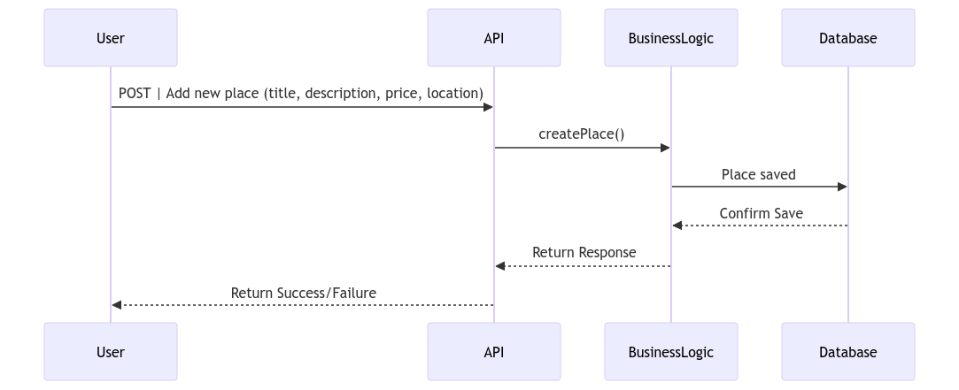
- User submits a request: The user sends details for a new place (title, description, price, location) to the PlaceController.
- PlaceController calls PlaceModel: The PlaceController invokes the createPlace() method in the PlaceModel to handle the request.
- PlaceModel calls PlaceAccess: The PlaceModel requests PlaceAccess to save the place details.
- PlaceAccess interacts with the database: PlaceAccess sends a request to the Database to insert the new place data.
- Database responds: The Database confirms the data has been successfully saved and sends a response back to PlaceAccess.
- PlaceAccess informs PlaceModel: Once the data is saved, PlaceAccess returns a confirmation to the PlaceModel that the place has been created.
- PlaceModel informs PlaceController: The PlaceModel passes this success confirmation to the PlaceController.
- Response to the user: Finally, the PlaceController informs the user that the new place has been added successfully.
This process describes how a new place is added in a structured way, showing how the different layers (controller, model, data access, database) interact to ensure data persistence.

Register Sequence Diagram:
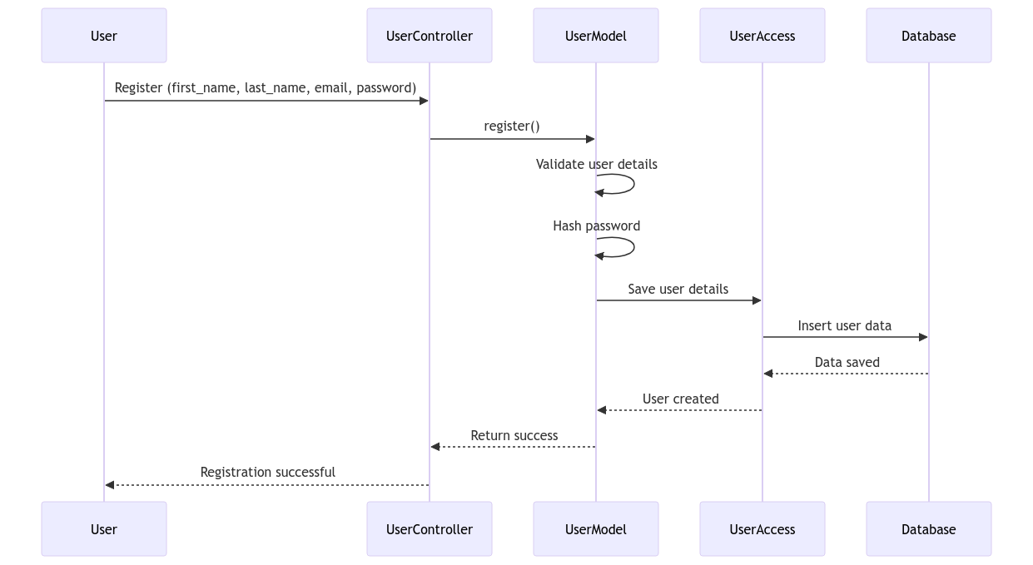
- User submits registration: The user sends their details (first name, last name, email, and password) to the UserController.
- UserController calls UserModel: The UserController invokes the register() method in the UserModel to process the registration.
- UserModel validates details: The UserModel validates the user details (e.g., checking if the email is valid or if required fields are provided).
- Password hashing: The UserModel hashes the password to securely store it in the database.
- UserModel requests UserAccess to save data: The UserModel requests UserAccess to save the validated and hashed user details.￼
- UserAccess interacts with the database: UserAccess sends a request to the Database to insert the new user data.
- Database confirms data save: The Database confirms that the user data has been saved and sends a response back to UserAccess.
- UserAccess informs UserModel: After saving the data, UserAccess returns confirmation to the UserModel that the user has been created.
- UserModel informs UserController: The UserModel passes this success confirmation to the UserController.
- Response to the user: Finally, the UserController informs the user that the registration was successful.
This sequence illustrates the flow for securely registering a new user and storing their data in the database, ensuring that sensitive information like passwords is hashed before storage.

Review Sequence Diagram:
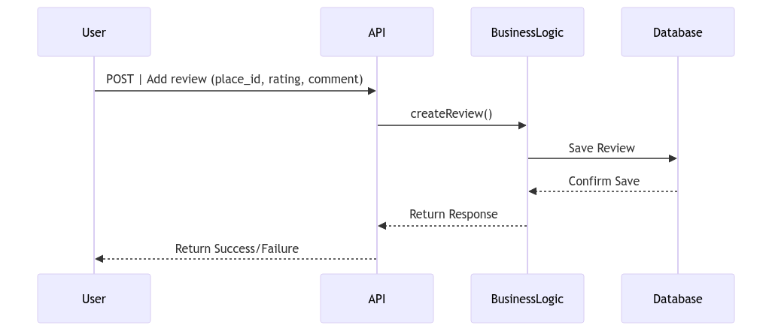
- User submits a review: The user sends details for a review, including place_id, rating, and comment, to the ReviewController.
- ReviewController calls ReviewModel: The ReviewController invokes the createReview() method in the ReviewModel to handle the review creation.
- ReviewModel requests ReviewAccess to save data: The ReviewModel asks ReviewAccess to save the review details.
- ReviewAccess interacts with the database: ReviewAccess sends a request to the Database to insert the review data.
- Database confirms data save: The Database confirms the review data has been saved successfully and sends a response back to ReviewAccess.
- ReviewAccess informs ReviewModel: Once the review data is saved, ReviewAccess returns confirmation to the ReviewModel that the review has been created.
- ReviewModel informs ReviewController: The ReviewModel passes this success confirmation to the ReviewController.
- Response to the user: Finally, the ReviewController informs the user that the review has been added successfully.
This sequence ensures the secure handling and storage of the user's review for a specific place.

