A Report on the World Environment Day

The Department of Environmental Studies, St. Philomena’s College celebrated the World Environment day on 19 ^{th} June 2019 at the college indoor stadium. The Chief Guest for the programme was Her Highness Smt. Pramoda Devi Wadiyar and the Guest of Honour was Ms. Devaki Panini, Environmental lawyer. Dr. Ruth Shantha Kumari, Principal, St. Philomena’s Degree College, Mysore. Rev. Fr. Dr. Bernard Prakash Barnis, Rector/ Manager, St. Philomena’s Institutions, Rev. Fr. Maria Xavier ,Vice Rector , St. Philomena’s Degree College, Dr. Sunil D’ Souza , Principal, St. Philomena’s P.U. College and Prof. Sanjay Nair, Vice Principal , St. Philomena’s Degree College were the other dignitaries who graced the occasion.

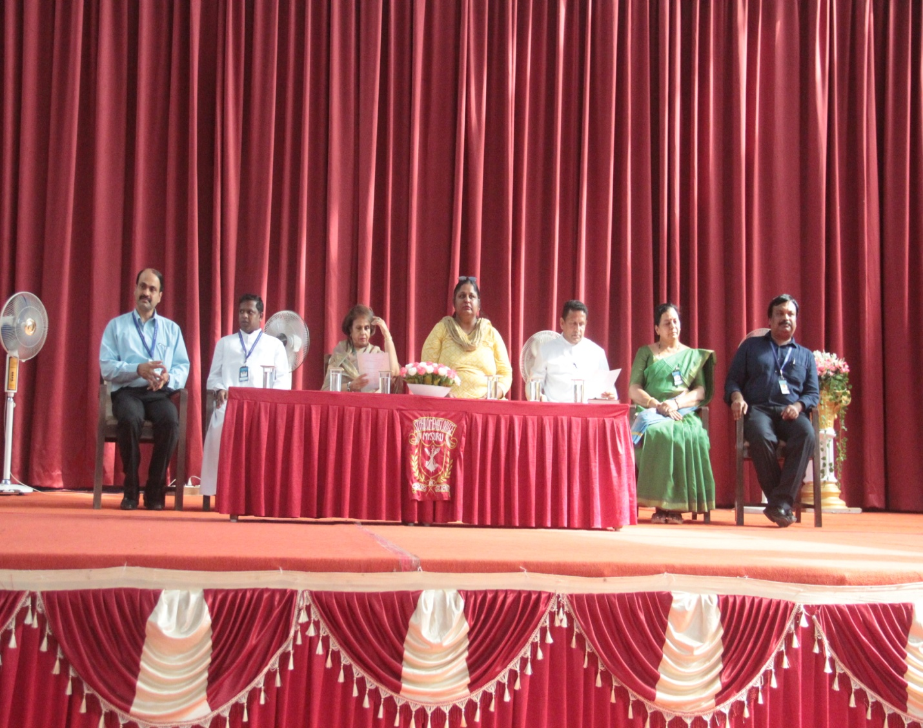
The programme began by enlightening the students on environmental issues, by playing a few short videos related to environmental degradation by anthropogenic activities.
The formal inauguration of the programme was done by invoking Gods blessings. Sister Angeline form the Department of English was the MC for the programme .Ms. Apeksha Rao rendered the invocation, which was followed by the lighting of the lamp by the dignitaries. Prof. Uzma Bathool, HOD, Dept. Of Environmental Studies, welcomed the dignitaries and the gathering. Prof. Juhie Singh from Commerce department introduced the guests to the audience.
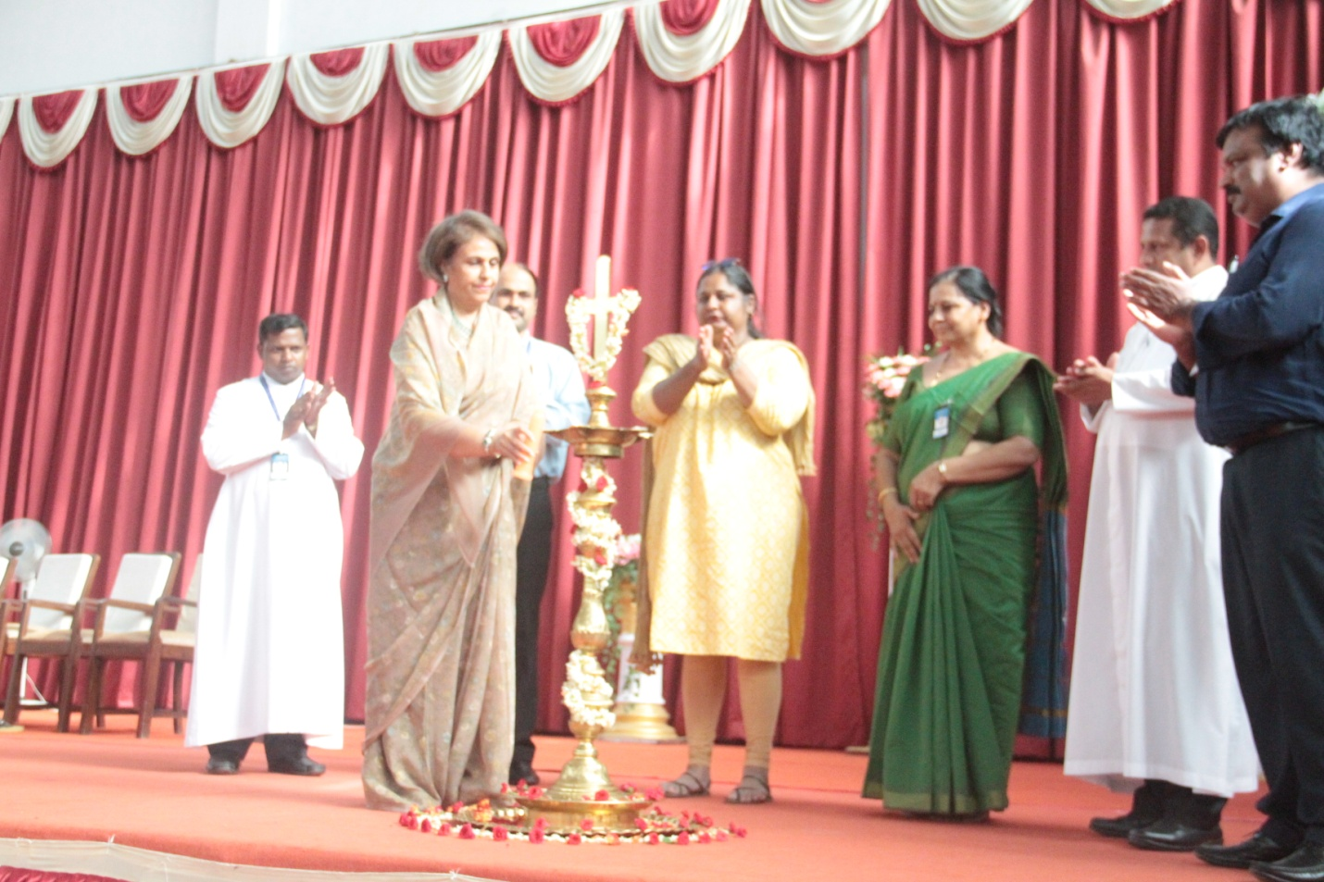
Her Highness Smt. Pramoda Devi Wadiyar , The Chief Guest for the programme spoke on the relevance of the day. She was nostalgic about her student days looking at the cheering crowd. She also made a mention that how she has seen most of the vegetation, and flowering plants in Mysore, are getting depleted from the heritage city, Mysore. She felt there was need to do something about it at a very local level.
Ms. Devaki Panini, an Environmental lawyer , a writer and poet spoke on the topic “ Conserving Biological Diversity For Posterity” . She was of the opinion that conserving biodiversity is not merely a priority now, it’s a prerequisite. Man has become the major threat to biodiversity by exploiting natural resources, mining , building dams and many such activities that has contributed enormously to destruction of nature and biodiversity.
She also stressed on how to tackle this problem of continuous destruction. Some of the measures suggested by her to halt the destruction of biodiversity was to practice community forestry , village forestry, private forestry etc.
She concluded her topic by saying that the need of the hour is to integrate biodiversity conservation with economic development. It is imperative to arrest and check development, which is unsustainable on account of unprecedented biodiversity loss.
Dr. Ruth Shantha Kumari spoke on how important it is for the youth to preserve and protect nature. They can change their lifestyle and also understand how it affects the environment. They can make their homes, colleges, surroundings more environmental friendly by adopting practices, recycling of different materials as well as preserving resources such as water and electricity.
To create seriousness about the problems associated with environmental deterioration there was administration of oath by Her Highness Smt. Pramoda Devi Wadiyar .
Declaration of Oath
“We the Staff and Students of St. Philomena’s Institutions pledge to practice everything in our power to protect, preserve, and enhance the beauty and glory of nature. We understand that we are responsible for sustaining the only livable planet “Mother Earth “and save it as a gift to the future generations. “

Ms. Sindhu form the Department of Economics proposed the vote of thanks .
The programme concluded by planting 80 saplings of various flowering plants at the sports ground. The planting of saplings of flowering plants was an ambitious project supported by Her Highness Smt. Pramoda Devi Wadiyar . The persons instrumental in getting this project to our campus were Mr. Srikanth Raje Urs , Prof. Babu and Prof. Rajalakshmi.



