'Swach Philo Abhiyan' and Gandhi Jayanthi Celebration

The celebration of Gandhi Jayanthi and 'Swach Philo Abhiyan', an initiative to clean the St. Philomena's campus were organised at the college campus on October 1, 2019 to mark the 150th birth anniversary of the 'Father of Nation' Mahatma Gandhi.

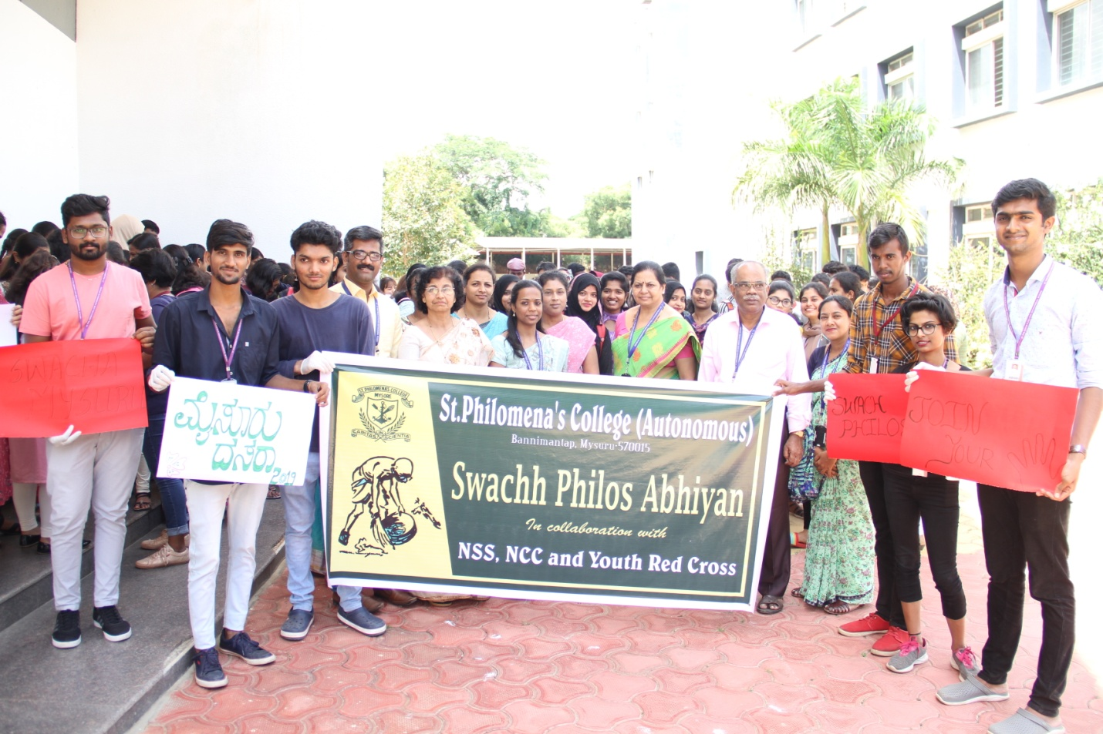

The UG and PG students of the college participated in these events and collected the polythene(plastics) bags and other waste materials in the campus.
Also, the students of social work, NSS, NCC and others enthusiastically took the initiative in the Abhiyan. 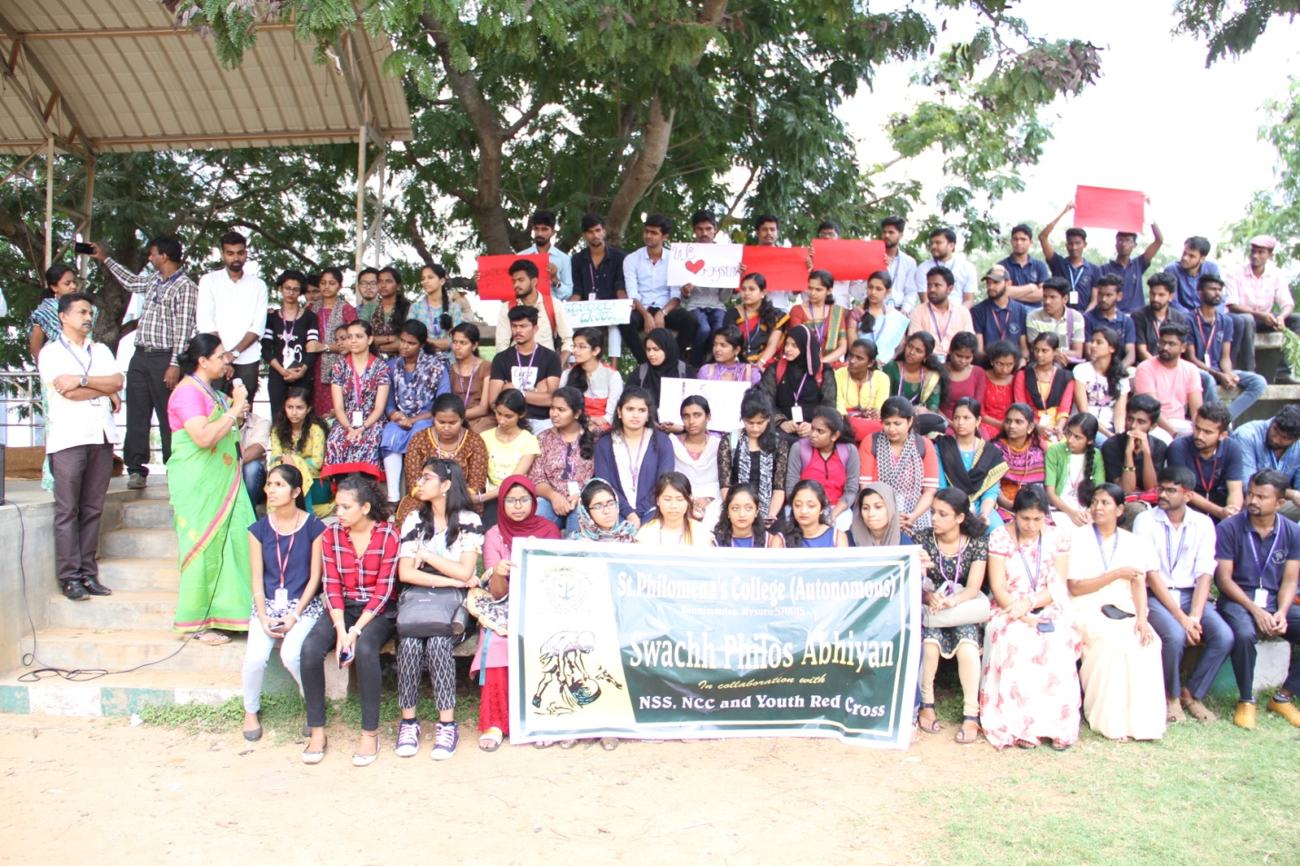

Prof. Ruth Shantha Kumari, Principal of the College, addressed the students and lauded their enthusiasm in participating in the initiative. In her brief address she said that the students have the potential to achieve anything. But, they just need guidance. With this drive, a rich tribute is paid to our national leader Mahatma Gandhiji and also to the ‘Swach Bharat Abhiyan', the call given by the Central Government, she said.

The teaching and non teaching staff of the institution were present on the occasion.
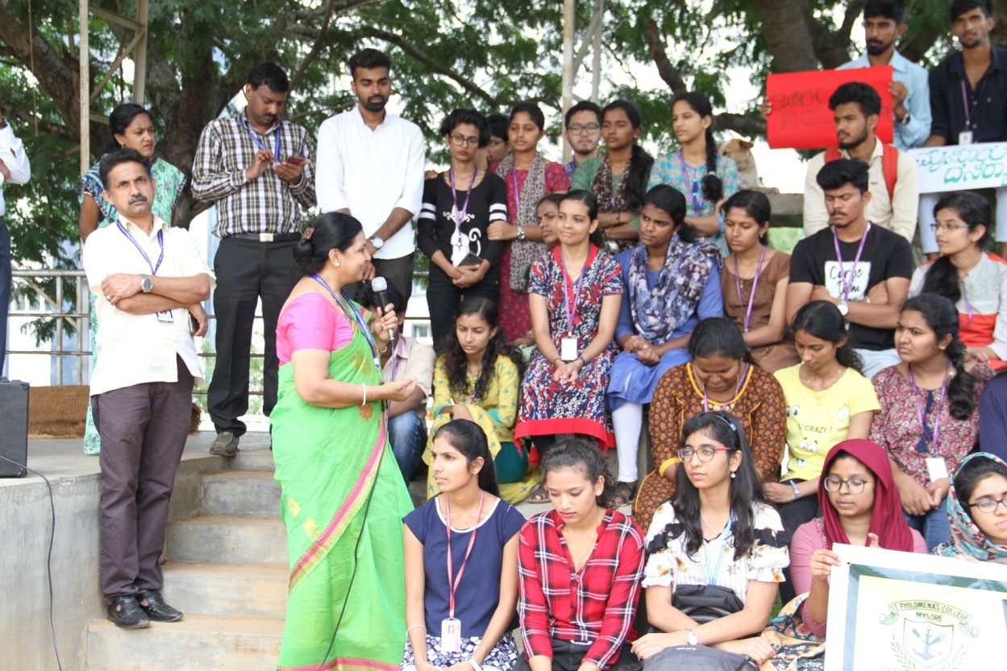
(Principal Prof.Ruth Shantha Kumari is seen addressing the students)



