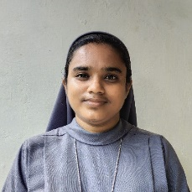

SistersofSacredSciencesMariaMandiraH.no.9,13thCrossKarunapura,NRMohallaPOMysore-570007
6364713413|archanamaryr@gmail.com

EnthusiasticandeagertocontributetotheexcellentcollegewhereIstudied.Withadeepdesiretoimprovemy teaching and communication skills and help young students understand the subject matter clearly. I desire
to be a part-time teacher.

EDUCATION

Karnataka State Open University 2019 - 2021
Masters of Arts in Mass Communication and Journalism
70.8%, 4th rank

St. Philomena's Degree College 2015- 2018
Bachelor of Vocational Studies in Media and Entertainment
82% 1st rank

Indira Gandhi Open University 2023
Bachelor of Arts Major in Philosophy
72%

Passed UGC NET in June 2023 June 2023

Qualified for Assistant Professor
Journalism and Mass Communication

Passed KSET in June 2024

Qualified for Journalism and Mass Communication

Skills

Can teach any topic related to Mass Communication and Journalism

Reference

Sr. Siji Narikulam

"Sisters of Sacred Sciences "
Superior General
sssgeneralate@gmail.com
9611273393

