Important meetings convened by IQAC during 2022-2023
Sl. No: | Date of the meeting convened | Agenda of the meeting
01 | 12.09.2022 | - Extension on Automonous status.  - Discussion on NAAC guidelines.
02 | 03.11.2022 | - Issues/problems faced while using ERP modules.  - Pricing of the modules opted by the college in ERP.
03 | 21.02.2023 | - Welcoming the new IQAC members of 2022-2023.  - Distribution of the documents of criteria metrics to the Criteria leaders.  - Installation of new IQAC Coordinator.
04 | 25.03.2023 | - Discussion on conducting 6-day FDP for the faculty members and assigning responsibilities to NAAC leaders.
05 | 19.04.2023 | - NAAC Criteria Leaders Meeting

- Minutes of the IQAC meeting held on 12.09.2022 at the college UG Conference Hall
Dr. Ravi JD Saldanha, the Principal and the IQAC Chairperson welcomed the members present for the meeting. The IQAC Coordinator, Mr. Ronald Prakash Cutinha presented the proceedings of the previous meeting held on 06.07.2022.
Discussions:
- To collect the 5 years of required data and to submit them within the last date to get approval for the Extension on Automonous status of the third phase of the college to the UGC.
- A thorough and thread bare discussion was taken up regarding the current guidelines of the NAAC and the modalities to be undertaken in compliance with the current scenario.
- The events and activities for the academic year were finalized.
- The academic calendar was approved after the discussions.

Members present:
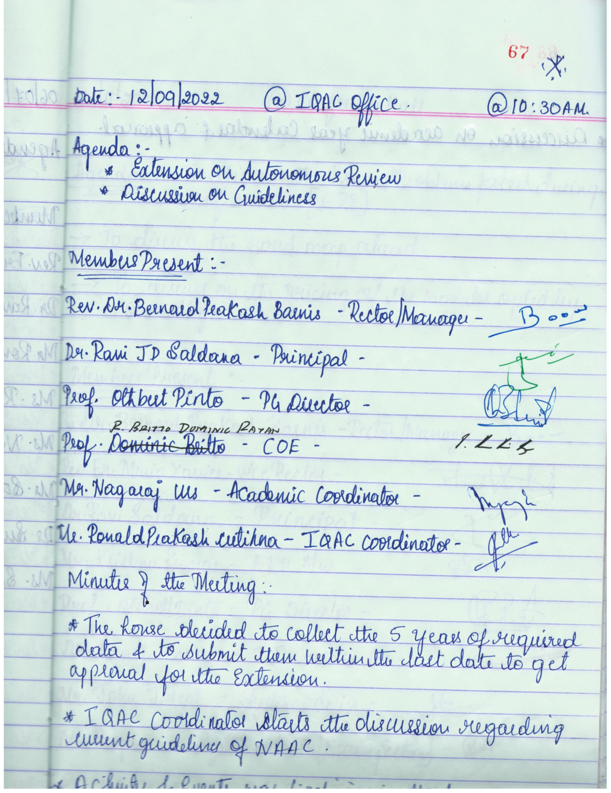

- Minutes of the IQAC meeting held on 21.02.2023at the college UG Conference Hall
Dr. Ravi JD Saldanha, the Principal and the IQAC Chairperson welcomed the members present for the meeting. The IQAC Coordinator, Mr. Ronald Prakash Cutinha presented the proceedings of the previous meeting held on 03.11.2022.
Discussions:
- After a short discussion a new team of members of the IQAC was formed for the Academic Year 2022-2023. The new members were welcomed by the Principal and the management. The roles and responsibilities of each member were discussed and assigned.
- It was discussed to get ready for the preparation of the AQAR for the year 2022-2023. The criteria wise metrics were distributed to the criteria leaders and were asked to collect the data according to the templates and collate them in line with the AQAR format.
- The management, after deliberations handed over the office of IQAC to the new IQAC Coordinator, A. Thomas Gunaseelan. He too was updated on the modalities of running the office of IQAC.

Members present:
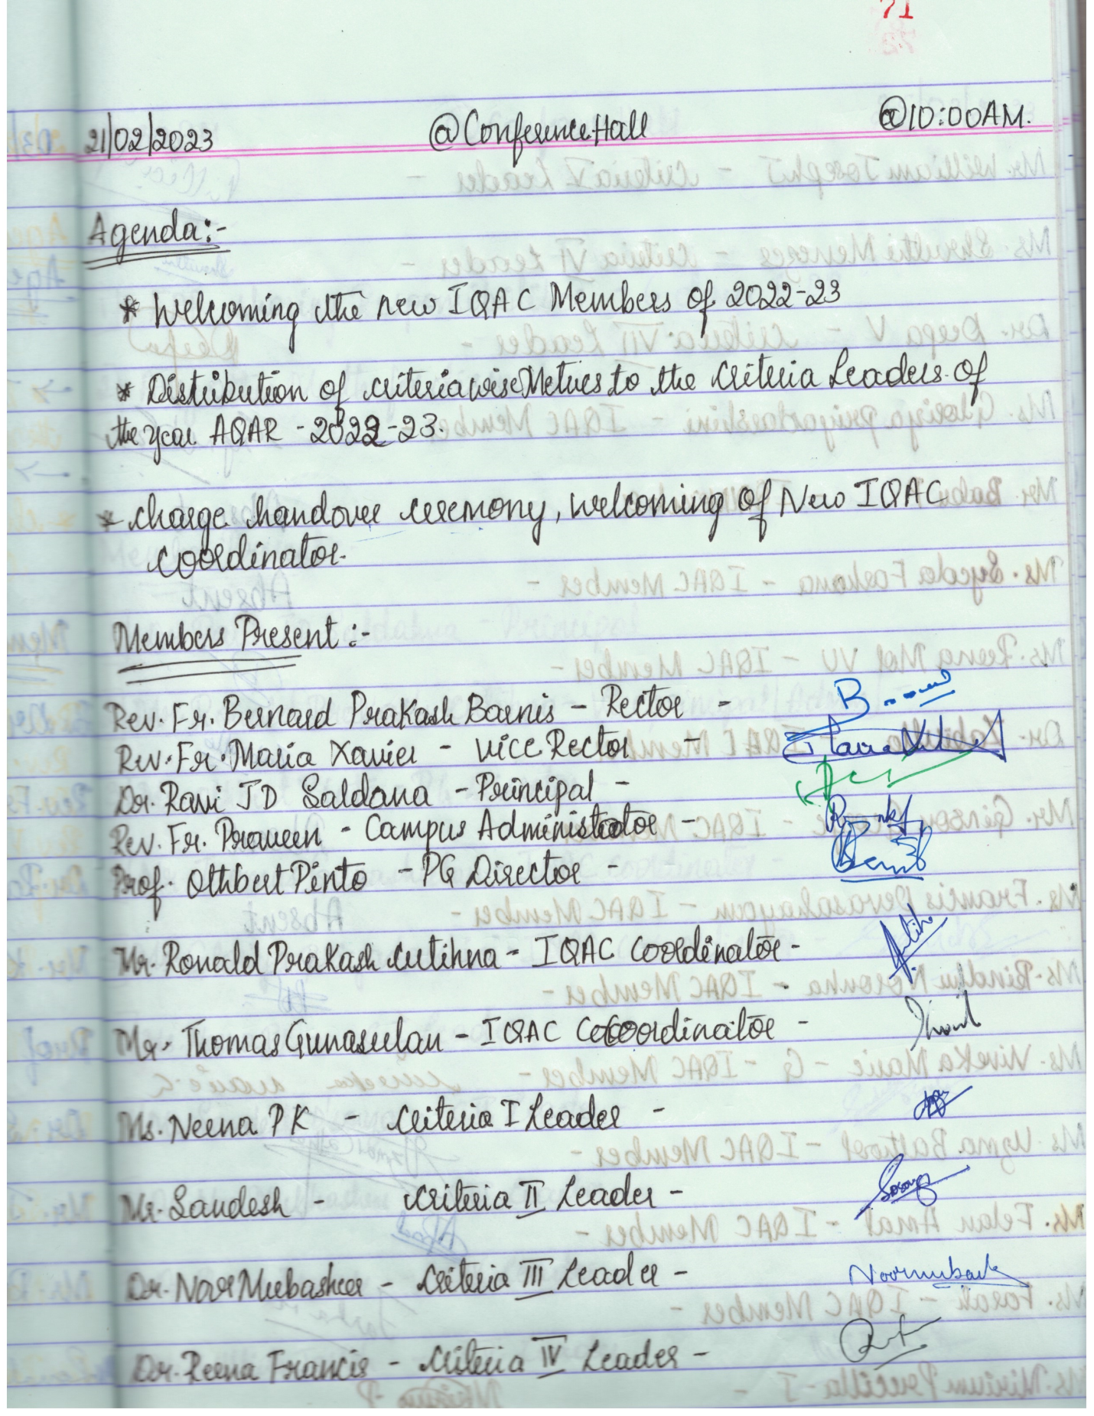
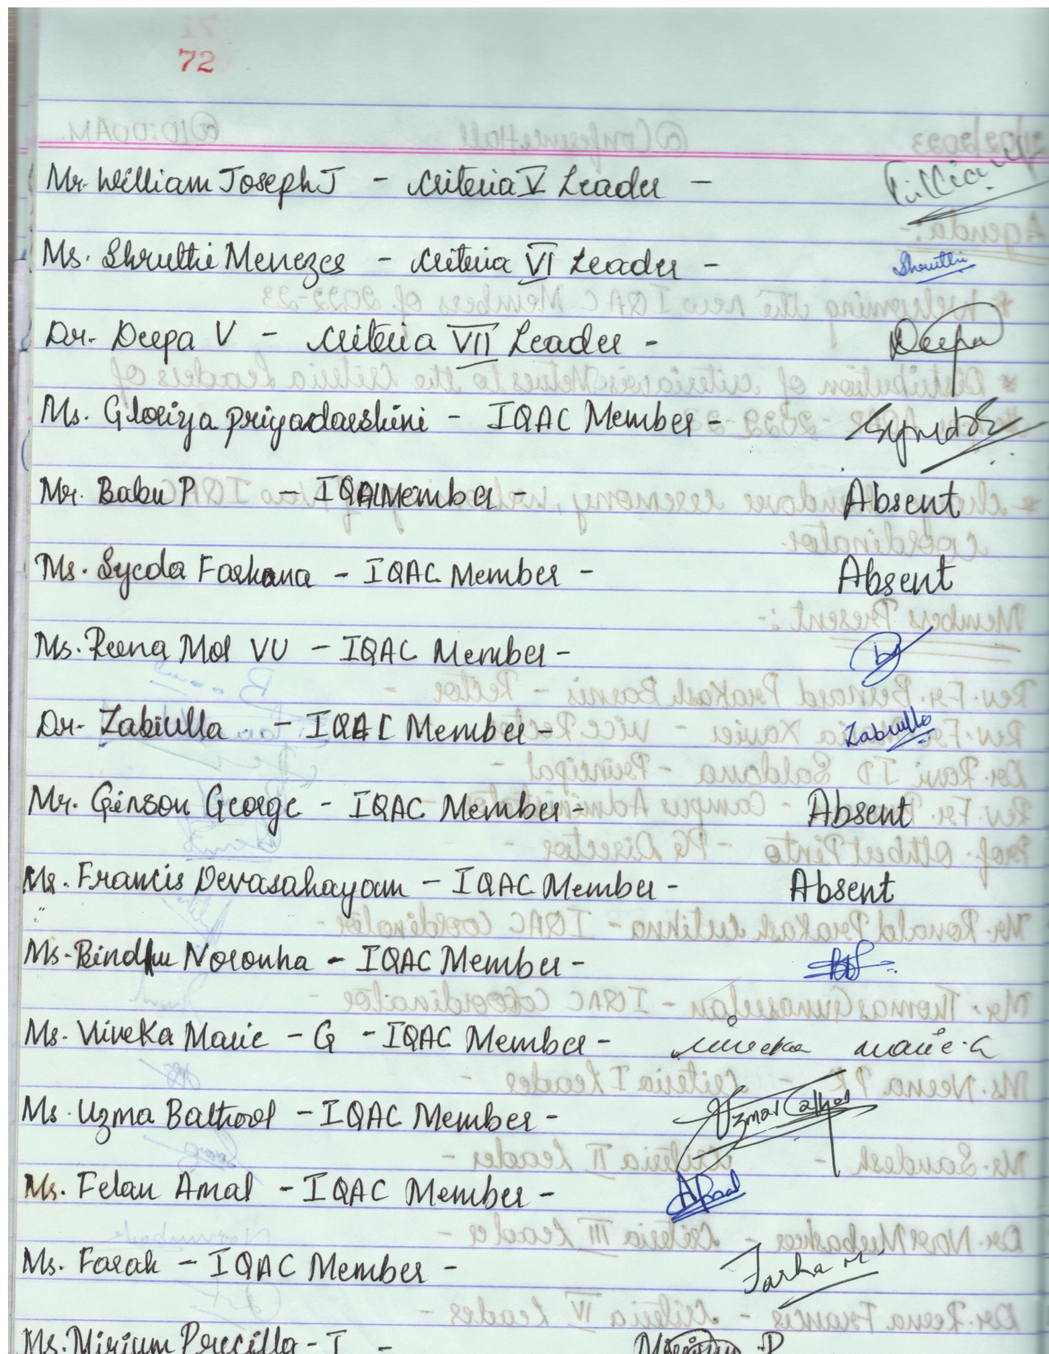
********
- Minutes of the IQAC meeting held on 25.03.2023
Dr. Ravi JD Saldanha, the Principal and the IQAC Chairperson welcomed the members present for the meeting. The IQAC Coordinator, Mr. A. Thomas Gunaseelan presented the proceedings of the previous meeting held on 21.02.2023.
- Discussed on conducting 6-day FDP for the faculty members and assigning responsibilities to NAAC leaders. It was decided to conduct the Capacity Building Programme for six days for the faculty members of St. Philomena’s College (Autonomous), Mysore. Further the dates were confirmedbetween 27.03.2023 and 01.04.2023 and the list of resource persons was finalized.

Members present:
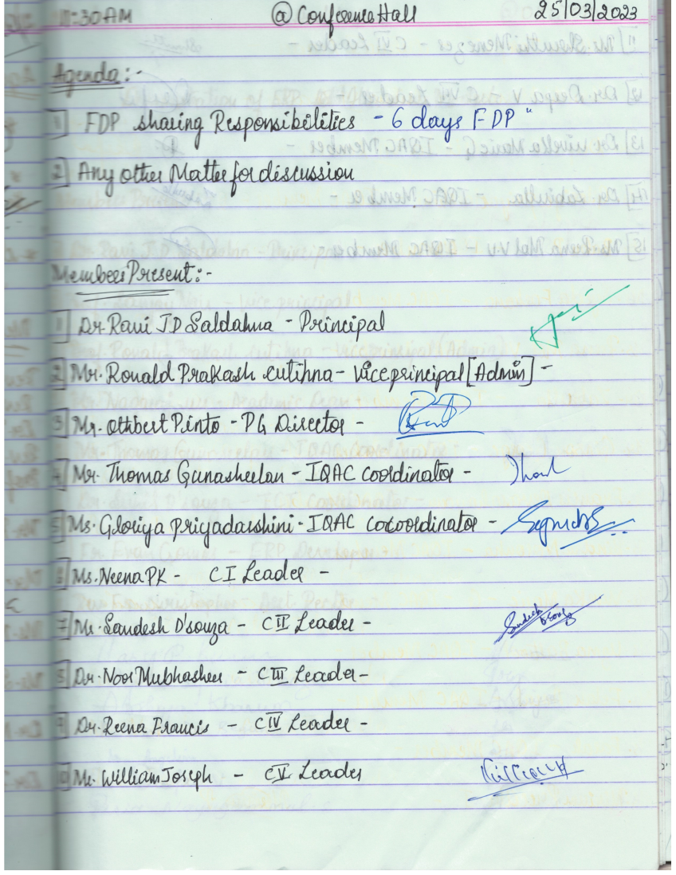
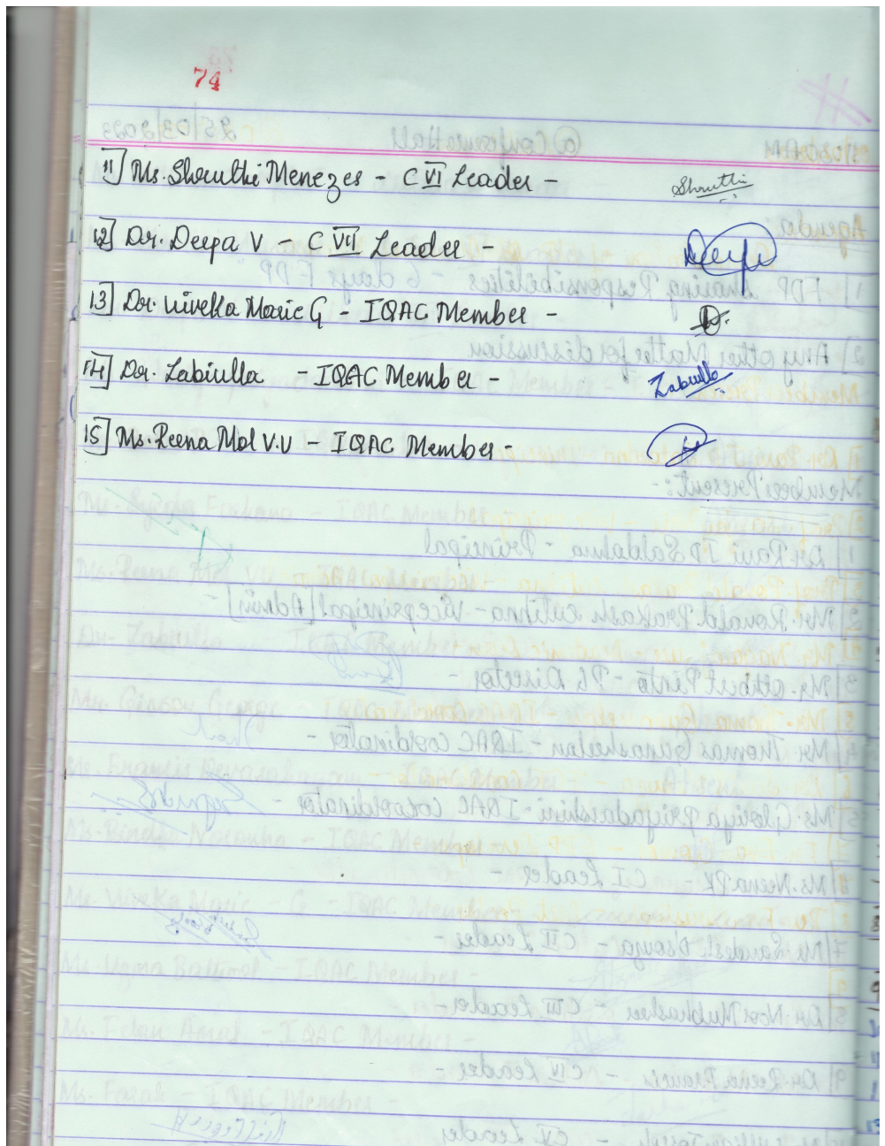

*******
- Minutes of the IQAC meeting held on 05.07.2023at the college UG Conference Hall
Dr. Ravi JD Saldanha, the Principal and the IQAC Chairperson welcomed the members present for the meeting. The IQAC Coordinator, Mr. A. Thomas Gunaseelan presented the proceedings of the previous meeting held on 05.06.2023.
- The entire college staff, management representatives and the administrative and academic heads had a discussion with the members of the Academic and Administrative Audit team at the college indoor stadium. The observations and recommendations of the AAA team were discussed among the stakeholders for further analysis. The report of the observations and the recommendations of the AAA team was presented to the authority at the exit meeting of the AAA visit.

Members present:
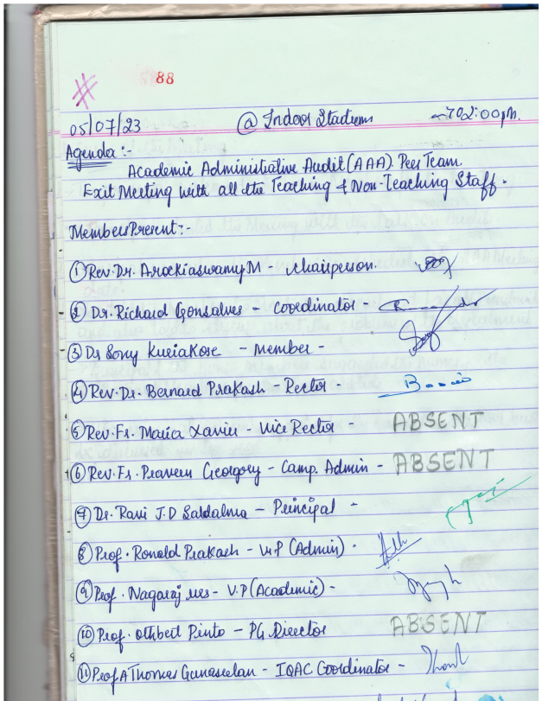
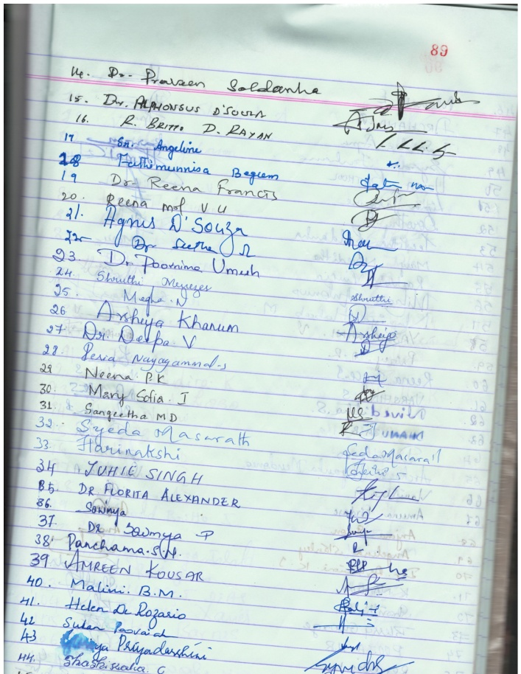
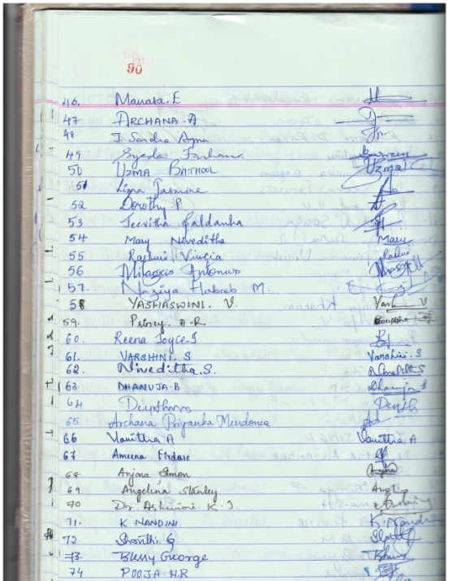
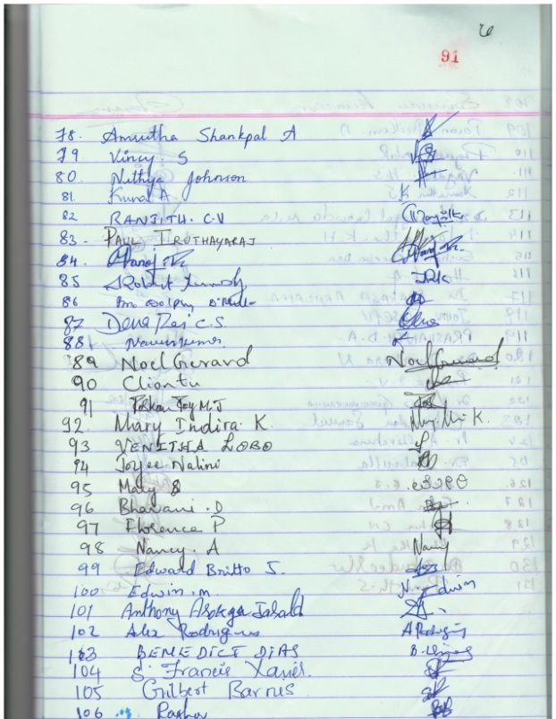
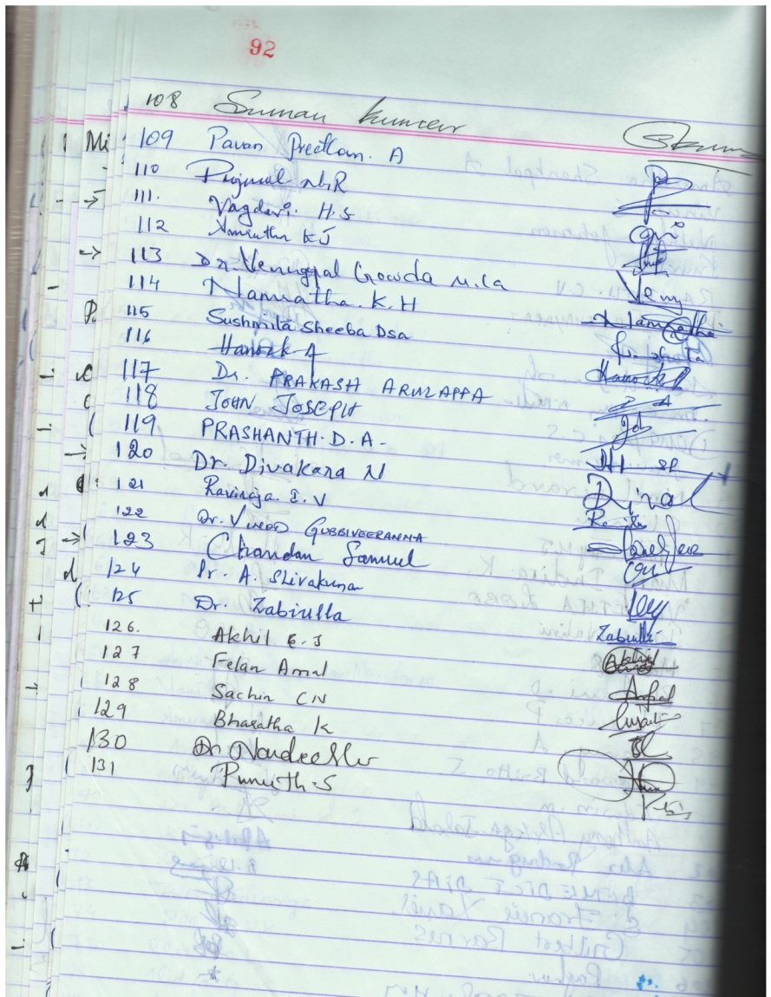
- Minutes of the IQAC meeting held on 19.04.2023 at the college UG Conference Hall
The meeting was chaired by Dr. Ravi JD Saldanha, the Principal. After welcoming the members, the proceedings of the previous meeting held on 25.03.2023 werepresented by the IQAC coordinator.

Discussions:
- The additional members required for each criteria were included and were recoined as extended criteria teams as directed by the Principal.
- A sample submitted AQAR report of an autonomous college was screened and discussed on the ways and means of preparing our AQAR for the years 2021-2022, 2022-2023. Mr. Prakash Cutinha gave detailed information on this.
- He further explained the modes of collecting various data across the different sections and departments and from the stakeholders.
- Dr. Deepa V, the IQAC Co-Coordinator thanked the members.

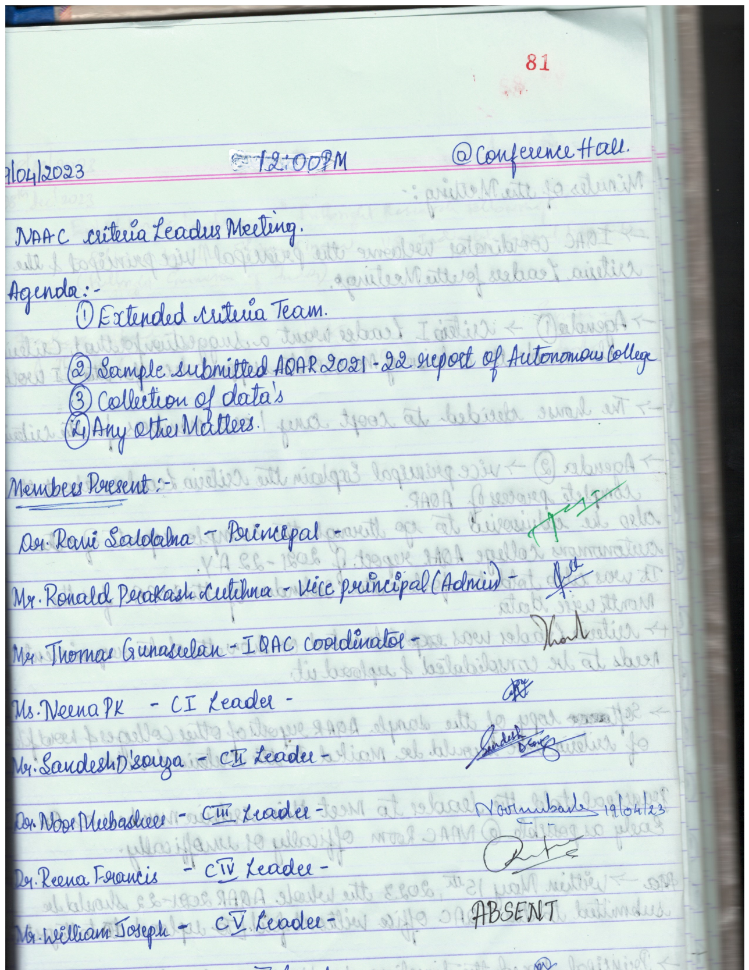
*******

The Action Taken Report (ATR) based on the Plan of Action of the academic year 2022-2023.
Plan of Action | Achievements/Outcomes
Enhancing the number of PG Programmes | MSc in Criminology and Forensic Science
To implement online admission process for the UG and PG programs | Students across the globe were the beneficiaries.
To conduct Orientation programme for the students | Orientation Programme was conducted for the students in the beginning of the academicyear for the complete personality development in the following areas for:  • First semester students on acquaintance of the campus, NEP-2020, significance of higher education, time management skills, library usage, language skills etc.  • Third semester students on physical health and the concepts of mental health, emotional management, and other life skills. Dr. Raveesh, Department of Psychiatry, Mysore Medical College, and Research Institution Mysore - (20th October 2022)  • Fifth semester students on the importance of one’s life - Dr. Sr. Juanita, the Director of Teresian college (20th October 2022)
To conduct Capacity Building Programme for the staff members | A 6-day Faculty Development Programme on “Revisiting NAAC Accreditation and Assessment Process in Autonomous colleges in the light of NEP” was organised for the teachers.  Outcomes:  - Enhanced their knowledge of accreditation, and assessment processes of autonomous colleges.  - Derived a complete idea of embracing the research culture.  - Earmarked the areas to be concentrated.  - Embraced the quality identifying processes like SWOC and Academic & Administrative Audit (AAA).
To conduct workshop on “Writing Research Proposal to funding agencies” in two phases | The workshops were conducted on 13.04.2023 (Part I) & on 05.05.2023 (Part II)  Outcomes: 18 proposals were received and scrutinized by a review team
To take part in NIRF 2022 and AISHE | Successfully took part in NIRF and AISHE
To organize an Induction Programme (Orientation Programme) for the Newlyrecruited Faculty members | Organised the Faculty Induction Programme for the newly recruited staff members in collaboration with the Conference of Catholic Colleges of Karnataka, Mysore (CCCK-M).  Outcome: Faculty were empowered with recent advancements pertaining to teaching methods & other pedagogical skills
To work for the approval of the extension of Autonomous status of the institution | Successfully received the order of the extension of Autonomous status (2023-2027) of the institution dated 31st May 2023 from UGC
To collect feedback from students and staff | Feedback was collected, analyzed, and published in the college website
To support and encourage various departments in organizing invited talks, seminars, workshops, conferences etc. | Activities like invited talks, seminars, workshops, conferences etc were conducted by various departments.

*********

