Antibodies
Antibodies or immunoglobulin (Ig) are substances that are produced rapidly in response to an antigen and can recognize and bind to the antigen that caused its production. Antibodies are chemically glycoprotein and present in the blood serum, tissue fluids and mucosal surface of vertebrate animals.
Antibody structure – Immunoglobulin are largely glycoproteins with molecular weight ranging from 150,000 to 900,000
- All immunoglobulins are having basic “Y” shaped structure. Consisting of four (two pairs) of polypeptide chains connected to each other by disulphide (-S-S) bonds.
- The smaller chains are called light (L) chains and the larger heavy (H) chains.
- The L chains has a molecular weight of approximately 25,000 (25KDa) and consisting of about 220 amino acid residues.
- The H chains has a molecular weight of approximately 50,000-70,000 and consist of about 440 amino acid residues.
- The L chains is attached to the H chains by a disulphide bond.
- The H chains are structurally and antigenically distinct for each class and are designated by the Greek latter corresponding to the immunoglobulin class as follows.
- Ig G - r (gamma)
- Ig A - α (alpha)
- Ig M - µ (mu)
- Ig D – δ (delta)
- Ig E – € (epsilon)
- Both the heavy chains (H) and light chains (L) contains two different regions constant & variable regions.
- Constant regions (C_{L} and C_{H}) have amino acid sequences that do not vary significantly between the antibodies of the same class.
- The variable regions (V_{L} and V_{H}) from different antibodies do have different sequence.
- The area of the H chain in the constant region (C) between the first and second ‘C’ region domains (CH₁) and (CH₂) is the Hinge region.
- The light chains are by two types i.e kappa (K) and lambda () type.
- Each antibodies is made up of either two kappa or two lambda , but never both together.
- The stalk of ‘Y’ consists of carboxyl terminal of chains and it composed of ‘Fc’ fragments.
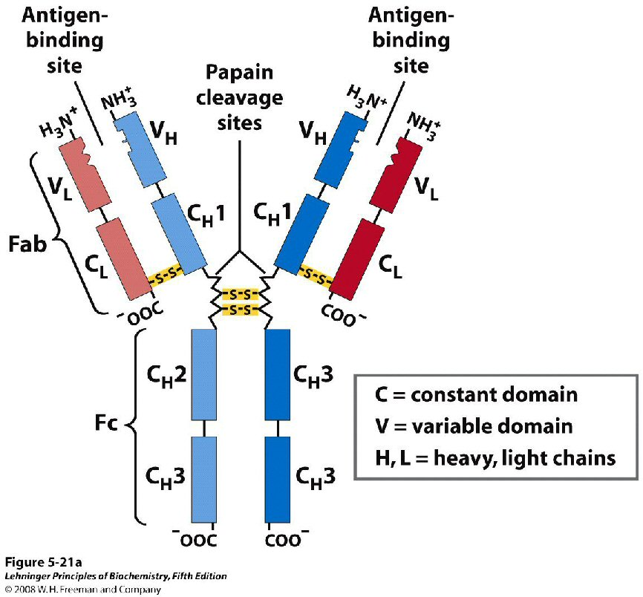
- The Fc fragments made up only the constant regions of the H chains and contain the site at which the antibody binds to a cell. It does not possess antigen combining site but is involved in compliment fixation, placental, transfer, skin fixation etc.
- The top of the Y contains two antigen binding fragments (Fab) present at the N-terminal of the antibody molecule. Fab contains both L & H chains.
- The papain enzyme cleave each monomeric unit, Y-shaped structure near hinge region into two fragments which bind to the antigen (Fab) and one fragment which does not bind to antigen but undergoes crystallization (Fc).
- The Fab fragment is involved in binding of antigen, whereas Fc fragment helps in binding to various cells of the immune system thus immunoglobin are bifunctional in nature.

Types of immunoglobulins – immunoglobulins are classified into five types based on the antigenic character of heavy chins. There are immunoglobulin G(Ig G), immunoglobulin A (Ig A), immunoglobulin M (Ig M), immunoglobulin D (Ig D) and immunoglobulin E (Ig E). The heavy chains in Ig G, ‘µ’ in Ig M, ’α’ in Ig A, ‘δ’ in Ig D and ‘€’ in Ig E. An individual person has the all the five types of immunoglobulins.
Immunoglobulin G (Ig G) –
- Ig G is a monomer unit.
- This is the major immunoglobulin in human serum and makes up 70 to 75% of the total immunoglobulin pool.
- The normal concentration of Ig G is about 8-16 mg/ml.
- The Ig G is present in blood plasma and tissue fluids.
- The Ig G class acts against bacteria and viruses by opsonizing the invaders and neutralizing the toxins. It also activates the complements by classical pathway.
- Ig G is the only immunoglobulin molecule able to cross the placenta(hence termed as maternal antibody) and provide naturally acquired immunity for the new born and persists for several months.
- Totally there are four Ig G subclasses: Ig G₁, Ig G₂, Ig G₃ and Ig G₄ that vary chemically in their V heavy chain composition and the number and arrangement of interchain disulfide bonds.
- Ig G₂ antibodies are opsonic and develop in response to antitoxins. Anti-Rh antibodies are of the Ig G₁ or Ig G₃ subclasses. Ig G₁ and Ig G₃ also bind best to monocytes and macrophages. Ig G₄ function as skin sensitizing immunoglobulin.

Immunoglobulin A (Ig A) –
- It is the second most abundant Ig and accounts for about 15%of the immunoglobulin pool.
- The normal concentration of Ig A is about 0.6 to 4.2mg/ml.
- It is the major immunoglobulin in colostrum, saliva and tears.
- Some Ig A is present in the serum as a monomer of two heavy and two light chains. Most Ig A, however occurs in serum as polymerized dimer joined together by a polypeptide J- chain.
- Ig A has special features that are associated with secretory mucosal surfaces.
- Ig A, when transported from the mucosal associated lymphoid tissue to mucosal surfaces, acquires a polypeptide termed secretory protein and called secretory antibody.
- The secretory Ig A (s Ig A), as the modified molecule is now called the primary immunoglobulin of the secretory immune system. This system is also found in gastrointestinal track, upper and lower respiratory track and genitourinary system.
- By the formation of an immune barrier s Ig A plays an major role in protecting surface tissues against infectious microorganisms. For example;
- In breast milk s Ig A maternal antibodies helps to protect newborns.
- In the intestine, s Ig A attaches to viruses, bacteria and protozoan parasites such as Entamoeba histolytica. This prevents pathogen adherence to mucosal surfaces and invasion of host tissues.

Immunoglobulin M (Ig M)-
- Ig M is the third most abundant immunoglobulin and accounts for about 10% of the immunoglobulin pool.
- The normal concentration of Ig M is about 1.5mg/ml.
- It is usually a polymer of five monomeric units (pentamer) joined by disulfide bonds.
- The monomer consists of Fc region in the center and consists of special J (joined) chain between two monomers.
- Ig M is the first immunoglobulin made during B-cell mutation and the first secreted into serum during primary antibody response.
- Since Ig M is so large it does not leave the blood stream or cross the placenta.
- Ig M agglutinates bacteria, activates complement by the classical pathway, and enhances the ingestion of pathogens by phagocytic cells.

Immunoglobulin D (Ig D)-
- Ig D is an immunoglobulin found in very low concentration in the blood stream.
- The normal serum concentration of Ig D is 30µg/ml.
- It is highly sensitive to proteolytic enzymes and to heat.
- Ig D has a monomer structure similar to Ig G.
- Ig D antibodies do not fix complement and cannot cross the placenta, but they are abundant on the surface of B-cells and bind antigens, these signaling the B-cells to start antibody production.

Immunoglobulin E (Ig E)-
- Ig E makes up only 0.00005% of the total immunoglobulin pool.
- The normal serum concentration of the Ig E is 0.3µg/ml.
- Most Ig E is bound to cytoplasmic membranes of basophils in blood and most cells are in connective tissue, where it mediates the release of histamine that cause immediate type allergic reactions.
- Ig E levels are only in traces in the body, but greatly elevated levels are seen in allergic conditions, such as asthma, hay fever, etc.
- Children living in insanitary conditions with a high load of intestinal parasites have high serum levels of Ig E.
- Ig E is chiefly used produced in the lining of the respiratory track and intestinal track.
NOTE: Ig G protects the body fluids, Ig A the body surfaces, and Ig M the blood stream, while Ig E mediates hypersensitivity. Ig D helps in signaling B-cells to start antibody production.

