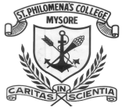

MYSORE DIOCESAN EDUCATIONAL SOCIETY
ST. PHILOMENA’S COLLEGE (AUTONOMOUS), MYSORE

Affiliated to University of Mysore

A REPORT ON INDUSTRIAL VISIT TO BEE 9 NUTRACEUTICAL, FARMER’S BEEKEEPING ACADEMY AND TRAINING CENTRE, MYSORE AND
AIISH, MYSORE

Preamble: The purpose of this report is to provide an introduction to an industrial visit conducted at a Bee9 neutraceutical, Farmer’s beekeeping academy and training centre, Mysore and AIISH, Mysore. The visit to Bee9 aimed to offer us an opportunity to explore benefits of beekeeping, honey harvesting, processing and its unit and packaging and its unit and The visit to All India Institute of Speech and Hearing (AIISH) aimed to offer us an opportunity to explore knowledge about speech language pathology, audiology, speech sciences and hearing sciences.

a. Bee 9 Unit

Introduction:

Bee 9 Unit is located at factory outlet area in Mysore, opposite to Seshadripuram College. Established as a Proprietorship Firm in the year 2019.The brain behind the way nature intended is Mr. prasad, an envinonmentalist and avid Apiarist. “Mack Bee9 Nutraceuticals” are a leading manufactur of a wide range of quality products like Natural Honey, Beeswax Bar, Bee Pollen etc.It has manufacturing unit for pure honey and a training centre. The beekeeping process in Bee 9 unit utilises the modern method of beekeeping, where the honey bees are raised in brood chambers in wooden boxes. In times when purity is a rarity, Bee 9 emerges as a harbinger of hope of caputuring the goodness of honey in all its Pureness. 70 students with faculty members visited the factory on 16th July, 2024.

Objectives:

- The industrial visit aimed to understand its significance in various sectors and the efforts undertaken by the factory to maintain high-quality standards. It provided valuable insights into the manufacturing processes, quality control measures and the global reach of Bee 9 products.
- Through this report, we explore the details of the visit, including the specific areas covered, observations made and the key learnings acquired during the visit to the Mack Bee9 Nutraceuticals.

Production:

- Extraction: There are 4 major types of Honey bee which are commonly used for commercial purpose :

- Apis dersata - it produces 38-40 kg of honey/year in each colony.
- Apis flonea - it produces 1 kg of honey yearly.
- Apis indica - it produces 2-8kg of honey per year.
- Apis mellifena - it produces honey between 20-40 kg yearly per colony.

- Processing: After the extraction of honey, it has sent to the processing unit for further processing, where the unwanted substances are removed and useful substances like wax is separated from the honey comb.
Thus, the unit gives the concentrated form of pure honey which has longer, the processing shelf-life and can be stored far longer period of time.

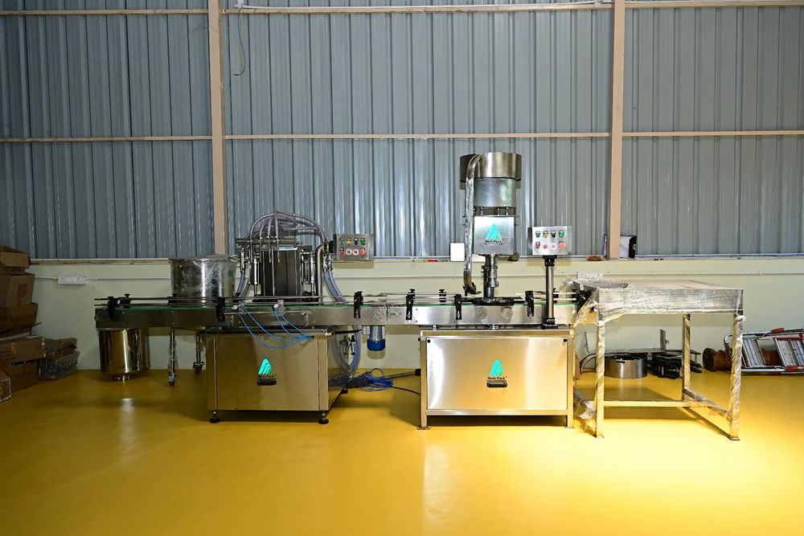
Processing unit

Types of Honey and their benefits:

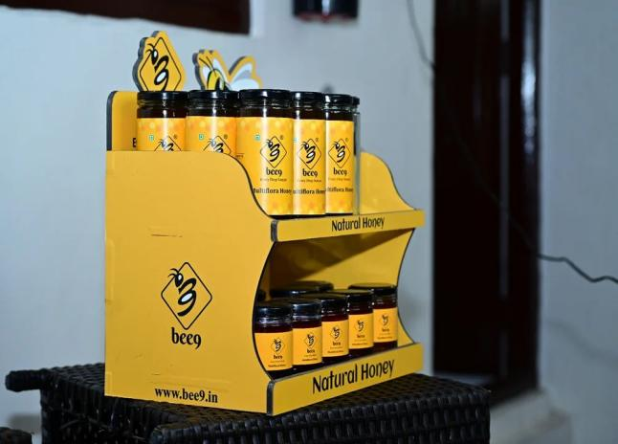

Sidr honey
It is mono -floral honey that is harvested from bees that feed solely on the nector of the Sidr tree, which is grown in the temperate and desert areas.
Benefits:
* Relieves throat pain, cough & flu symptoms
* Boosts memory retention
* Helps in weight loss as it has zero fat & low sugar
* Tremendously strengthens immunity

Jamun honey
It is Uni-flora honey which means, it contains the nectar of the Jamun flower.
Benefits:
* Treats Amnesia
* Helps in diabetes management
* Improves eye healthy
* Helps in fighting cancer

Wild forest honey
It is derived from the wild flora of the uttarkhand. It is completly free from perticides and Inseticides or other toric substances.
Benefits:
* Has immunity-boosting properties
* Suitable for diabetic patients
* Prevents cold and sore throat

Himalayan Multiflora honey
Multiflona honey is a blend of honey from Various floral sources in foot hills of Himalaya, this honey is an amalgamation of several floral honey.
Benefits:
* Kills harmful bacteria,
* It solves skin problems
* It helps reduce swelling,heals wounds & burns
* It is a healthy drink that improves digestion
* It Provides big relief from cold and sore throat

Kashmir Multiflora honey
It is also known as honey dew, is derived from various floral Sourced diretly vallys of Kashmir, its nectar is entirely unfiltered and unpasteurized, retaining all its nutrifional value.
Benefits:
* It boosts immunity.
* Helps in glowing Skin
* It diminishes acidity.
* Improves digestion

Coffee Honey
It is a type of honey that is collected by installing bee colonies inside the fields of blooming coffee flowers. It has a caramel flavor with earthly & floral notes & it contains trace amounts of caffeine, anti-oxidants & Minerals.
Benefits:
* Antimiuobial and anli -inflammatory
* Provides instanta enugy knugy & Stnengthens Immunity.
* Rich in antioxidants, flavonoides and nutrients

Outcomes:
Overall, the visit was a great learning experience, allowing us to witness firsthand the intricacies of the Honey Bee processing, types of honey and the importance of sustainable practices in the industry.

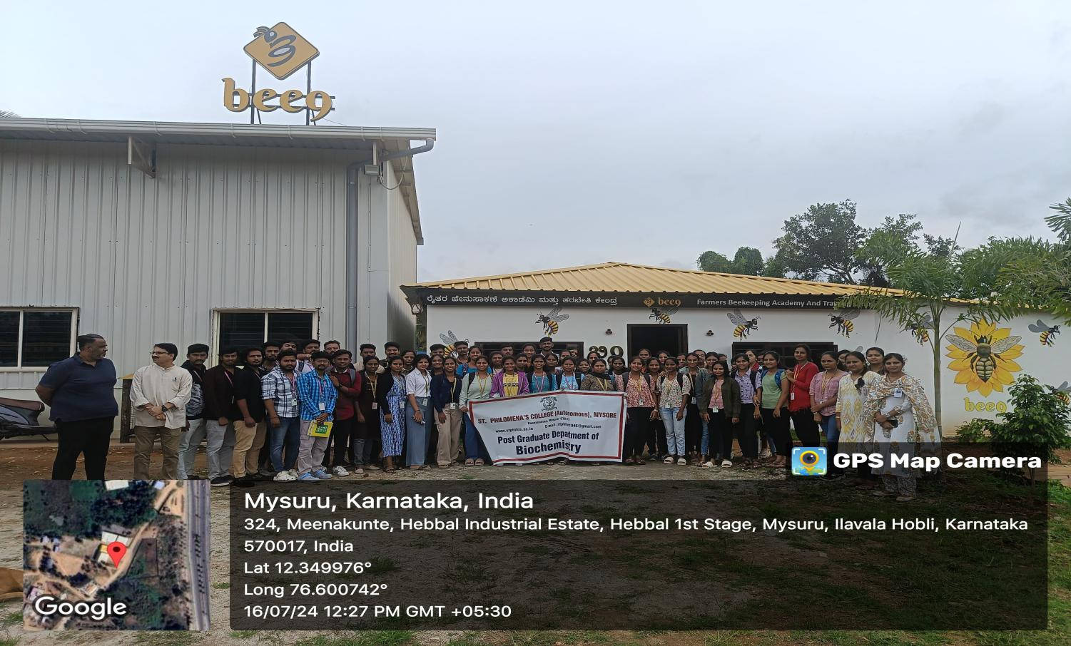

BEE 9 NUTRACEUTICAL, FARMER’S BEEKEEPING ACADEMY AND TRAINING CENTRE

b. All India Institute of Speech and Hearing (AIISH)

Introduction:

The All India Inititute of Speech and Hearing, also known as AllSH, is located in Manasagangotri, Mysore, It is an autonomous institute under the Ministry of Health and family Welfare. The institute was established in 1966 with a focus on training professionals for speech & hearing. AlISH is affiliated to the University of Mysore & offers undergraduate, graduate and doctoral degrees in Speech and Hearing.
AlISH also conducts research in speech-language pathology Sciences, Speech sciences & audidogy. Some of the current hearing research activities focus on early identification and genetics of hearing impairement, effectiveness of intervention strategies, development of assessment materials for Indian languages and speech speaker recognition.
It has developed normative data for speech and lauguage acquistion in children for Various Indian lauguages & established a research fund from which small grants are awarded to specialists working in fields such as neurology, genetics, epidemiology, linguistics and clinical psychology.70 students with faculty members visited the factory on 16th July, 2024.

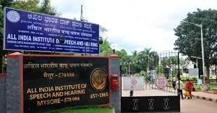
AIISH, Mysore

Objectives:

- Education and training
- Human resource development
- Research
- Clinical services
- Public Education

Educational programmes:

AIISH offers a range of academic programs at undergraduate, postgraduate and doctoral levels. some of them includes,
•Bachelor of Audiology & Speech - Language Pathology [BASLP):- A four year undergraduate program designed to train students in the assessment and treatment of communication disorders.
•Master of Audiology 4 speech-Language pathology (MASLP): A two year postgraduate program provides advanced training in andrology & speech-language pathology.
•Doctoral programs (Ph.D):- Research-oriented programs aimed at developing experts in various subfields of speech and hearing sciences.

Research:

AIISH is recognized for its cutting edge research in the field of communication disorder.
•Speech & language development
•Audiology & hearing science
•Neurogenic communication disorders
•Voice & fluency disorders
•Augmentative & alternative communication.

Clinical services:

The institute provides a wide range of clinical services through its various departments and specialized centers.

These services include
•Diagnostic services - Comprehensive evaluation and diagnosis of speech, language & hearing disorders
•Therapeutic services - Evidence-based Intervention and rehabilitation programs tailored to the individual needs of clients
•Hearing Aid fitting and cochlear implant program - Advanced services for individuals with hearing impairement induding hearing aid fitting, cochlear implants and auditory training.
•Voice & fluency Clinic - Specialized services for individuals with voice disorders and

Public awareness and outreach:

AIISH actively engages in public awareness campaigns to educate the community about communication disorder and their management. The institute conducts workshops, seminar and training programs for professionals, caregivers and the general publics. It also collaborates with government and non-governmental organization to extend its services to underserved populations.
Hearing Aids provided by All India institute of speech and Hearing (AIISH).

Conclusion

The AlISH stands as a beacon of excellence in the freld of communication disorders in India. They provide comprehensive range of hearing aids, ensuring that individuals with hearing impairement recieve the most suitable 4 advanced solutions for their needs. AllSH continues to improve the quality of life, helping them to hear and communicate effectively.

Outcomes

Overall, the visit was a great learning experience, AIISH offers a comprehensive range of hearing aids and related services tailored to meet the diverse needs of individuals with hearing impaisements. AIISH ensures that clients recieve the most apprpopriate hearing aid based on the specific auditory profile and lifestyle requiements.

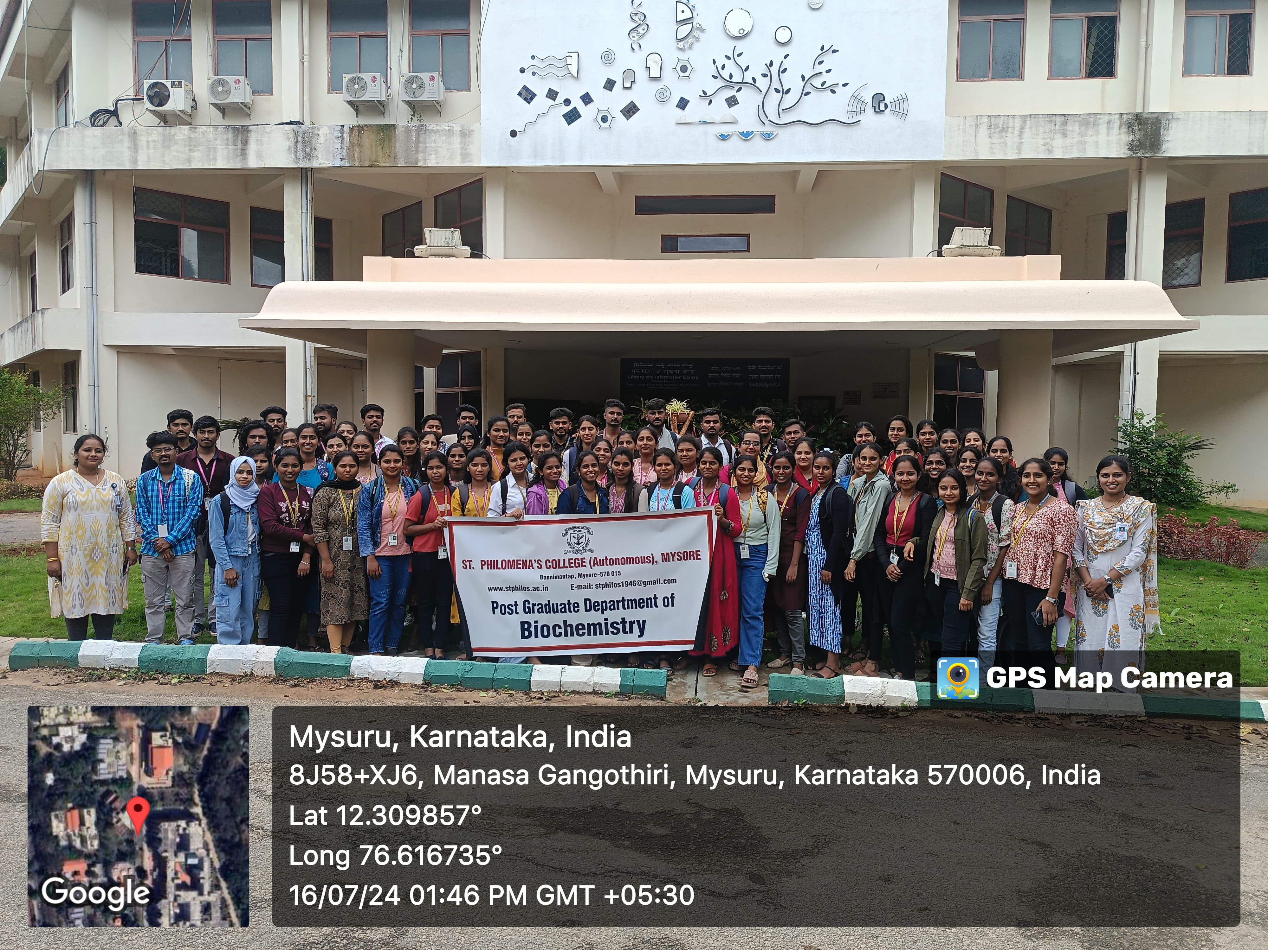

All India Institute of Speech and Hearing (AIISH) Mysore

Feedback analysis:

