
ST. PHILOMENA’S COLLEGE (Autonomous), MYSORE – 570 015
Affiliated to University of Mysore
College of Excellence – UGC, Re-accredited by NAAC
PG DEPARTMENT OF ECONOMICS
REPORT
The PG Department of Economics had conducted a special lecture for MA Economics students, on the part of their curriculum. Special lecture was delivered by Dr.Sarah Razack Assistant Professor in Economics, on 04/03/2023on the topics of “Budget Analysis- 2023-24” respectively.

OBJECTIVES OF THE INVITED LECTURE
- To understand the need of Budget to a country.
- To understand the basic procedure of central and state budget.
- To learn about the components and instruments of budget.
- To analyse the overall budget provision sector and state wise.

The session was started on 04-03-2023 at 11.00 am, on the topic of “Budget Analysis- 2023-24”. The session was attended by both Iss and III semester students of MA Economics and session was informative and interactive. The resource person throw a light on the need and essentials of budging. Budget analysis is a crucial process that involves evaluating and assessing the financial aspects of an individual, organization, or government entity. It helps in understanding income, expenses, and financial goals, and provides a framework for effective financial planning and decision-making. When conducting a budget analysis, there are several essentials to consider income, fixed assets, debt and loans , savings and investment and financial goals. Totally the session was very useful and students were enjoyed the session.
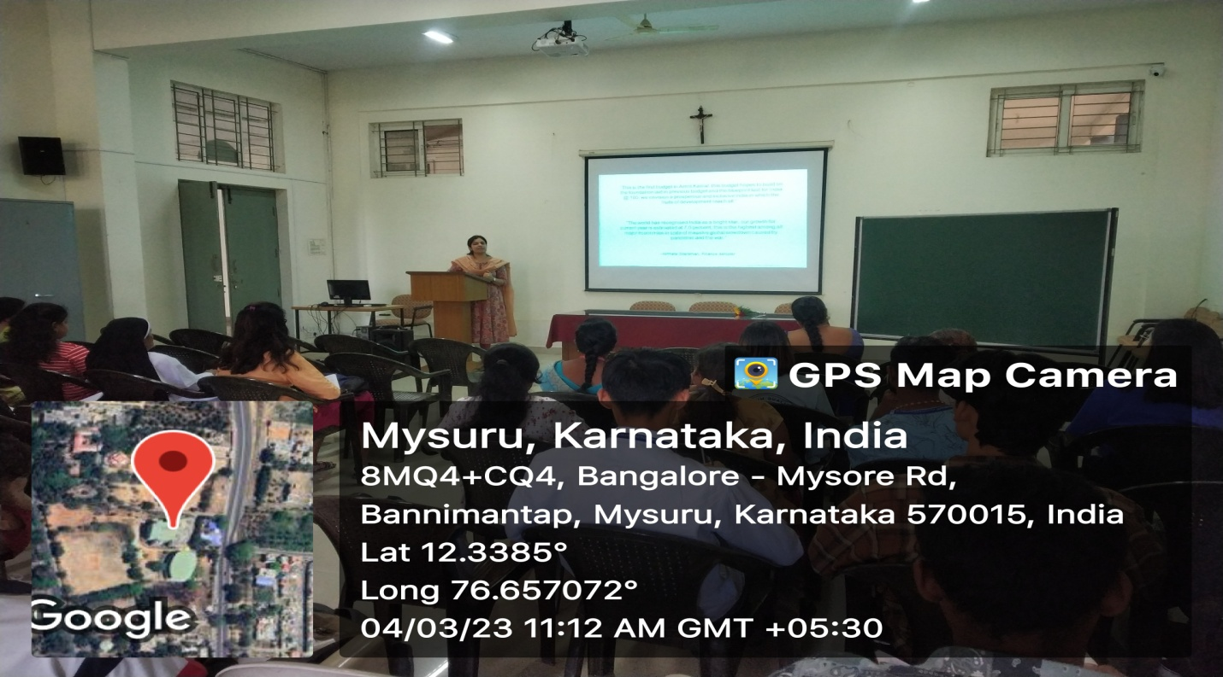

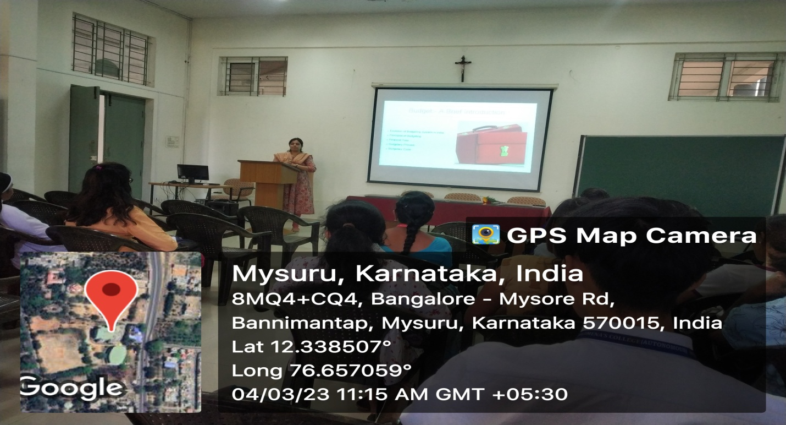

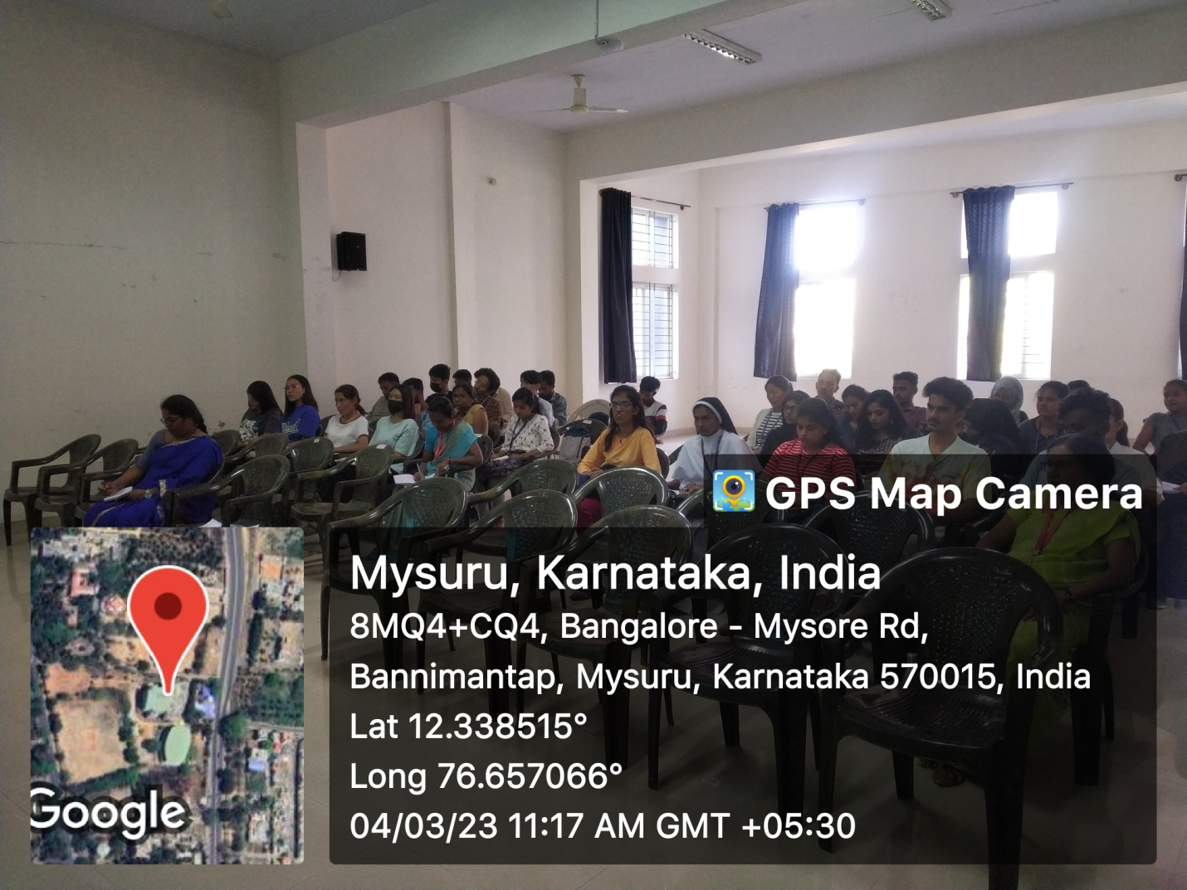

OUTCOMEOF THE INVITED LECTURE
The special lecture sessions were knowledgeable and useful for the students to make clear and easy understand the budget concepts and components. Students gain the knowledge on Public expenditure and revenues and also need for the budget in a country. They also understands the relationship between the public expenditure, revenues and deficit financing. They analysed the essentials of good budget.

STUDENTS ATTENDANCE
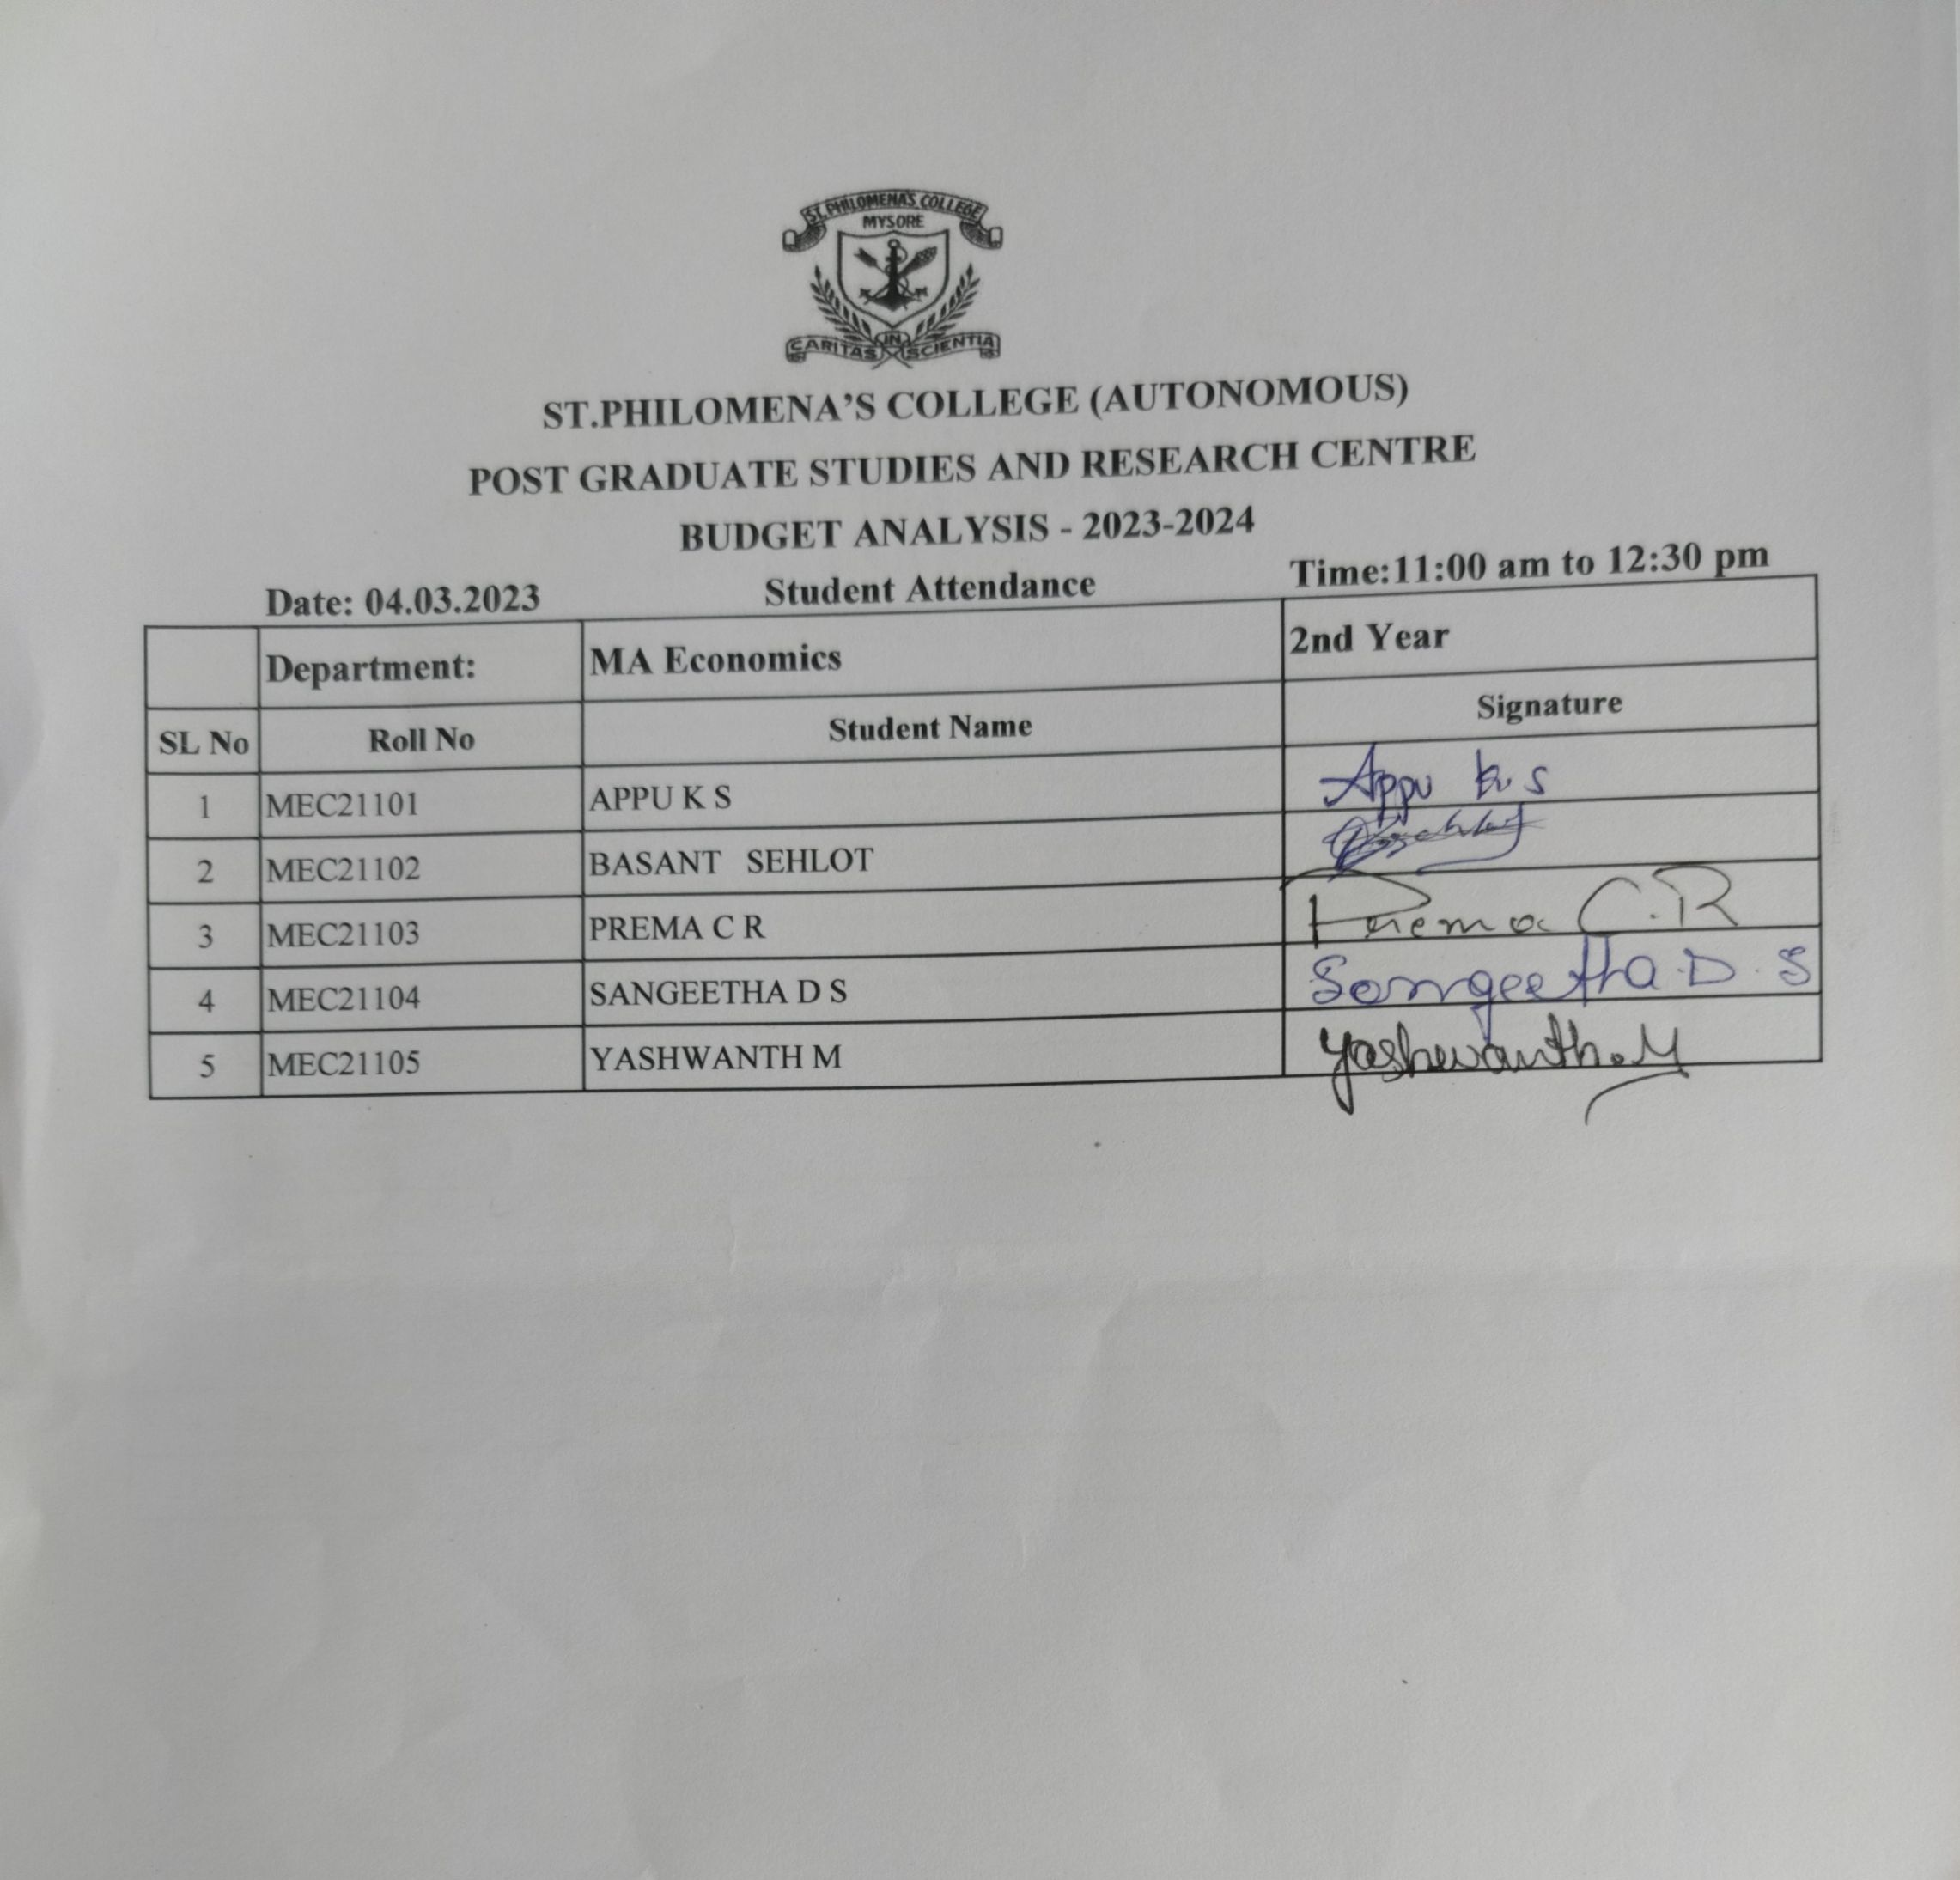

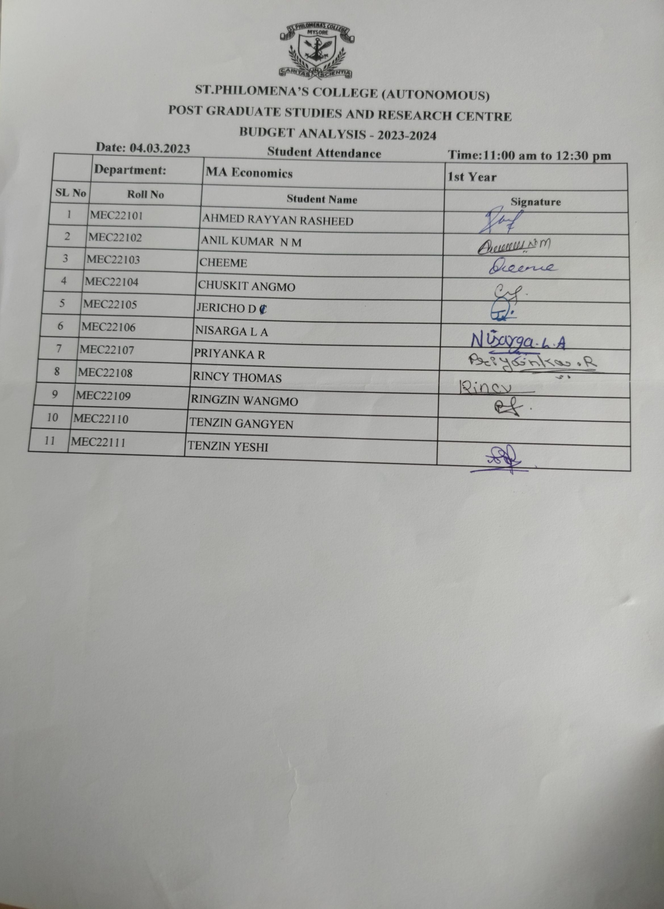
FEEDBACK

