CO-Dominance:
It is the phenomenon in which two alleles express themselves independently when present together in an organism. In other words, it is the phenomenon in which offspring shows resemblance to both the parents.
For example:
1. In cattles, if a cattle with black coat is crossed to a cattle with white color, the F₁ hybrids possess roan coat. In roan coat, both black and white patches appear separately. So, the alleles which are able to express themselves independently when present together are called co- dominant alleles.
2. ABO blood group in humans: ABO blood groups are controlled by the gene I. The plasma membrane of the red blood cells has sugar polymers that protrude from its surface and the kind of sugar is controlled by the gene.
The gene I has three alleles I_{A}, I_{B} and i. The alleles I^{A} and I^{B} produce a slightly different form of the sugar, while allele i does not produce any sugar. In humans, each person possesses any two of these three I gene alleles. I^{A} and I^{B} are completely dominant over i. When I^{B} and i are present, only I^{B} expresses (because i does not have any sugar).
Same is the case with I^{A} and i. But when I^{A} and I^{B} are present together, they both express their own types of sugars, this is due to co-dominance. Therefore, the red blood cells have both A and B types of sugars. Since, there are three different types of alleles; there can be six different combinations.
3.Another example of incomplete dominance (at cellular or cell shape level) and co domince(at molecular,i.e., haemoglobin level) is with sickle cell anemia, a disease in which a blood protein called hemoglobin is produced incorrectly. This causes the red blood cells to have a sickle shape, making it difficult for these misshapen cells to pass through the smallest blood vessels. A person that is homozygous recessive (ss) for the sickle cell trait will have red blood cells that all have the incorrect hemoglobin. A person who is homozygous dominant (SS) will have normal red blood cells

Incomplete Dominance:
In incomplete dominance the genes of an allelomorphic pair are not expressed as dominant and recessive but express themselves partially when present together in the hybrid. As a result F₁ hybrids show characters intermediate to the effect of two genes of the parents.
A good example of incomplete dominance is seen in Mirabilis jalapa (Four o’clock plant) and Antirrhinum majus. It has also been noticed in Andalusian fowl.
Four o’clock plant:
In Mirabilis jalapa (Four o’clock var. Gulbansi) and Antirrhinum majus (snapdragon or dog flower), there are two types of flower colours i.e., red and white
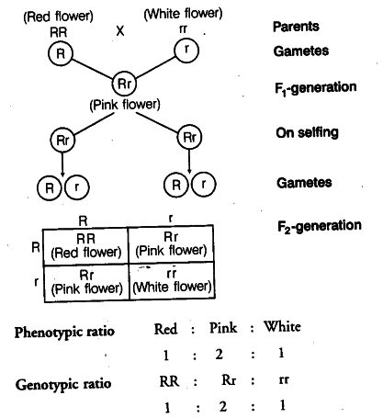
Here, when a cross is made between red flowered (RR) and white flowered (rr) varieties, F₁ (Rr) progeny produced is an all pink flowered. When these F₁ pink flowers are self pollinated or crossed among themselves to raise F₂ generation, they produce red (RR), pink (Rr) and white (rr) flowers giving 1:2:1 ratio. This phenotypic ratio is identical with genotypic ratio because heterozygotes are phenotypically intermediate between two homozygous types.
Andalusian fowl:
The Andalusian fowl is found in three colours: Black, white and blue. Pure forms are black (BB) and white (bb). If these two forms are crossed, F₁ individuals appear blue (Bb) coloured. The blue hybrids on crossing with each other (Bb x Bb) give rise to one black, two blue and one white in 1:2:1 ratio.
Out of three types blue coloured fowls are favoured as delicacy and are in demand for food, but the blacks and whites are wasters. Previously, poultry men had been destroying blacks and whites.
Crosses were being made only between blues but to get only 50% blues, others 25% blacks and 25% whites (wasters). Now there is no need to destroy blacks and whites. If blacks and whites are crossed all the offsprings are blue.
Naziya Habeeb M.
Department of Biotechnology

.
*********************

